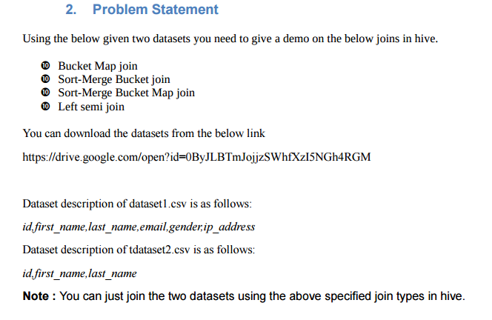

**Solution-**

**Input Dataset 1-**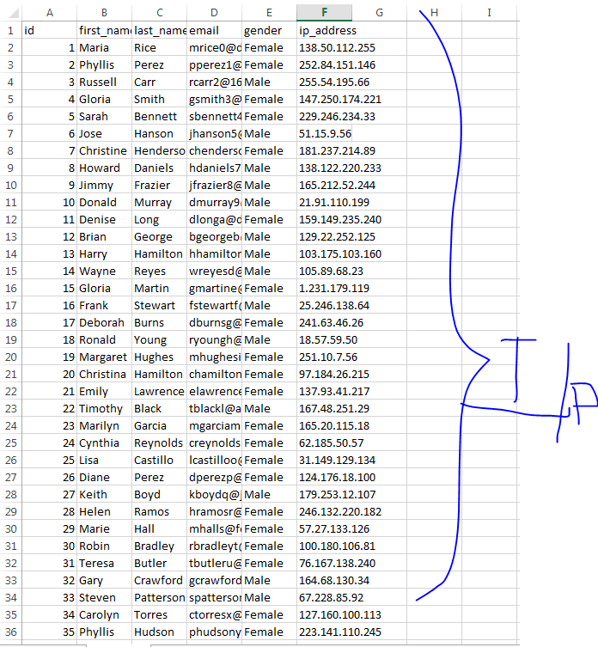

**Input Dataset 2-**

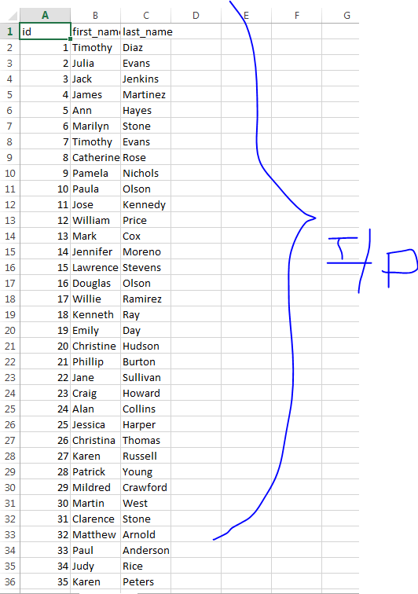

**Create Table-**

* Table created for dataset 1.
* Loaded data in Table.
* Table created for dataset 2.
* Data loaded in Table.
* Bucket table created for dataset 1 and dataset 2.

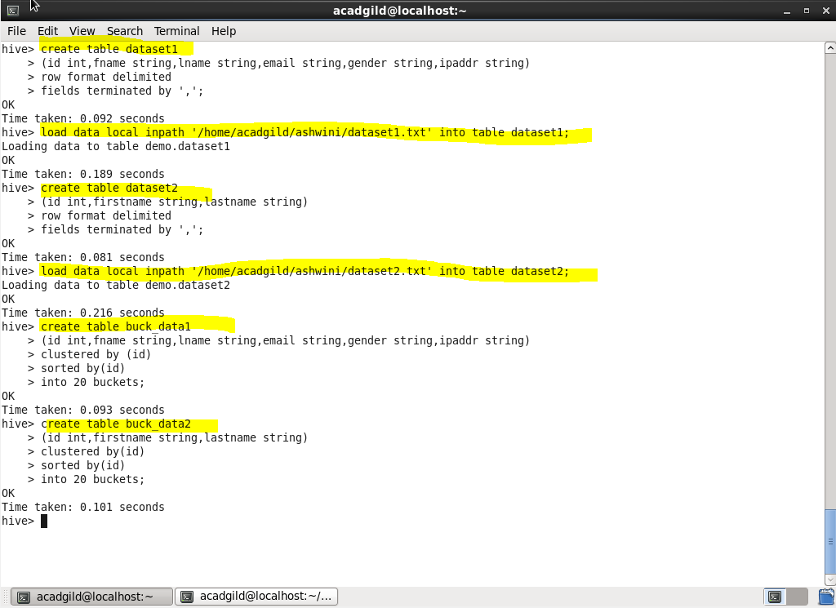

**Insert Data-**

* Inserted data in bucket table 1 and bucket table 2.

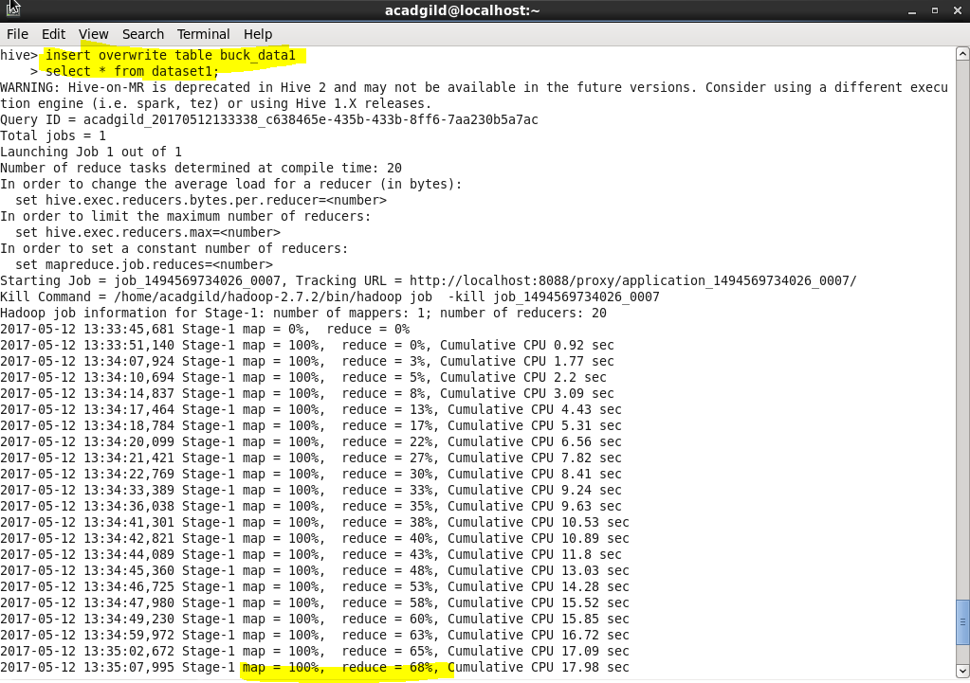

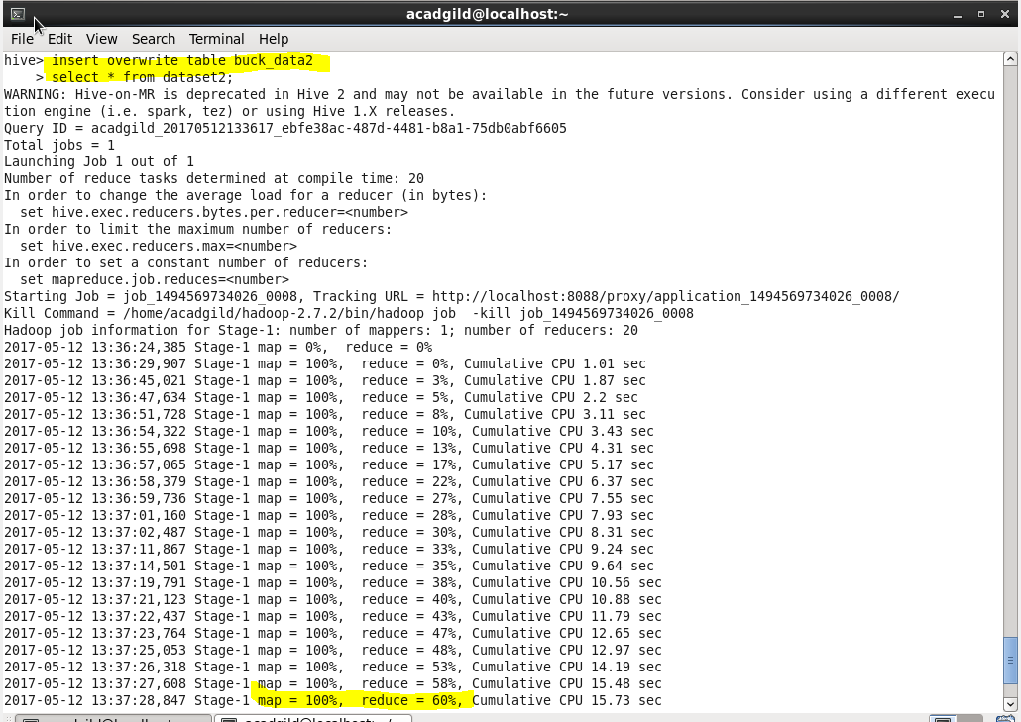

**Bucket Map Join-**

* Set properties for bucket map join.
* Join query to apply bucket map join.

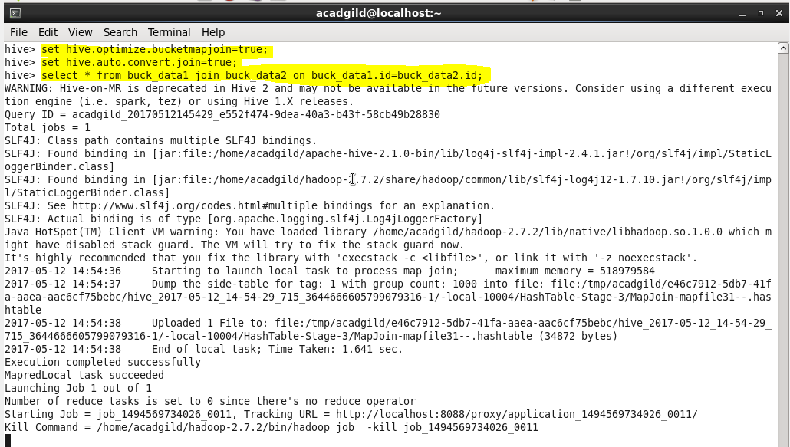

**Output-**

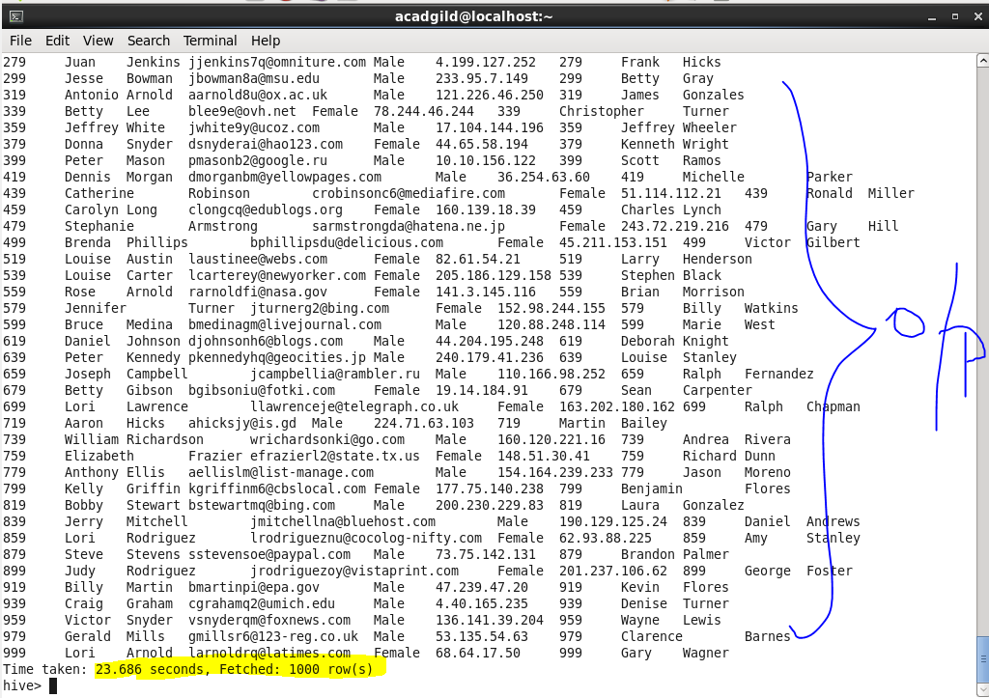

**Sort Merge Bucket Map Join-**

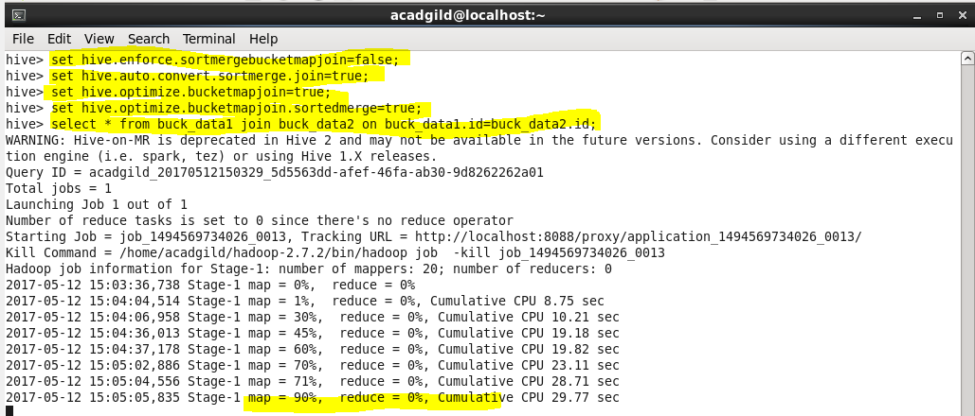

**Output-**

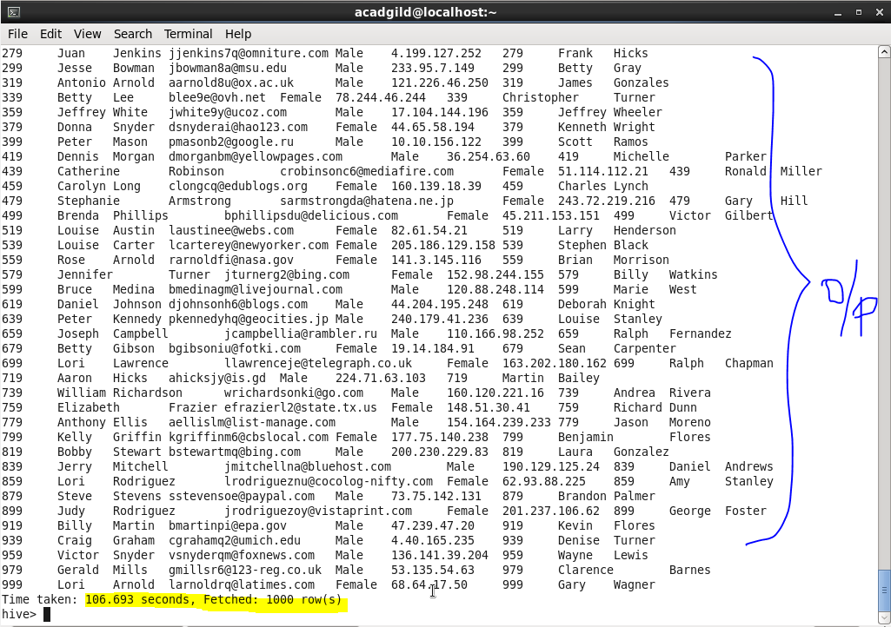

**Left Semi Join-**

