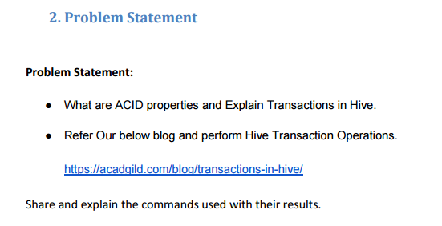

**Solution-**

**ACID Properties-**

1. **A-Atomicity-** Atomicity means, a transaction should complete successfully or else it should fail completely i.e. it should not be left partially.
2. **C-Consistency-** Consistency ensures that any transaction will bring the database from one valid state to another state.
3. **I-Isolation-** Isolation states that every transaction should be independent of each other i.e. one transaction should not affect another.
4. **D-Durability-** Durability states that if a transaction is completed, it should be preserved in the database even if the machine state is lost or a system failure might occur.

**Transactions in Hive-**

Transactions in Hive are introduced in Hive 0.13, but they only partially fulfill the ACID properties like atomicity, consistency, durability, at the partition level. Here, Isolation can be provided by turning on one of the locking mechanisms available with zookeeper or in memory.

But in Hive 0.14, new API’s have been added to completely fulfill the ACID properties while performing any transaction.

Transactions are provided at the row-level in Hive 0.14. The different row-level transactions available in Hive 0.14 are as follows:

1. Insert
2. Delete
3. Update

There are numerous limitations with the present transactions available in Hive 0.14. ORC is the file format supported by Hive transaction. It is now essential to have ORC file format for performing transactions in Hive. The table needs to be bucketed in order to support transactions.

**Example of Hive Transactions-**

**Step 1-** Setting following properties for performing transactions in hive.

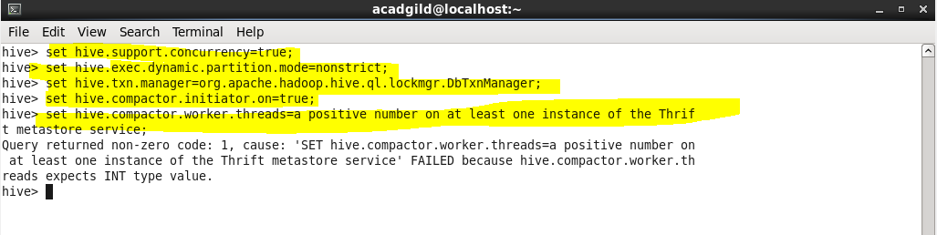

**Step 2-** Creating a table named college which supports hive transactions.

* It is clustered by id and divided into 5 buckets.
* Transactions are enabled by setting the ORC file format and transaction properties as true.

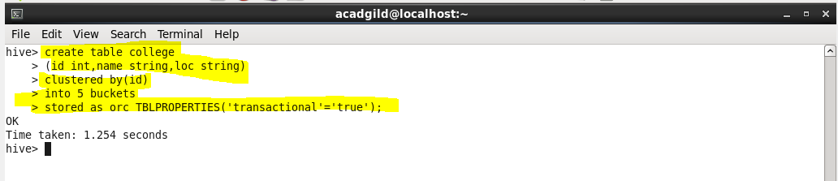

**Step 3-** Inserting values in hive table.

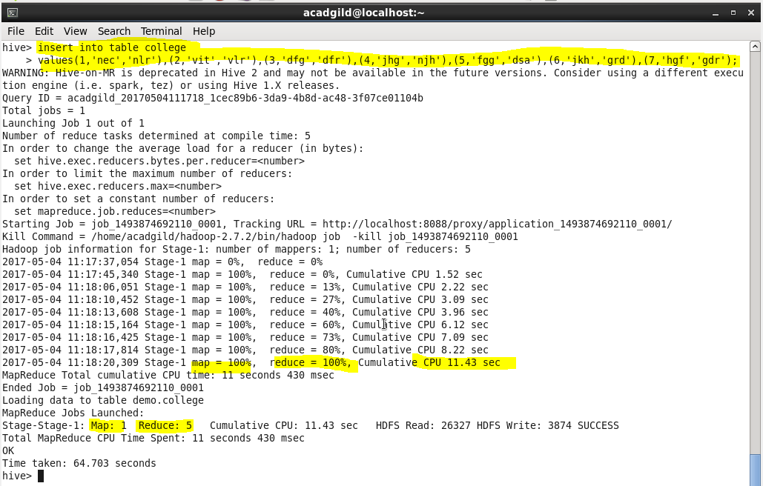

**Step 4-** If we do a select * from college, it will give all the stored details.

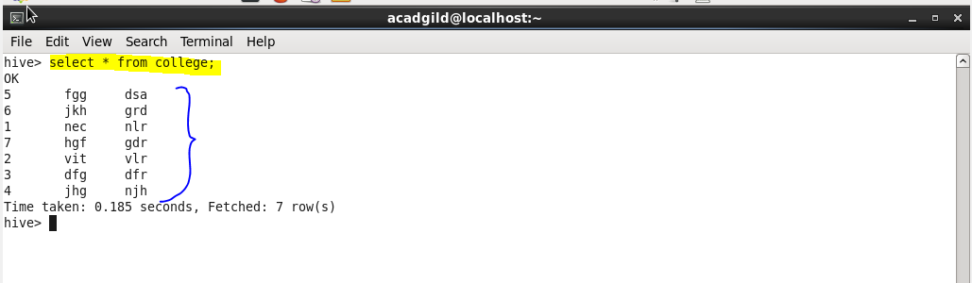

**Step 5-** If we try to insert other values in the same table, it will be appended into the old table.

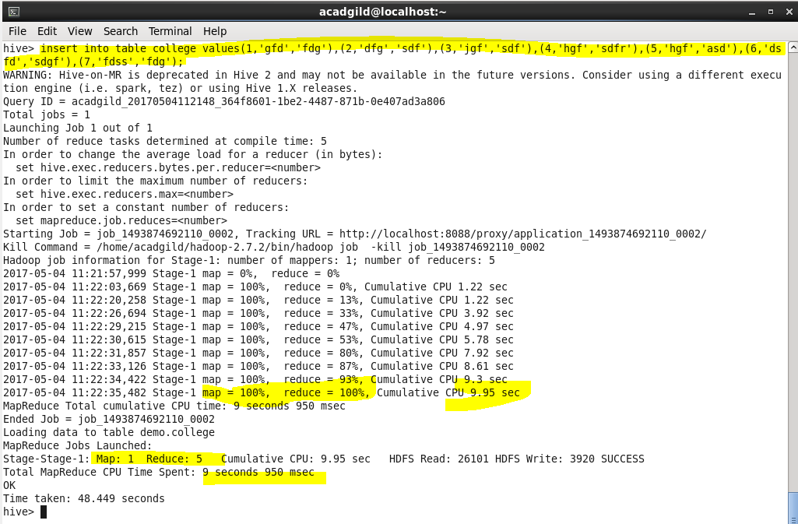

**Step 6-** If we try to update the column by the bucketed column, then it will throw an error.

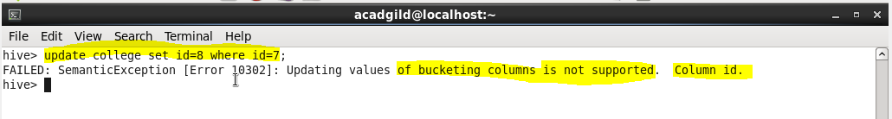

**Step 7-** We can update any entry on the non-bucketed column by following command.

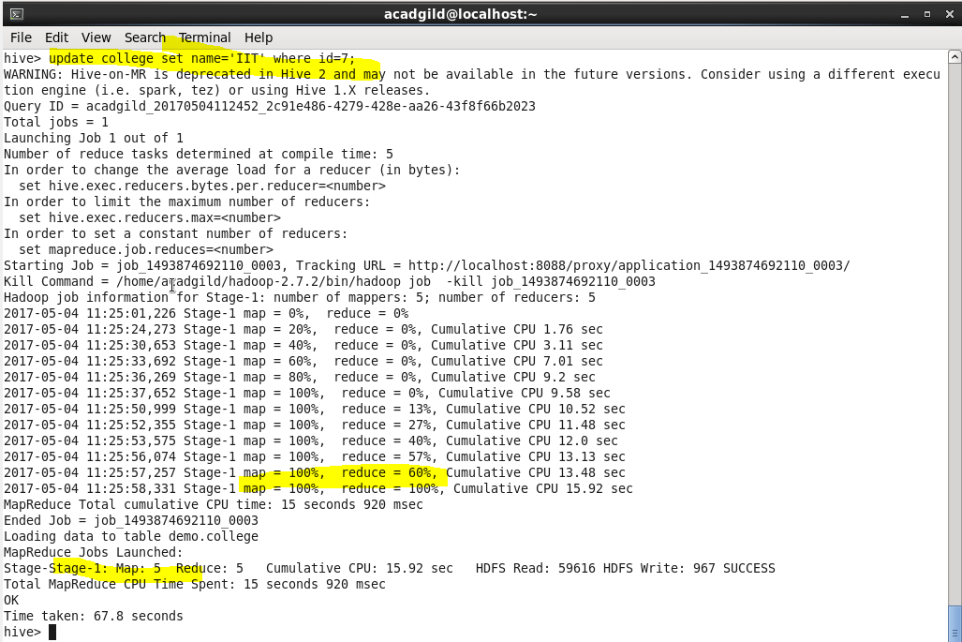

**Step 8-** If we do a select * from college, it will give the updated data.

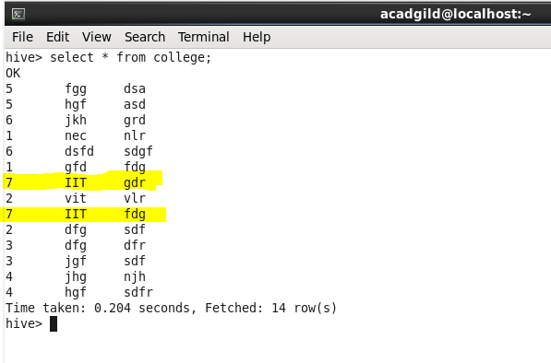

**Step 9-** We can also delete any data from the table by following command.

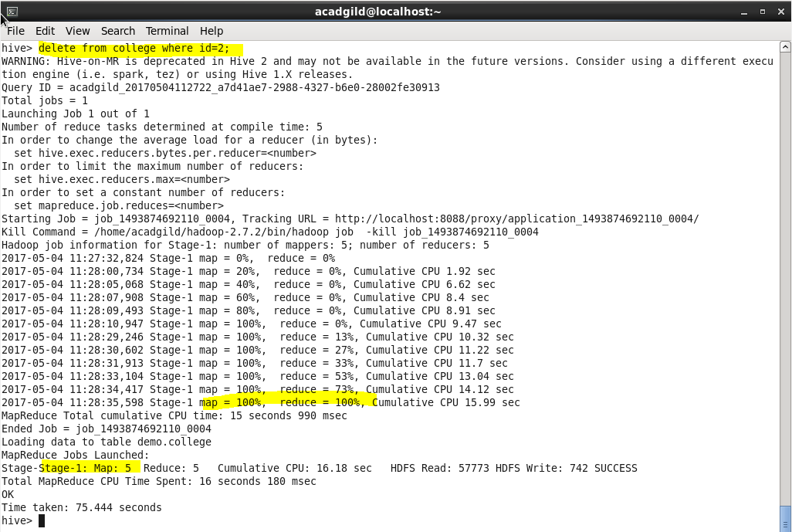

**Step 10-** A select * from college, will give the output after deleting id =2;

