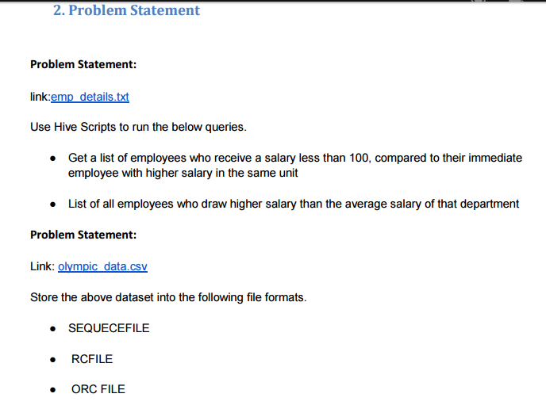

**Solution-  
1.** Table created for emp_sal and data is loaded into the table.

Then select query is fired to select name of employees whose salary is greater than or equal to 100.

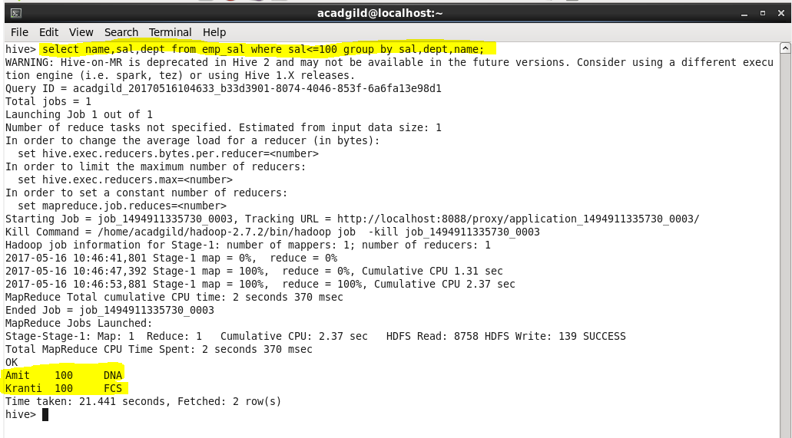

**2.** Select query to select average salary from each department.

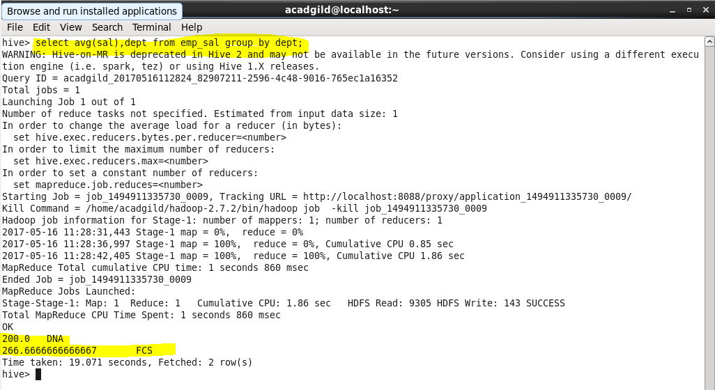

**3.** i. Table created for sequence file and stored as sequence file format.

ii. Data is loaded in the table.

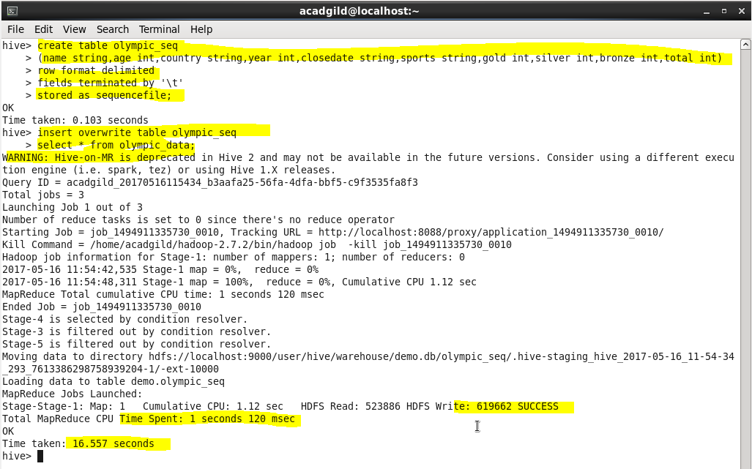

**4.** i. Table created for rc file and stored as rc file format.

ii. Data is loaded in the table.

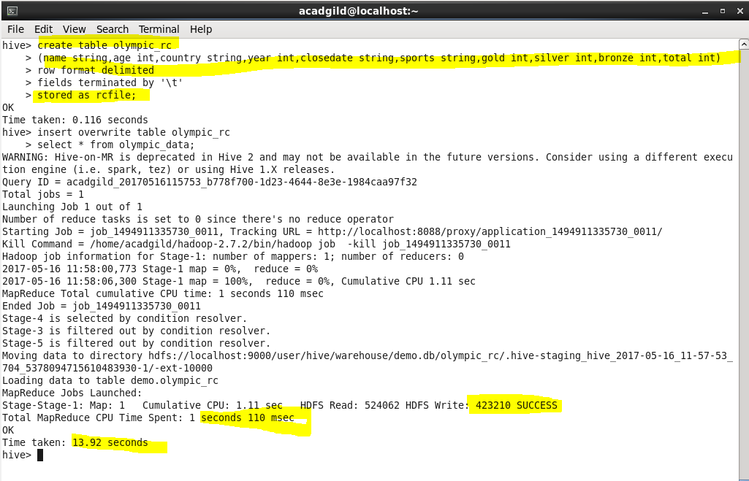

**5.** i. Table created for orc file and stored as orc file format.

ii. Data is loaded in the table.

