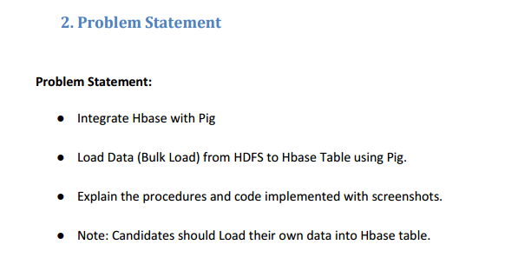

**Integrate Hbase with Pig and Load Data (Bulk Load) from HDFS to Hbase Table using Pig**

**Input File**

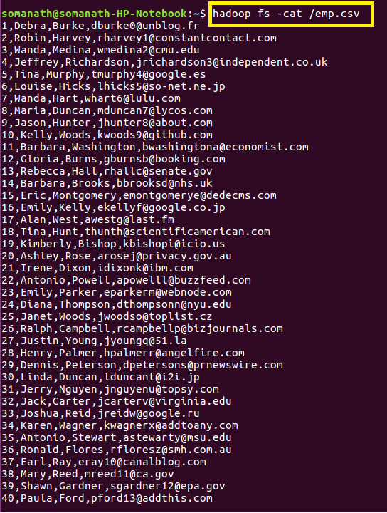

**Step1: Since we want to load the data into Hbase we will create a Table “pig_employee” with column family “employee_details” where the data will be loaded**

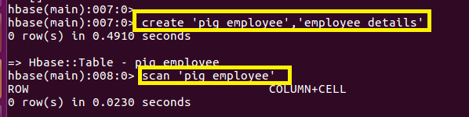

**Step2:Open pig grunt shell in Map reduce mode and Loading the data from Hdfs into pig_input as shown**

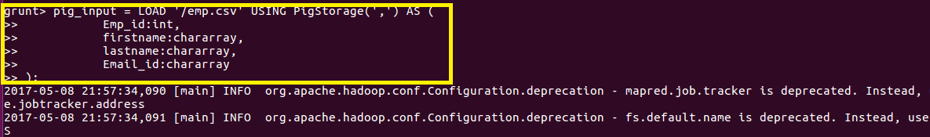

**Step3:Storing the data into Hbase**

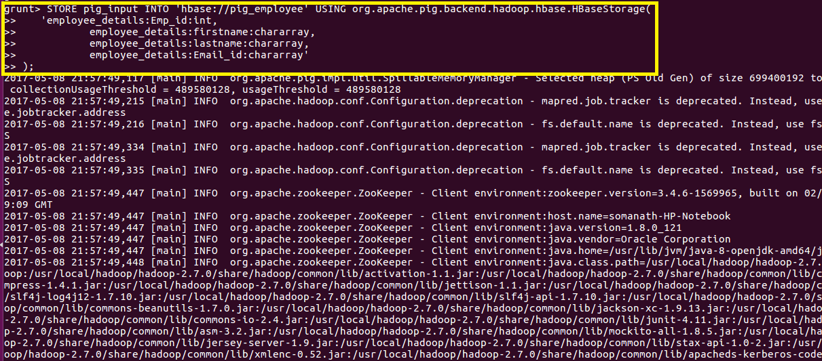

**File is successfully stored in Hbase as shown below**

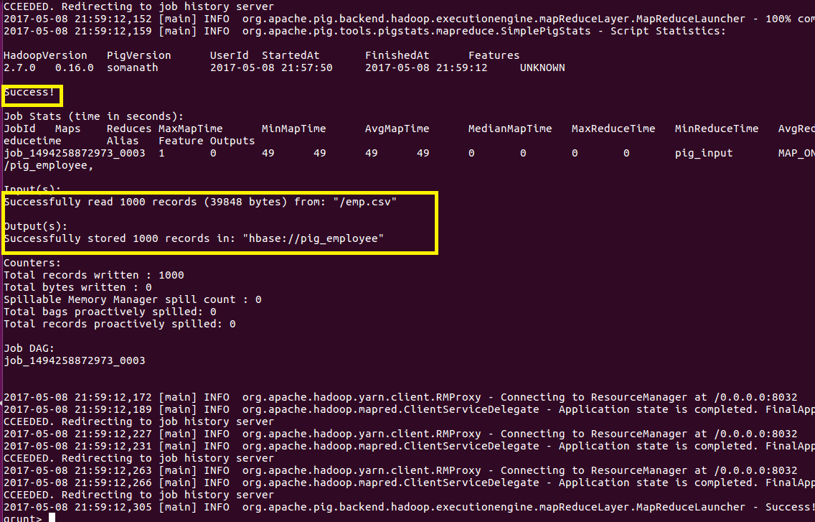

**Step4:Output Verification**

**Scan “pig_employee” is used to verify that the data is loaded into Hbase**

