**Problem Statement1**

**Write a Java program, to take a HDFS Path as input and display all the files and sub-directories in that HDFS path.**

**Screenshot of Code for listing the files**

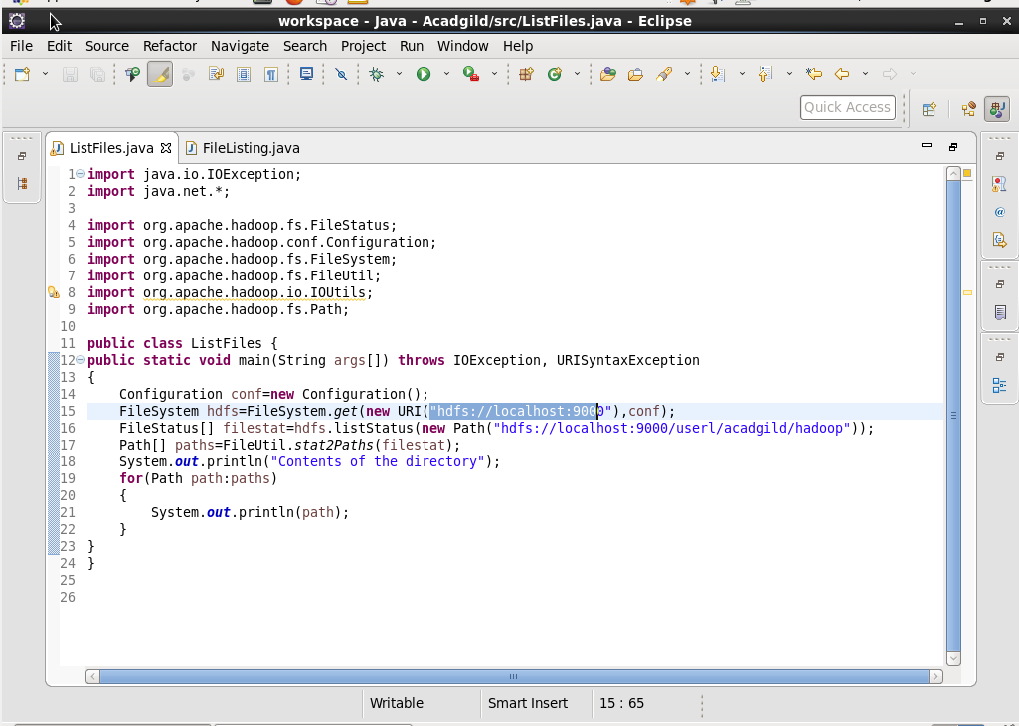

**Screenshot of the output for the above code-**

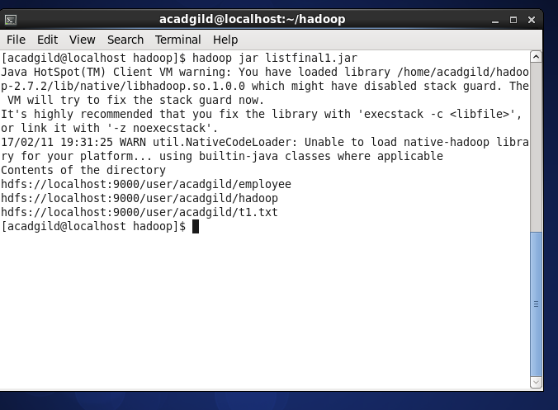

**Problem Statement2**

**Modify the previous program to list all the files and sub-directories in the HDFS path recursively.**

**Screenshot of Code for listing the files**

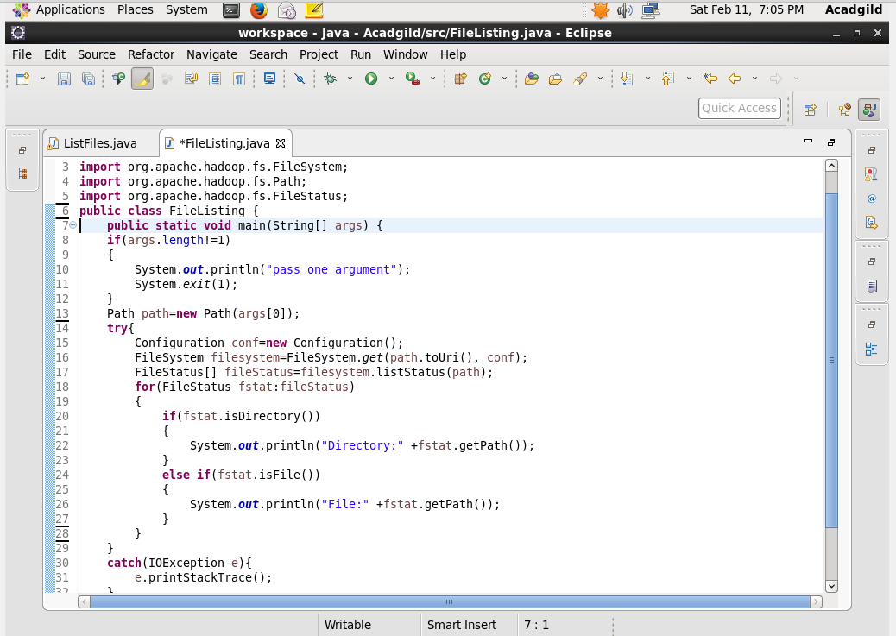

**Screenshot of the output for the above code-**

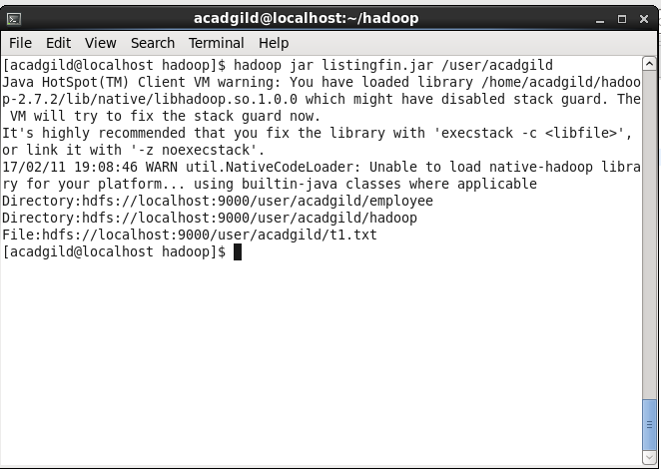

**Problem Statement3**

**Modify the previous program to take multiple HDFS paths (separated by space) and list all the files and sub-directories in those HDFS paths recursively.**

**Screenshot of Code for listing the files**

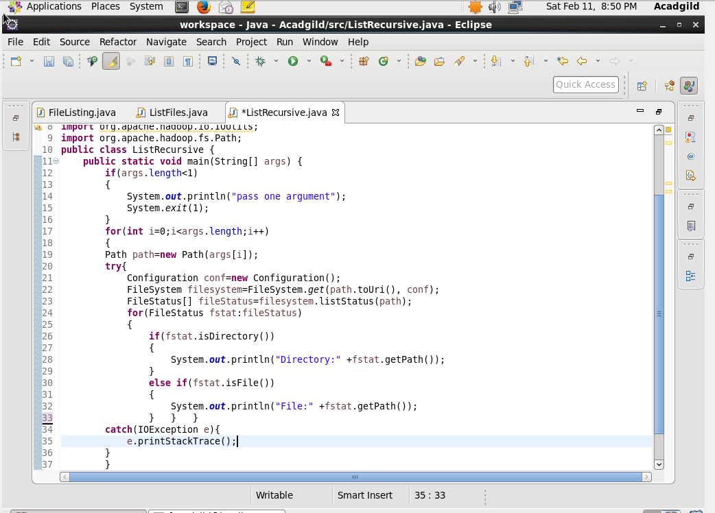

**Screenshot of the output for the above code-**

