**Problem Statement**

Problem Statement1 Write a Java program to list down all the files inside a directory and its sub-directories who have last modified timestamp between the start_ts and end_ts passed as an argument. The default value of start_ts is 0 and for end_ts is infinite.

**Code-**

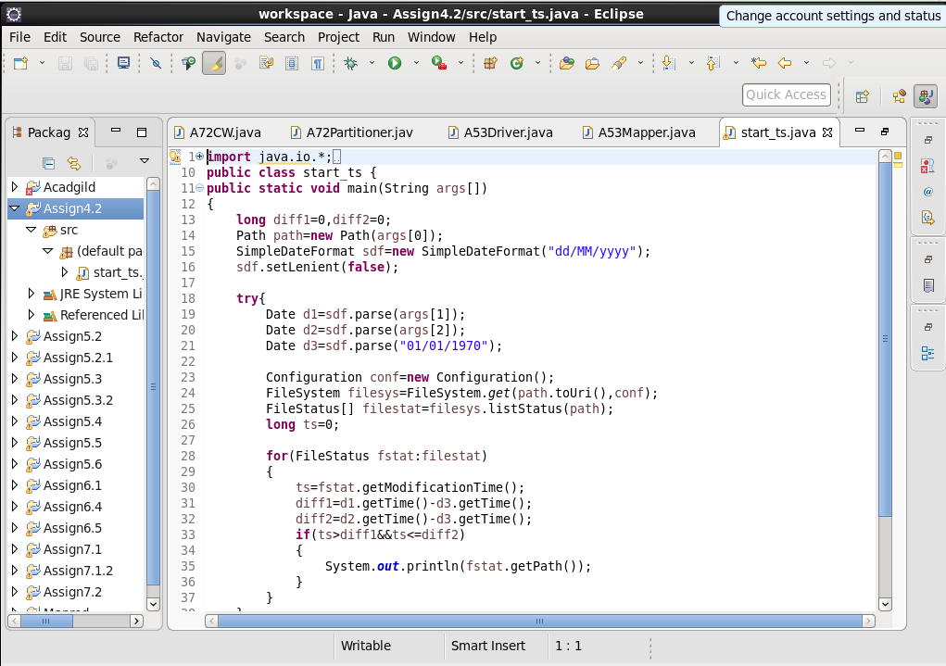

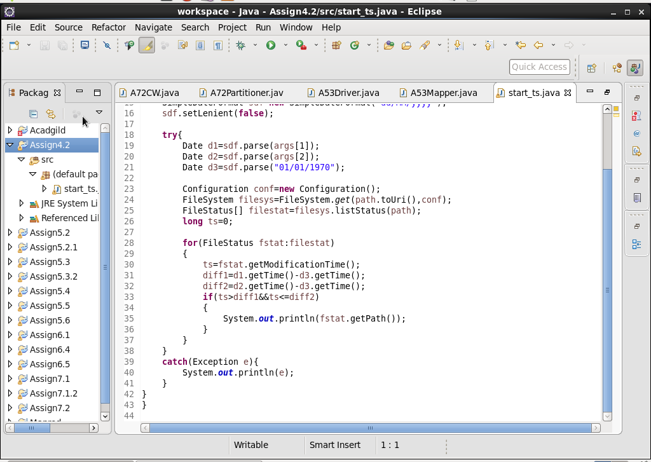

**Output-**