**Problem Statement1**

**Write a Java program to display the content of a file in HDFS on screen.**

**Program to read a file.**

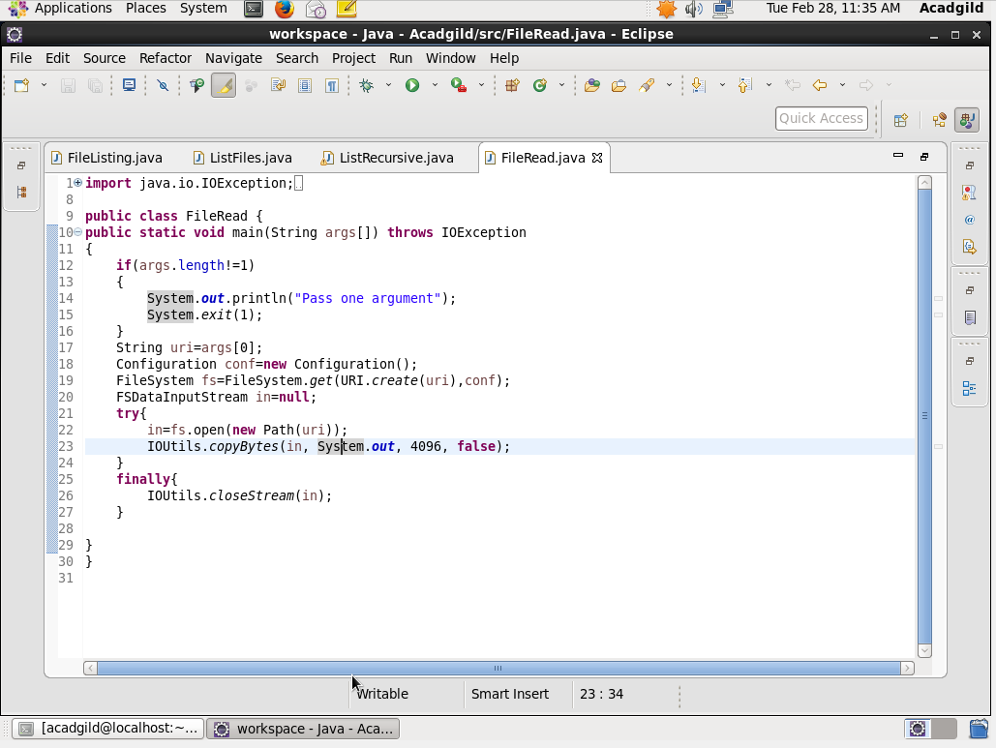

Output Screen of reading a file.

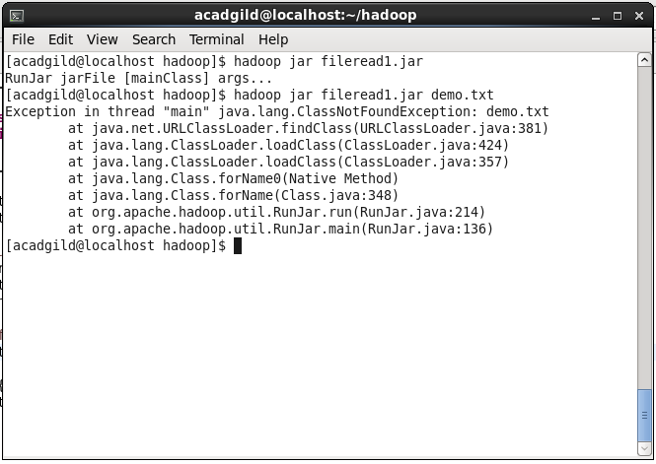

**Problem Statement2**

**Write a Java program to copy a file from local filesystem to HDFS.**

**Program to read a file.**

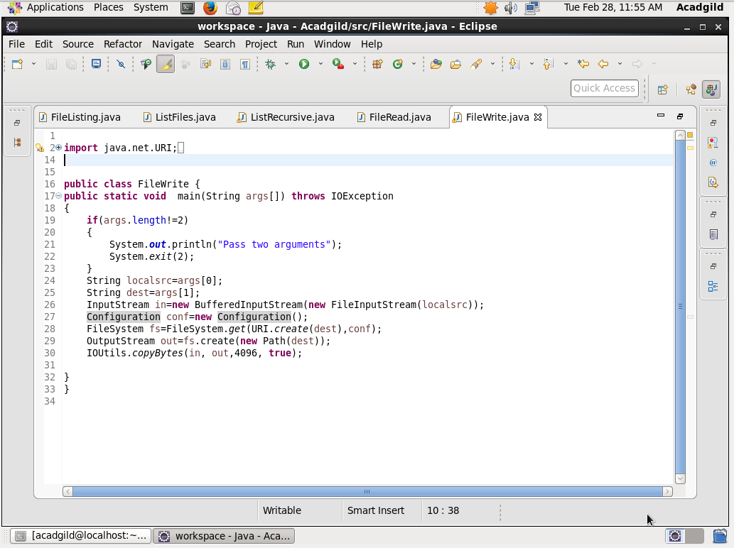

Output screen of copying a file on HDFS

