**Problem Statement**

Titanic Data Analysis Write a mapreduce program to find the total number of people travelled in titanic.

**DATA SET DESCRIPTION**

Column 1 : PassengerId Column 2 : Survived (survived=0 & died=1) Column 3 : Pclass Column 4 : Name Column 5 : Sex Column 6 : Age Column 7 : SibSp Column 8 : Parch Column 9 : Ticket Column 10 : Fare Column 11 : Cabin Column 12 : Embarked

**Input File-**

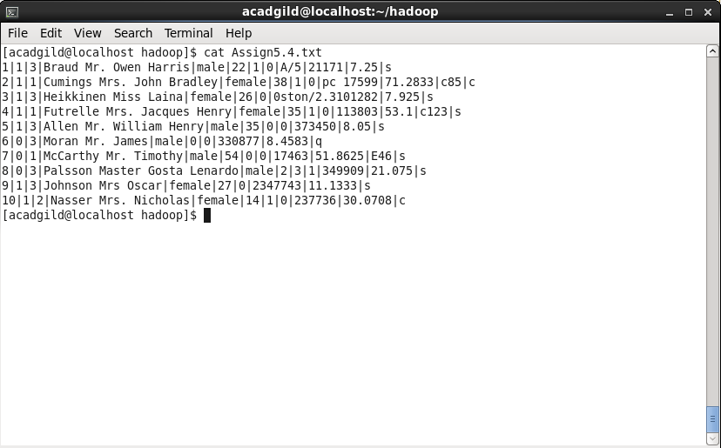

**Driver Code-**

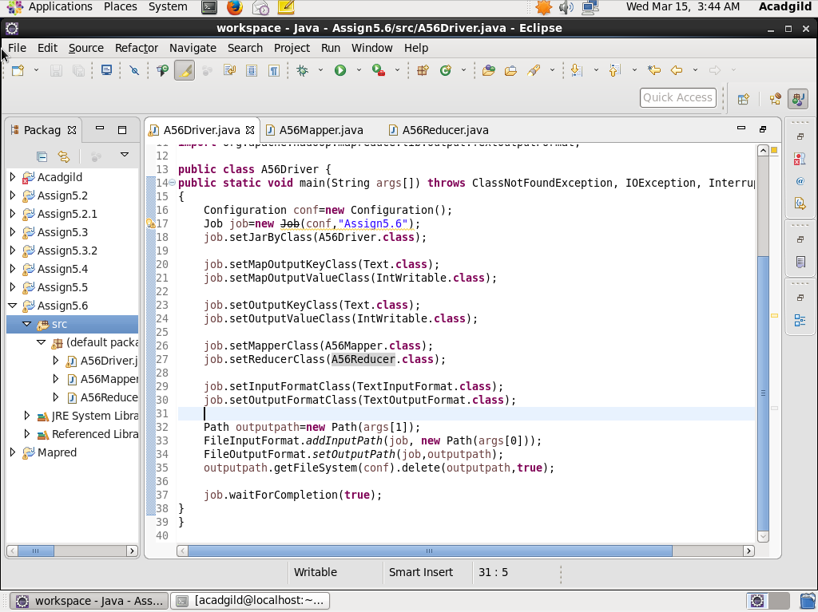

**Mapper Code-**

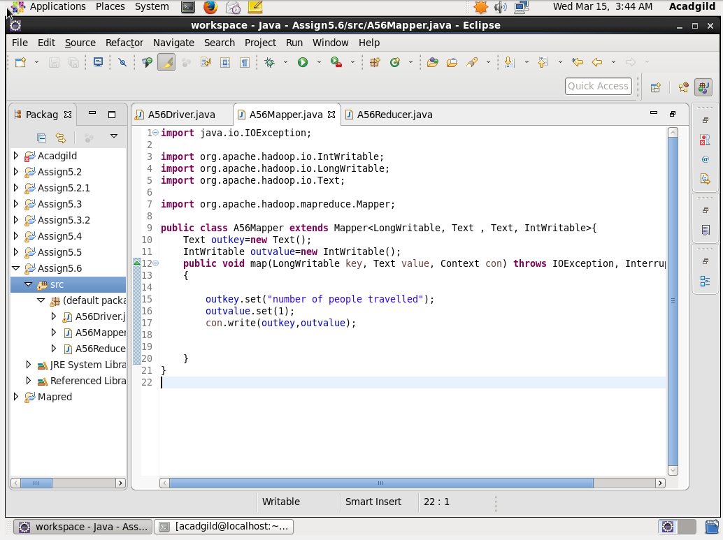

**Reducer Code-**

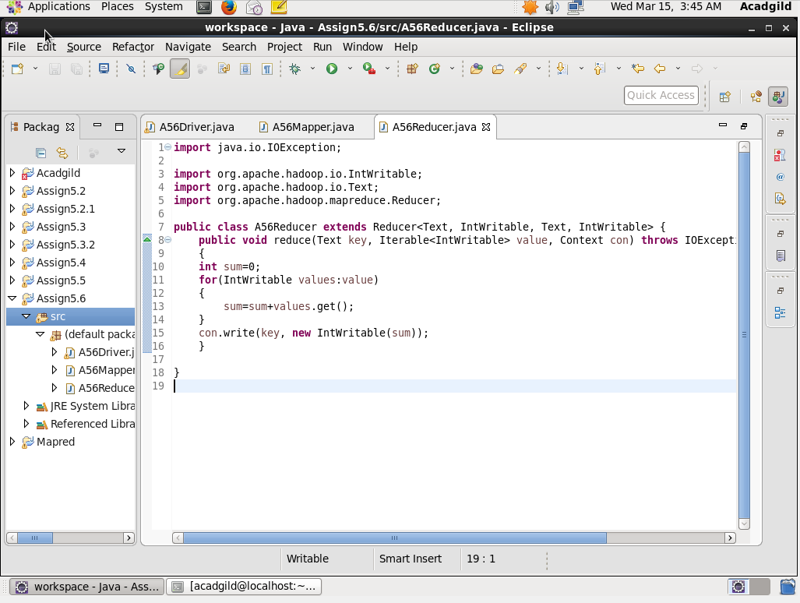

**Output File-**



