**Problem Statement**

We have a dataset of sales of different TV sets across different locations. Records look like:

Samsung|Optima|14|Madhya Pradesh|132401|14200 The fields are arranged like:

Company Name|Product Name|Size in inches|State|Pin Code|Price Sales_differentTV:

There are some invalid records which contain 'NA' in either Company Name or Product Name. Sales of different TV

**Task 2: Write a MapReduce program to calculate the total units sold for each Company. Sales of different TV**

Driver Code-

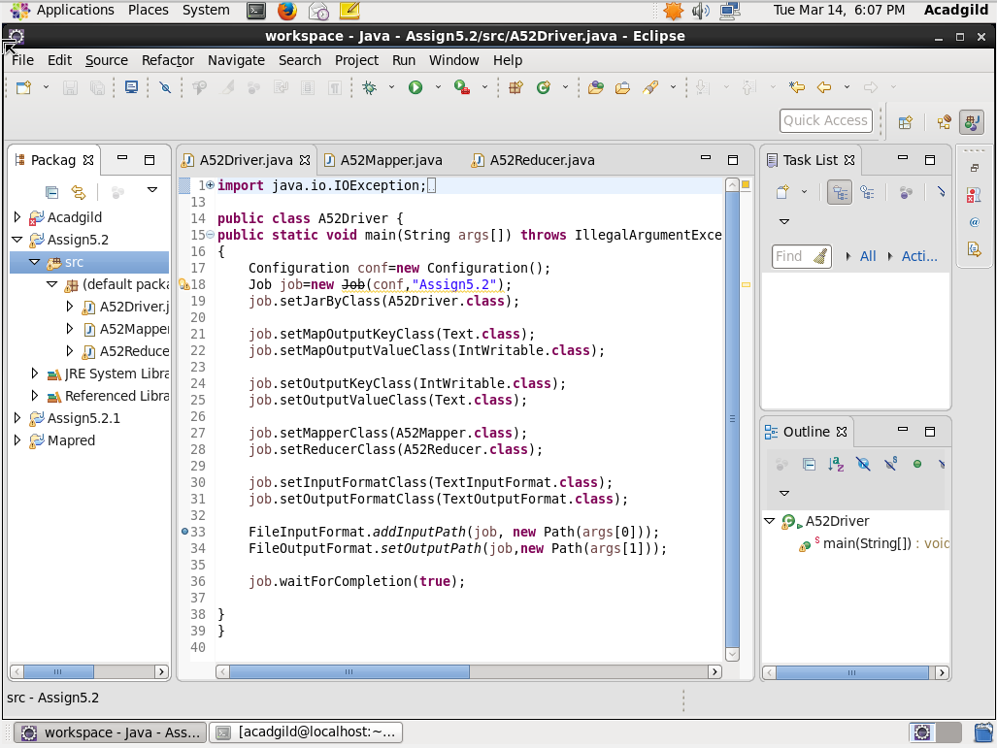

Mapper Code-

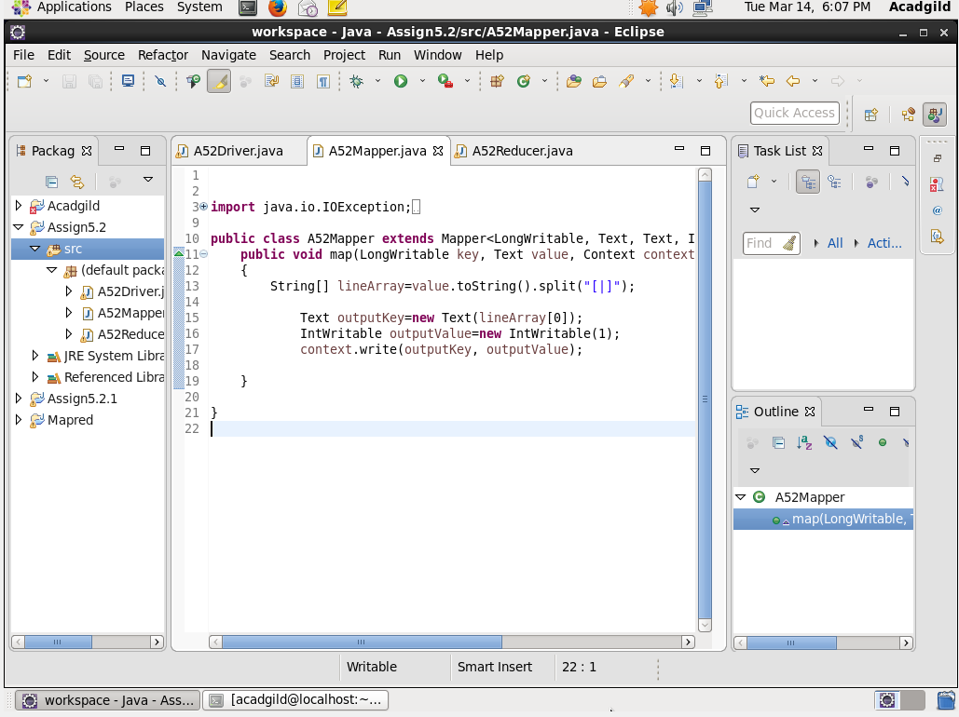

Reducer Code-

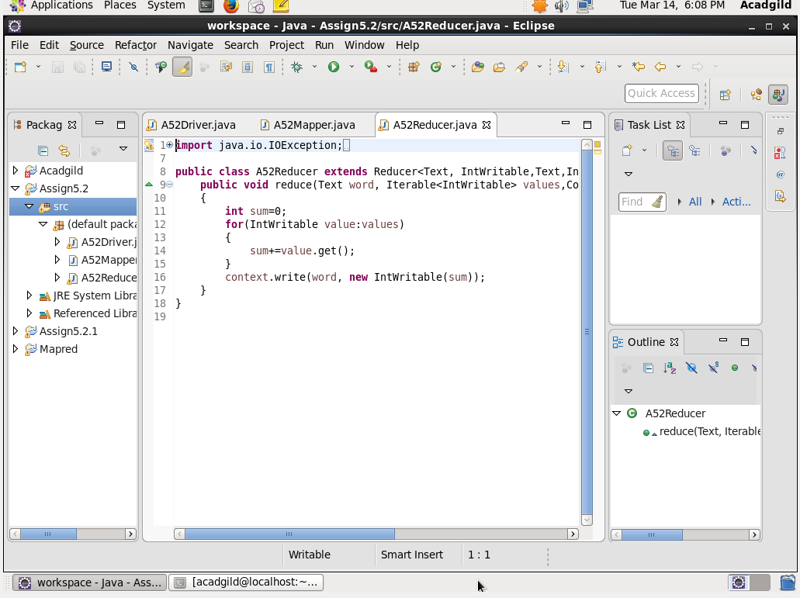

**Output**

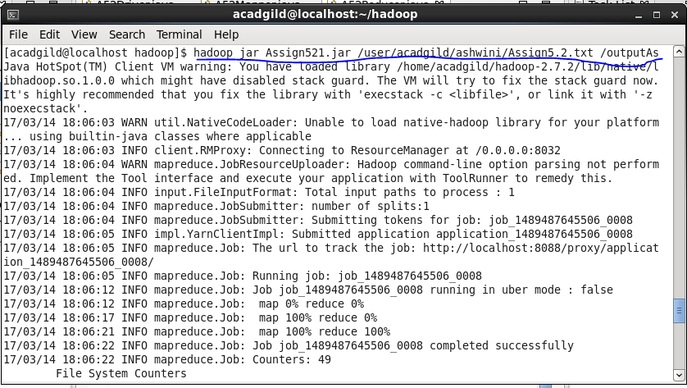



**Task 3: Write a MapReduce program to calculate the total units sold in each state for Onida company.**

**Driver Code-**

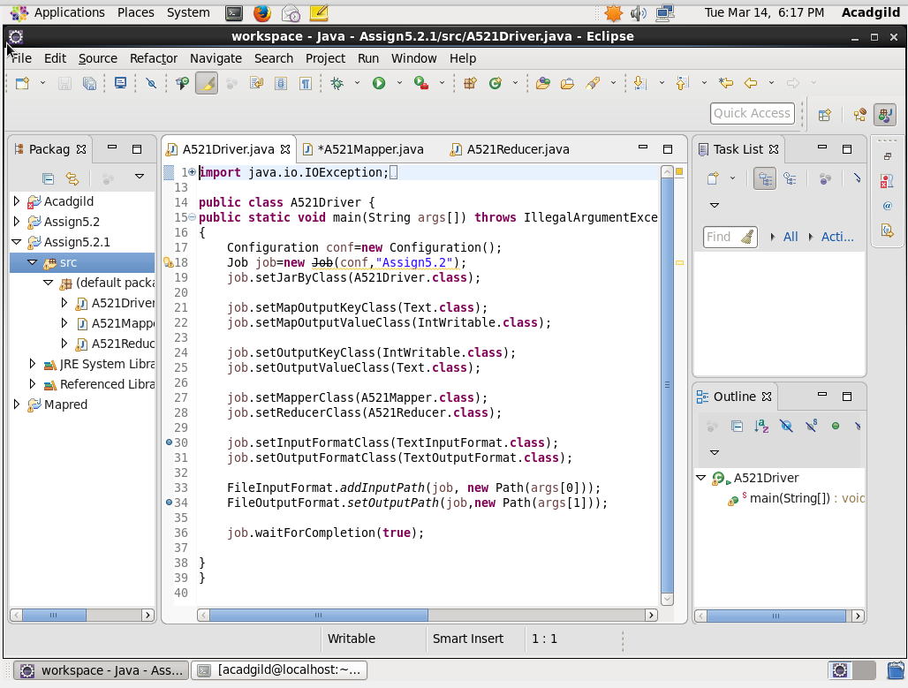

**Mapper Code-**

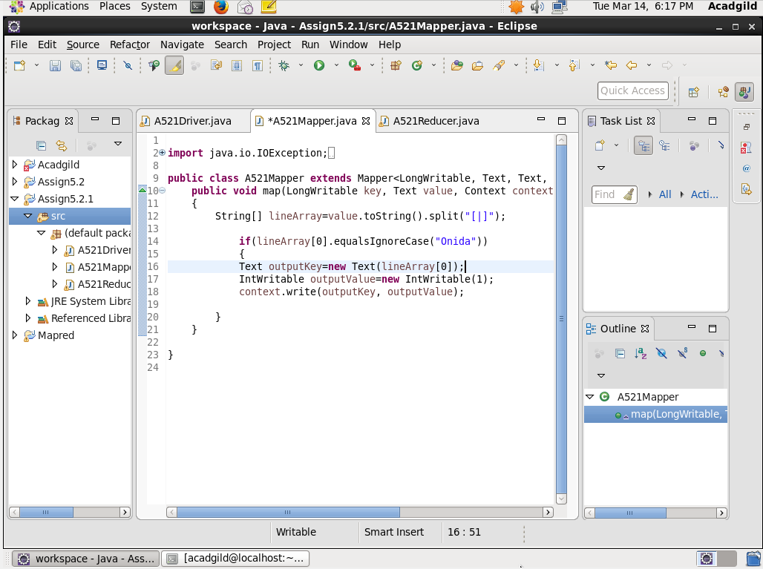

**Reducer Code-**

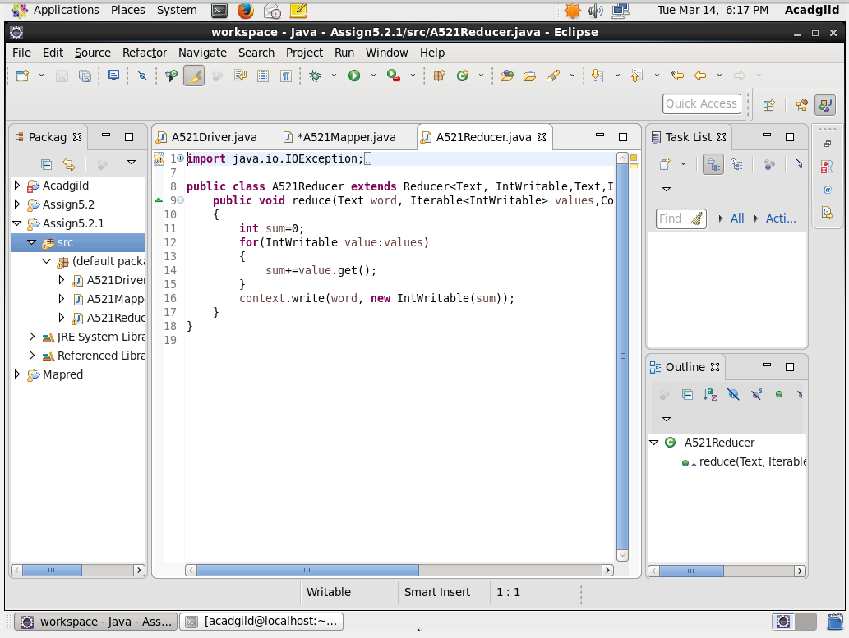

**Output-**



