**Problem Statement**

We have a dataset of movie data analysis Column Name:

Column 1: User ID Column 2: Movie ID Column 3: Rating Column 4:

**Problem statement 1: Find the number of ratings given by each user.**

Input File

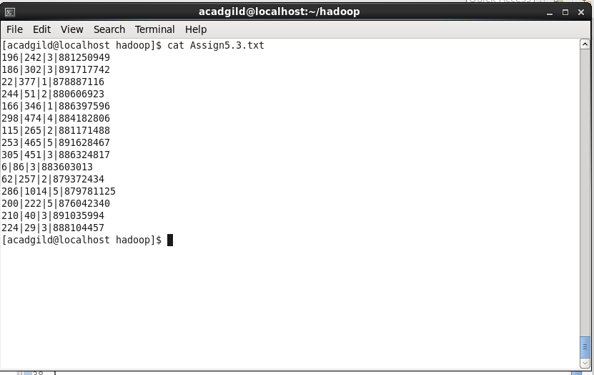

**Driver Code**

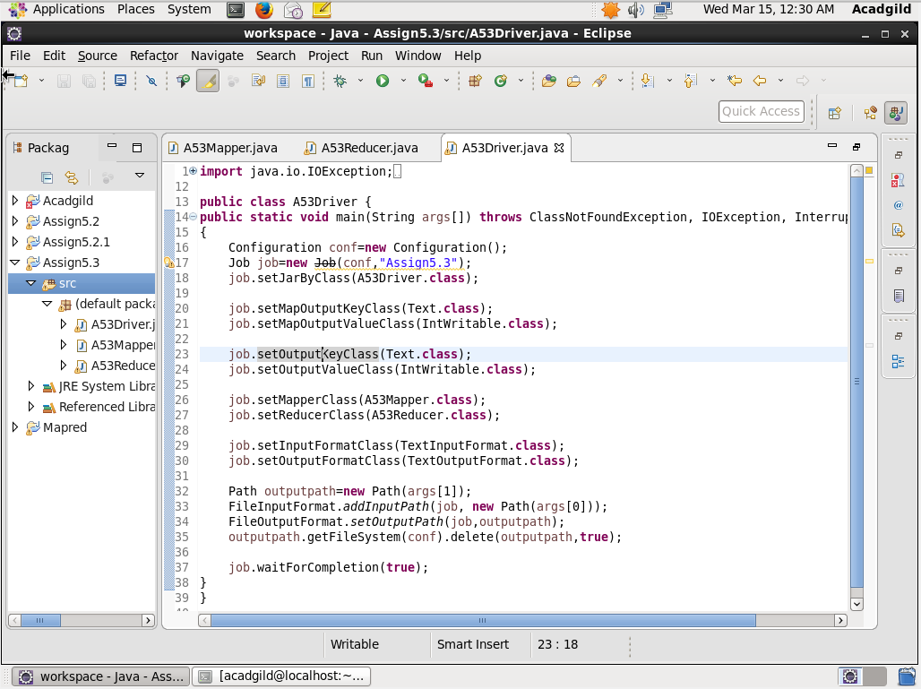

**Mapper Code**

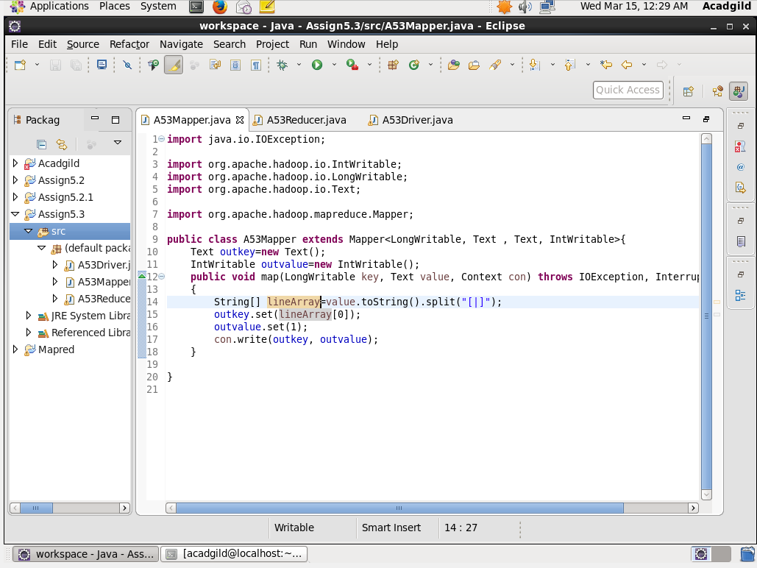

**Reducer Code-**

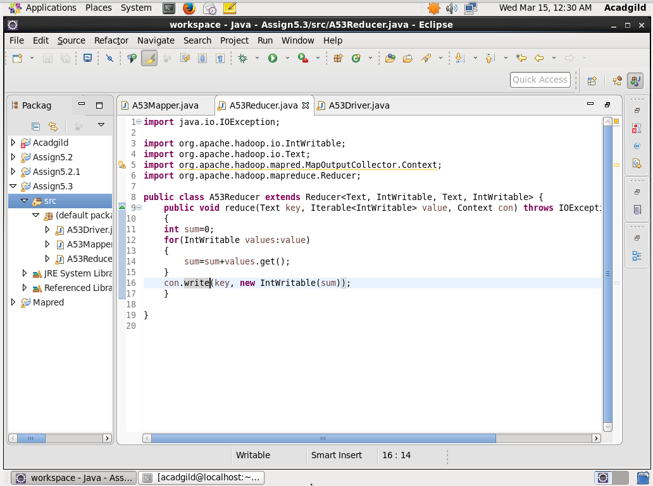

**Output-**

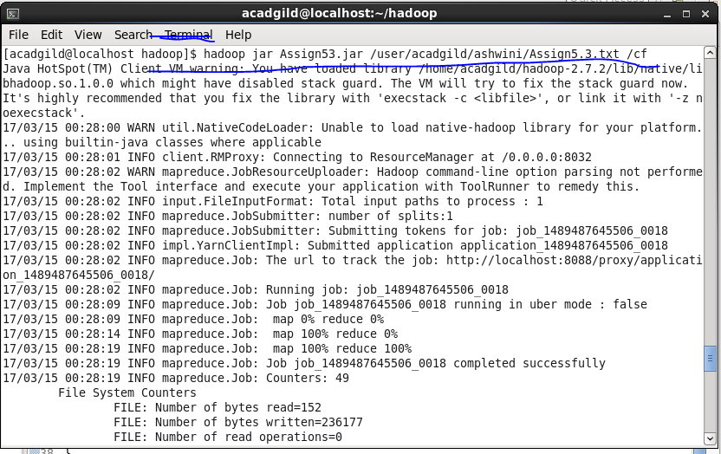

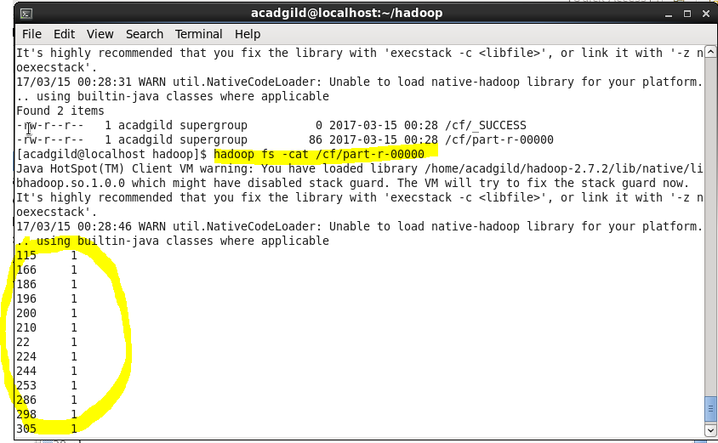

**Problem statement 2: Find the number of ratings received by each movie.**

**Input File-**



**Driver Code-**

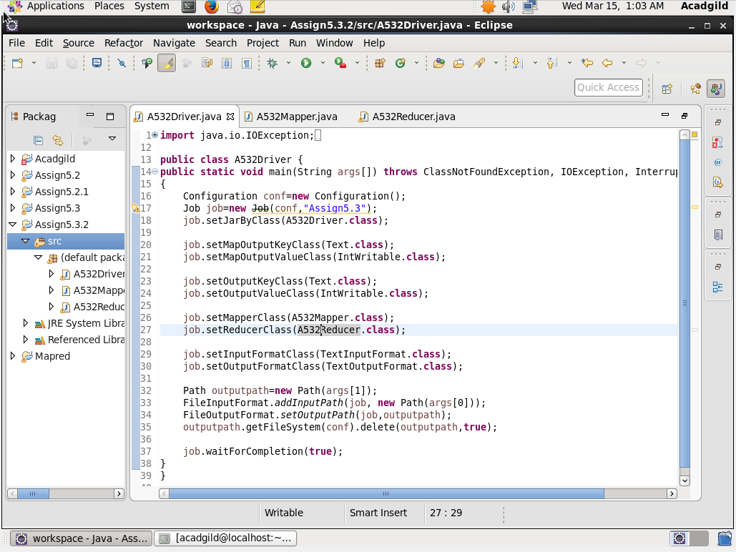

**Mapper Code-**

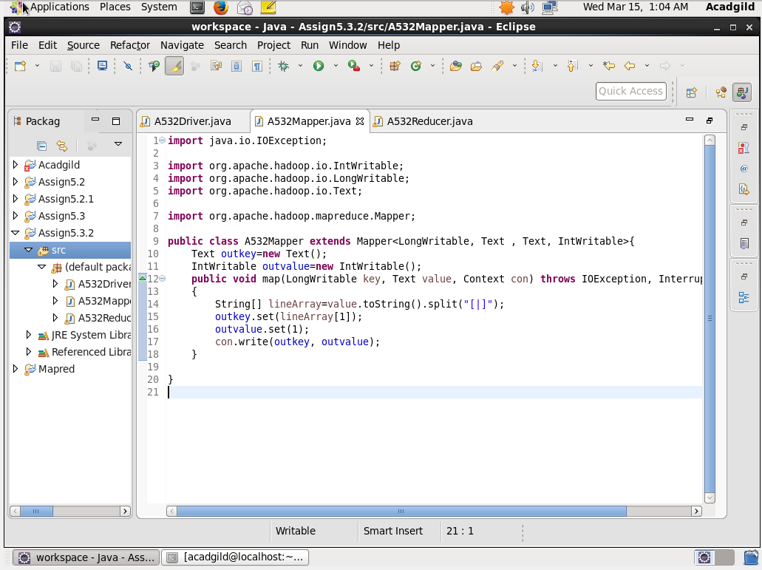

**Reducer Code-**

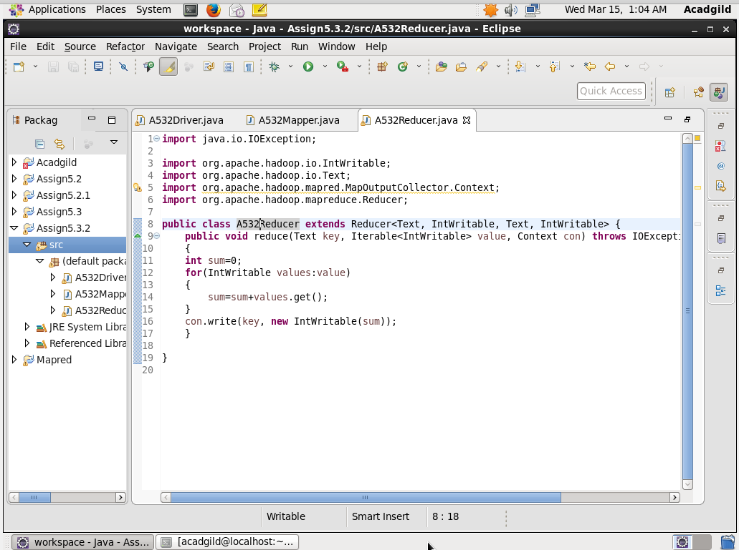

**Output File-**



