**Problem Statement**

"We have a dataset of sales of different TV sets across different locations. Records look like: Samsung|Optima|14|Madhya Pradesh|132401|14200 The fields are arranged like :

Company Name|Product Name|Size in inches|State|Pin Code|Price Sales_TV : of

**Task 6 : Modify Sales of different TV Task 3 (refer session 5, assignment 2) to take advantage of Combiner. Sales of different TV**

**Input File-**

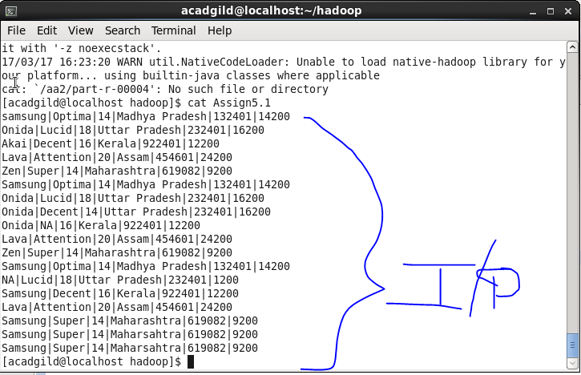

**Driver Code-**

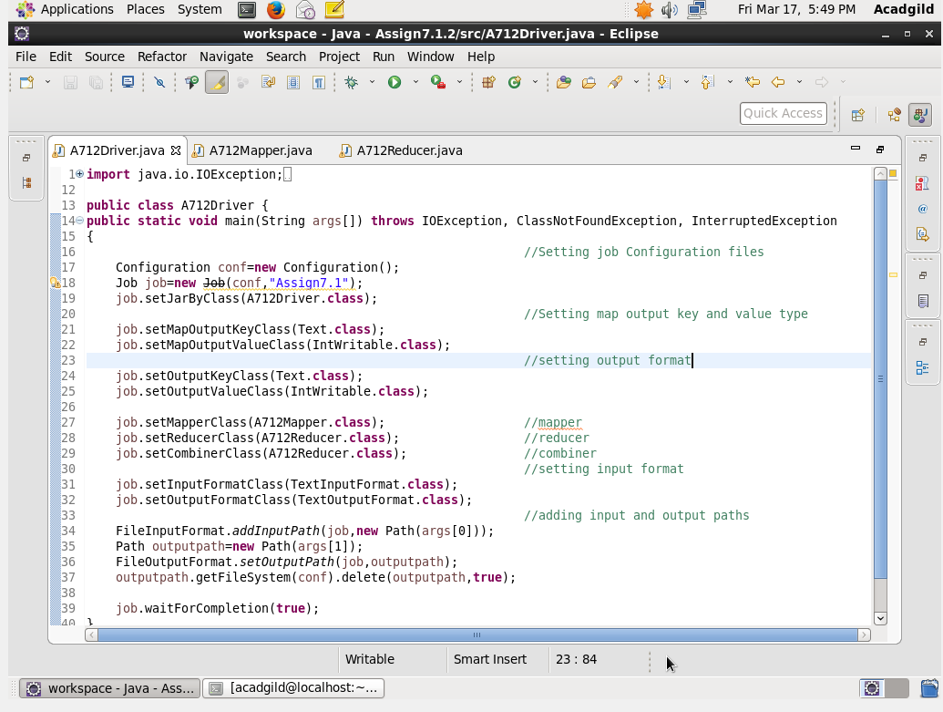

**Mapper Code-**

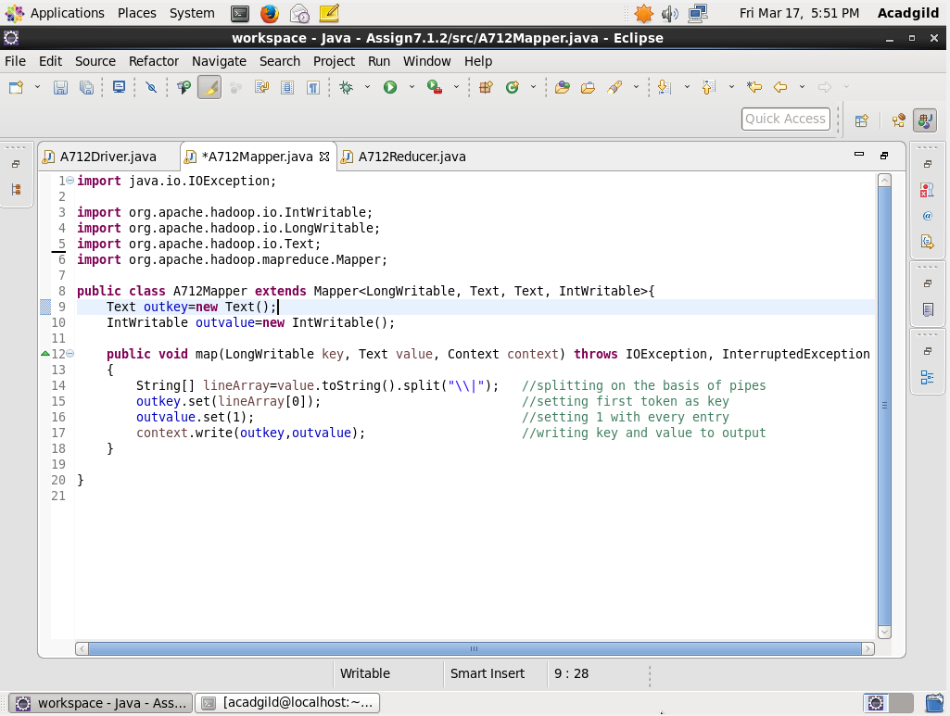

**Reducer Code-**

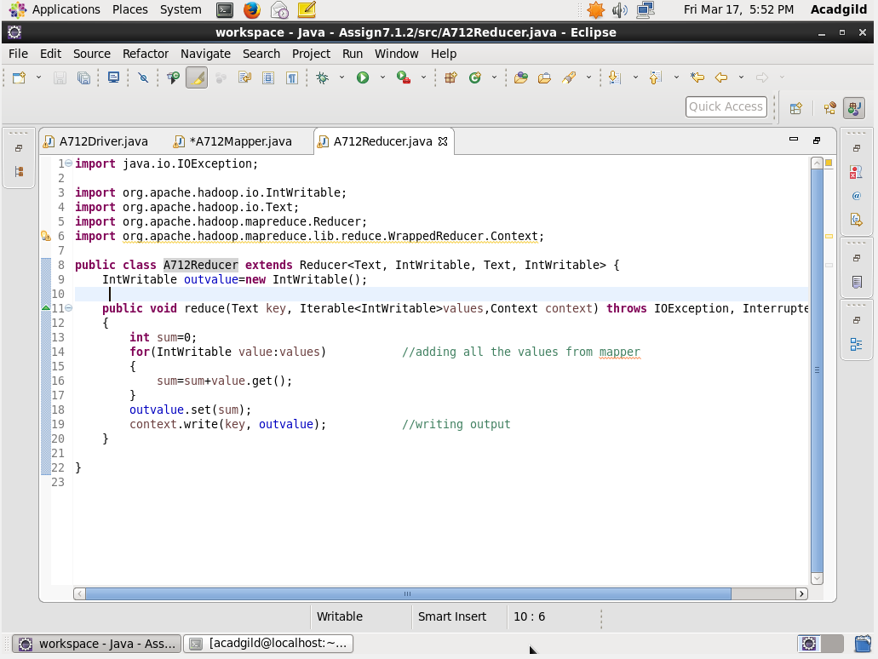

**Output File-**

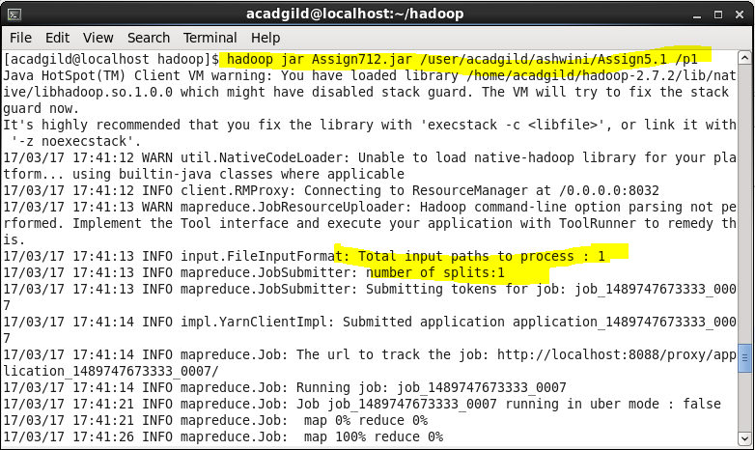

**Task 7 : Write a Mapreduce program to view the total sales for each product for every Company corresponding to each size. Make sure that all records for a single company goes to a single reducer and inside every reducer, keys must be sorted in descending order of the size. You may write a custom WritableComparable for this purpose. "**

**Input File-**



**Driver Code-**

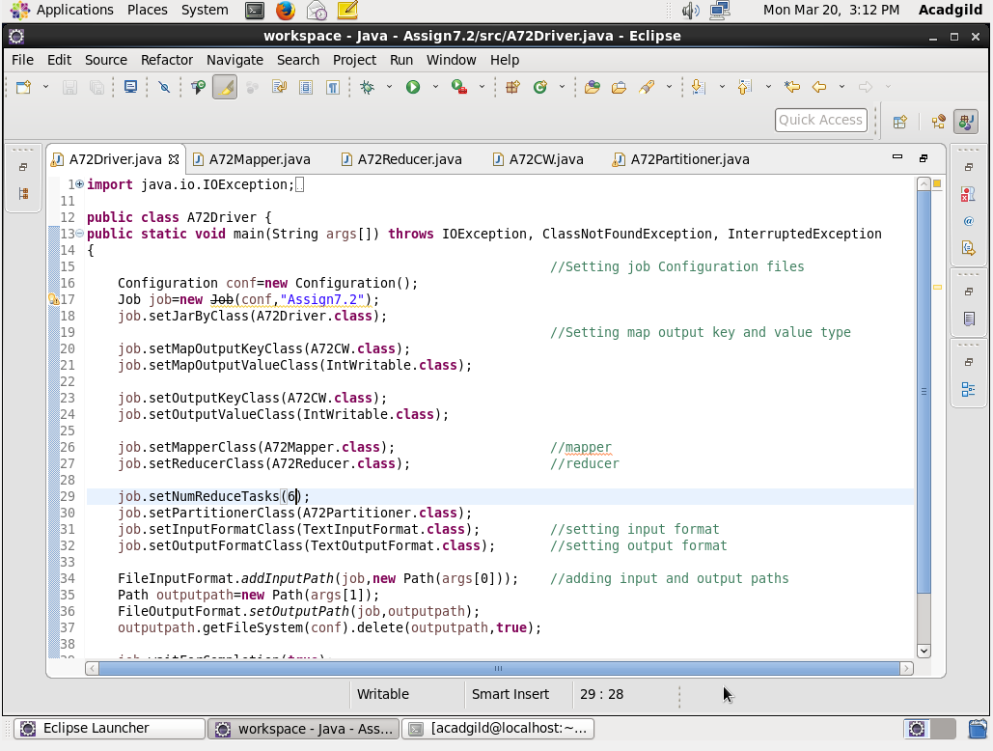

**Mapper Code-**

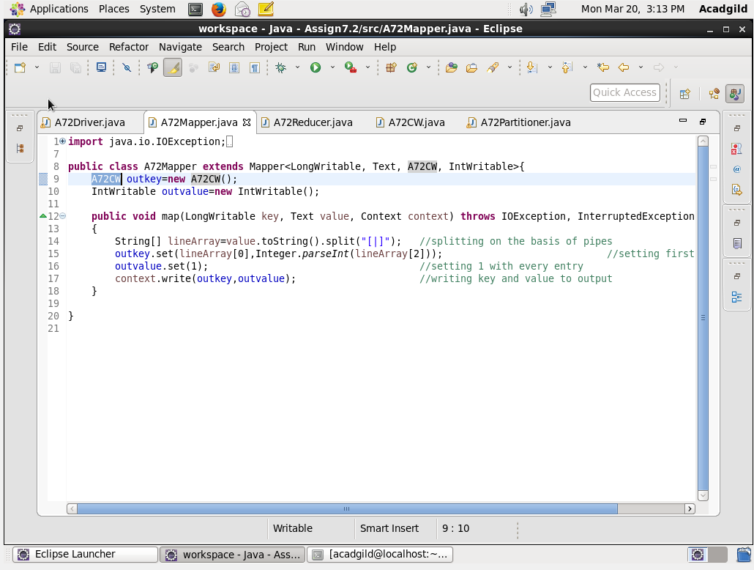

**Reducer Code-**

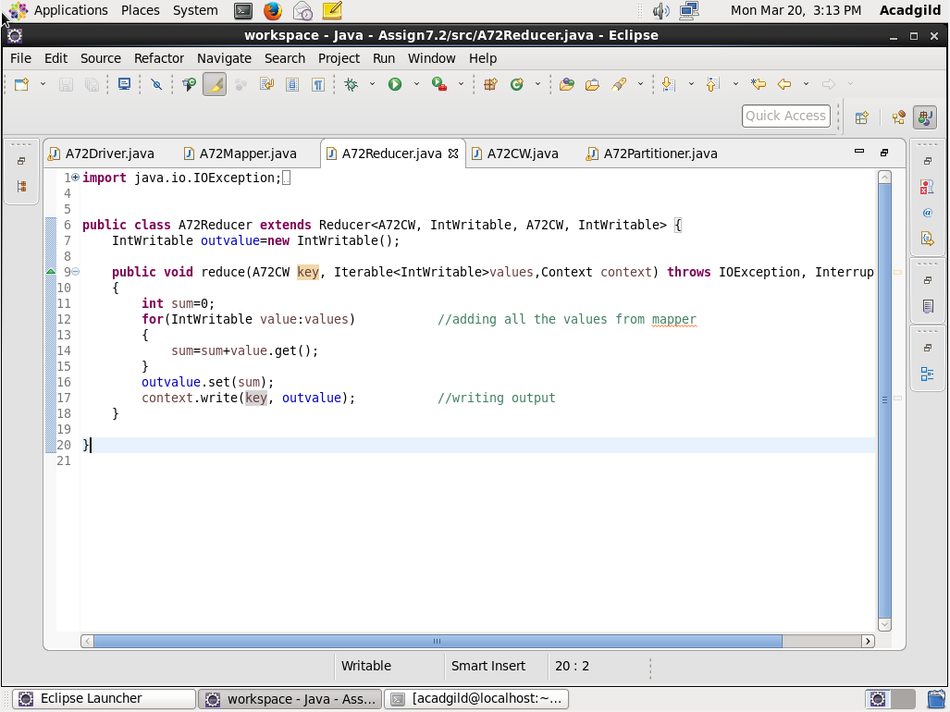

**Custom Writable-**

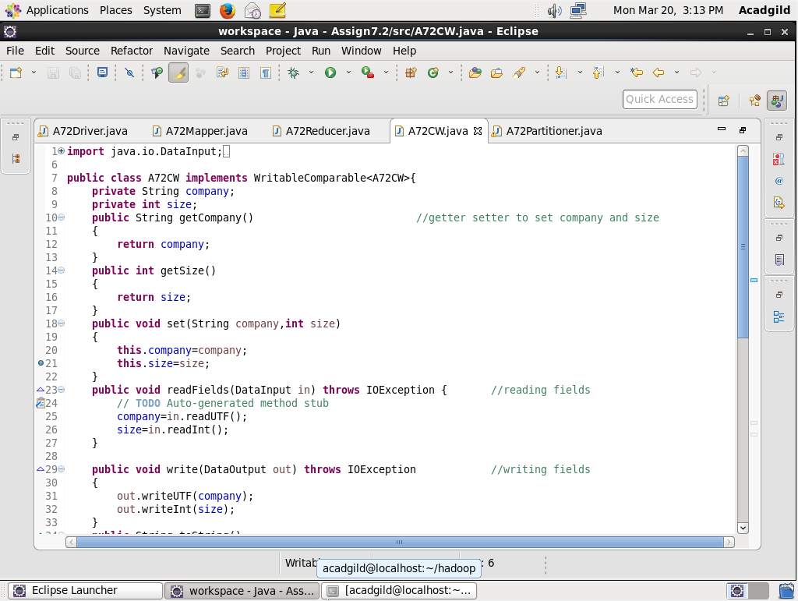

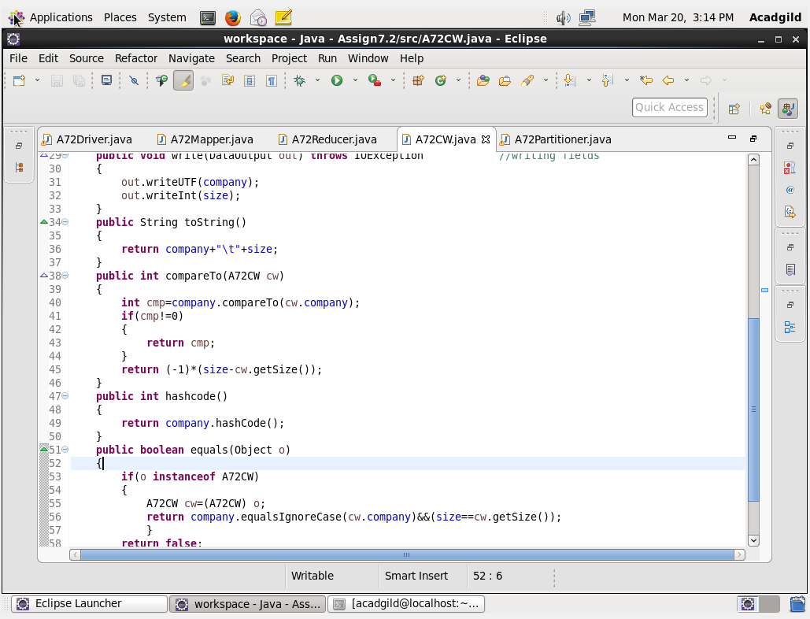

**Partitioner Code-**

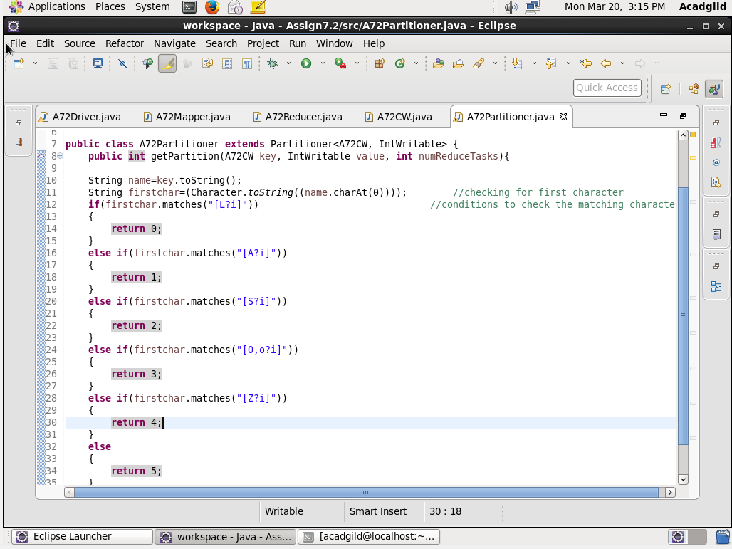

**Output File-**









