**Problem Statement**

DATA SET DESCRIPTION

Column 2 : Survived (survived=0 & died=1)

Column 3 : Pclass

Column 4 : Name

Column 5 : Sex

Column 6 : Age

Column 7 : SibSp

Column 8 : Parch

Column 9 : Ticket

Column 10 : Fare

Column 11 : Cabin

Column 12 : Embarked

**Input File-**

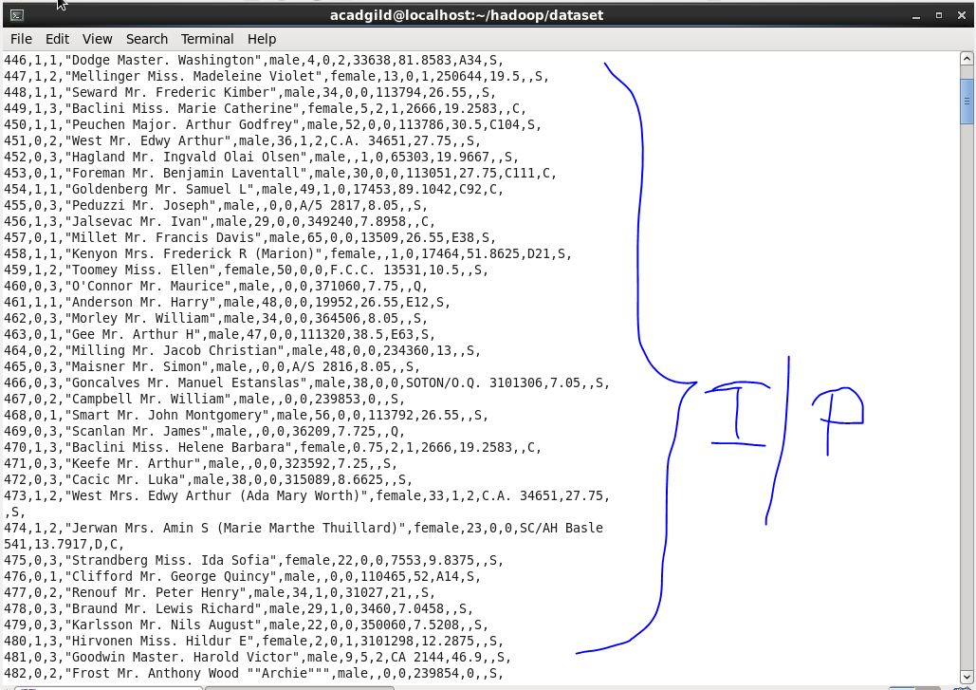

**Problem statement 1: Write a custom key to evaluate the number of people who died and the number of people who survived, along with their genders.**

**Driver Code-**

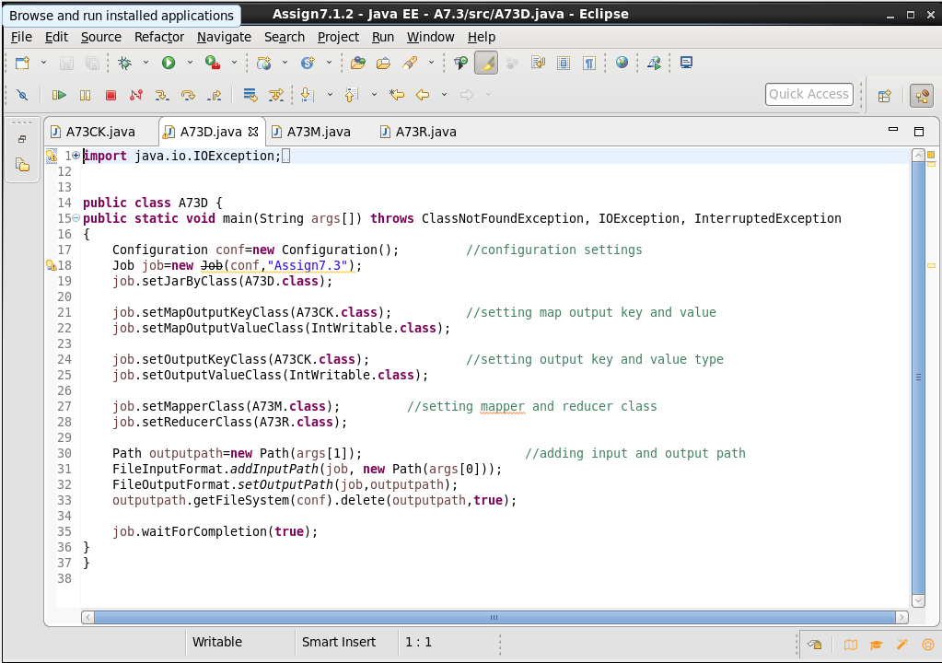

**Mapper Code-**

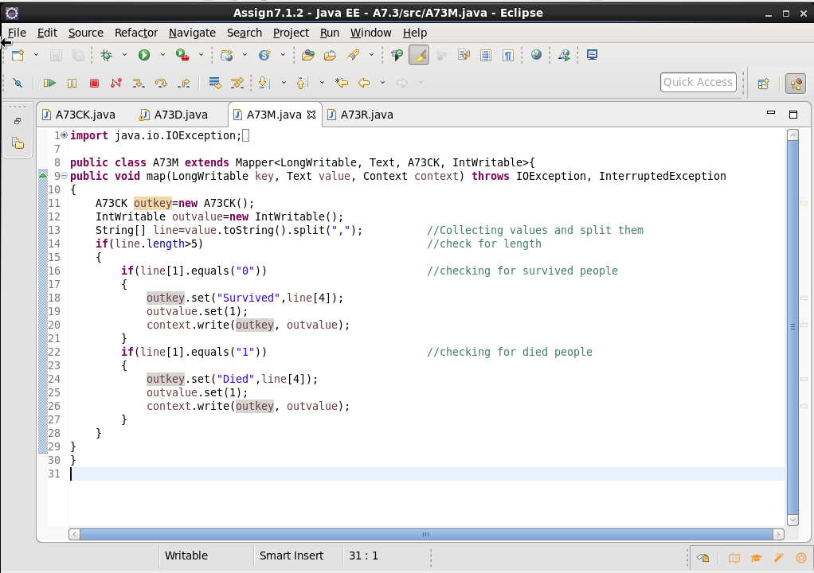

**Reducer Code-**

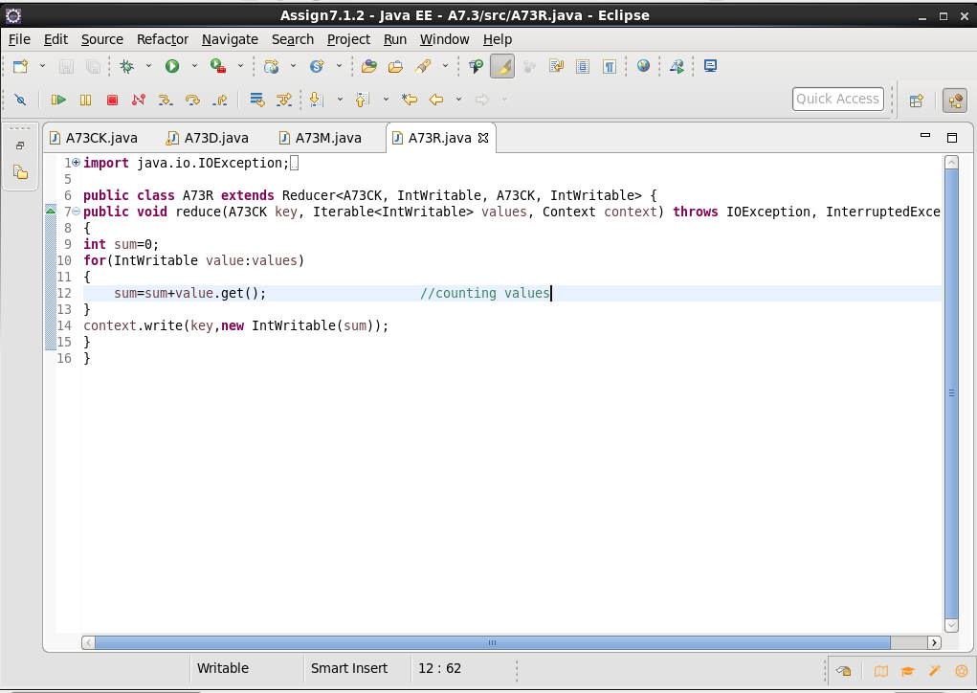

**Custom Key Class-**

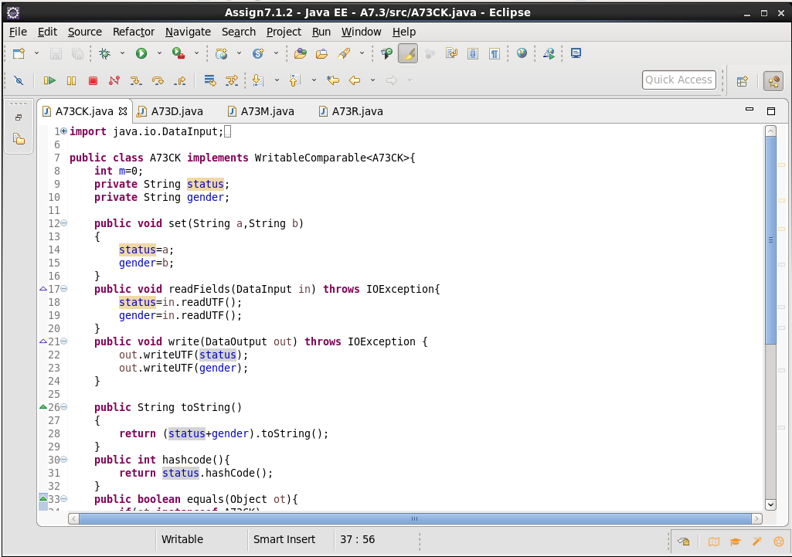

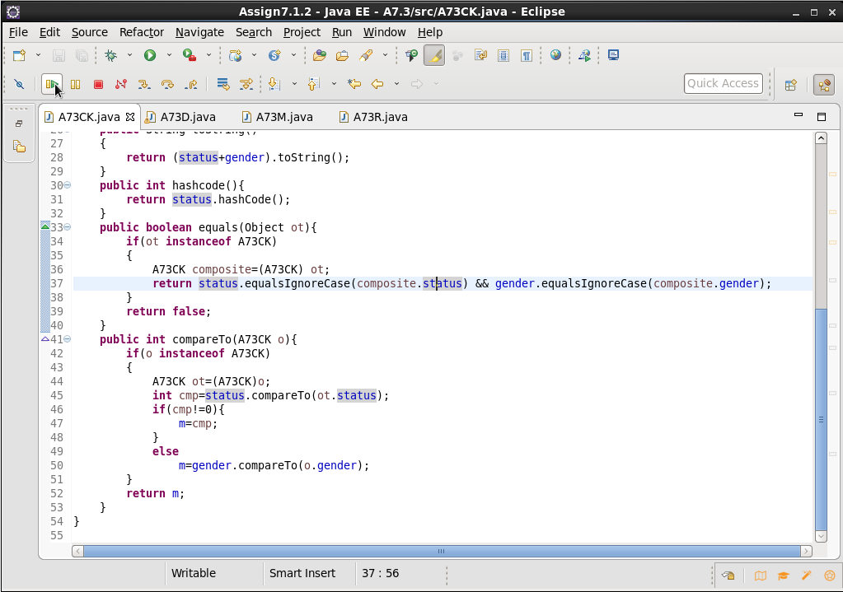

**Output-**

