**Problem Statement**

**Write a word count program using partitioner and implement the following logic in the partitioner words with length 5 should go into reducer 1 and words with length 6 should go into reducer 2 and the rest of the words should go into reducer 3.**

**Input File-**

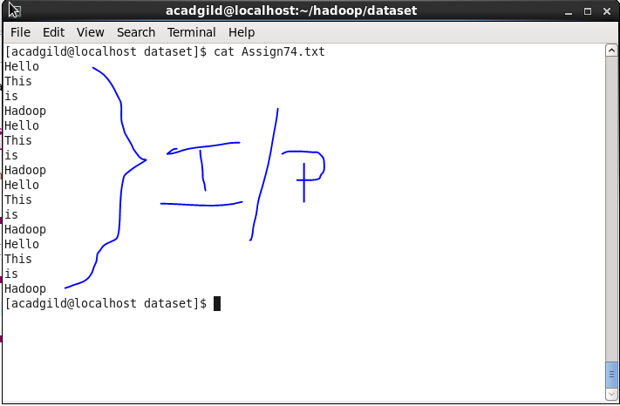

**Driver Code-**

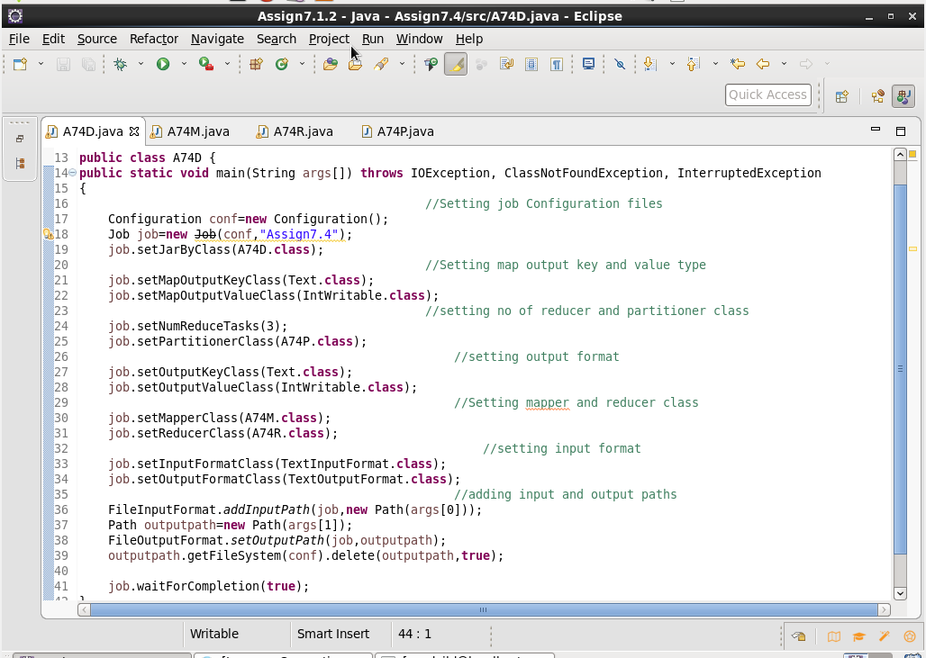

**Mapper Code-**

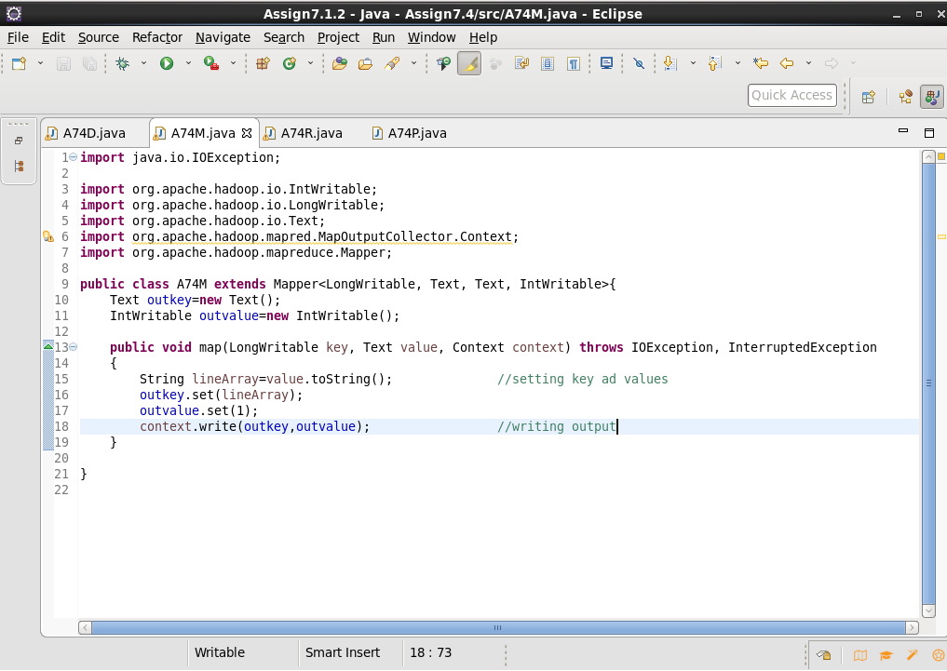

**Reducer Code-**

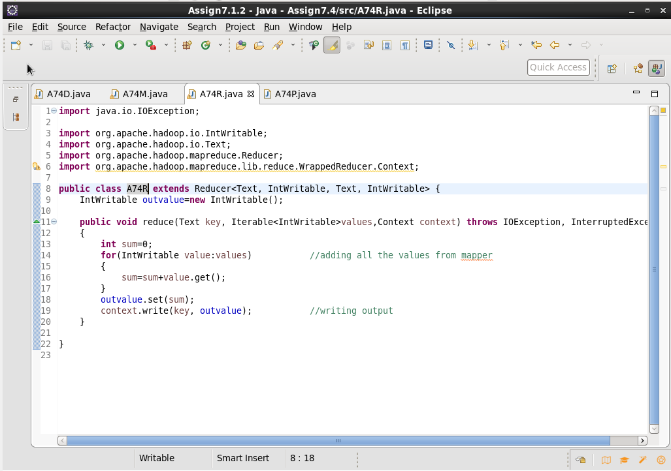

**Partitioner Class-**

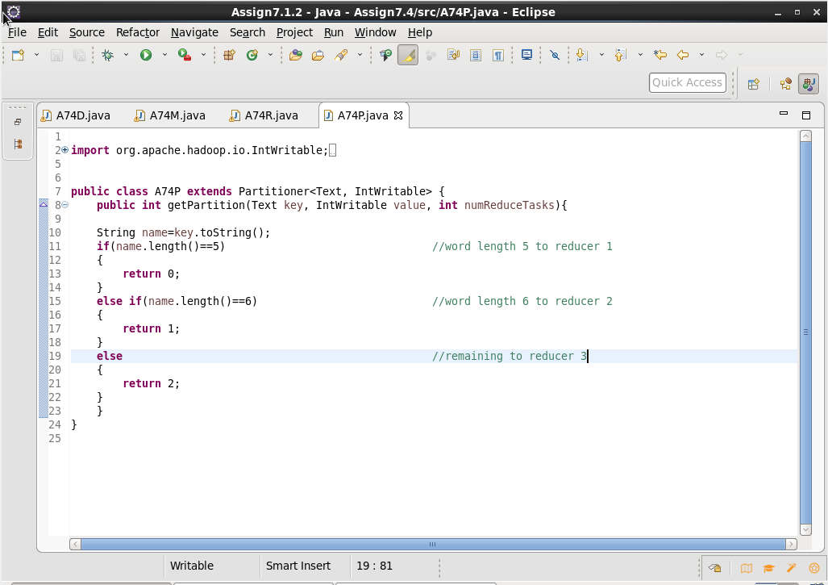

**Output-**

