**Problem Statement**

Explain the working of below pig script commands with an example:

1. LOAD – LOAD command is used to load data from file system.

Syntax- A=LOAD ‘myfile.txt’ USING PigStorage(‘ ‘) AS (f1:int,f2:int);

myfile.txt - is the file to be loaded.

PigStorage - is specifying separator.

(f1:int,f2:int) – specify the schema and data types for fields.

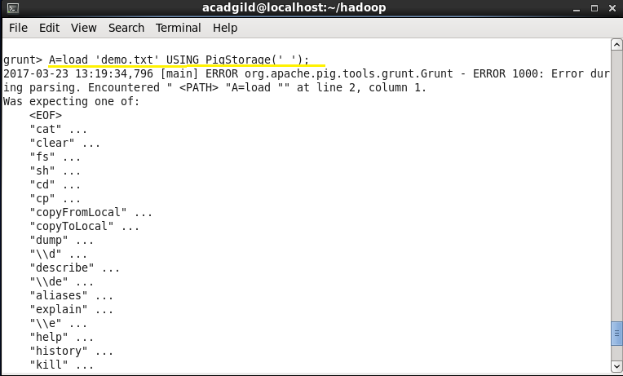

1. STORE- Store or saves file to the file system.

Syntax- STORE A INTO ‘myoutput’ USING PigStorage (‘*’);

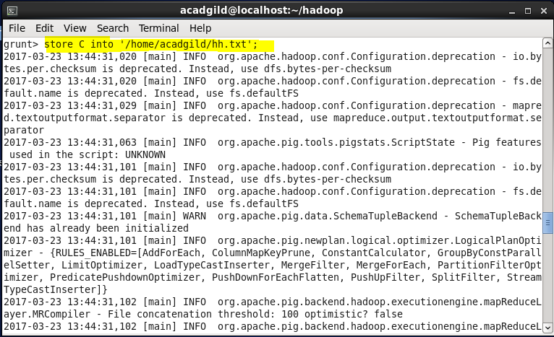

1. DUMP – DUMP command shows output on screen.

Syntax- DUMP A;

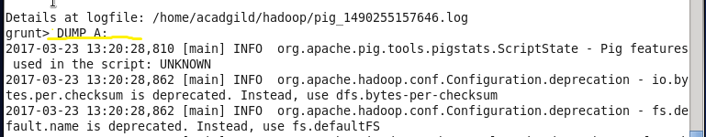

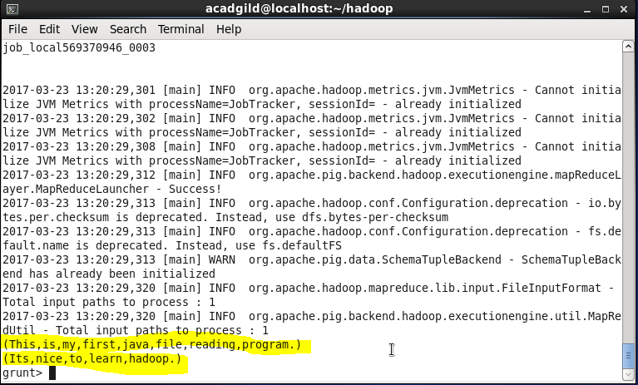

1. FOREACH – Generates transformation of data for each row as specified.

Syntax- X=FOREACH A GENERATE a1;

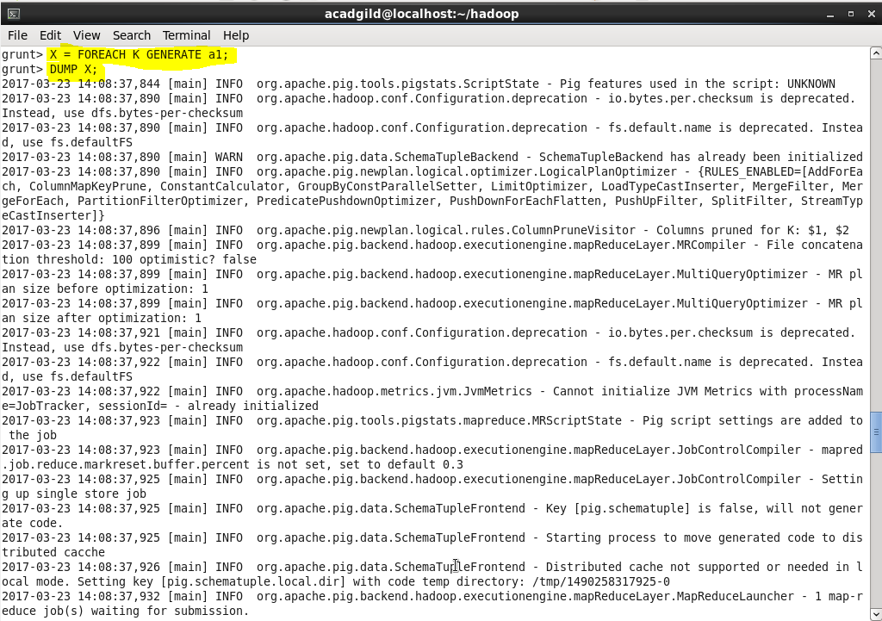

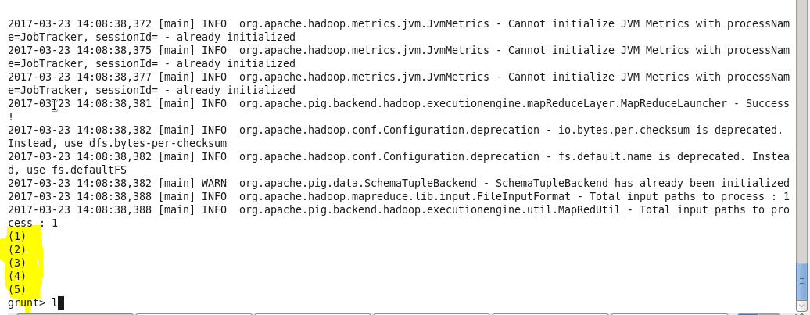

1. FILTER – Select tuples from a relation based on some condition.

Syntax- X=FILTER A by f3==f3;

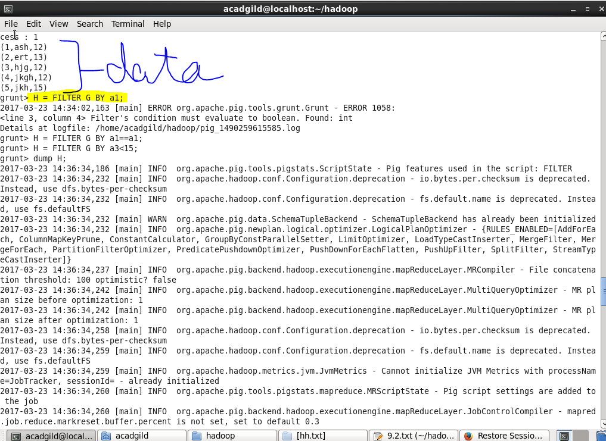

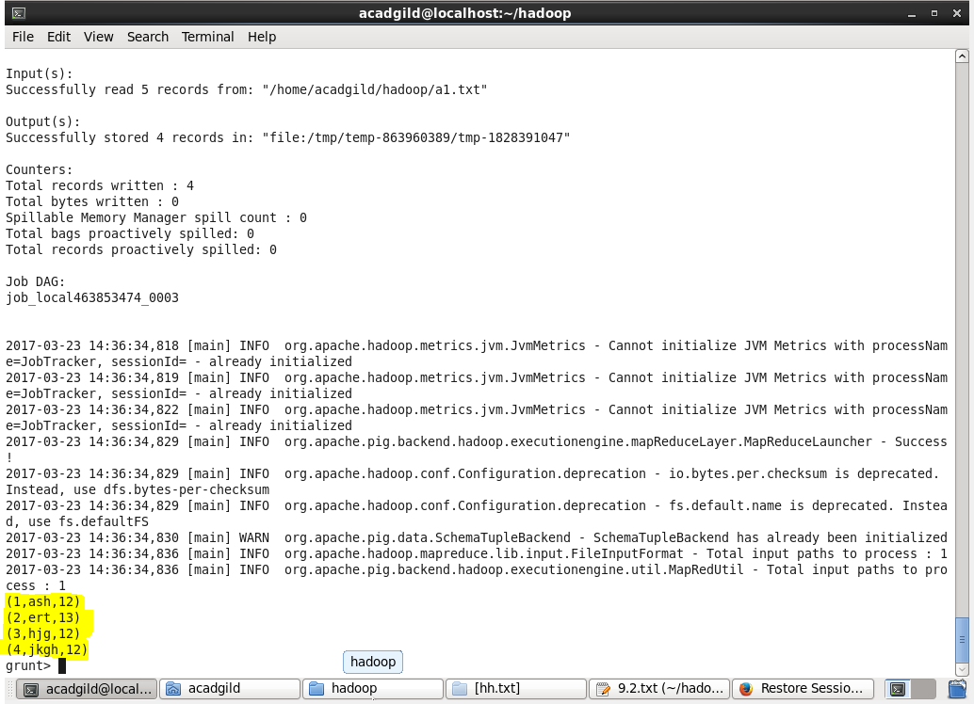

1. GROUP BY- Group the data in one or more relations. The GROUP operator groups together tuples that have the same group key (key field)

Syntax- A= LOAD ‘student’ AS (name:chararray,age:int,gpa:float);

B=GROUP A BY age;

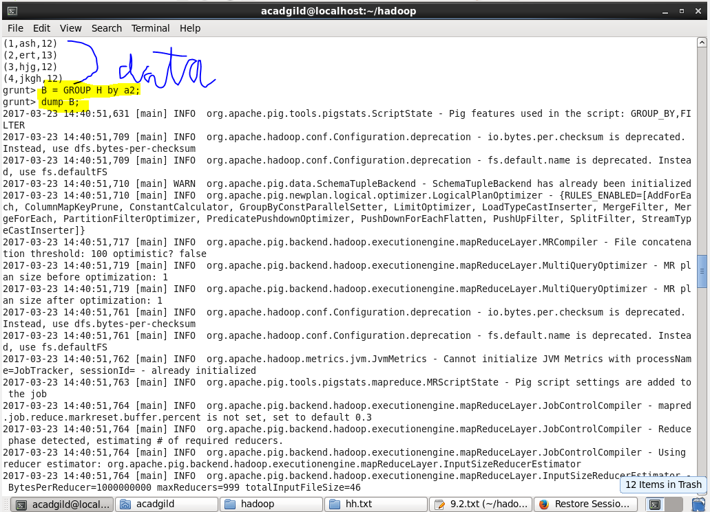

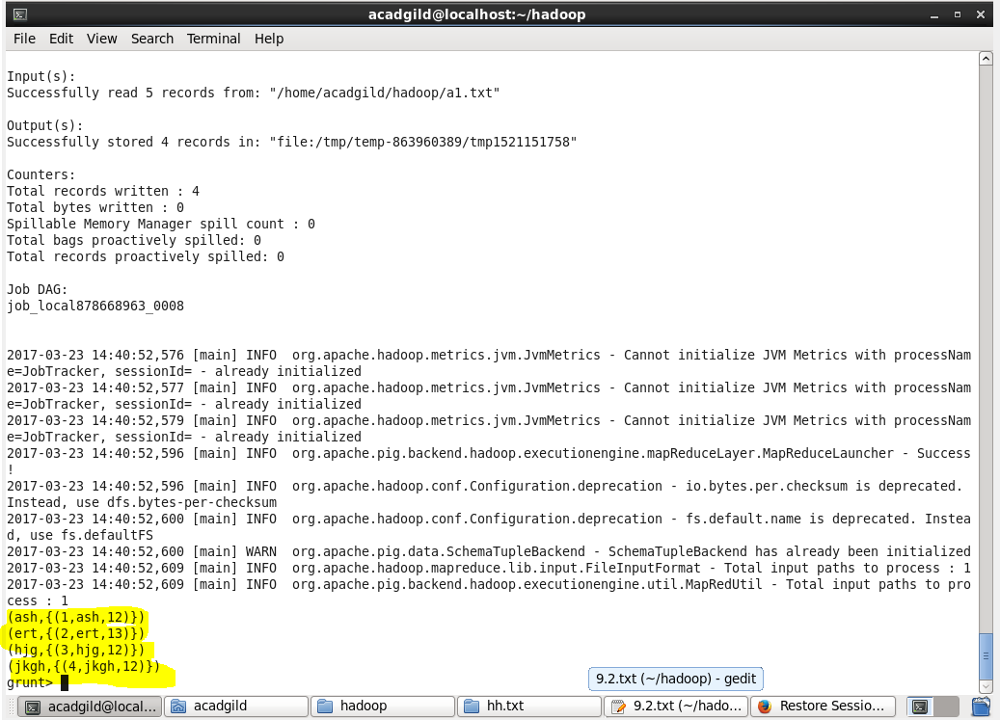

1. ORDER BY – Sorts a relation based on one or more fields.

Syntax- A= LOAD ‘data’ AS (a1:int,a2:int,a3:int)

X= ORDER A BY a3 DESC;

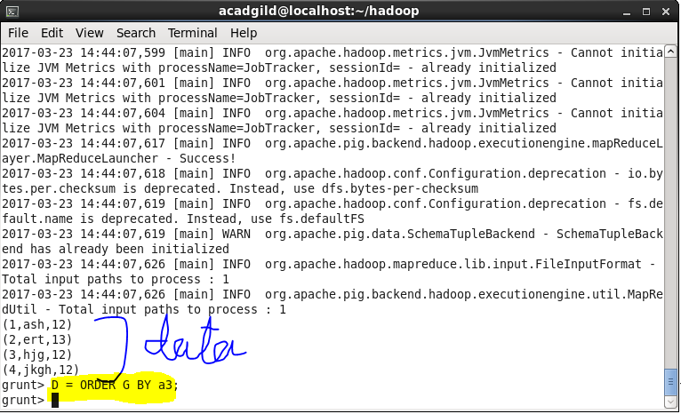

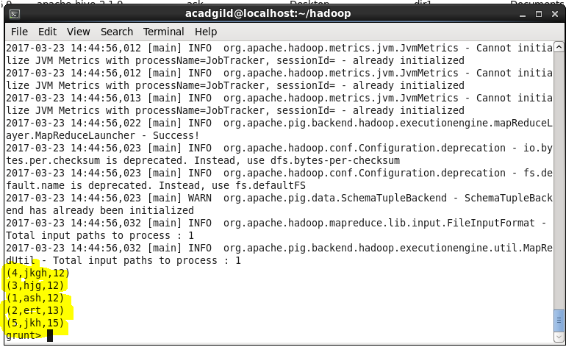

1. DESCRIBE- Describes the schema of any field.

Syntax- DESCRIBE A;

Output- A:{name:chararray,age:int,gpa:float}

