Part A (To be referred by students)

Topic: HTML (Text Formatting, Paragraph, Header, Lists, Nested Lists, Character Entities, Image, Images Tags)

Aim: Choosing an organization which requires online reference and implementing its requirements through HTML Text Formatting Tags, Lists, Nested List, Character Entities, Image & Image Map.

Learning Outcome: Study consists of learning the following concepts
- Identifying structure of a HTML document and basic HTML tags with required attributes required to solve a given scenario.
- Understanding the syntax & rules of using following HTML Tags with Attributes

  - Text Formatting
  - Paragraph
  - Header
  - Lists, Nested Lists
  - Character Entities
  - Empty Tags
  - Image Tags

Description:
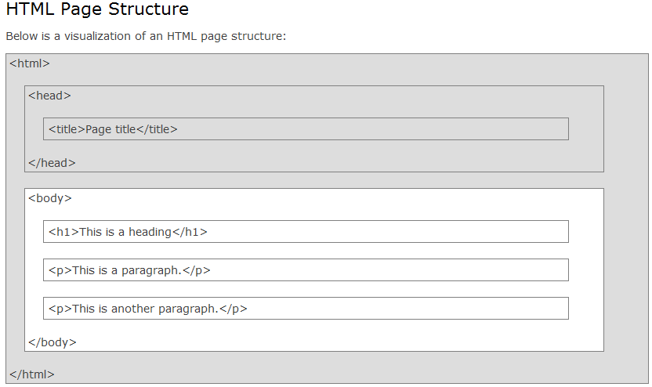
HTML Elements and headers | <body> </body>
  Tag | Description
  <html> | Defines an HTML document
  <body> | Defines the document's body
  <head> | Defines the document's head element
  <h1> to <h6> | Displays text in varying size
  Type | Description
  bgcolor=”blue” | Background color
  text=”red” | Body text color
  link=”yellow” | a normal, unvisited link
  vlink=”green” | a link the user has visited
  alink=”blue” | an active link the moment it is clicked
  background=”.gif” | Background Image
<font> </font> | HTML Paragraph Elements
  Type | Description
  face="" | Type of font
  size=“12” | Size of font
  color=”red” | Color of text
  Tag | Description
  <p> | Defines a paragraph
  <pre> | Defines pre-formatted text
HTML Text Formatting Elements  Comment tags <!-- and --> are used to insert comments in HTML.  HTML Empty Tags | HTML List Tags  Ordered HTML Lists - The Type Attribute  A type attribute can be added to an ordered list, to define the type of the marker:
  Tag | Description
  <b> | bold text
  <u> | underlined text
  <i> | italic text
  <sub> | subscripted text
  <sup> | superscripted text
  <mark> | marked/highlighted text
  <em> | emphasized text
  <small> | smaller text
  <strong> | important text
  <ins> | inserted text
  <del> | deleted text
  <acronym title=””> | Specifies the title attribute content in a popup tag when the text is highlighted.
  Tag | Description
  <br/> | Line Break
  <hr/> | Horizontal Rule
  Tag | Description
  <ul> | unordered list
  <ol> | ordered list
  <li> | list item
  <dl> | description list
  <dt> | term in a description list
  <dd> | description in a description list
  Type | Description
  type="1" | The list items will be numbered with numbers (default)
  type="A" | uppercase letters
  type="a" | lowercase letters
  type="I" | uppercase roman numbers
  type="i" | lowercase roman numbers
  type=”circle” | white circle.
  type=”disc” | filled black circle.
  type=”square” | filled black square.
  start=”3” | To start numbering from 3.

HTML Image Tags  <img> Attributes |  |  | Image Maps  For an image, you can create an image map, with clickable areas:  Example  <img src="planets.gif" alt="Planets" usemap="#planetmap" width="145" height="126">  <map name="planetmap">  <area shape="rect" coords="0,0,82,126" alt="Sun" href="sun.htm">  <area shape="circle" coords="90,58,3" alt="Mercury" href="mercur.htm">  <area shape="circle" coords="124,58,8" alt="Venus" href="venus.htm">  </map>
  Tag | Description
  <img> | Image
  <map> | image-map
  <area> | clickable area inside an image-map
  Type | Description
  width=”128” | width and height attributes to define the image size in pixels.
  height=”128”
  border=”5” | Frame the image.
  align=”left”  align=“right” | Align image to the left or right of the following text.
  alt=”text” | alt attribute to define an alternative text if image is not displayed
  src=”some.gif” | src attribute to define the image file name
  hspace=”” | Horizontal space
  vspace=”” | Vertical space
Character Entities

Result | Description | Entity Name |  | Entity Number
 | non-breaking space | &nbsp; |  | &#160;
< | less than | &lt; |  | &#60;
> | greater than | &gt; |  | &#62;
& | ampersand | &amp; |  | &#38;
¢ | cent | &cent; |  | &#162;
£ | pound | &pound; |  | &#163;
¥ | yen | &yen; |  | &#165;
€ | euro | &euro; |  | &#8364;
§ | section | &sect; |  | &#167;
© | copyright | &copy; |  | &#169;
® | registered trademark | &reg; |  | &#174;
™ | trademark | &trade; |  | &#8482;

EXPERIMENT:
Choose an online shop/organization (Cake, Books, Cars, Icrecream, University etc.) as your practical scenario. Create a Web Page with the described HTML tags with attributes for:
- Text Formatting,
- Paragraph,
- Header,
- Lists,
- Empty Tags,
- Use of Character entities,
- Image Tag

Part B
(to be completed by students)

(Students must submit the soft copy as per the following segments. The soft copy must be uploaded on the Blackboard. The filename should be WP_Batch_RollNo_Exp_No)

Each Experiment should have the following added in the first page followed by the answers of Questions given below:
Roll No.: F051 | Name: Neev
Prog/Yr/Sem: BTI-3-6 | Batch: F2
Date of Experiment: | Date of Submission:

Questions:
- Explain all the tags and attributes of HTML specified in the Experiment Writeup. Explain the use of Character Entities.

<html>
- Root tag of an HTML document.
- Contains all other HTML elements.
- Tells the browser that the document is an HTML page.

2. <head>
- Contains metadata about the document.
- Not displayed on the web page.
- Includes elements like <title>.

3. <title>
- Specifies the title of the web page.
- Displayed on the browser’s title bar or tab.

4. <body>
- Contains all the visible content of the webpage.
- Attribute used:
  - bgcolor="yellow" → Sets the background color of the page.

5. <center>
- Aligns the enclosed content to the center of the page.
- Used for headings, images, and text alignment.
(Note: deprecated in HTML5 but used for learning basics)

6. <font>
- Used to change text appearance.
- Attributes used:
  - color → Sets text color
  - face → Specifies font style (Courier)
(Deprecated in HTML5, replaced by CSS)

7. Heading Tags <h1> to <h4>
- Used to define headings.
- <h1> is the largest heading.
- <h4> is smaller than <h2>.
- Helps in structuring content.

8. <img>
- Used to insert images.
- Attributes used:
  - src → Path of the image file
  - width → Image width
  - height → Image height
  - border → Thickness of image border

9. <br/>
- Inserts a line break.
- Self-closing tag.

10. <hr>
- Inserts a horizontal line.
- Attributes used:
  - color → Color of the line
  - width → Width of the line
  - size → Thickness of the line

11. <p>
- Defines a paragraph.
- Automatically adds spacing before and after text.

12. Text Formatting Tags
- <b> → Makes text bold
- <u> → Underlines text
- <i> → Italicizes text

13. <pre>
- Displays preformatted text.
- Preserves spaces, tabs, and line breaks exactly as written.
- Useful for displaying timetables and formatted data.

14. <sub> and <sup>
- <sub> → Subscript (H₂O)
- <sup> → Superscript (x²)

15. List Tags

a) <ul> (Unordered List)
- Displays bullet points.
- Attribute:
  - type="circle" → Bullet style

b) <ol> (Ordered List)
- Displays numbered/alphabetical lists.
- Attribute:
  - type="a" → Alphabetical order (a, b, c)

c) <li>
- Defines list items inside <ul> or <ol>.

16. Alignment Attribute
- <p align="center">
- Aligns paragraph text to the center.

17. HTML Comments (Not used but conceptually important)
- Used to add notes inside HTML code.
- Not displayed in browser.

b) Use of Character Entities in HTML

What are Character Entities?
- Character entities are used to display special symbols that cannot be typed directly or may conflict with HTML syntax.
- They begin with & and end with ;.

Character Entities Used in the Experiment
Entity | Symbol | Use
&copy; | © | Copyright symbol
&reg; | ® | Registered trademark
&#8377; | ₹ | Indian Rupee symbol
&gt; | > | Greater than symbol
&lt; | < | Less than symbol

Why Character Entities Are Used?
- To display reserved HTML symbols.
- To show special characters correctly.
- To avoid confusion with HTML tags.
- To ensure browser compatibility.

- Write the experiment scenario and add the HTML code and snapshot of the web page.
<html>
<head>
<title> Experiment1 HTML Basic Tags </title>
</head>
<body bgcolor = "yellow">
<center>
<font color="Blue" face="Courier">
<h1> ABC University </h1>
</font>
<font color="Green" face="Courier"
<h2> Empowering education for a better tomorrow </h2>
</font>
<h4> University Campus </h4>
<img src="C:\Users\mpstme.student\Desktop\F051_BWD\College.jpg" width="450" height = "280" border="4" />
</center>
<br/>
<hr color="green" width="80%" size="4"/>
<p> <b> <u> Stony Brook </u> </b> is part of the State University of <i> New York (SUNY) </i> system, a center of academic excellence and an internationally recognized <u> research institution </u> that offers all students a world-class education at an affordable price.
</p>
<hr/>
<p> The campus is divided into numerous sections, with County Route 97 (Nicolls Road) dividing the university's West and East campuses.[7] The West Campus, centered around the Academic Mall, includes many of the university's academic buildings, student dormitories and athletic facilities. </p>
<h2> University Timings </h2>
<pre>

Monday - Friday : 9:00 AM - 5:00 PM

Saturday : 9:00 AM - 1:00 PM

Sunday : Holiday
</pre>
<hr/>
<h2>Academic Info</h2>
<p>

Total Students : <b>12000+</b><br/>

Faculty :<i>500+</i><br/>

Water formula:H<sub>2</sub>o<br/>

Maths:x<sup>2</sup>
</p>
<hr/>
<h2>Program offred </h2>
<ul>
<li>Under graduate</li>
<ol>
<li>Btech</li>
<li>Bsc</li>
<li>BA</li>
</ol>

<li>gradutation program
<ol type ="a">
<li>Mtech</li>
<li>MBA</li>
<li>MSC</li>
</ol>
</li>
<li>Doctrate
<ul type="circle"
<li>PhD in Engg </li>
<li>Phd in Mgmt </li>
<li>PhD in Science </li>
</li>
</ul>
<hr/>
<h2> Important details </h2>
<pre>
&copy; 2025 ABC University
All rights Reserved &reg;
Semester Fees : &#8377;75,00,0,
Eligibility : Marks &gt; 50%
Seats Available &lt; 500
</pre>
<hr color+"blue" size="7"/>
<p align="center">
<b> contact information </b> <br/>
Email: info@abcuniversity.edu<br/>
Phone: +91 999988888222 <br/>
</p>
</body>
</html>

- How is the defined outcome for the experiment in Part a fulfilled through the scenario?
