**Agent Copy Issue:**

Updated file we can place from source (clear case) to destination (FileZilla )

**Source:**

Select proper path and file.

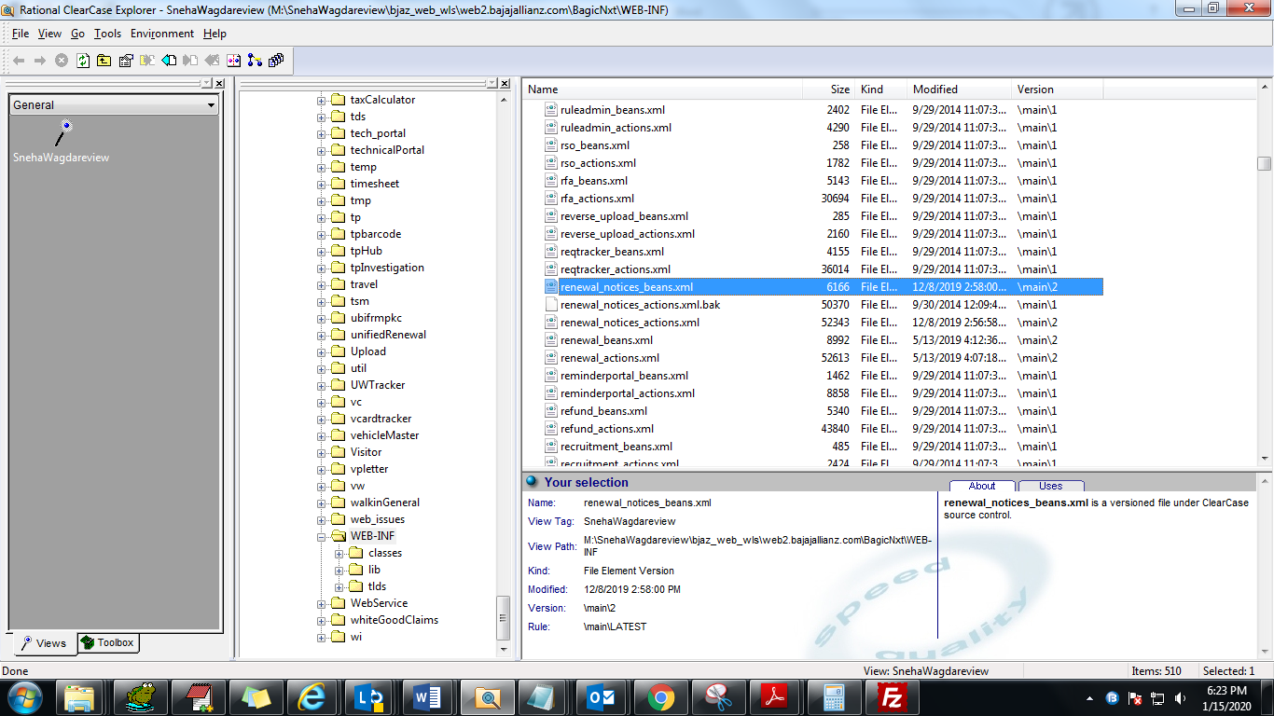

**Destination:**

