IMD Remapping:

IMD can map from old to new IMD.

Please refer below screenshots and queries for your references.

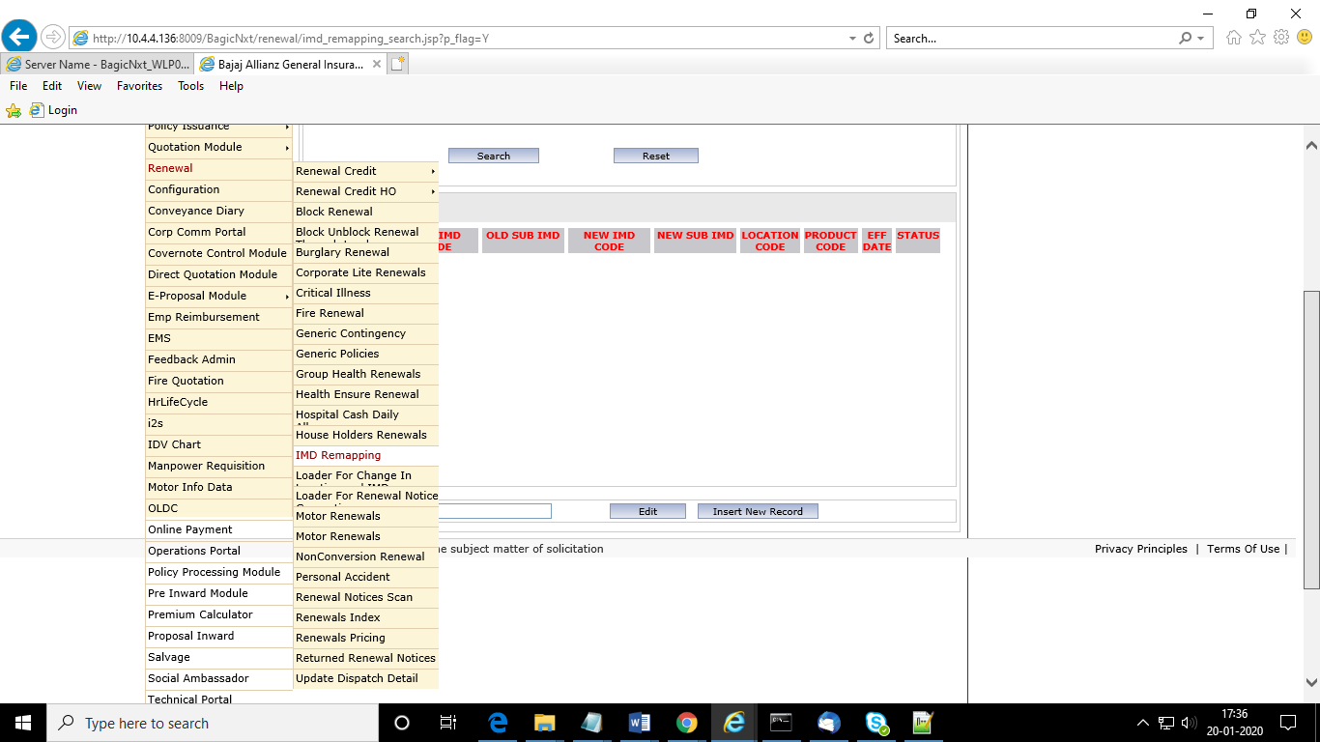

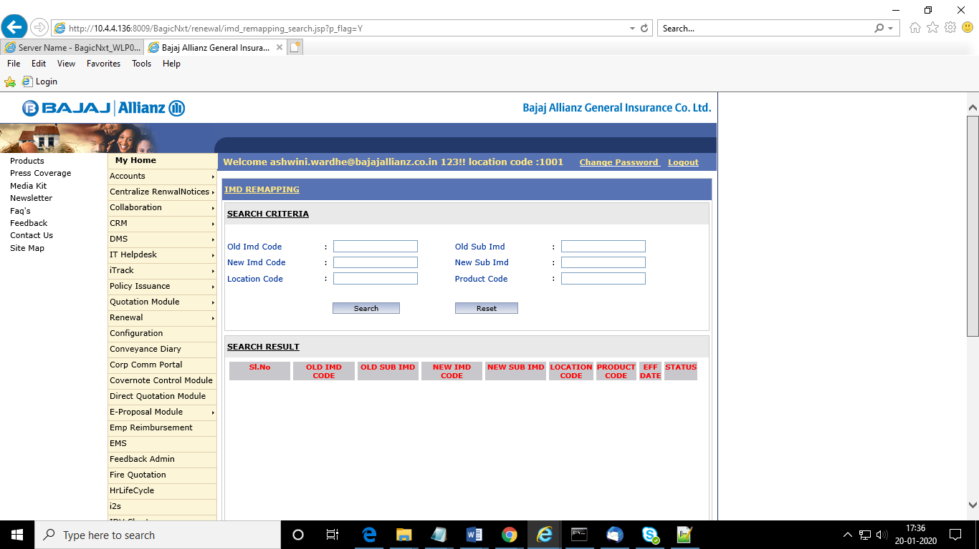

----------------------location remapping----------------------------------------------------------

SELECT * FROM bjaz_packpol_agent_validations

where validation_no='REASSIGN_LOC' and OLD_LOCATION_CODE=2234 and IMD_CODE='10074906'

----IMD Resassignment Query----------------------------

SELECT * FROM bjaz_packpol_agent_validations

WHERE validation_no = 'REASSIGN_IMD';