**Known Error Database**

**For**

**MD Portal Application – Renewal Issue**

**(Dealer Portal)**

**Revision History**

|  |  |  |  |  |
| --- | --- | --- | --- | --- |
| **Sr. No.** | **Author Name** | **Version Number** | **Date** | **Remarks** |
| 1 | Rajesh Ramakrishnan | V1.0 | 13-Jan-2020 |  |
|  |  |  |  |  |

**Approval History**

|  |  |  |  |  |
| --- | --- | --- | --- | --- |
| **Sr. No.** | **Author Name** | **Version Number** | **Date** | **Remarks** |
|  |  |  |  |  |
|  |  |  |  |  |

**Table of Contents**

Introduction 4

Purpose 4

Issue 4

Resolution 4

Document Review Mechanism 12

# Introduction

## Purpose

The purpose of this document is to record known errors and serve as a knowledge base used for more efficient incident and problem resolution.

## Issue

When user tried to renew Bajaj policy from dealer portal is was displaying as error message as, ‘Kindly contact branch office for the renewal of this policy.'

**Refer below screenshot for more details:**

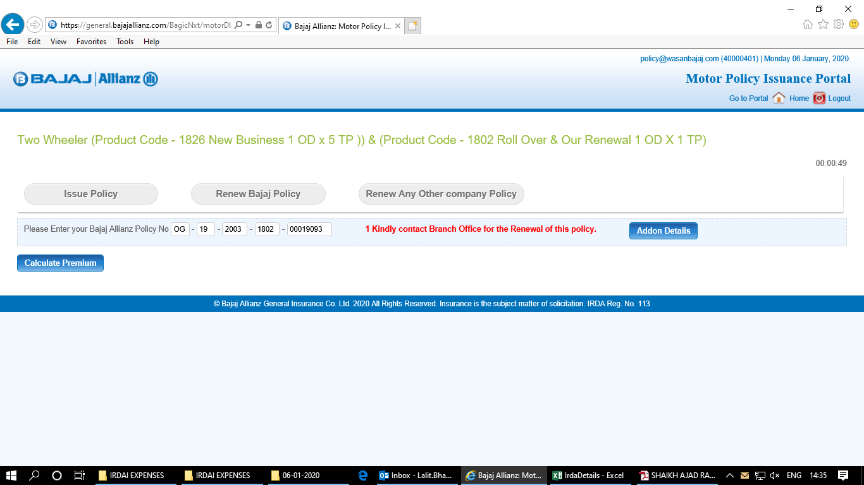

## Resolution

Follow below steps for resolve issues related to ‘Bajaj Renewal Policy’:

**Step 1:** Check user rights and product code configured for user, whose policy needs to be renewed.

**Step 2:** Check whether user rights date is valid or not, if it is expired then extend the expiry date.

**Step 3:** Check whether top indicator is ‘Y’ or ‘N’, if it is ‘N’ then update the record with ‘Y’.

***Note:*** Need to check above 3 steps in below table using respective query displayed below:

* **ba_external_config**

SELECT * from ba_external_config where USER_ID='riktashah@general.bajajallianz.co.in'

and PARAM_REF='PRODUCT_CODES'

* **bjaz_vehicle_type_master_act**

SELECT * from bjaz_vehicle_type_master_act where user_name in ('riktashah@general.bajajallianz.co.in');

**Step 4:** Create below script to configure user rights and location code using below query and send it to your approval authority:

DECLARE

--v_user_id VARCHAR2 (500) := :p_user_id;

v_sub_imd_code VARCHAR2 (50) := 'ALL';

v_domain VARCHAR2 (20) := 'ALL';

v_product_code NUMBER (4) := '0';

v_effective_from_date VARCHAR2 (100) := '01-jan-2016'; --dd/mm/yyyy

v_effective_to_date VARCHAR2 (100) := '01-jan-2020'; --dd/mm/yyyy

v_status CHAR (1 BYTE) := 'A';

v_recorded_by VARCHAR2 (100 BYTE)

:= 'Customer.Support@bajajallianz.co.in';

v_remarks VARCHAR2 (100) := 'added for qutation rights';

v_count_1801 NUMBER := 0;

v_count_1803 NUMBER := 0;

v_count_1802 NUMBER := 0;

v_count_ag NUMBER := 0;

v_count_nb NUMBER := 0;

v_count_otrnw NUMBER := 0;

v_count_ol NUMBER := 0;

v_count_referal NUMBER := 0;

v_count_integrated NUMBER := 0;

v_count_floatquot NUMBER := 0;

v_count_onlinelink NUMBER := 0;

BEGIN

FOR x IN

(SELECT agentcode, locationcode, loginname

FROM agents

WHERE loginname IN

('policy@wasanbajaj.com'))

LOOP

BEGIN

---- Initalise VAriables ----

v_sub_imd_code := 'ALL';

v_domain := 'ALL';

v_product_code := '0';

v_effective_from_date := '01-jan-2016'; --dd/mm/yyyy

v_effective_to_date := '01-jan-2020'; --dd/mm/yyyy

v_status := 'A';

v_recorded_by := 'Customer.Support@bajajallianz.co.in';

v_remarks := 'added for qutation rights';

v_count_1801 := 0;

v_count_1802 := 0;

v_count_1803 := 0;

v_count_ag := 0;

v_count_nb := 0;

v_count_otrnw := 0;

v_count_ol := 0;

v_count_referal :=0;

v_count_integrated:=0;

v_count_floatquot := 0;

v_count_onlinelink := 0;

-----------1801------------

BEGIN

SELECT COUNT (1)

INTO v_count_1801

FROM ba_external_config

WHERE user_id = x.loginname AND imd_code = x.agentcode

AND sub_imd_code = v_sub_imd_code AND domain = v_domain

AND product_code = v_product_code

AND location_code = x.locationcode

AND param_ref = 'PRODUCT_CODES' AND param_value = '1801';

EXCEPTION

WHEN OTHERS THEN

v_count_1801 := 0;

END;

-- .put_line ('v_count==' || v_count_1801);

IF v_count_1801 = 0 THEN

INSERT INTO ba_external_config

(user_id, imd_code, sub_imd_code, domain,

product_code, location_code, param_ref,

param_value, param_label,

effective_from_date,

effective_to_date,

status, recorded_by, recorded_on, remarks

)

VALUES (x.loginname, x.agentcode, v_sub_imd_code, v_domain,

v_product_code, x.locationcode, 'PRODUCT_CODES',

'1801', 'Private Car - Package Policy',

TO_DATE (v_effective_from_date, 'dd/mm/yyyy'),

TO_DATE (v_effective_to_date, 'dd/mm/yyyy'),

v_status, v_recorded_by, SYSDATE, v_remarks

);

COMMIT;

END IF;

-----------1803

BEGIN

SELECT COUNT (1)

INTO v_count_1803

FROM ba_external_config

WHERE user_id = x.loginname AND imd_code = x.agentcode

AND sub_imd_code = v_sub_imd_code AND domain = v_domain

AND product_code = v_product_code

AND location_code = x.locationcode

AND param_ref = 'PRODUCT_CODES' AND param_value = '1803';

EXCEPTION

WHEN OTHERS THEN

v_count_1803 := 0;

END;

-- .put_line ('v_count==' || v_count_1803);

IF v_count_1803 = 0 THEN

INSERT INTO ba_external_config

(user_id, imd_code, sub_imd_code, domain,

product_code, location_code, param_ref,

param_value, param_label,

effective_from_date,

effective_to_date,

status, recorded_by, recorded_on, remarks

)

VALUES (x.loginname, x.agentcode, v_sub_imd_code, v_domain,

v_product_code, x.locationcode, 'PRODUCT_CODES',

'1803', 'Commercial Vehicle - Package Policy',

TO_DATE (v_effective_from_date, 'dd/mm/yyyy'),

TO_DATE (v_effective_to_date, 'dd/mm/yyyy'),

v_status, v_recorded_by, SYSDATE, v_remarks

);

COMMIT;

END IF;

--------- 1802

BEGIN

SELECT COUNT (1)

INTO v_count_1802

FROM ba_external_config

WHERE user_id = x.loginname AND imd_code = x.agentcode

AND sub_imd_code = v_sub_imd_code AND domain = v_domain

AND product_code = v_product_code

AND location_code = x.locationcode

AND param_ref = 'PRODUCT_CODES' AND param_value = '1802';

EXCEPTION

WHEN OTHERS THEN

v_count_1802 := 0;

END;

IF v_count_1802 = 0 THEN

INSERT INTO ba_external_config

(user_id, imd_code, sub_imd_code, domain,

product_code, location_code, param_ref,

param_value, param_label,

effective_from_date,

effective_to_date,

status, recorded_by, recorded_on, remarks

)

VALUES (x.loginname, x.agentcode, v_sub_imd_code, v_domain,

v_product_code, x.locationcode, 'PRODUCT_CODES',

'1802', 'Two Wheeler - Package Policy',

TO_DATE (v_effective_from_date, 'dd/mm/yyyy'),

TO_DATE (v_effective_to_date, 'dd/mm/yyyy'),

v_status, v_recorded_by, SYSDATE, v_remarks

);

COMMIT;

END IF;

DBMS_OUTPUT.put_line ('Sucessful Entry for ID ' || x.loginname);

EXCEPTION

WHEN OTHERS THEN

DBMS_OUTPUT.put_line ('Error for ID ' || x.loginname || SQLERRM);

END;

END LOOP;

END;

DECLARE

v_user_name VARCHAR (100) := 'p.reddy01@general.bajajallianz.co.in';

v_locationcode agents.locationcode%TYPE;

v_imd_code agents.agentcode%TYPE;

v_cnt PLS_INTEGER;

CURSOR web_id

IS

(SELECT loginname, locationcode, agentcode

FROM agents

WHERE loginname IN

('policy@wasanbajaj.com'));

CURSOR veh_id

IS

(SELECT DISTINCT vehicle_type_code

FROM bjaz_vehicle_type_master_act

WHERE product_code = 1831

AND vehicle_type_code NOT IN (21, 22, 29,34, 35,37,38,39,40)

AND active_yn = 'Y');

BEGIN

FOR j IN web_id

LOOP

FOR i IN veh_id

LOOP

SELECT COUNT (1)

INTO v_cnt

FROM bjaz_vehicle_type_master_act

WHERE product_code = 1831

AND vehicle_type_code = i.vehicle_type_code

AND active_yn = 'Y'

AND user_name = j.loginname;

IF v_cnt = 0

THEN

INSERT INTO bjaz_vehicle_type_master_act

(vehicle_type_code, imd_code, location_code,

user_name, cover_type, min_rid, effective_date,

active_yn, product_code

)

VALUES (i.vehicle_type_code, j.agentcode, j.locationcode,

j.loginname, 'A', 2, TRUNC (SYSDATE),

'Y', 1831

);

ELSE

UPDATE bjaz_vehicle_type_master_act

SET imd_code = j.agentcode,

location_code = j.locationcode

WHERE product_code = 1831

AND vehicle_type_code = i.vehicle_type_code

AND active_yn = 'Y'

AND user_name = j.loginname;

END IF;

END LOOP;

END LOOP;

COMMIT;

EXCEPTION

WHEN OTHERS

THEN

DBMS_OUTPUT.put_line ('Error - ' || SQLERRM);

END;

-- 1805/1806

DECLARE

v_user_name VARCHAR (100) := 'p.reddy01@general.bajajallianz.co.in';

v_locationcode agents.locationcode%TYPE;

v_imd_code agents.agentcode%TYPE;

v_cnt PLS_INTEGER;

CURSOR web_id

IS

(SELECT loginname, locationcode, agentcode

FROM agents

WHERE loginname IN

('policy@wasanbajaj.com'));

CURSOR veh_id

IS

(SELECT DISTINCT vehicle_type_code

FROM bjaz_vehicle_type_master_act

WHERE product_code = 1805

AND vehicle_type_code IN (22)

AND active_yn = 'Y');

BEGIN

FOR j IN web_id

LOOP

FOR i IN veh_id

LOOP

SELECT COUNT (1)

INTO v_cnt

FROM bjaz_vehicle_type_master_act

WHERE product_code = 1805

AND vehicle_type_code = i.vehicle_type_code

AND active_yn = 'Y'

AND user_name = j.loginname;

IF v_cnt = 0

THEN

INSERT INTO bjaz_vehicle_type_master_act

(vehicle_type_code, imd_code, location_code,

user_name, cover_type, min_rid, effective_date,

active_yn, product_code

)

VALUES (i.vehicle_type_code, j.agentcode, j.locationcode,

j.loginname, 'A', 2, TRUNC (SYSDATE),

'Y', 1805

);

ELSE

UPDATE bjaz_vehicle_type_master_act

SET imd_code = j.agentcode,

location_code = j.locationcode

WHERE product_code = 1805

AND vehicle_type_code = i.vehicle_type_code

AND active_yn = 'Y'

AND user_name = j.loginname;

END IF;

END LOOP;

END LOOP;

COMMIT;

EXCEPTION

WHEN OTHERS

THEN

DBMS_OUTPUT.put_line ('Error - ' || SQLERRM);

END;

DECLARE

v_user_name VARCHAR (100) := 'p.reddy01@general.bajajallianz.co.in';

v_locationcode agents.locationcode%TYPE;

v_imd_code agents.agentcode%TYPE;

v_cnt PLS_INTEGER;

CURSOR web_id

IS

(SELECT loginname, locationcode, agentcode

FROM agents

WHERE loginname IN

('policy@wasanbajaj.com'));

CURSOR veh_id

IS

(SELECT DISTINCT vehicle_type_code

FROM bjaz_vehicle_type_master_act

WHERE product_code = 1806

AND vehicle_type_code IN (21)

AND active_yn = 'Y');

BEGIN

FOR j IN web_id

LOOP

FOR i IN veh_id

LOOP

SELECT COUNT (1)

INTO v_cnt

FROM bjaz_vehicle_type_master_act

WHERE product_code = 1806

AND vehicle_type_code = i.vehicle_type_code

AND active_yn = 'Y'

AND user_name = j.loginname;

IF v_cnt = 0

THEN

INSERT INTO bjaz_vehicle_type_master_act

(vehicle_type_code, imd_code, location_code,

user_name, cover_type, min_rid, effective_date,

active_yn, product_code

)

VALUES (i.vehicle_type_code, j.agentcode, j.locationcode,

j.loginname, 'A', 2, TRUNC (SYSDATE),

'Y', 1806

);

ELSE

UPDATE bjaz_vehicle_type_master_act

SET imd_code = j.agentcode,

location_code = j.locationcode

WHERE product_code = 1806

AND vehicle_type_code = i.vehicle_type_code

AND active_yn = 'Y'

AND user_name = j.loginname;

END IF;

END LOOP;

END LOOP;

COMMIT;

EXCEPTION

WHEN OTHERS

THEN

DBMS_OUTPUT.put_line ('Error - ' || SQLERRM);

END;

# Document Review Mechanism

As and when a change takes place, process will be updated accordingly. Periodically process will be reviewed.