**DAILY ONLINE ACTIVITIES SUMMARY**

|  |  |  |  |  |  |  |  |  |
| --- | --- | --- | --- | --- | --- | --- | --- | --- |
| **Date:** | **18-05-2020** | | | | | **Name:** | **Ashwini** | |
| **Sem & Sec** | **A** | | | | | **USN:** | **4AL17CS017** | |
| **Online Test Summary** | | | | | | | | |
| **Subject** | | **CNSC** | | | | | | |
| **Max. Marks** | | **60** | | **Score** | | | **36** | |
| **Certification Course Summary** | | | | | | | | |
| **Course** | **Front end development HTML** | | | | | | | |
| **Certificate Provider** | | | **Greatlearning** | | **Duration** | | | **3 hr** |
| **Coding Challenges** | | | | | | | | |
| **Problem Statement:Program for thread** | | | | | | | | |
| **Status:completed** | | | | | | | | |
| **Uploaded the report in Github** | | | | | **yes** | | | |
| **If yes Repository name** | | | | | **coding** | | | |
| **Uploaded the report in slack** | | | | | **no** | | | |

Online Test Details:

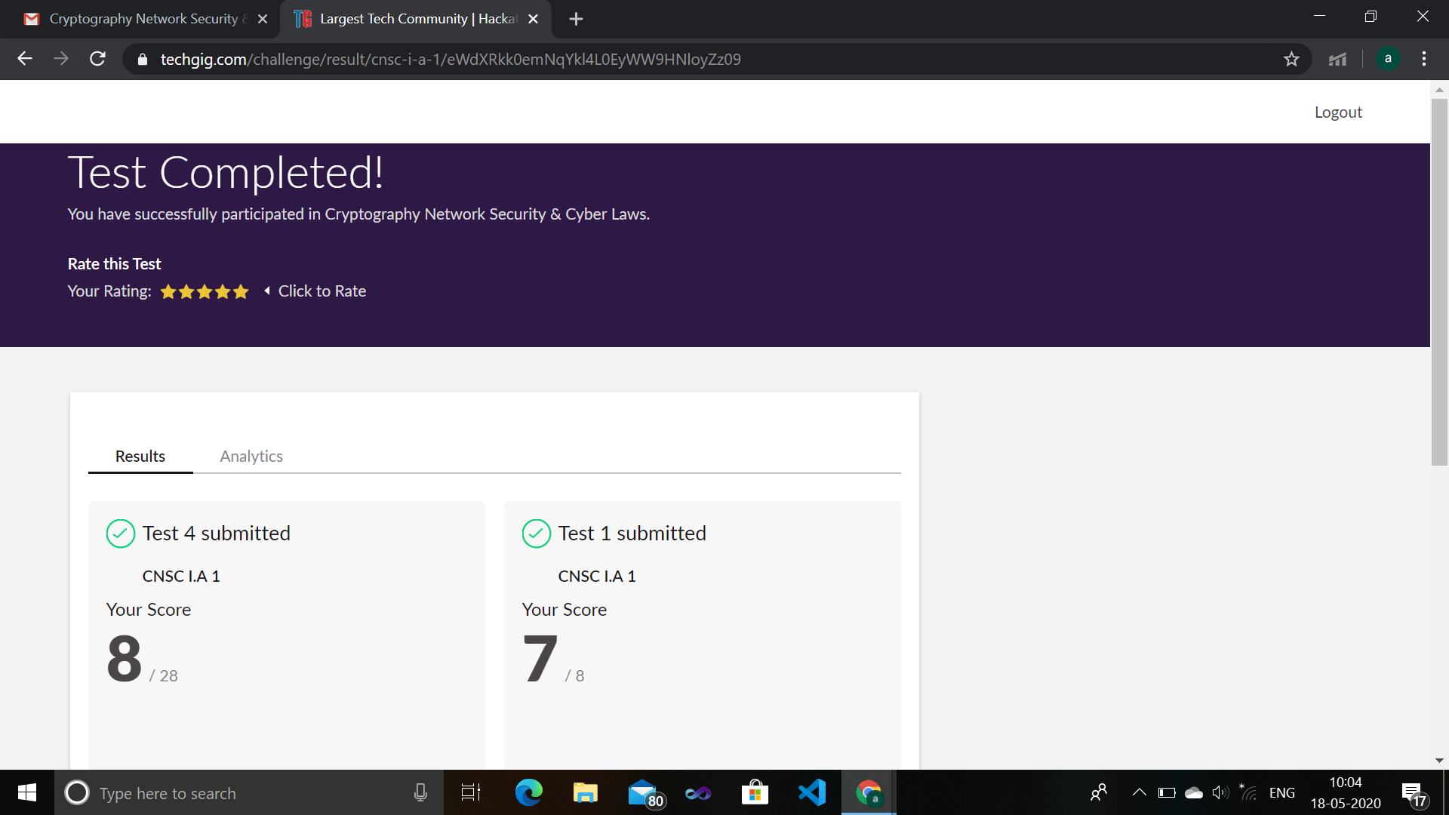

Certification Course Details:

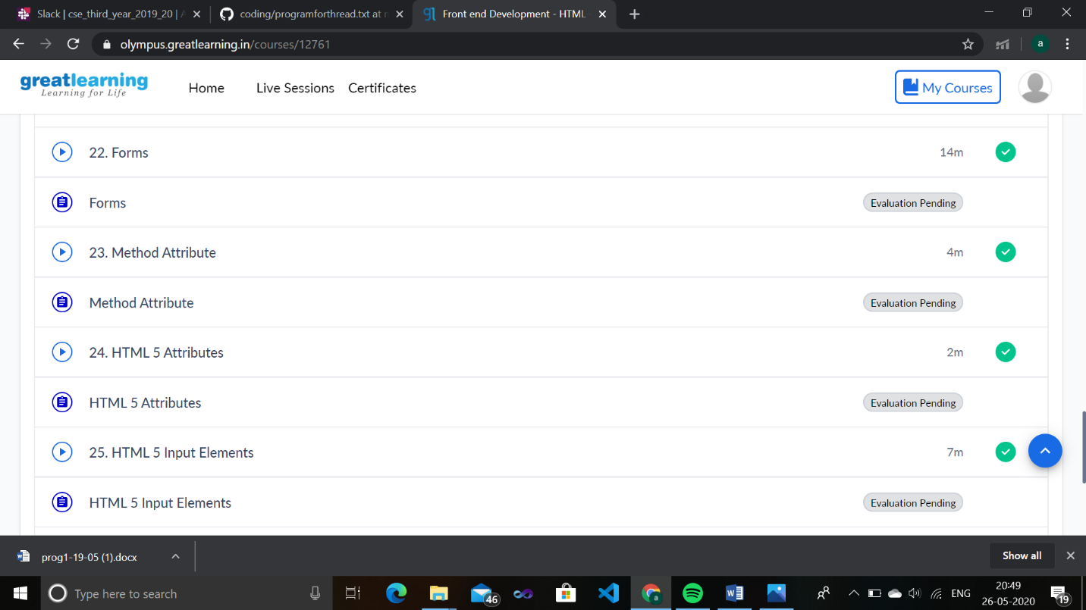s

Coding challenge:

|  |
| --- |
| public class PingPong extends Thread { |
|  | static StringBuilder object = new StringBuilder(""); |
|  |  |
|  | public static void main(String[] args) throws InterruptedException { |
|  |  |
|  | Thread t1 = new PingPong(); |
|  | Thread t2 = new PingPong(); |
|  |  |
|  | t1.setName("\nping"); |
|  | t2.setName(" pong"); |
|  |  |
|  | t1.start(); |
|  | t2.start(); |
|  | } |
|  |  |
|  | @override |
|  | public void run() { |
|  | working(); |
|  | } |
|  |  |
|  | void working() { |
|  | while (true) { |
|  | synchronized (object) { |
|  | try { |
|  | System.out.print(Thread.currentThread().getName()); |
|  | object.notify(); |
|  | object.wait(); |
|  | } catch (InterruptedException e) { |
|  | e.printStackTrace(); |
|  | } |
|  | } |
|  | } |
|  | } |
|  | } |