### 

### **BigMart Sales Prediction ML Project**

This is an excellent ML project idea for beginners. This ML project is best for learning how unsupervised ML algorithms function. The BigMart sales dataset comprises of precisely 2013 sales data for 1559 products across ten outlets in various cities.

The aim here is to use the BigMart sales dataset to develop a regression model that can predict the sale of each of 1559 products in the upcoming year in the ten different BigMart outlets. The BigMart sales dataset contains specific attributes for each product and outlet, thereby helping you to understand the properties of the different products and stores that influence the overall sales of BigMart as a brand.

<https://www.kaggle.com/brijbhushannanda1979/bigmart-sales-data>

1. Are the items with more MRP have more item outlet sales.
2. Are the stores which have established earlier have more sales.
3. Size of the stores could have an effect on the item sales at a particular store.
4. Location of the stores might depends on the Item outlet sales.
5. Are the supermarkets have more sales than others.

Data We have train (8523) and test (5681) data set, train data set has both input and output variable(s). You need to predict the sales for test data set.

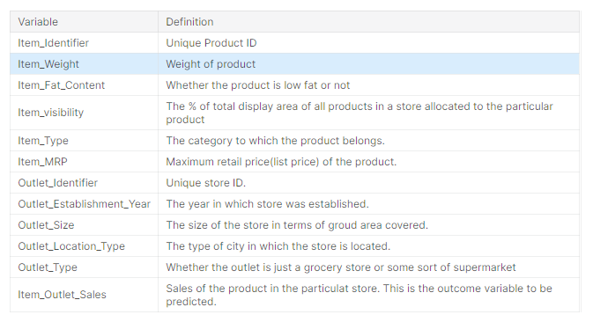

1.import required libraries

2.load the data

3.rows and cols

4.concatenate

4.description

5.information

6.finding missing values- imputation technique-NAN-mean-median-mode-ffill-bfill

7.EDA-exploratory data analysis--80%time

Distplot,outliers-boxplot,scatterplot,pairplot,......

8.split train and test

9.Scaling

10. Apply algorithm on train data

11. Evaluation

12. Predict --new feature values and check result