Project Design Phase-II
Data Flow Diagram & User Stories

Date | 3 October 2026
Team ID | SWTID-2026-3878
Project Name | Implement Client Script & UI Policy (Incident)
Maximum Marks | 4 Marks

Data Flow Diagrams:
A Data Flow Diagram (DFD) is a traditional visual representation of the information flows within a system. A neat and clear DFD can depict the right amount of the system requirement graphically. It shows how data enters and leaves the system, what changes the information, and where data is stored.
Data Flow Diagram (Level 0): Incident Form
Flow description:
1. The end user or service desk agent opens or edits the Incident form and enters or changes field values (for example, State).
2. The form passes the field values to the UI Policy check, which reads the policy rules and actions stored in D1.
3. The condition result decides which fields become mandatory, read-only or visible, and the Client Script (D2) runs on load or on change to show messages or update fields.
4. The updated form behaviour is shown to the user immediately, without submitting the form.
5. On save, the record is validated (mandatory fields filled) and a valid record is stored in the Incident table (D3).
6. The administrator creates and maintains the UI Policies and Client Scripts that drive this behaviour.
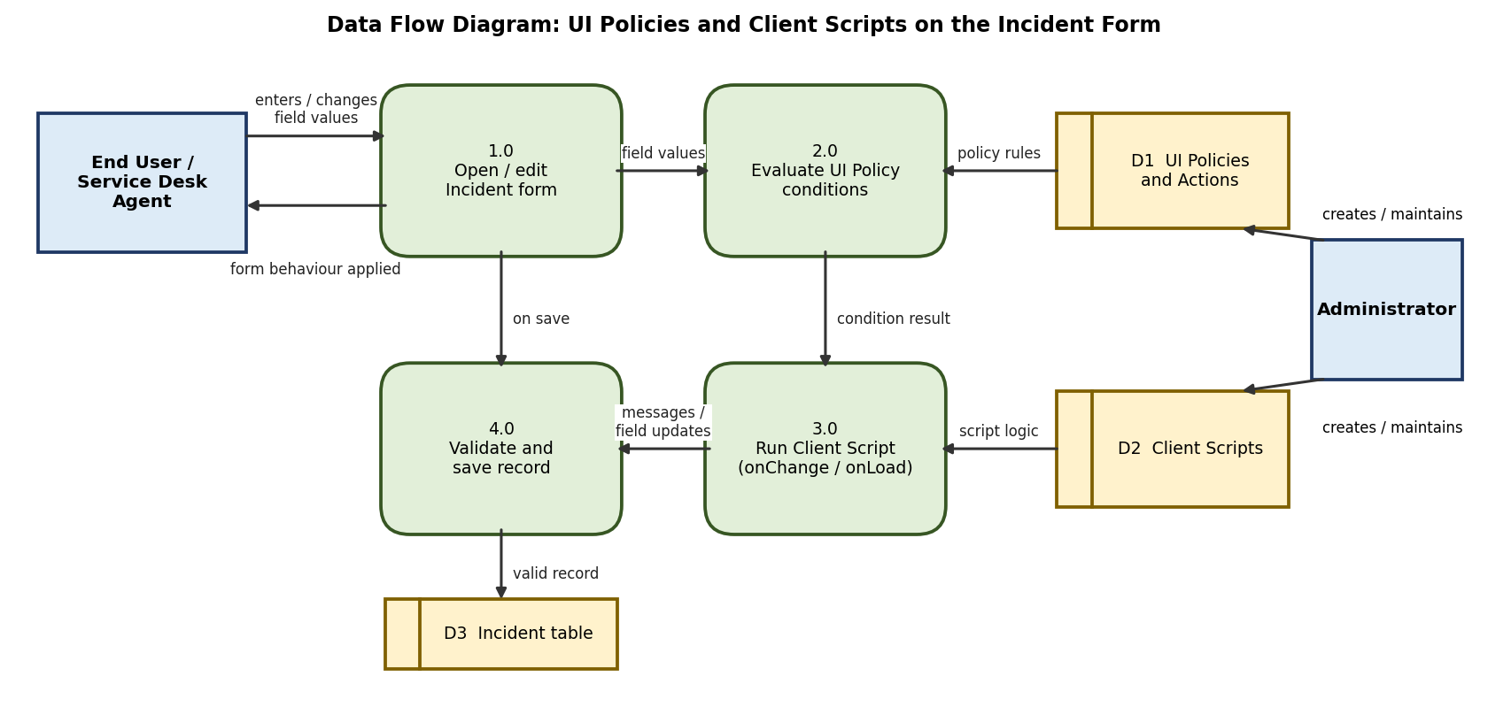

User Stories
Use the below template to list all the user stories for the product.
User Type | Functional Requirement (Epic) | User Story Number | User Story / Task | Acceptance criteria | Priority | Release
Service Desk Agent | Mandatory Fields (UI Policy) | USN-1 | As a service desk agent, I want Hold reason to become mandatory when State is On Hold, so that no incident is put on hold without a reason. | Hold reason is marked mandatory and the form cannot be saved while it is empty | High | Sprint-1
 | Field Visibility (UI Policy) | USN-2 | As a service desk agent, I want Hold reason to appear only when State is On Hold, so that the form stays simple. | Hold reason is visible only when State is On Hold | Medium | Sprint-1
 | Read-Only Fields (UI Policy) | USN-3 | As a service desk agent, I want Caller to become read-only when the incident is On Hold, so that it cannot be changed by mistake. | Caller is read-only when the condition is met | High | Sprint-1
 | Reverse Behaviour | USN-4 | As a service desk agent, I want the fields to return to normal when State changes from On Hold, so that the form is not left locked. | Reverse if false restores Hold reason and Caller to their normal behaviour | High | Sprint-2
 | User Guidance (Client Script) | USN-5 | As a service desk agent, I want a message when State changes to On Hold, so that I know what information is needed. | An onChange Client Script shows a message on Hold reason and clears it when State changes | Medium | Sprint-2
End User (Caller) | Incident Creation | USN-6 | As an end user, I can raise an incident and clearly see which fields are required, so that my request is complete. | Required fields are marked and saving is blocked until they are filled | High | Sprint-1
Administrator | UI Policy Configuration | USN-7 | As an administrator, I can create UI Policies and UI Policy Actions on the Incident table, so that field behaviour is controlled without code. | The UI Policy is active, saved with its actions and applied on the Incident form | High | Sprint-1
 | Client Script Configuration | USN-8 | As an administrator, I can create Client Scripts on the Incident table, so that extra form logic can be added. | The Client Script is active and runs when the field changes | Medium | Sprint-2
 | Server-Side Validation | USN-9 | As an administrator, I can add a Data Policy or Business Rule, so that the same rules apply to imports and API updates. | Rules are enforced even when records are not created through the form | Low | Sprint-3

