Project Design Phase
Solution Architecture
Date | 3 October 2026
Team ID | SWTID-2026-3878
Project Name | Implement Client Script & UI Policy (Incident)
Maximum Marks | 4 Marks
Solution Architecture:
Solution architecture is a complex process, with many sub-processes, that bridges the gap between business problems and technology solutions. Its goals are to:
- Find the best tech solution to solve existing business problems.
- Describe the structure, characteristics, behavior, and other aspects of the software to project stakeholders.
- Define features, development phases, and solution requirements.
- Provide specifications according to which the solution is defined, managed, and delivered.
Solution Architecture Diagram:
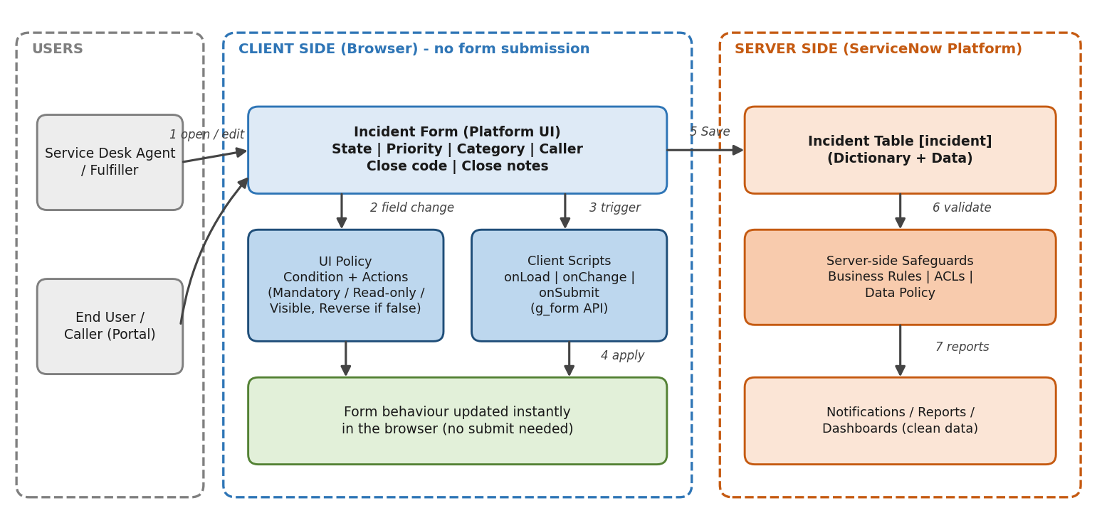
Figure 1: Architecture and data flow of UI Policies and Client Scripts on the ServiceNow Incident form
Architecture Components:
No. | Component | Role in the solution
1 | Incident Form (Platform UI) | Form where agents and callers create and update incidents. All field behaviour is applied here.
2 | UI Policy | Condition-based rule on the incident table. When the condition is true its actions make fields Mandatory, Read-only or Visible; "Reverse if false" restores them automatically.
3 | Client Scripts | onLoad, onChange and onSubmit scripts (g_form API) for logic a UI Policy cannot cover, such as field messages, alerts and auto-populating values.
4 | Incident Table [incident] | Stores the incident records and field definitions (dictionary).
5 | Server-side Safeguards | Business Rules, ACLs and Data Policy that validate data on save, so rules still hold for imports, integrations and APIs.
6 | Reports and Notifications | Consume the cleaner, complete data for dashboards, SLAs and email alerts.
Data Flow:
- The agent or caller opens a new or existing incident in the form.
- The user changes a field (for example State, Priority or Category).
- The UI Policy condition is evaluated and any matching Client Script runs in the browser.
- Fields instantly become mandatory, read-only or visible, with no form submission or page reload.
- The user completes the required fields and saves the record.
- Server-side Business Rules, ACLs and Data Policy validate the record on save.
- Complete, consistent incident data flows into reports, SLAs and notifications.
Team:
Team Leader: Ashwini V. Team Members: Gunasri E, Dhivyabharathi G, Asanciya V, Niveatha J (team size: 5).

