System Requirements Statement (SRS) –

EduConnect

Doc. Ref. :

Version : 0.4

Status : Drafted

Created by : Aishwarya Badgujar, Sayali Mane, Nikita Shinde, Ashwini Dhumal, Nilima Jarad.

Date : 18-06-2024

1. Introduction 3

2. Functional Requirements 4

2.1 Admin Module 5

2.2 Teacher Module 11

2.3 Parent Module 17

2.4 Use Case Diagram.............................................................................................................................22

THIS DOCUMENT CONTAINS 13 NUMBERED PAGES

# Introduction

This document explains the system requirements and scope for developing EduConnect System.

EduConnect System can be divided into three main parts,Admin part, Teacher part, Parent part .

This document describes the system requirement of the Account part.

# Functional Requirements

The Account part of Edu-Connect System has three modules which are divided 22 processes described as below.

|  |  |  |
| --- | --- | --- |
| **No** | **BRS requirement ID** | **Description** |
| **2.1** | **Admin Module** | |
| **2.1.1** | **F1** | **Login Process** |
| **2.1.2** | **F2** | **Add User** |
| **2.1.3** | **F3** | **Assign Parent** |
| **2.1.4** | **F4** | **Add Subject** |
| **2.1.5** | **F5** | **Assign Student** |
| **2.1.6** | **F6** | **Assign Teacher** |
| **2.1.7** | **F7** | **Update User** |
| **2.1.8** | **F8** | **Logout** |
| **2.2** | **Teacher Module** | |
| **2.2.1** | **F10** | **Login Process** |
| **2.2.2** | **F11** | **View Marks** |
| **2.2.3** | **F12** | **Add Marks** |
| **2.2.4** | **F13** | **Add Homework** |
| **2.2.5** | **F14** | **View students** |
| **2.2.6** | **F15** | **View Assigned Classes** |
| **2.2.7** | **F16** | **Logout** |
| **2.3 Parent Module** | | |
| **2.3.1** | **F17** | **Login Process** |
| **2.3.2** | **F18** | **View Child** |
| **2.3.3** | **F19** | **View Marks** |
| **2.3.4** | **F20** | **View Homework** |
| **2.3.5** | **F21** | **View Teachers** |
| **2.3.6** | **F22** | **Logout** |

#### 2.1 Admin Module

* Administratorshould be responsible for following activities**,**

### 2.1.1 Login Process

* EduConnect System always compels user authentication before using itself.
* The user authentication demands UserID and Password. The UserID and the Password should be checked in three ways.
  + First, The UserID and the Password should be existed and correct.
* If The UserID and the Password are not equal to what the admin has registered, the Admin authentication cannot be provided.
  + Second, the User Type linked to the UserID should be "Admin".
* When the User Type is "Admin", user can be placed on “Admin Home”.
* The Admin account should alive for so long as the duration decided by Admin.
* Only when the two checks are successfully completed, Admin can be placed on respected page.
* The “Admin Home” provides the some items described as below.

1. A trigger to Create parent account according to student

2. A trigger to Create teacher account

3. A trigger to Add Subject list

4. A trigger to Assign Students to Standards

5. A trigger to Assign Teacher to Standard and Subject

6. A trigger to Update User

### 2.1.1 Create Parent Account According to Student

* This menu is used to create an account for parent which include information about Student.

The Account creation process is described as below.

* + Admin will fill information about Students and parents on the basis of following points.

1. Student Name
2. Student Registration number
3. Standard
4. Division
5. Parent name
6. E-mail address
7. Contact details
8. Permanent address

* All items are compulsory demanded.
* Student Registration number should be unique.It should not be case sensitive and previously used.

### Teacher Account Creation Process

* This menu is used to create an account for Teacher which include information about Teacher.

The Account creation process is described as below.

* + Admin will fill information about Teachers on the basis of following points.

1. Teacher Name
2. Teacher Identity number
3. E-mail address
4. Contact details
5. Permanent address

* All items are compulsory demanded.
* Teacher Identity number should be unique.It should not be case sensitive and previously used.

### Add subject list

* Admin will create list of standards.

### Assign Students to Standard

* Assigning students to standard typically refers to placing them into groups or categories based on predefined criteria .
* These criteria will include academic records,age etc.

### 2.1.5 Assign Teacher to Standards and Subject

* Assigning teacher to standards typically involves matching educators with specific role for class teacher.
* Admin will assign teachers to specific subjects according to their qualification,subject expertise or any specialized training relevant to standards.

### 2.1.6 Update user List

* Admin will Update user list .

## 2.3 Teacher Module

### 2.3.1 Login Process

### Entering Credentials: On the login page, teachers are required to enter their credentials. This typically includes:

* **Username**: The unique identifier assigned to the teacher by the system admin.
* **Password**: A secure password that the teacher has been assigned.

**2.3.2 View** Marks

* Teacher can view the marks of students.

### 2.3.3 View Assigned classes

* On the teacher dashboard, there will be classes section too view a list of classes teacher are assigned to teach.
* This view will include subject name along with schedule time, class name,etc.

### 2.3.4 Add homework

* Uploading homework assignments in a Teacher Module involves a straightforward process designed to upload homework task.
* Here teacher will provide description of assignments with some instructions and due time for when homework is expected.

### 2.3.5 Add marks

* Upload marks in the teacher module is the process where teacher will manage and upload student marks.
* Within the Marks section, teacher can find the specific subject, assignment or project for which he/she want to upload marks.
* Once marks are uploaded, parents can typically view them within the Marks section.
* **Instructions**: Provide clear instructions for students on what they need to accomplish or submit.
* **Due Date and Time**: Set a due date and possibly a due time for when the activity is expected to be completed.

**2.3.6 View Students**

* Viewing performance in the Teacher Module allows teachers to monitor and analyze students' academic progress and achievements.
* **Understanding Student Performance:  
  Assessment:** Evaluate student work using predefined criteria such as learning standards.

**Data Analysis:** Analyze assessment results to identify strengths, weaknesses, and areas for improvement.

**Monitoring Progress**: Monitor student progress over time to assess the effectiveness of feedback.

## 2.3 Parent Module

* Parent module will provide following features:

### 2.3.1 Login Process

* Parent is the user of system who requires login process for accessing the system.
* Admin will create account of parent and login credentials also will be provided by admin, so that using that credentials parent can access system.
* Login will include following fields
* User ID
* Password
* User ID and password will be provided by Admin after creation of account.
* During login credentials filled by parent should match already allocated login credentials, otherwise parent access will be denied.

**2.3.2 View Child**

* Parent can view child in given list.

**2.3.3 View Marks**

• After uploading the performance by the teacher, parent can view following contents.

* Marks
* Progress of projects
* Performance in other academics

**2.3.4 View Homework**

• The parent sees a list of all assigned homework, organized by date or subject.

**2.3.5 View Teachers**

• Parent can view the Teacher assigned to subject and class of child.

#### 2.4 Use Case Diagram

**Admin:**

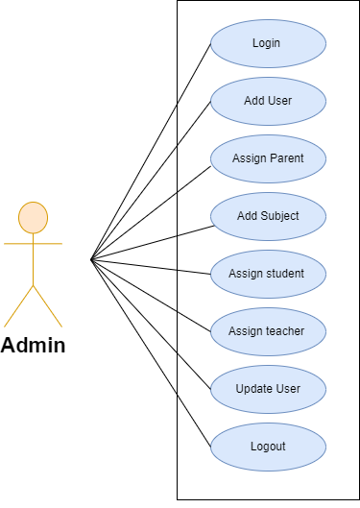

*Fig. Use case diagram for admin*

1. In Admin use case diagram, Admin is the Actor.
2. Admin can handle following use cases:
3. Login
4. Add User
5. Assign Parent
6. Add Subject
7. Assign Student
8. Assign Teacher
9. Update User
10. Logout

**Teacher:**

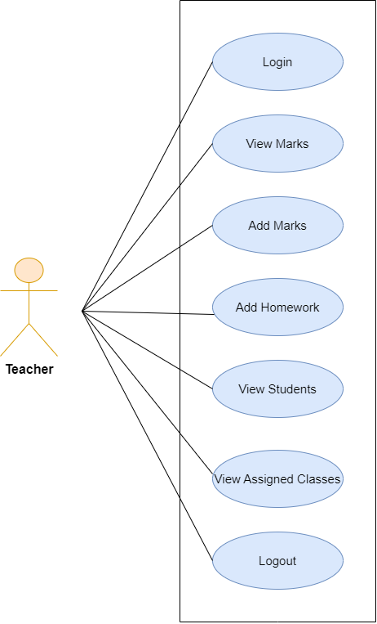

*Fig. Use case diagram for teacher*

1. In Teacher use case diagram, Teacher is the Actor.
2. Teacher can handle following use cases:
3. Login
4. View Marks
5. Add Marks
6. Add Homework
7. View Students
8. View Assigned Classes
9. Logout

**Parent:**

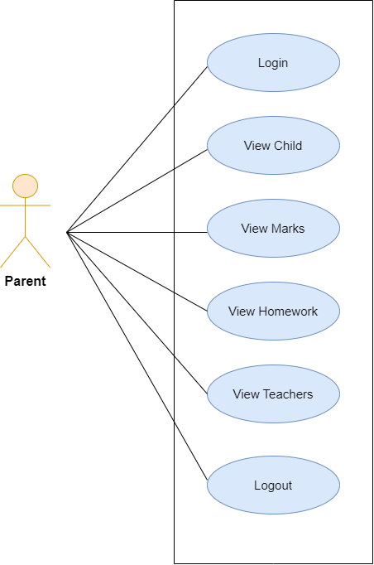

*Fig. Use case diagram for parent*

1. In Parent use case diagram Parent is the Actor.
2. Parent can handle following use cases:
3. Login process
4. View Child
5. View Marks
6. View Homework
7. View Teachers