16th INTERNATIONAL CONFERENCE ON RECENT ENGINEERING AND TECHNOLOGY 2025

16 ICRET- HYBRID CONFERENCE

EAST WEST COLLEGE OF ENGINEERING, Bangalore, India
In Collaborated with

SAMARKAND STATE UNIVERSITY, UZBEKISTAN
17th and 18th May 2025
CONFERENCE ATTENDANCE:

Choose one option from the below-

Option 1: PPT sharing (Inabsentia) –
Please share your presentation PPT to icretconf@gmail.com

(Conference certificates will be provided and publication also done based on author willingness)

Option 2: ONLINE/VIRTUAL presentation –

(Conference certificates will be provided and publication also done based on author willingness)
Registration done on or before 17 May 2025 (11.59am), Registration done after that will be considered in option 1

DECLARATION & Copyright transfer form for ICRET 2025 TO BE SIGNED BY AUTHORS I/We, the undersigned author(s) of the manuscript entitled,
Real time sign language to text conversion with emergency assistance

Hereby declare that (a) the above manuscript which is submitted for publication in the ICRET 2025 is not under consideration elsewhere. (b) The manuscript is not published already in part or whole (except in the form of abstract) in any journal or magazine for private or public circulation. The work described in the manuscript is my/our own and my/our Individual contribution to this work is significant enough to qualify authorship. (c) No one who has contributed significantly to the work has been denied authorship and those who helped have been duly acknowledged. (d) Free journal category for publication will be considered only if the article meets the journal requirement and with good quality. There is no assurance for publication in any journal unless the quality of the article meets requirement of the journal and editors has all right to reject the paper (e) Indexing of articles will be sole responsible of respective author/s once published. (f) Journal payment received are inclusive of service charge, tax, any refund once paid will be refunded with service charges and tax deduction.
(g) Paper can be rejected if it doesn’t meet the journal standard or not in scope. Article should be grammar error free and plagiarism should be less, do not use any AI generated content like chatgpt or quilibot. (h) Paper publication once processed in journal cannot be withdrawn, any withdrawn with the processed paper will attract 80%-100% of the journal fee based on the journal/s. (i) All journal/reviewer corrections are expected to be received within the timeline mentioned. Failure to follow will lead to paper rejection. (j) I/we also agree to the authorship of the article in the following sequence:

Authors Name 1. Dr.Keerthi Kumar H M
Mail id and mobile number hmk@mcehassan.ac.in 9886664922

Authors Name 2. Ankitha K N
Mail id and mobile number knankitha73@gmail.com 8217831584

Authors Name 3. Ashwini D M
Mail id and mobile number dmashwini40@gmail.com 6361636073

Authors Name 4. Preksha H S
Mail id and mobile number prekshahs03@gmail.com 9148031801

Authors Name 5. Vikas B
Mail id and mobile number vikasb.kadlaji.24@gmail.com 9110628010

NOTE: 1. Authors is required to sign this form. Signature (s)

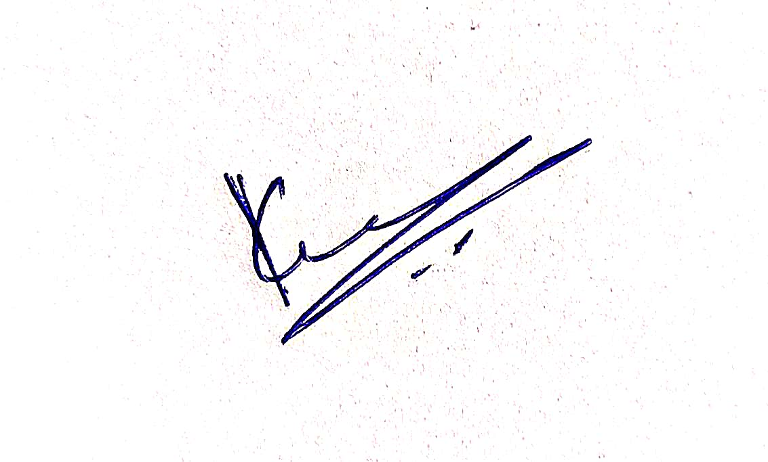

2. No addition, deletion or change in the sequence of authors is allowed at the later stage without valid reasons.

