PART A

1.echo command prints the message

2.In this variable name is assigning the value productive

3.By touch command an empty file is made

4.By ls -a it will list all the files including hidden

5.By this command file.txt will be removed

6.By this it is giving the permissions to file script.sh to write read and execute

7.By grep command pattern word is find in file.txt

8.By kill command the process is killed by giving public id

9.By this command mkdir mydir && cd mydir && touch file.txt && echo "Hello, World!" > file.txt && cat file.txt firstly a directory named mydir will be made and change dir to mydir after that make an empty file in mydir then print hello world take that input for file.txt and print it on the console

10.By this it will list all files and it will find all the .txt files

11. cat file1.txt file2.txt | sort | uniq By this command firstly file1 and fle2 data will be sorted and uniq command will remove the duplicates of the data

12. ls -l | grep "^d" by this command it says list all the files which is starting from d

13. grep -r "pattern" /path/to/directory/ In this command grep is used recursively to find pattern into the given path

14. cat file1.txt file2.txt | sort | uniq –d By this command it will sort the data of both the files and uniq will remove all the duplicates but -d will only show the lines which was repeated data

15.chmod 644 file.txt This will give perimissions like _rw_r__r__ to file.txt

16. cp -r source_directory destination_directory In this source directory will be copied to destination directory

17. find /path/to/search -name "*.txt" this will find the name given into the given path in files which ends with .txt

18. chmod u+x file.txt this will give executing permission to user

19. echo $path will print the value of path

PART B

IDENTIFYING TRUE AND FALSE

1. TRUE
2. TRUE
3. FALSE
4. PWD – PRINT WORKING DIRECTORY AND YES DISPLAYS PRESENT DIRECTORY
5. FALSE
6. TRUE
7. TRUE
8. TRUE

Identify the Incorrect Commands

1. Chmod is used to change file permissions
2. cp is used to copy files and directories
3. cat is used to concatenate files
4. rm is used to rename files

PART C

1)

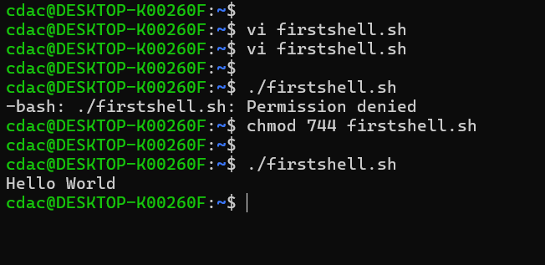

2)

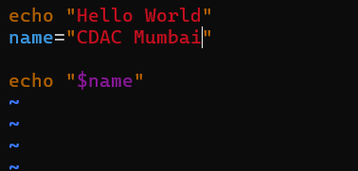

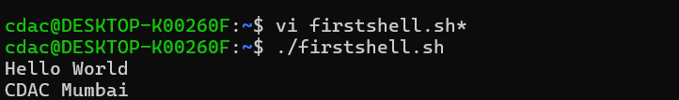

3)

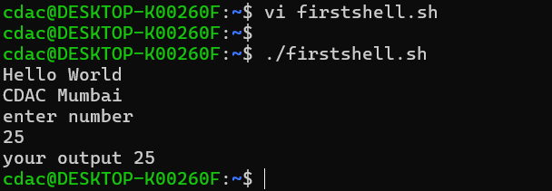

4)

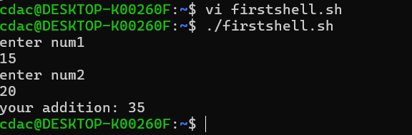

5)

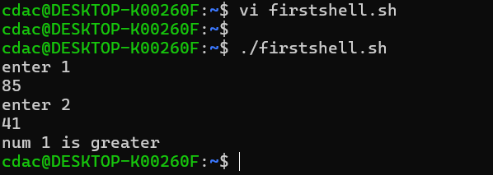

6)

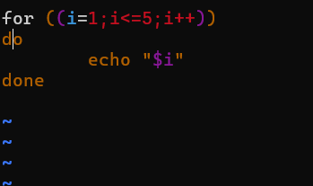

7)

8)

9)

10)

11)

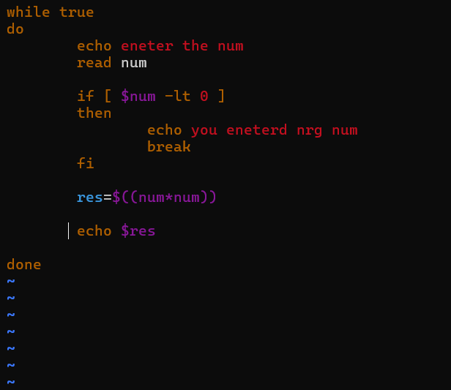

PART E

1)3.33

2)4.75

3)

4)6

5) #include <stdio.h>

int main() {

int x=5;

fork();

x=x+1;

printf("%d\n",x);

return 0;

}