A)

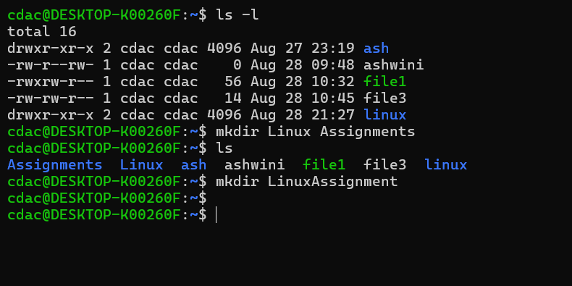

b)

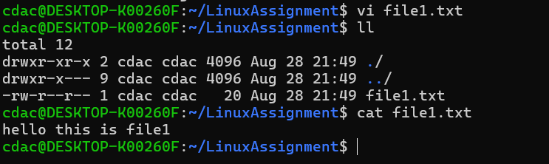

C)

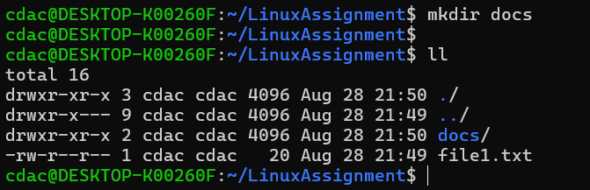

D)

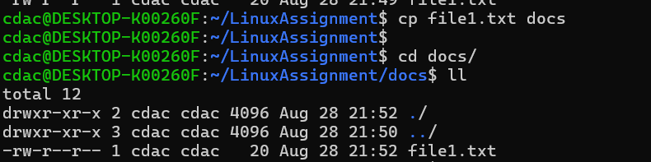

E)

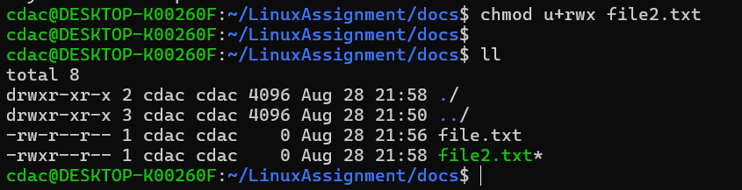

f)

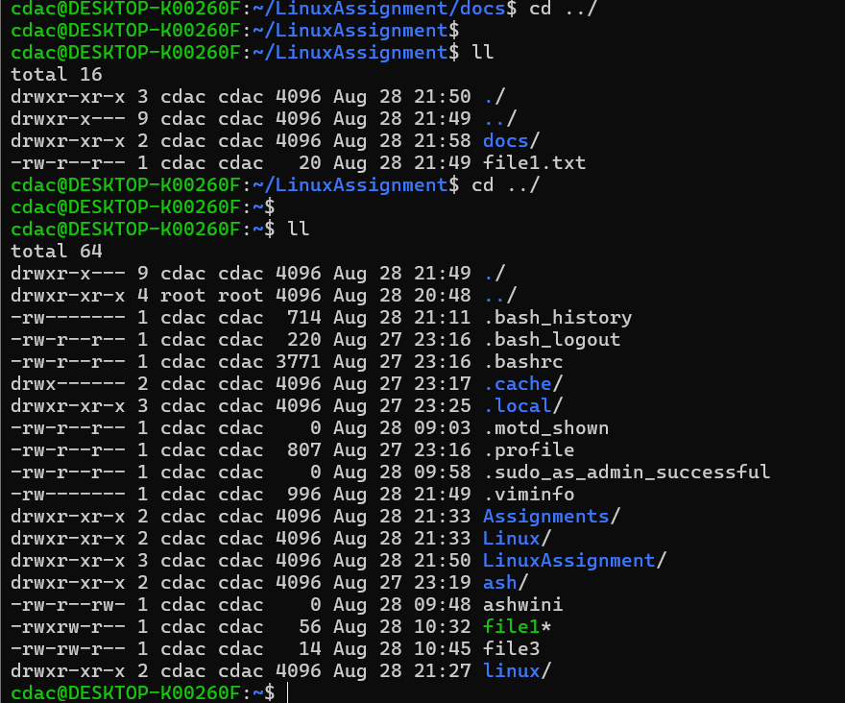

g)a

b)



h)

i)a

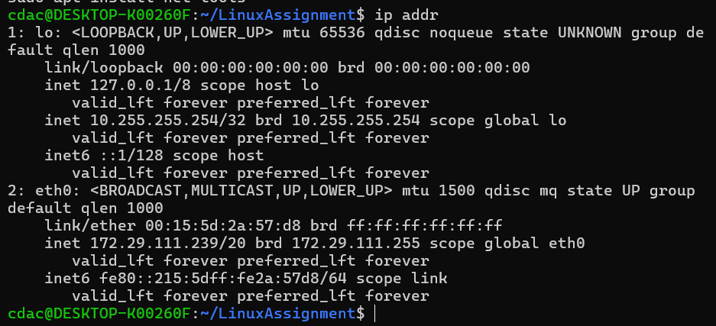

j)a)

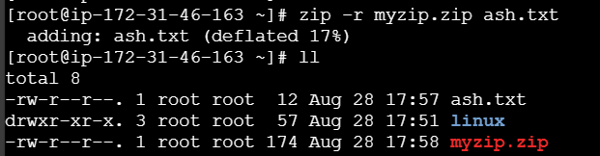

b)



K)

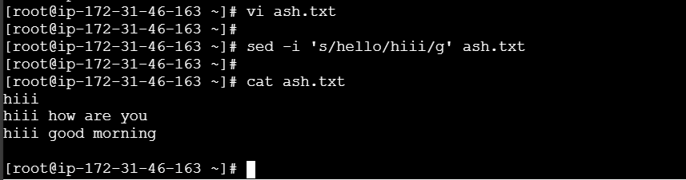

PROBLEM 2

A)

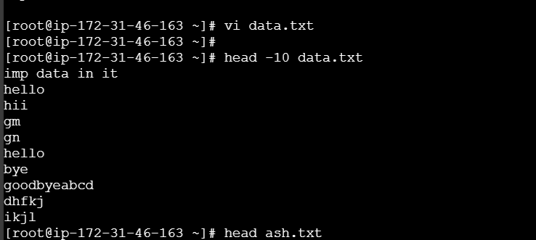

b)



C)

d)

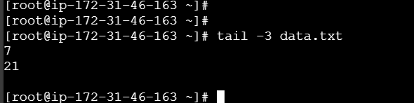

f)

g)

