1. Json parser details :  
     
   Artifacts used :  
   Wrapper_json_parser.sh  
   jsonParserMapper.py  
   inter_output  
   sample.json  
     
   command to trigger the parser:  
   sh -x Wrapper_json_parser.sh *<queue_name>* <json_file_name> *<intermediate _output_location>* *<python_file_name>*

**Note: all locations must be full absolute paths**

I need to parse tst.JSON into test.CSV format (flat file) with required columns listed in expected_output.xlsx file

Below are the main nodes

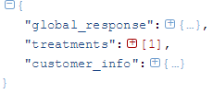

Under Treatments there can be more multiplecomponent_treatments nodes

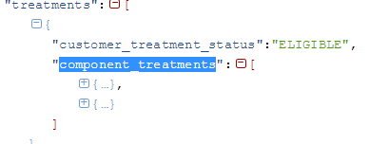

Under treatment_metadata node there can be multiple card_objects  
holding information about cards  
each card has different properties specific to it  
along with that there are two nodes   
1.additional_parameters  
2.talking points => can have multiple properties (rows)  
properties present under these two nodes are applicable to each card

For eg.

Card_objects=> ABC

XYZ

triggers_and_true_needs=>   
 1  
 2  
then output row :

ABC,1   
ABC,2  
XYZ,1  
XYZ,2  
  
customer_info node is common to all cards  
it should be appended to each and every row  
column order is given in the Expected_Output.xlsx document