Managing access control and authorization

**project-based security**

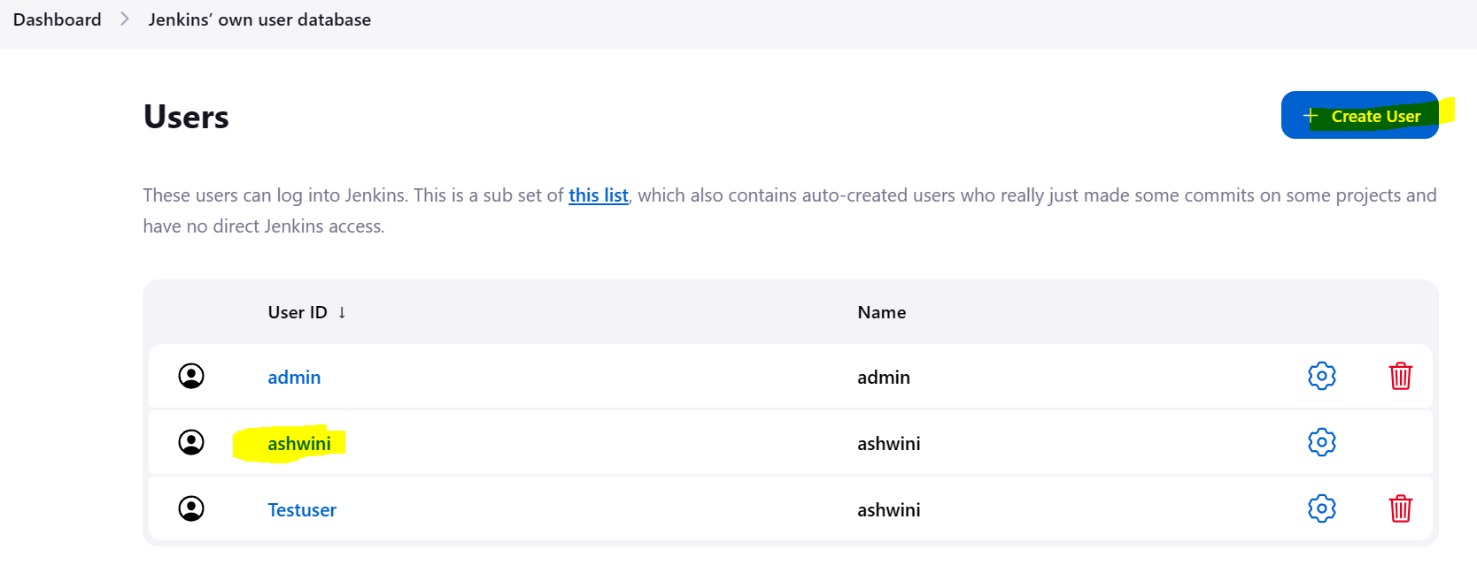

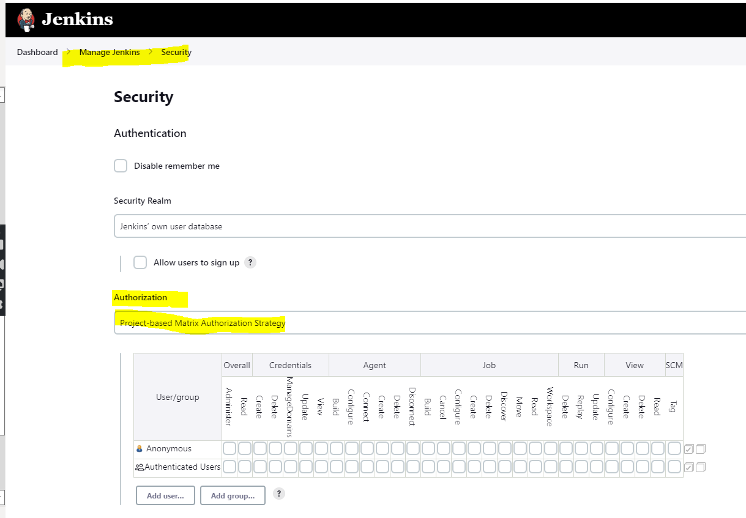

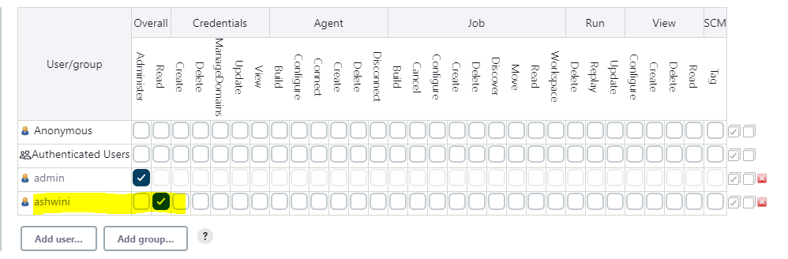

**Role-Based Strategy**

-for this we need to download a plugin to appear this option in Authorization

Plugin- Role -based Authorizatin Strategy.

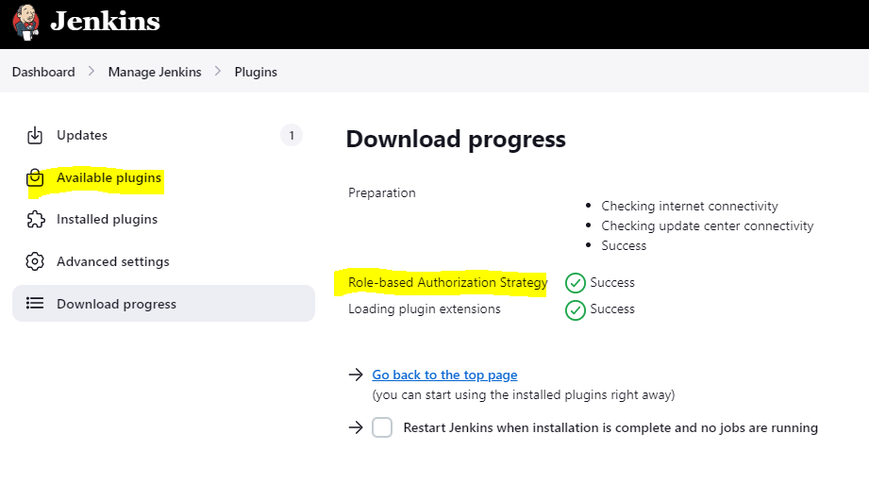

Once the plugin is installed we will see below options.

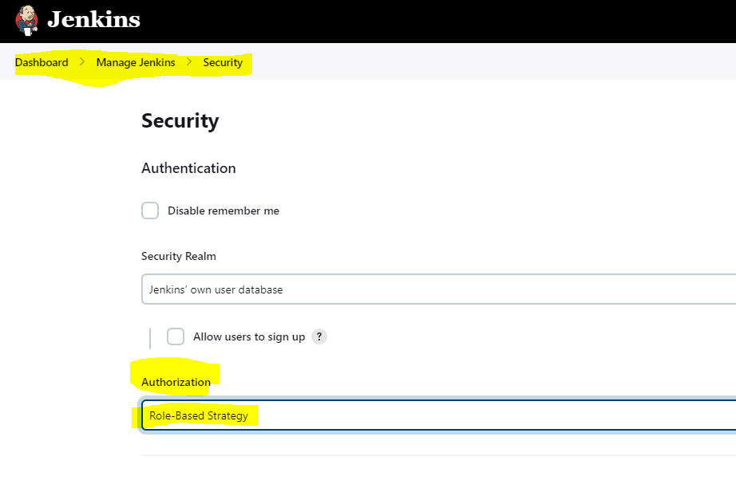

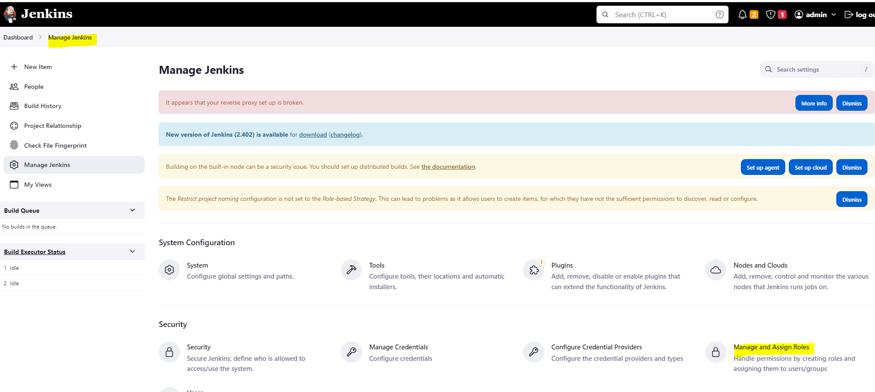

-Under manage and Assign roles create a role (This is nothing to do with IAM role)

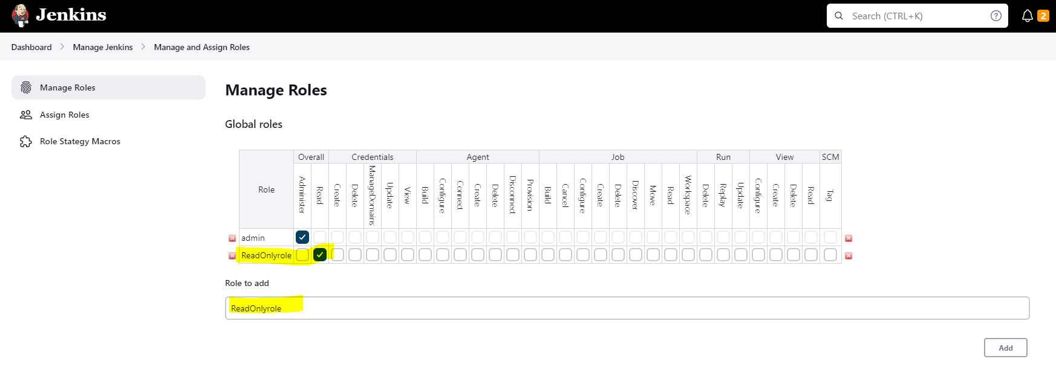

-now assign this role to specific user.

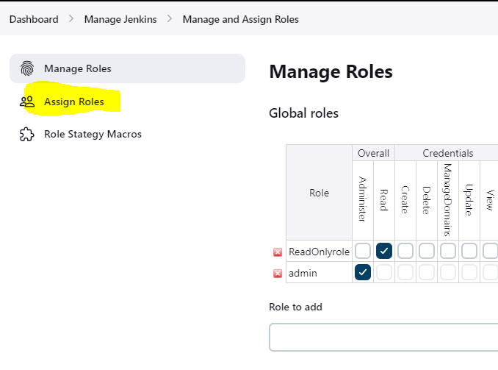

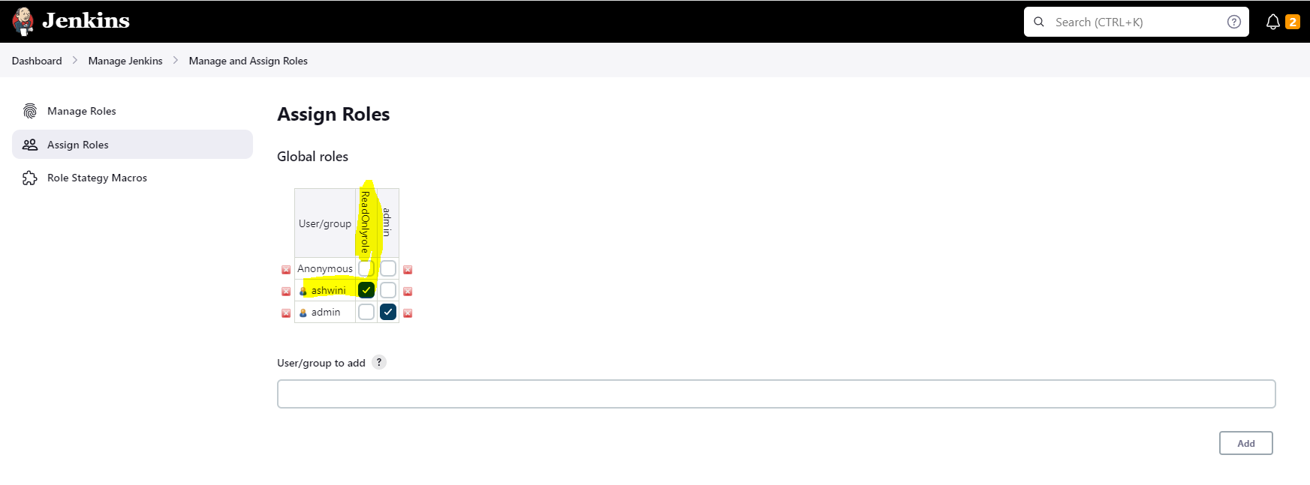

This is the way we can handle the access in Jenkins for different user.