Jenkins Github Webhook-

-There are standard type of ways that can used to trigger pipeline.

1)**Event based Trigger(Push based mechanism)**

CloudWatch event in AWS codepipeline

Github Webhook for Jenkins pipeline.

2**)Poll SCM trigger**

-In case of poll SCM trigger we need to give cron schedule like every 2 hr fo codepipeline .

-In AWS codepipline knows which code to look at meaning which Repo and branch , pipeline will go every 2 hrs and check in branch if there is any new commit from last commit from which the build was successful.

If new commit is present it will trigger the build.

-In case of Jenkins as well we need to mention every 2 hrs look at the repo and branch and then trigger the same.

[Webhook events and payloads - GitHub Docs](https://docs.github.com/en/webhooks-and-events/webhooks/webhook-events-and-payloads#push)

-In AWS codepipeline we had seen that we will have clouldwatch event which is looks for commit on specified branch and based on it event it will call specific codePipeline.

-In Jenkins we do not have above setup.

-Code is in Github and requirement is any change in the branch should Jenkins specific job(Jenkins Pipeline).

-In Jenkins we have Github webhook events.

Logically when in github in specific repo-branch any changes happens github server generates and sents an event to an Jenkins server.

-jenkins server will use that event to run specific job automatically.

-Integrate jenkins with github so automatically CICD works when any commit is made to the repo.

-In Jenkins under below tab we need to add GitHub server which will accept the request meaning Jenkins will know which API to listen for event.

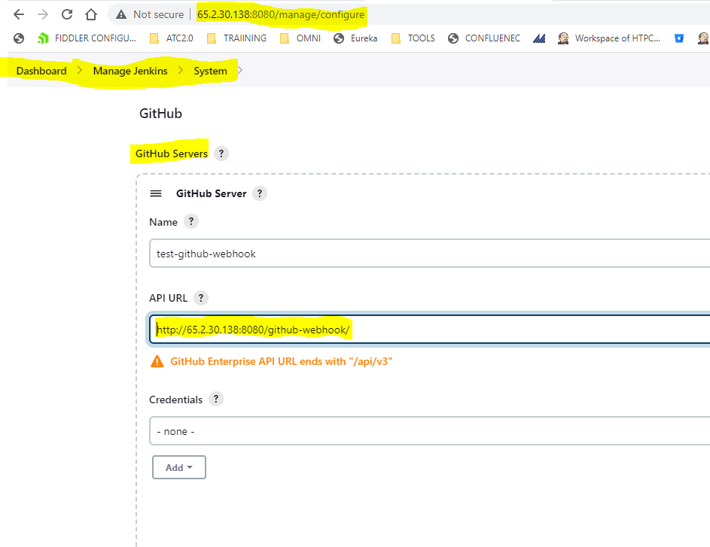

-In github also we need to do the configuration which help github to know which Jenkins server it wants to send the event to trigger the pipeline.

-Select the webhook option and add the Jenkins url-here the IP is EC2 public IP where Jenkins is installed

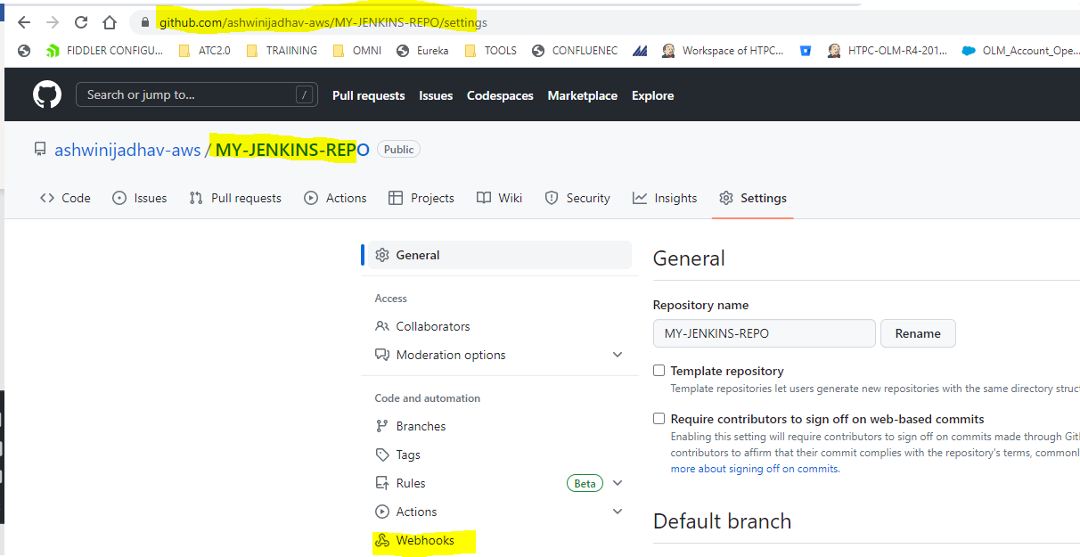

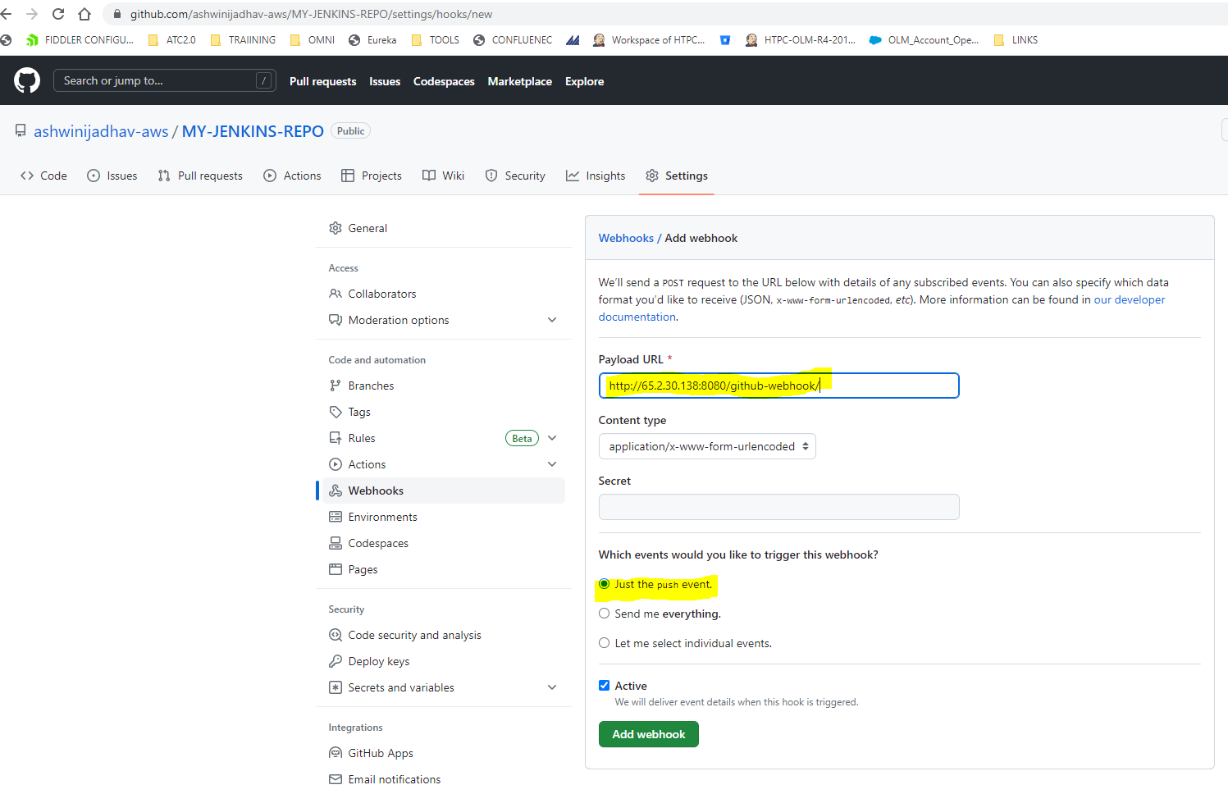

This means Github will push the event on this URL and Jenkins knows which URL it has to listen the event data.

-Now which job it should trigger on this event is the setting at job level where under build trigger configuration under configure tab of job we need to select below option.

-In this case we have configured this in our pipeline Job.

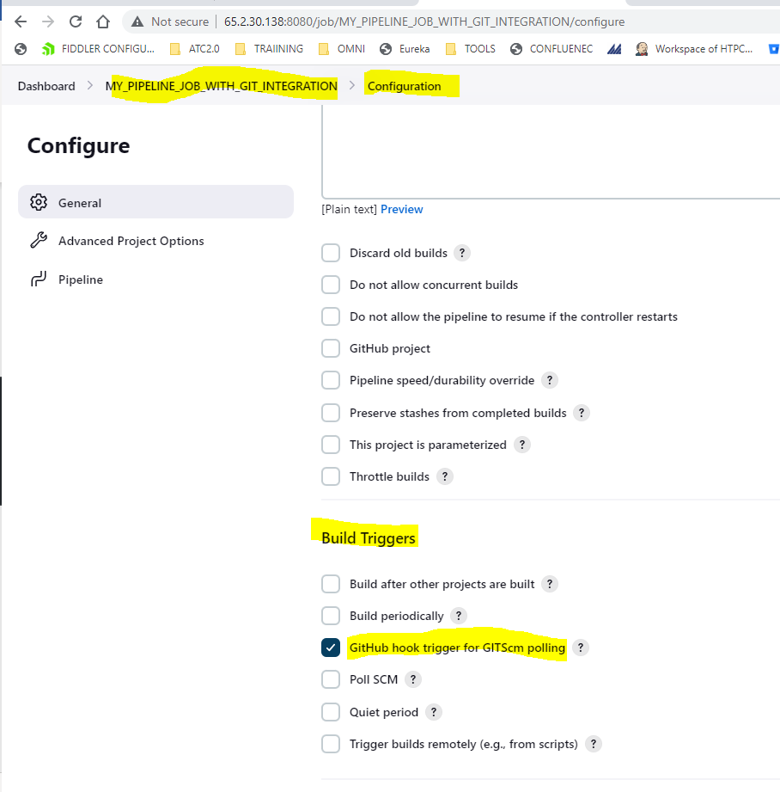

If all the configuration is correct in Github and Jenkins we will see below ping successful fromGithub to Jenkins in Github Webhook UI .

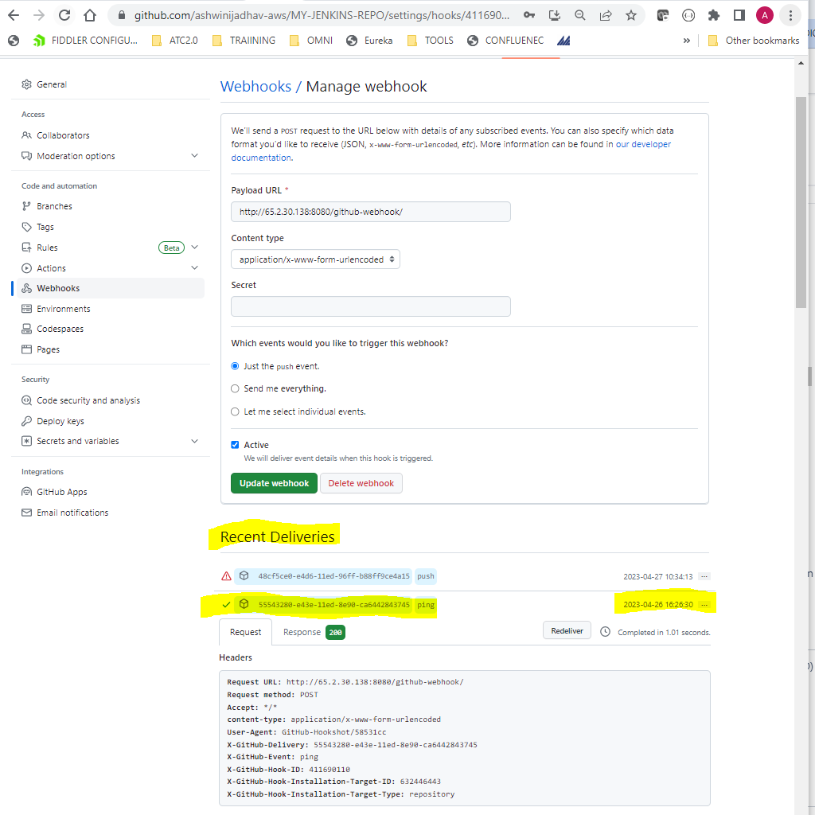

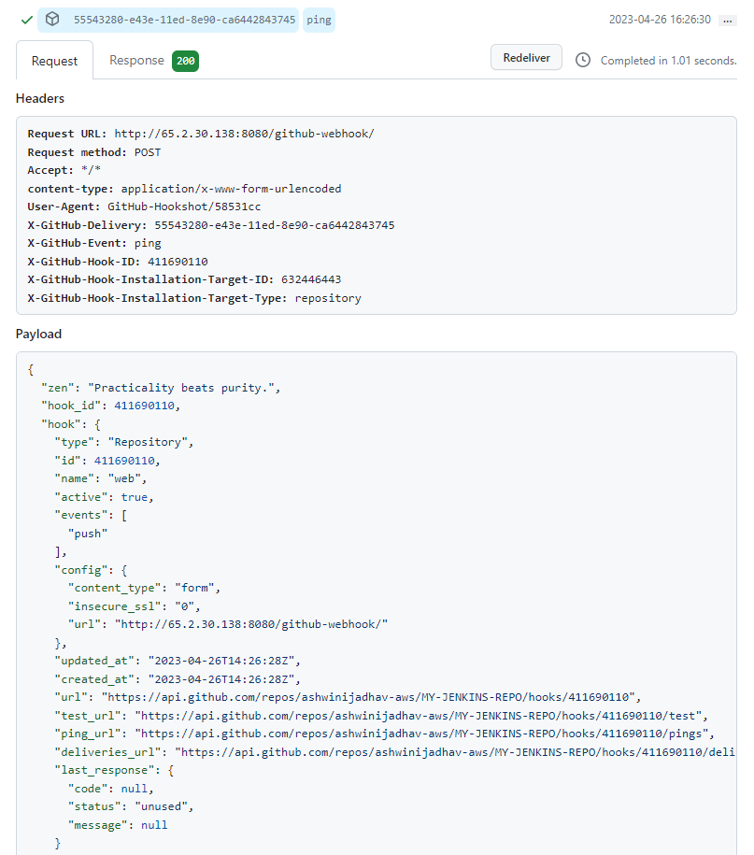

Now to actually test if it working fine or not we can do commit in the configured repo and as we can see in below screenshot we have recent deliver of type push but is failed to connect to Jenkins which is hosted on our EC2 instance.

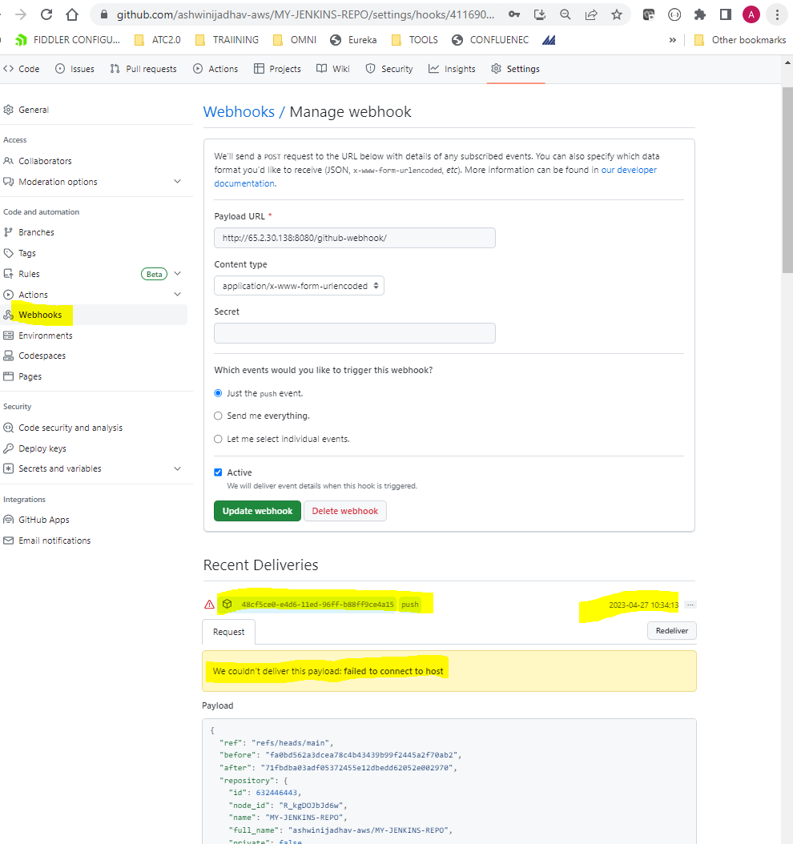

-What we need to validate is why github is not able to reach the Jenkins server on EC2

-Check for security group .

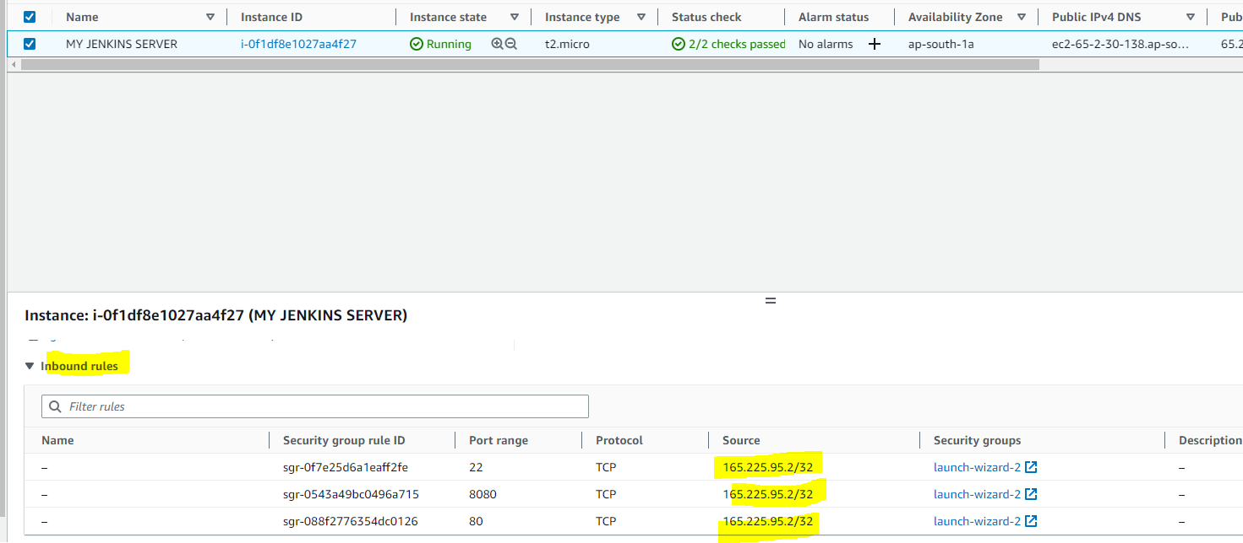

-For Webhook to work, open port 8080 in security group for IP address of Github.

How to get the IP address of Github to add it to the ingress rule is something we need to understand

<https://medium.com/cloud-security/creating-an-aws-security-group-rule-to-access-github-with-a-customer-managed-prefix-list-a0c5a38aa4a7>

<https://api.github.com/meta>

* As of now for port 8080 I am going to open the ingress for all the IP’s but we need to check this .

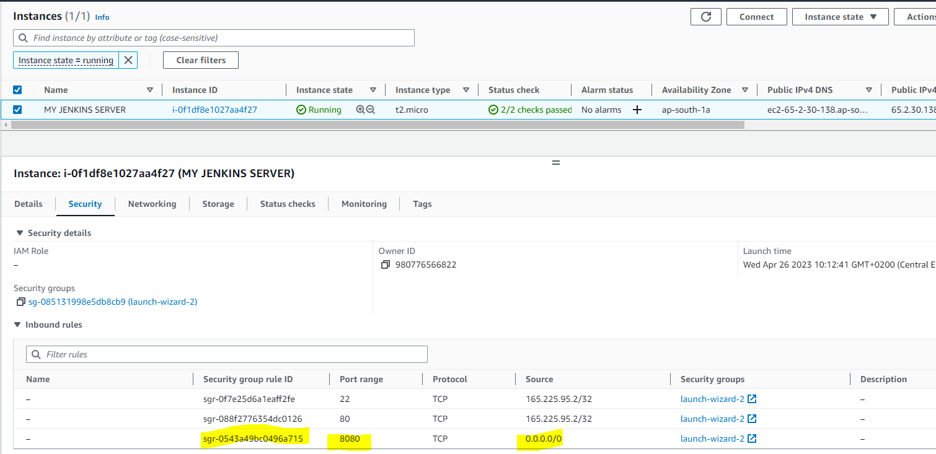

-As we can see we clicked redeliver the same event and it successfully able to reach EC2 instance intern Jenkins job got triggered.

