**ScienceQTech Employee Performance Analysis**

*#1. Create a database named employee, then import data_science_team.csv proj_table.csv and emp_record_table.csv into the employee database from the given resources.*

1. *data_science_team*

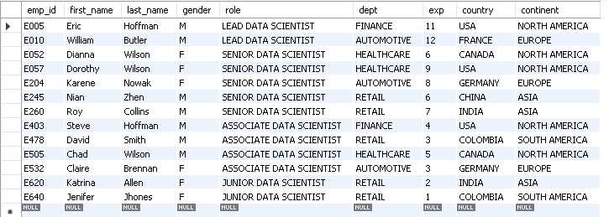

1. proj_table

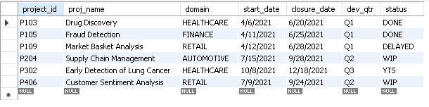

1. emp_record_table;

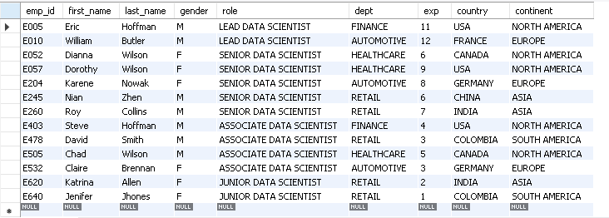

*#2. Create an ER diagram for the given employee database.*

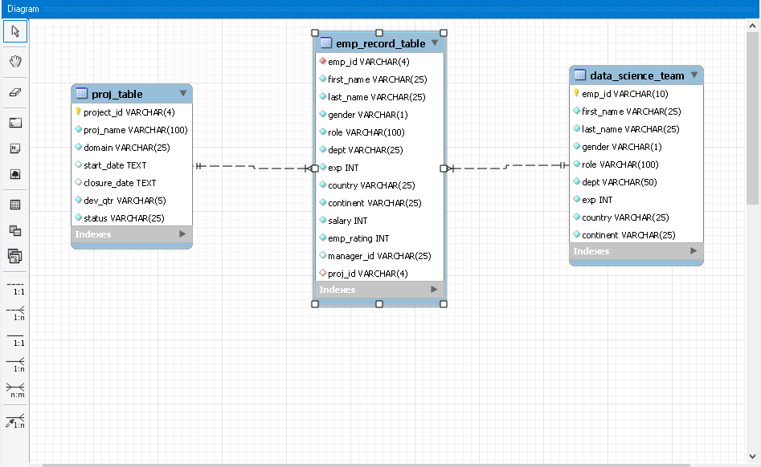

*#3. Write a query to fetch EMP_ID, FIRST_NAME, LAST_NAME, GENDER, and DEPARTMENT from the employee record table, and make a list of employees and details of their department.*

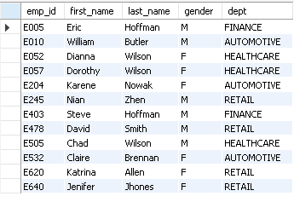

*#4. Write a query to fetch EMP_ID, FIRST_NAME, LAST_NAME, GENDER, DEPARTMENT, and EMP_RATING if the EMP_RATING is:*

*#i. less than two*

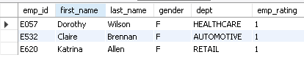

*#ii. greater than four*

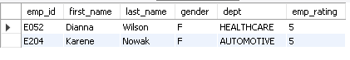

*#iii. between two and four*

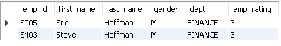

*#5. Write a query to concatenate the FIRST_NAME and the LAST_NAME of employees in the Finance department from the employee table and then give the resultant column alias as NAME.*

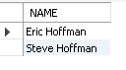

*#6. Write a query to list only those employees who have someone reporting to them. Also, show the number of reporters (including the President).*

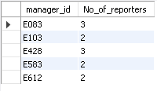

*#7. Write a query to list down all the employees from the healthcare and finance departments using union. Take data from the employee record table.*

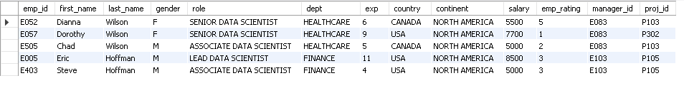

*#8. Write a query to list down employee details such as EMP_ID, FIRST_NAME, LAST_NAME, ROLE, DEPARTMENT, and EMP_RATING grouped by dept. Also include the respective employee rating along with the max emp rating for the department.*

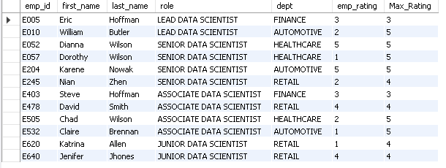

*#9. Write a query to calculate the minimum and the maximum salary of the employees in each role. Take data from the employee record table.*

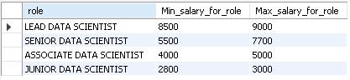

*#10. Write a query to assign ranks to each employee based on their experience. Take data from the employee record table.*

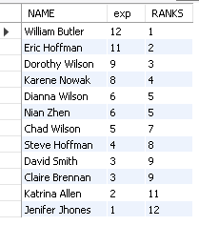

*11. Write a query to create a view that displays employees in various countries whose salary is more than six thousand. Take data from the employee record table.*

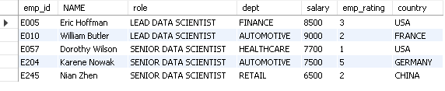

*#12. Write a nested query to find employees with experience of more than ten years. Take data from the employee record table.*

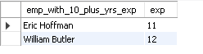

*#13. Write a query to create a stored procedure to retrieve the details of the employees whose experience is more than three years. Take data from the employee record table.*

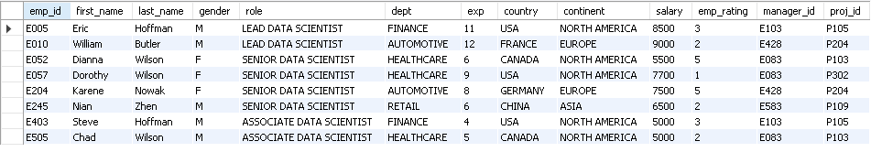

*#14. Write a query using stored functions in the project table to check whether the job profile assigned to each employee in the data science team matches the organization’s set standard.*

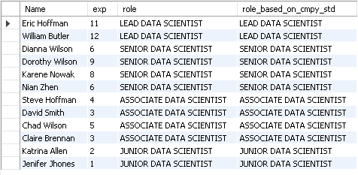

*#15. Create an index to improve the cost and performance of the query to find the employee whose FIRST_NAME is ‘Eric’ in the employee table after checking the execution plan*.

CREATE INDEX firstName ON emp_record_table(first_name);

*#16. Write a query to calculate the bonus for all the employees, based on their ratings and salaries (Use the formula: 5% of salary * employee rating).*

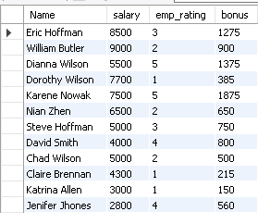

*#17. Write a query to calculate the average salary distribution based on the continent and country. Take data from the employee record table.*

