1. Home page

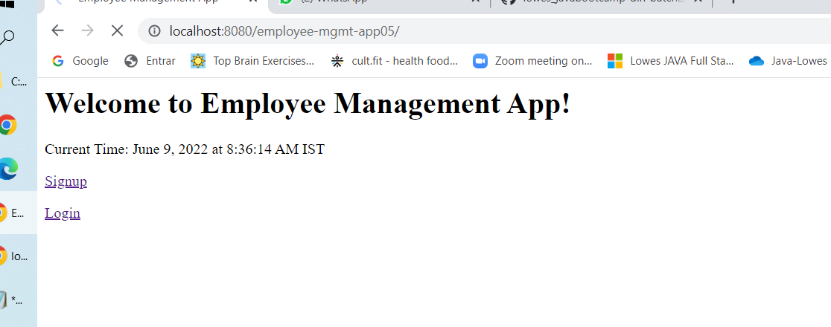2.Signup

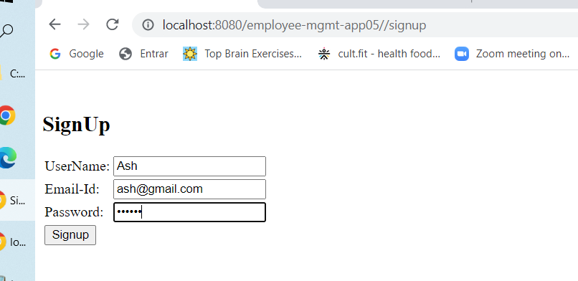

3.signup successful page

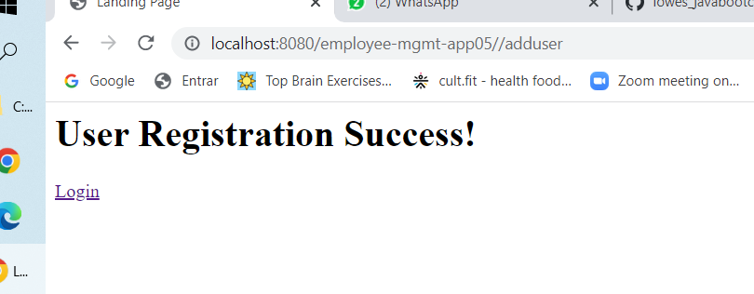4.Login with new user registered

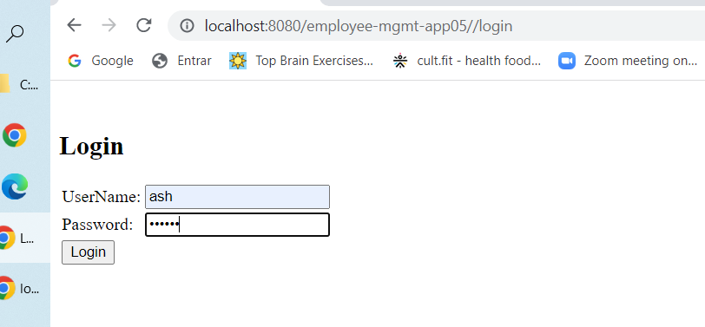

5. Employee details displayed after login –

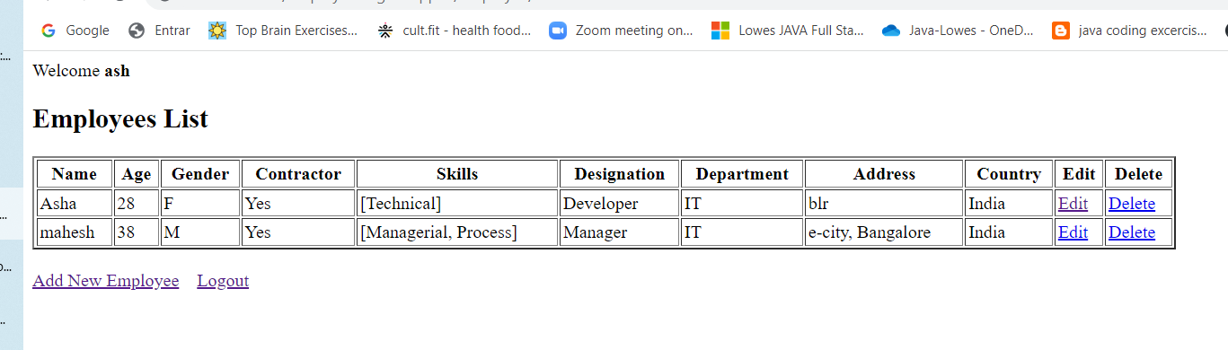

6. Add new employee page

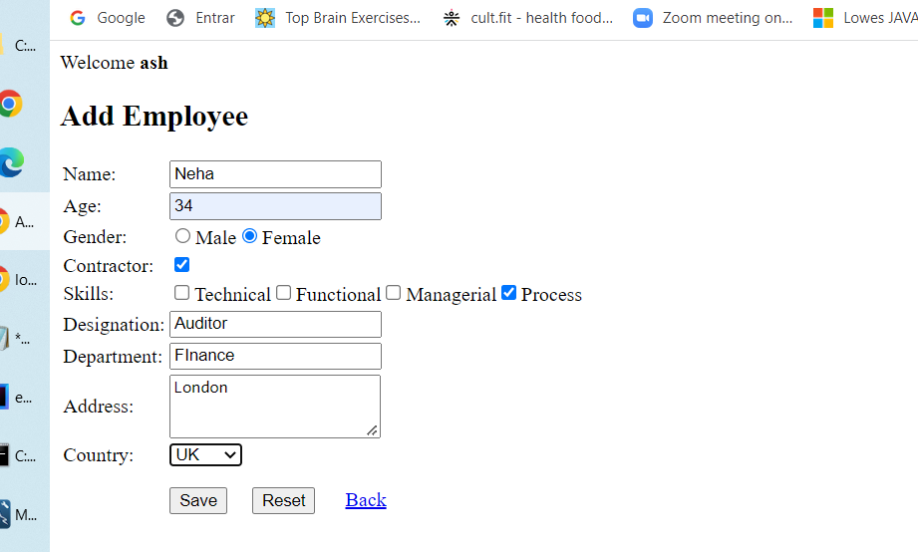

7. New employee added successfully and shown in the list –

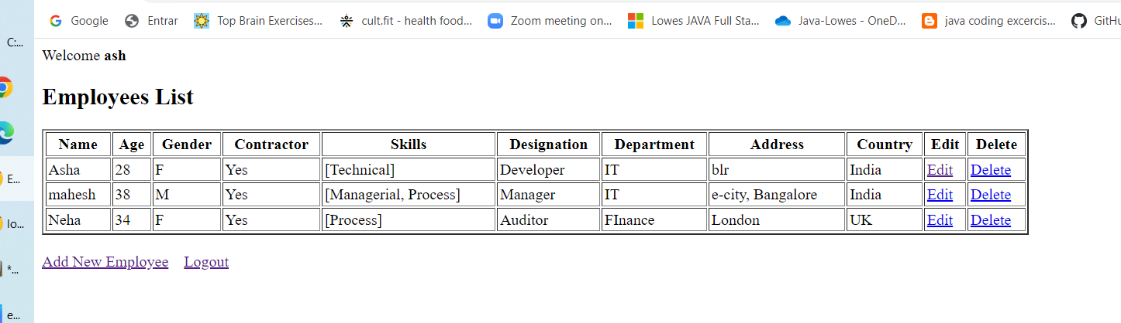

8. Update employee – Employee Asha edited

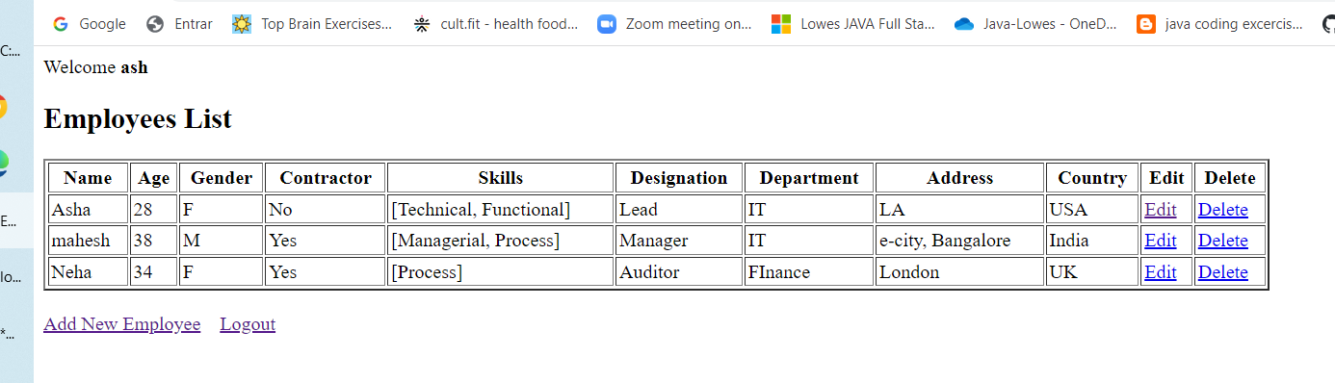

9. Delete Employee – employee Asha deleted

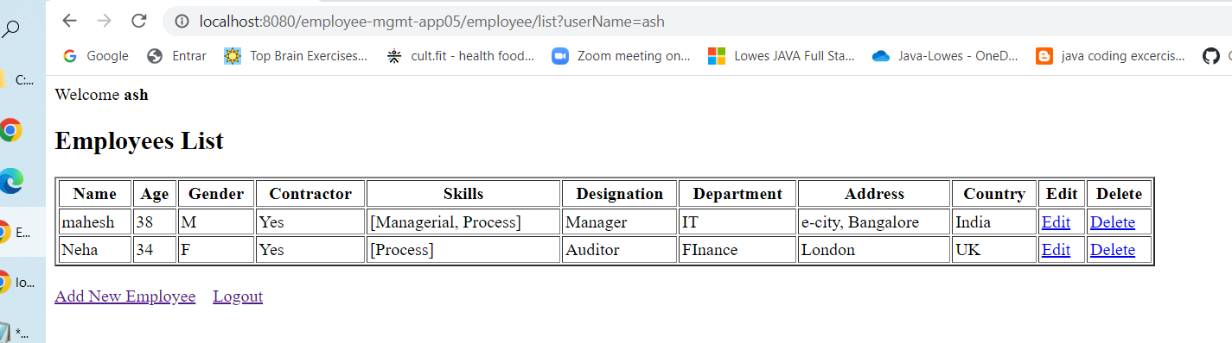

10. logout – shows home page after logout

