Show list of employees

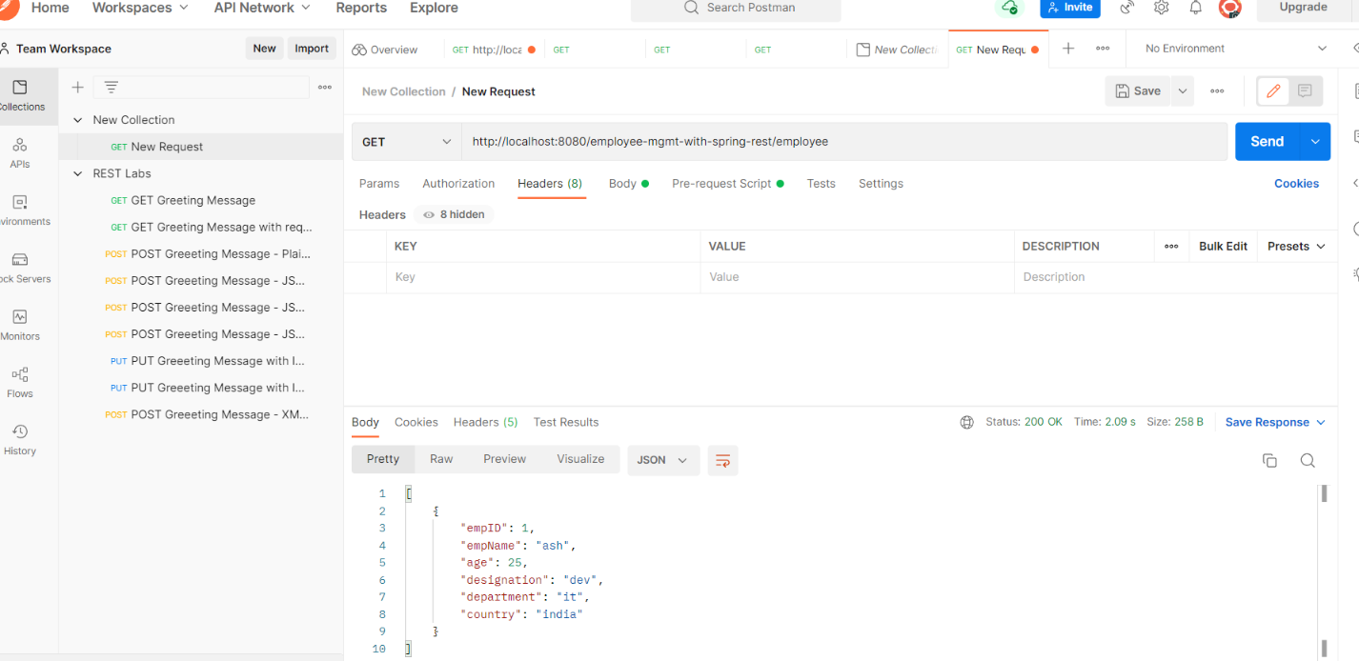GET - http://localhost:8080/employee-mgmt-with-spring-rest/employee

Add New employee

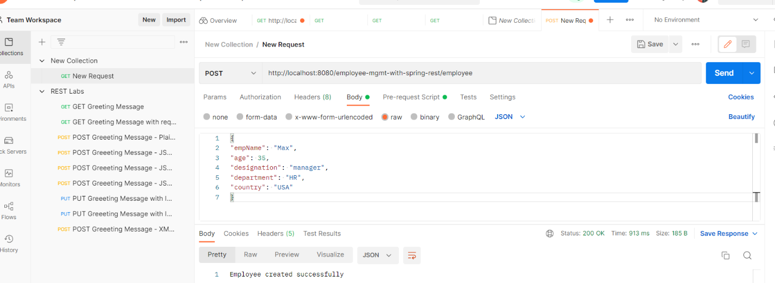POST - GET - http://localhost:8080/employee-mgmt-with-spring-rest/employee

Update Employee id - 6

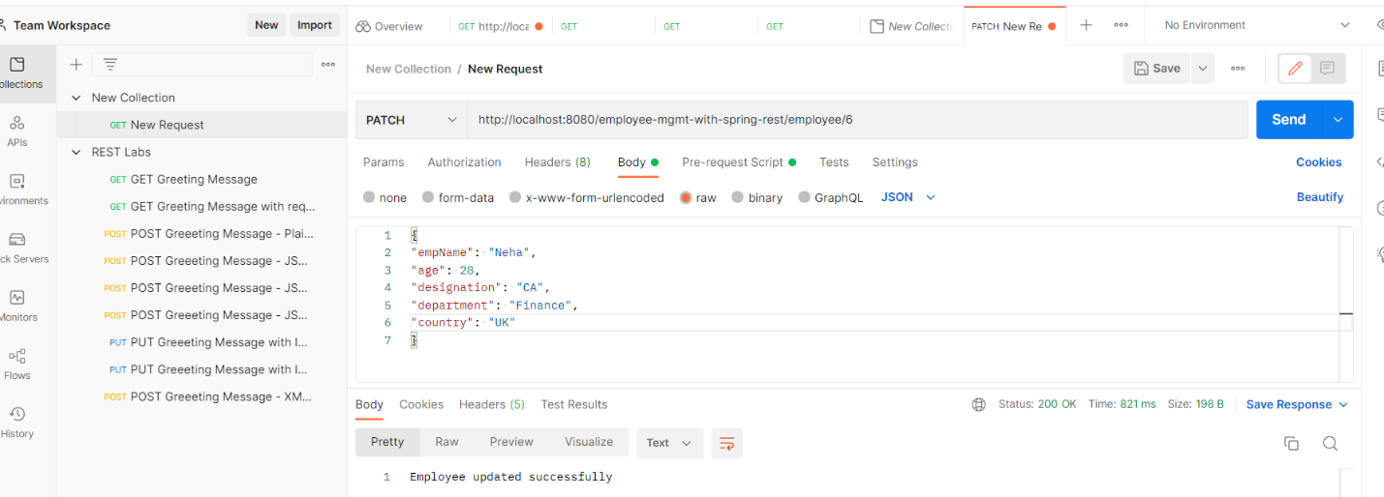PATCH - <http://localhost:8080/employee-mgmt-with-spring-rest/employee/6>

Delete employee id 5

PUT - <http://localhost:8080/employee-mgmt-with-spring-rest/employee/5>

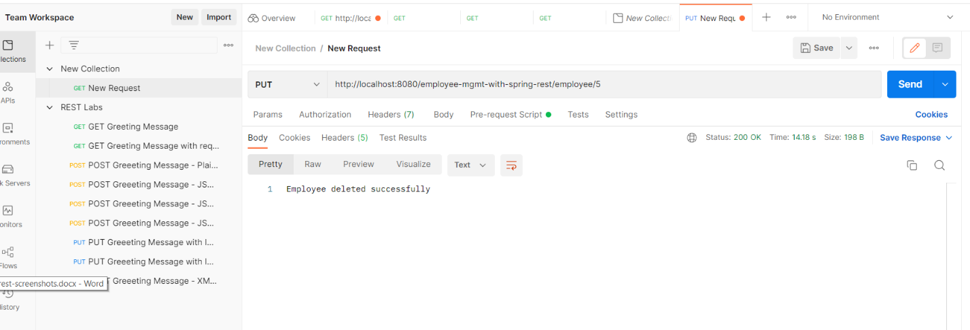

Get Employee by Id –

GET - http://localhost:8080/employee-mgmt-with-spring-rest/employee/9

