# Project Design Document

All In One Information Station

|  |  |
| --- | --- |
| Created By | Ashwini, Vinita |
| Created Date | October 23, 2016 |
| Version | 1.0 |
| Approved By | NA |
| Approved Date | NA |

* **Introduction**

The purpose of this software design document is to provide a low-level description of the All In One Information Station system, providing insight into the structure and design of each component.

Topics covered include the following:

1. Major Modules
2. Design Architecture
3. Class Diagram
4. Sequence Diagram
5. Use Case Diagram

* **Goal :**

All in One information station is a one stop solution for everyone to view the discussions includes buying or selling advertisements, queries, or any informative material which will help other fellow students. This is a platform for meeting other students/end users regarding their advertisements, or any discussion which is going on this application forum. In case of buy and sells advertisements, once the information about the item is known, the sellers and buyers can complete the deal offline.

The system intends to provide secured login to all the users. The users are classified into three types.

**End Users** can view, add, delete and modify the comments.

**Security manager** will block or remove any malicious post.

**Admin** will do all application management from Frond end and back End.

* **Functional Description:**

1. User classified as Admin, End Users and Security Manager are able to register and login
2. End User is able to post the item and its related information with initiating Discussion
3. End User is able to see existing items posted in application and its related information, and can comment on it
4. Security Manager can check any malicious activity of the user and block it
5. Admin can modify security user profile; also can check how many threads are not verified by Security managers.
6. Data like passwords, discussions are securely stored and retrieved for the user.

* **User Interface :**

1. User login page for the user to login or register successfully
2. Interface for item selection and viewing the related post on it
3. Interface for the user to be able to post comment on the item
4. Interface for Admin, Security Manager and User

* **Design Diagrams**

1. Major Modules: Following are major application modules with respect to this application.

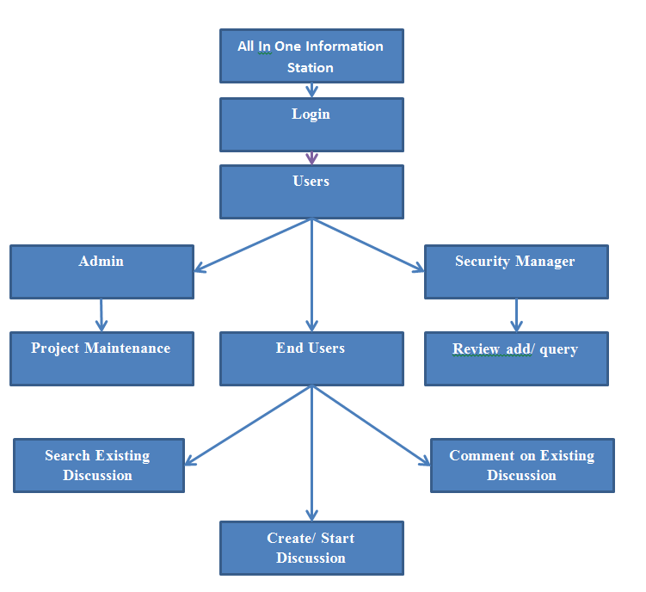

1. Design Architecture: We are having Client server Architecture with Windows Client where Front end is designed in C#.Net and Backend with Go language using SQL data Base Connection.

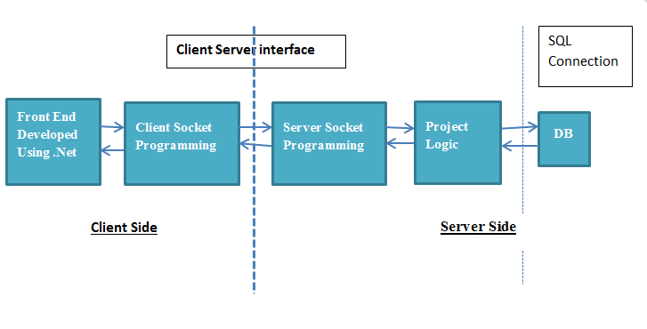

1. Class Diagram
2. Client Side Class Diagram: Following figure contains objects in application from front end development and static Relationships between them.

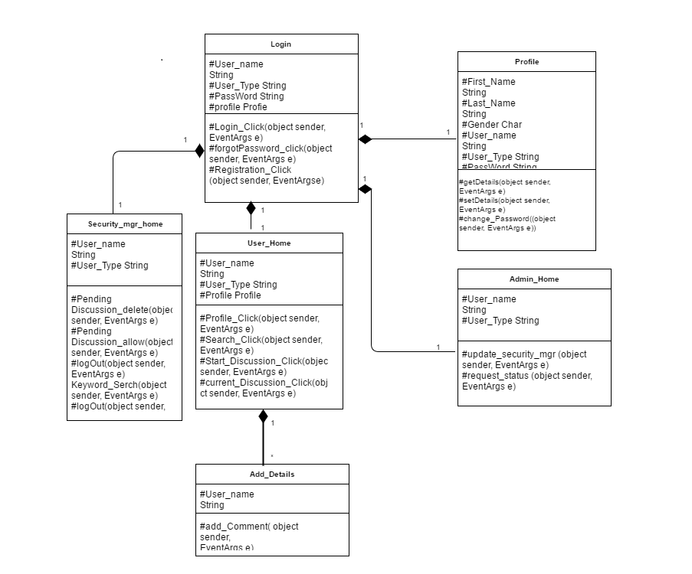

Server Side Class Diagram: Following figure contains type objects in application from back end development and static Relationships between them.

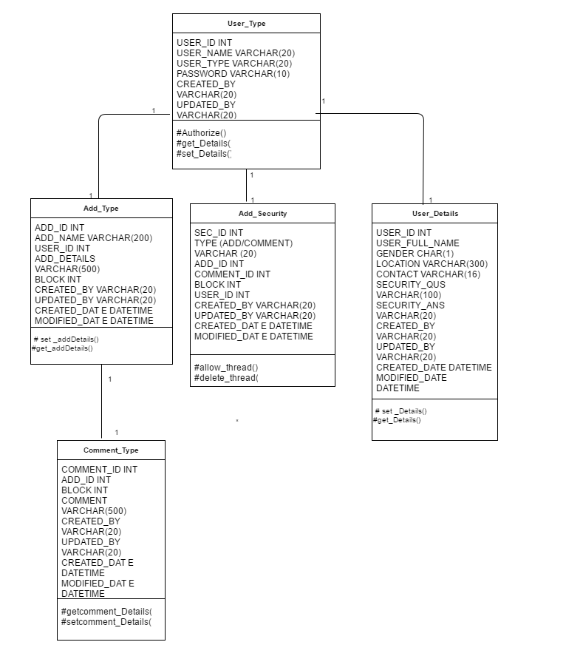

1. Sequence Diagram:

Following fig shows interaction **diagram** that shows how objects operate with one another and in what order. It is a construct of a message **sequence** chart.

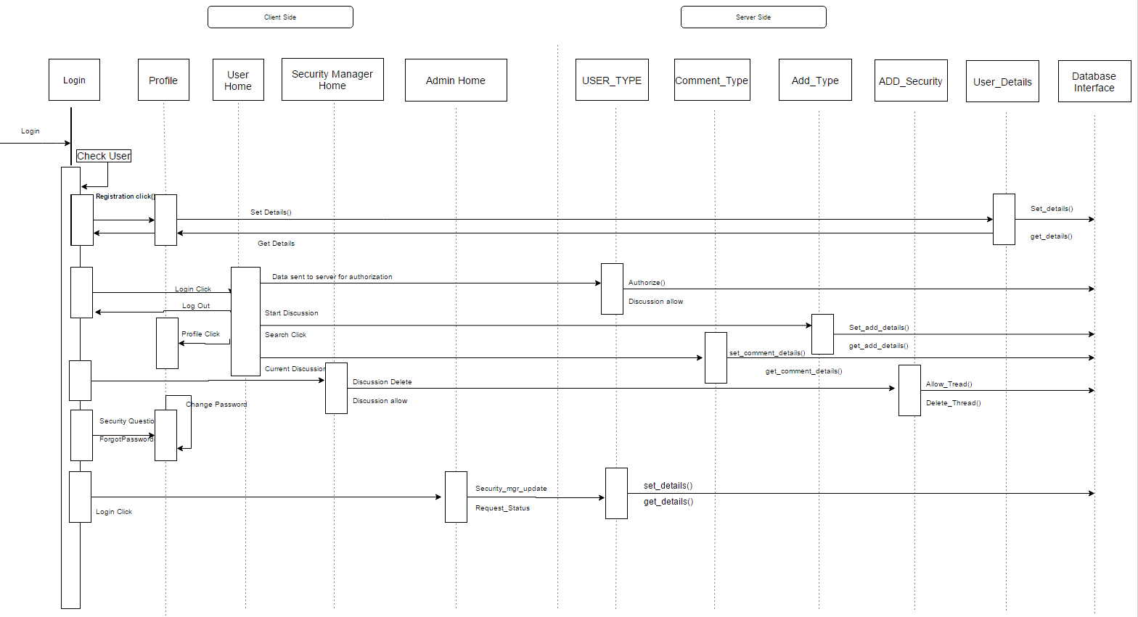

1. Use Case Diagram:

A **use case diagram** at its simplest is a representation of a user's interaction with the system with the help of actors and operation blocks.

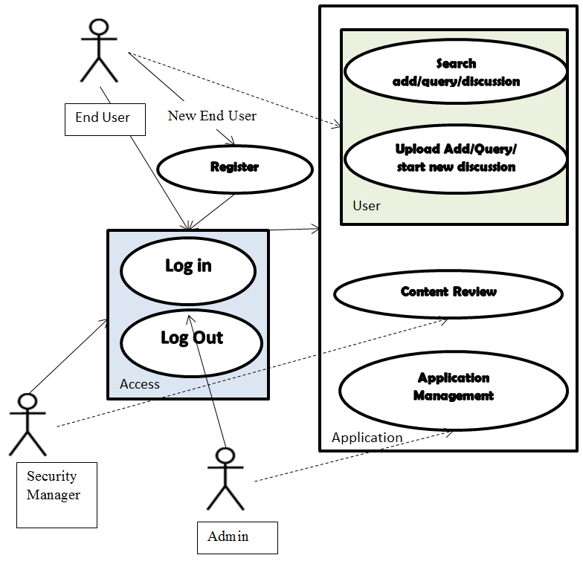

* **Milestones :**

1. Conceptualizing the project to address a specific problem
2. Creating class and sequence flow diagram for the project
3. Setting up the client side and server side connection
4. Completing the populated database set up for the project
5. Completing the UI designing for the project
6. Testing the project with limited number of users
7. Testing the project with more number of users
8. Performance testing in Beta environment
9. Release

***