# Homework: HW1

# Answers

1. GIT, GitHub, and Bitbucket.

Installation and Signup is Completed. Also Sent invite to TA & Instructor.

1. Use the following languages to show “Hello ACS560!” Output Screenshot
2. C/C++

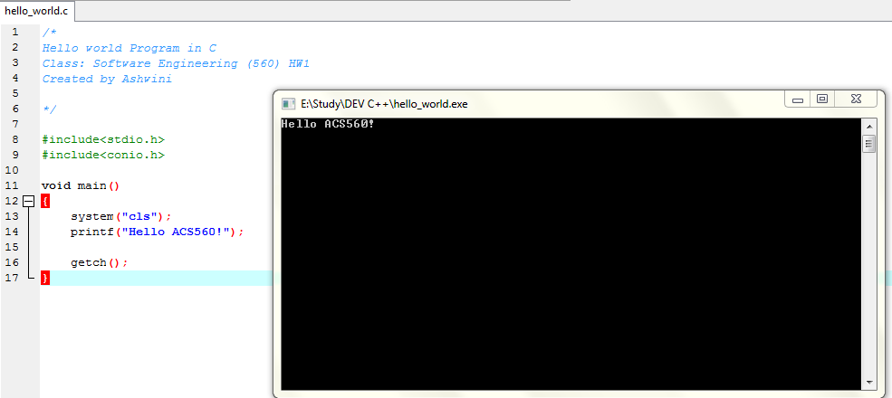

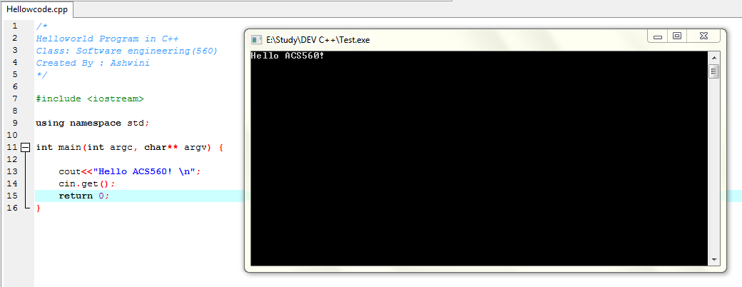

1. Java

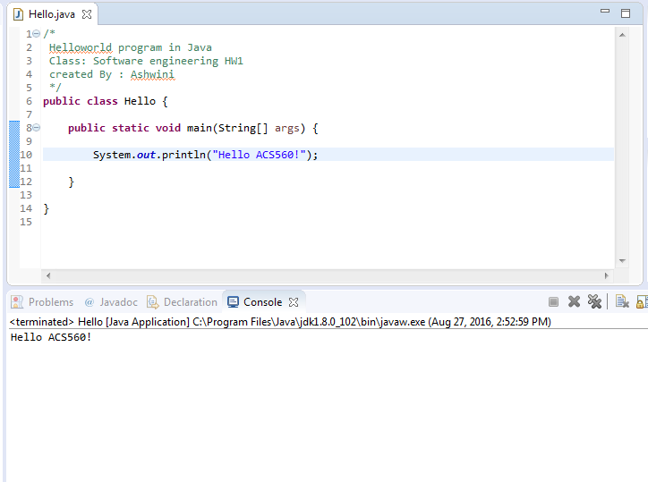

1. Python

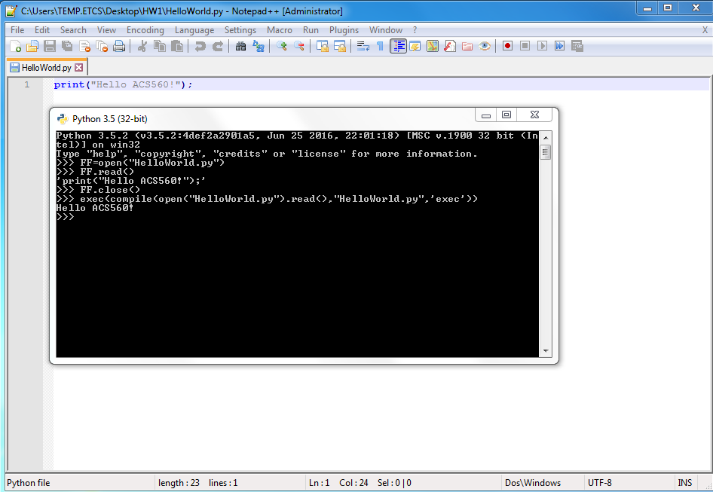

1. C#

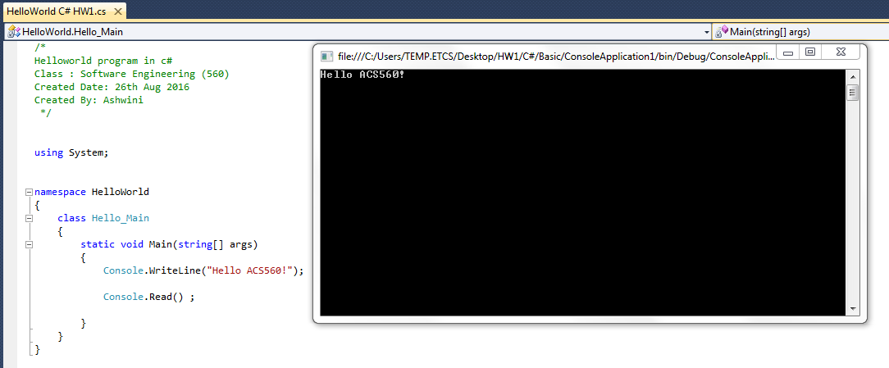

1. HTML

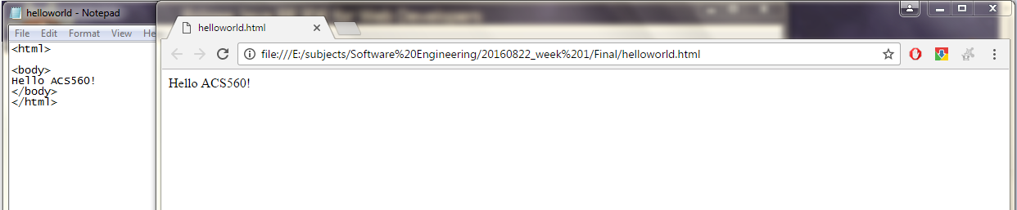

1. JavaScript

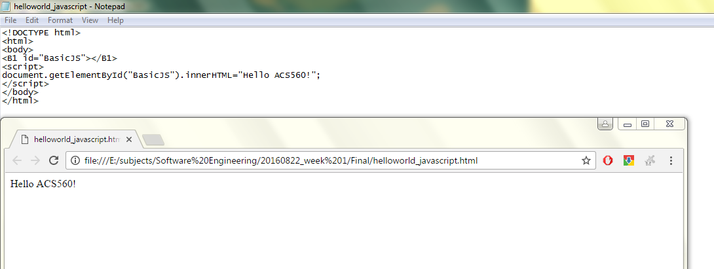

1. Go

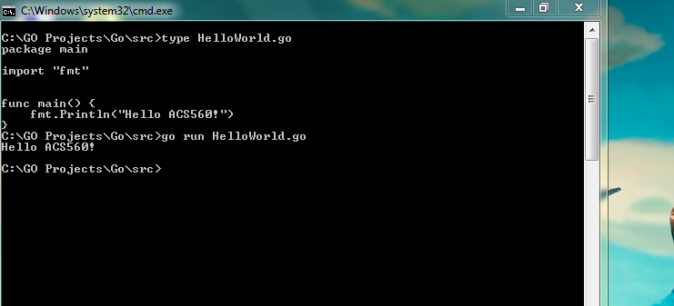

1. Shell Scripting

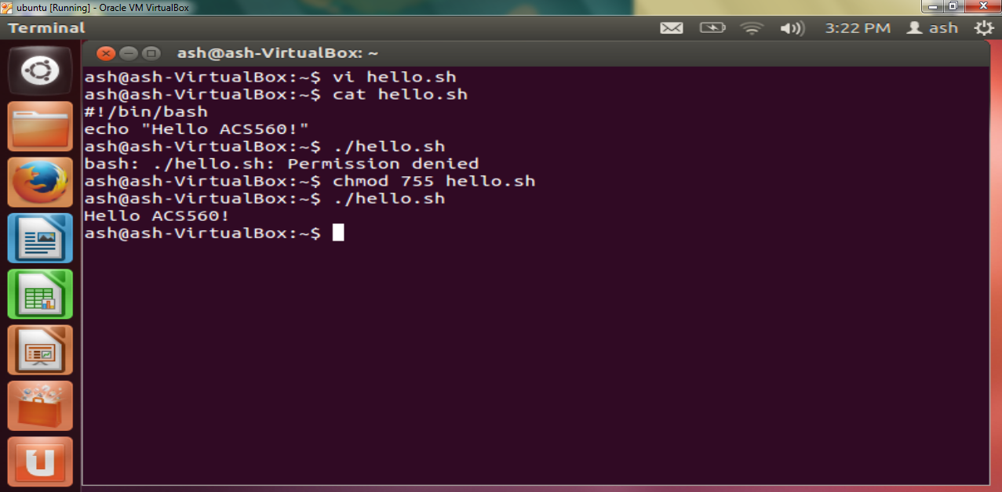

1. Two Method to remove ^M

Before removing:

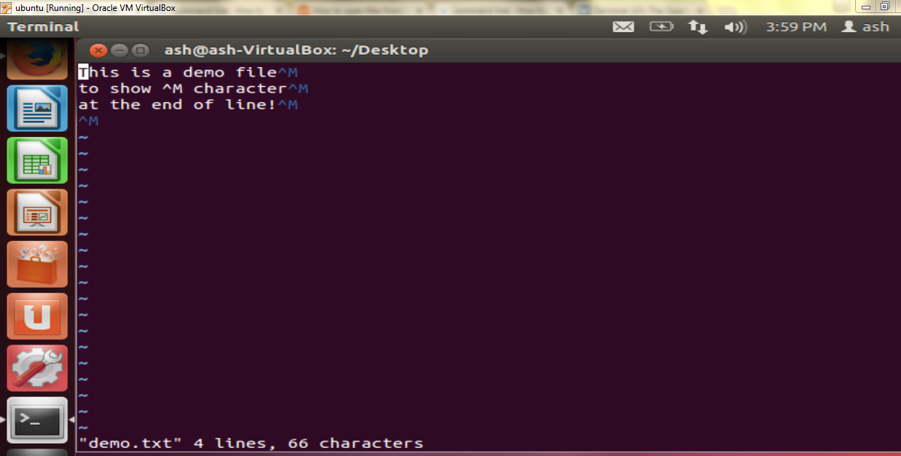

After Removing:

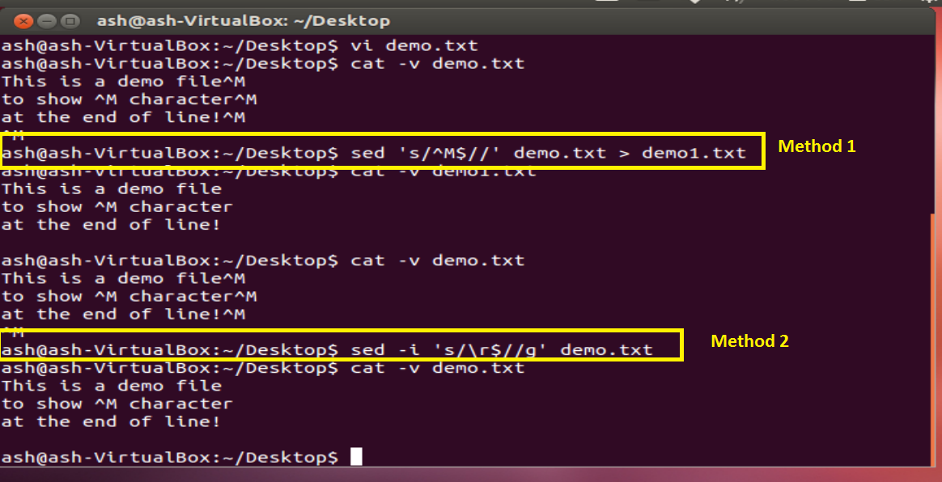

File demo.txt

