# ACS 560 Software Engineering

# Homework 08

# (Ashwini Kulkarni)

**Qus. 1:**

1. go run Server_Hello.go
2. open browser and type <http://127.0.0.1:12000/>

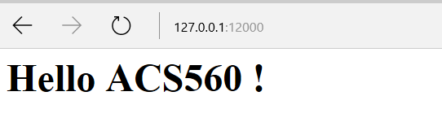

**Qus. 2:**

1. Please run Pg_src_code.go file with passing URL argument like

go run Pg_src_code.go http://www.ipfw.edu