# ACS 567 Software Project Management

# Homework 02

# (Ashwini Kulkarni)

1. Questions on Scrum:

**a. What are three roles in Scrum? What are their responsibilities?**

1. **The product owner:**

The product owner is the hub of business value for Scrum initiatives; his or her entire focus is on ensuring that the work actually done aligns with the work that needs to be done to meet the project objectives.

* The product owner is the cornerstone of project success, responsible for defining the work that needs to be completed and prioritizing that work.
* He or she needs to know what the project is expected to deliver and why those elements are important -- to customers, to the market, to the organization.
* The product owner must also be the face of all of those interests to the project team, acting as an expert guide as the team carries out the project.  
    
  An important difference between the product owner and any nominally similar role in traditional project execution is that the product owner remains actively involved throughout.
* The product owner reviews and reprioritizes outstanding work based on shifting needs and ongoing feedback.
* The product owner is also responsible for communicating and explaining those changing priorities and their impacts to the project team.

Product Owner is assisted in that by the ScrumMaster.

1. **The ScrumMaster:**

The ScrumMaster role has two distinct elements. First, he or she acts as the protector of the team, making sure that everyone on the project, especially the development team members, can focus on their work without any distractions.

Some of those distractions may be directly associated with the work such as the product owner who oversteps the boundaries, for example, and starts to dictate the work approach to the team.

The ScrumMaster may need to protect the team from organizational disruptions or internal distractions such as arranging to replace problematic computers or providing a less noisy work area.  
  
The second element of the ScrumMaster role is to protect the Scrum process itself. The ScrumMaster is the expert on how Scrum works and how it should be applied. He or she will ensure that the product owner and development team stay within the Scrum framework. By extension, the ScrumMaster can coach the other team members on how to use Scrum in the most effective manner.  
  
This is a very different role from that of a traditional project manager, despite frequent comparisons made between the two. Project managers are responsible for managing the work of project team members, and that guides their own day-to-day work. For the ScrumMaster, however, the only formal accountability is over the process.

The Scrum Master facilitates the Daily Scrum meeting. Asks each developer:

• What did you do yesterday? • What are you doing today • What is in your way?

1. **The development team:**

A typical Scrum team consists of five to nine people and generally includes the typical functional roles required to complete the project. In software development, that means architects, testers, developers, and designers.  
The team acts collectively to determine how to achieve their goals. The specific features they work on are determined by the priority established by the product owner.

The way they work is guided by the Scrum process, as monitored by the ScrumMaster. Everything else is up to the team to manage, with the ScrumMaster providing as much support as needed to allow that to happen. For example, each team member can take a feature from the prioritized product backlog, then decide individually how to execute that work.  
  
This level of autonomy is a cornerstone of Scrum. It encourages strong bonds between team members and helps create a positive working environment. While the idea of a team exists in Waterfall projects as well, in that environment the team is functionally managed by the project manager, rather than being self-managed.

**b. In daily scrum, what are three questions that each team member takes turns to answer for the benefit of the other team members?**

In daily scrum, following three questions are asked and need to answer by team members for benefits of other team member

**What did you do yesterday?**

**What will you do today?**

**What is blocking progress?**

By focusing on what each person accomplished yesterday and will accomplish today, the team gains an excellent understanding of what work has been done and what work remains. The daily scrum meeting is not a status update meeting in which a boss is collecting information about who is behind schedule. Rather, it is a meeting in which team members make commitments to each other.

Any problems/blockers that are raised in the scrum meeting become the ScrumMaster's responsibility to resolve as quickly as possible.

1. Dig/nslookup

Commands used:

dig ipfw.edu

nslookup 52.205.6.225 (Where is it hosted)

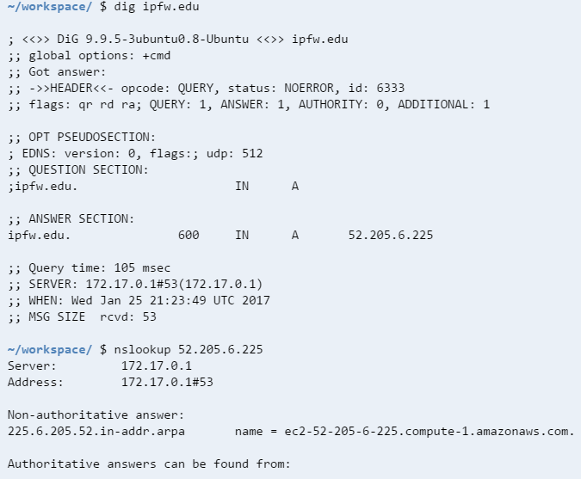

dig ipfw.edu NS (For DNS)

dig ipfw.edu MX (For Mail Server)

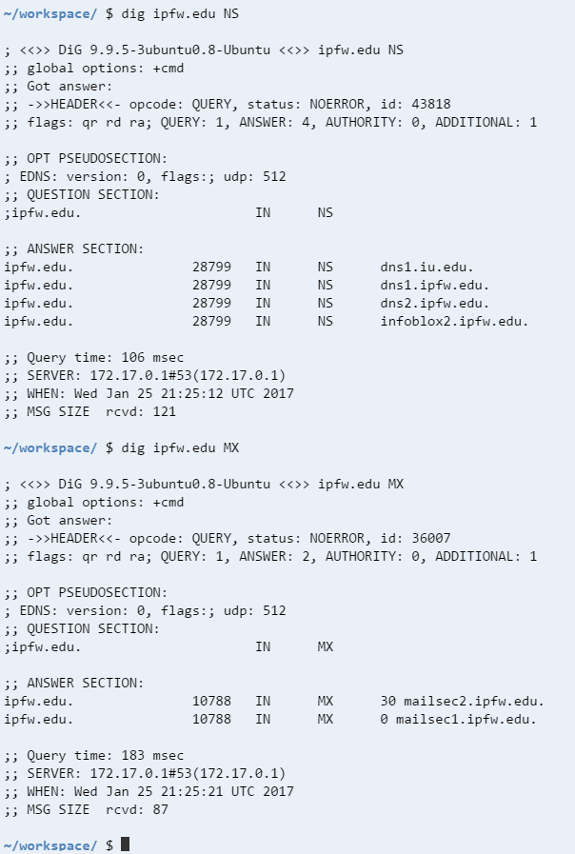

Using ARIN

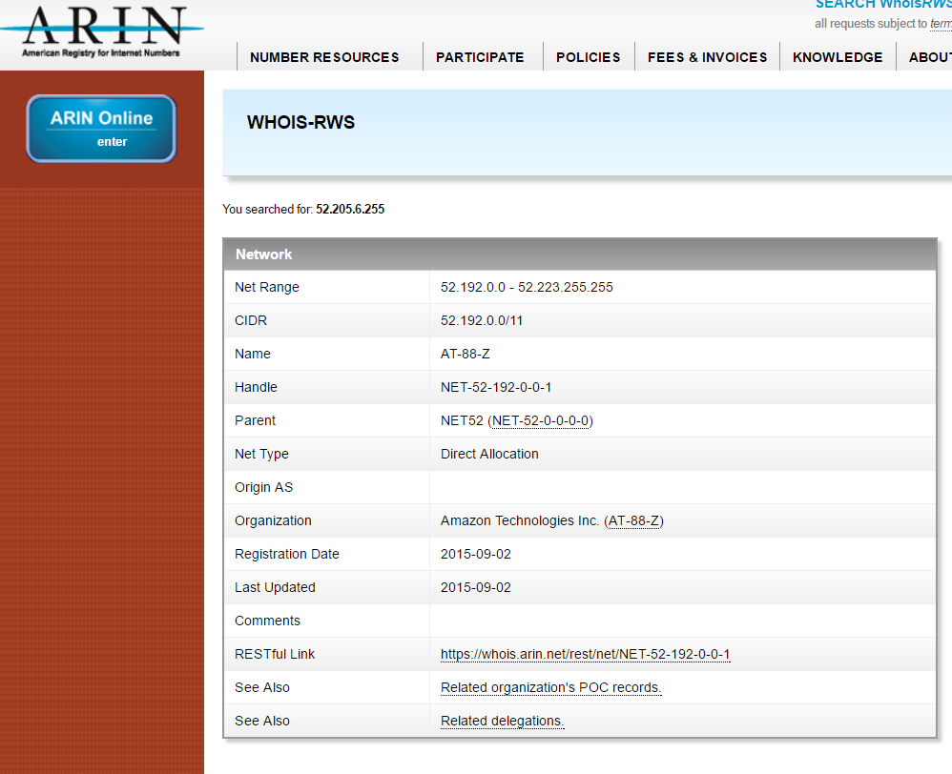

1. telnet

Updated Code

echo "open $1 80"

sleep 2

echo "GET $2 HTTP/1.1"

echo "Host: $1"

echo

sleep 2

Output :

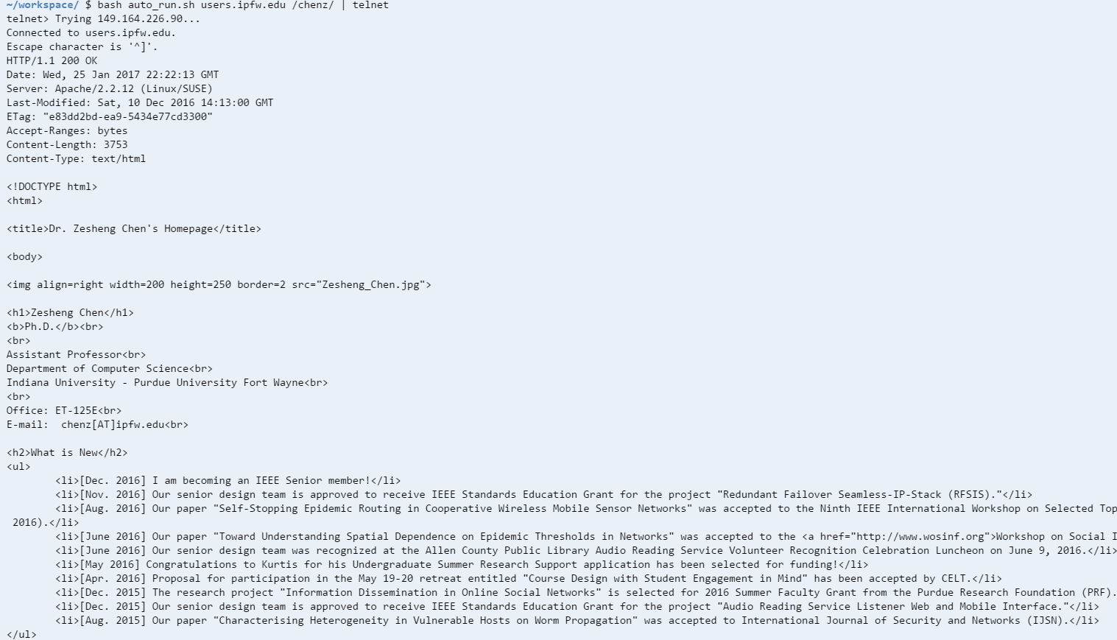

1. Advanced REST client

Fort Wayne IN:

Latitude :41.079273

longitude: -85.1393513

Screenshot:



Miami, FL

Latitude : 25.7616798,

longitude: -80.1917902

Screenshot:



San Francisco, CA

Latitude :37.7749295,

longitude: -122.4194155

Screenshot:

