# ACS 567 Software Project Management

# Homework 05

# (Ashwini Kulkarni)

1. **Task Estimation**

**PERT:**

Program evaluation and review technique (PERT) is a technique used to analyze and represent the activity in a project, and to illustrate the flow of events in a project. PERT is a method to evaluate and estimate the time required to complete a task within deadlines.

PERT serves as a management tool to analyze, define and integrate events. PERT also illustrates the activities and interdependencies in a project. The main goal of PERT is to reduce the cost and time needed to complete a project.

Provide three number (trivariate analysis) with time estimation:

O: Optimistic estimate (wildly optimistic) : The shortest time to complete an activity

N: Nominal estimate (greatest chance of success) : The completion time having the highest probability

P: Pessimistic estimate (wildly pessimistic) : The longest time to complete an activity

Using PERT,

Estimate the expected duration of the task(s) and the standard deviation of the probability distribution for the task(s).

For Single Task:

µ is the expected duration of the task

$$μ=\frac{O+4N+P}{6}$$

σ is the standard deviation

$$σ=\frac{P-O}{6}$$

For Multiple task :

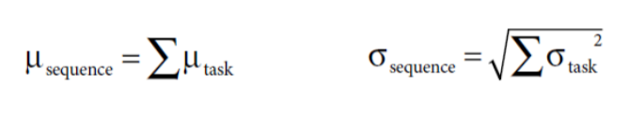

µsequence : Summation of the expected duration of the individual task

σsequence : Square root of Summation of square of the standard deviation of the individual task

1. **Pressure. How will you avoid the pressure? How will you handle the pressure?**

**Avoid:**

**Avoiding pressure**

The best way to stay calm under pressure is to avoid the situations that cause pressure

**Commitments**

Professionals will always help the business find a way to achieve its goals. But professionals do not necessarily accept commitments made for them by the business

**Staying clean**

We can avoid pressure by keeping our systems, our code, and our design as clean as possible. (Use DRY principle, refactoring, bug free code)

**Crisis discipline**

Choose discipline that you feel comfortable following in a crisis. Then follow them all the time.

**Handle:**

**Don’t panic**

Because tight deadlines or any other issue which may lead to panic state. So calm down and Think the problem through.

**Communicate**

Let your team and your superiors know that you are in trouble. Avoid creating surprises. Surprises multiply the pressure by ten. Be transparent when it comes to work problem.

**Rely on your discipline**

The only way through the pressure cooker is to rely on what you already know works – your disciplines.

**Get help**

When the heat is on, find an associate who is willing to pair program with you.

1. **Simple Calculator**

Code file: BasicCalculator.html

1. **Form verification**

Code Files: SignupForm.html

Myscripts.js