# ACS 567 Software Project Management

# Homework 06

# (Ashwini Kulkarni)

1. **Sprints.**

**What is the definition of done?**

**Ans:**

* It is a checklist of the types of work that the team is expected to successfully complete before it can declare its work to be potentially shippable.
* The definition of done is orthogonal to user acceptance criteria (functional acceptance) for a feature. It is a comprehensive checklist of necessary, value-added activities that assert the quality of a feature and not the functionality of that feature.
* Definition of done is informed by reality where it captures activities that can be realistically committed by the team to be completed at each level (feature, sprint, release).

1. **Product Backlog.**

**What are good product backlog characteristics?**

Good Product Backlog Characteristics:  An acronym DEEP to summarize several important characteristics of good product backlogs: Detailed appropriately, Emergent, Estimated, and Prioritized.

**Detailed Appropriately:**

The product backlog items will differ in their level of detail. Those that we will work on sooner, those at the top off the product backlog, will be more detailed. Those that we won't work on or some time will be less detailed. We want to **refine** backlog items as they rise in priority, adding details in a just-enough, just-in-time fashion.

**Emergent**

* The product backlog is a living document, constantly changing as the product is being developed or maintained. As the team and product owner learn more about the product and the marketplace, they might add new items, discard some, and change others.
* The emergent nature of the product backlog is not only expected but is a sign of a healthy and functioning product backlog.

**Estimated**

Each product backlog should have a size estimate that corresponds to the effort required to develop that item. The product owner uses these estimates to help determine a product backlog item's priority. Ideally most of items at the top of the product backlog will be sprint-sized, small enough to be worked on during a single sprint.

**Prioritized**

A product backlog should be a prioritized list of PBIs, but not every PBI needs to be prioritized. I recommend prioritizing about a release worth of PBIs. Prioritizing beyond that is likely a waste of effort, as too much might change by the time the first release is out. Instead, prioritize new items as they emerge and save the "someday" or "future release" items for later.

1. **PHP Language.**

**Implement your own version of hexdec() function in PHP.**

Code File: hexdec.php

Output Screenshot

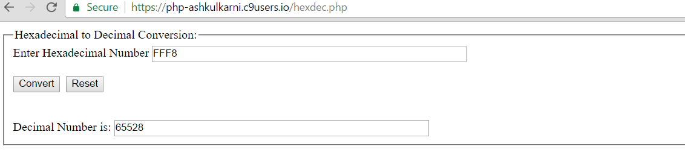

1. **PHP**

**Web Page.**

Code File: hw6.php, Confirmation.html

Output Screenshot

