# ACS 567 Software Project Management

# Homework 08

# (Ashwini Kulkarni)

1. **Pivotal Tracker.**

**User Story For Qus 2, Qus 3, Qus 4 : in Pivatal Tracker Tool**

1. **Product Owner and ScrumMaster.**
2. **What are the responsibilities of the product owner?**
3. Manage Economics

Release-level economics: Continuously makes trade-offs in scope, date, budget, and quality as a stream of economically important information arrives during product development

Sprint-level economics: Ensures that a good return on investment (ROI) is delivered from each sprint

Product backlog economics: Prioritizes the product backlog

1. Participate in Planning: Participates in the portfolio-, product-, release-, and sprint-planning activities
2. Groom the product Backlog : Oversees the grooming of the product backlog
3. Define Acceptance criteria and verify that they are met.
4. Collaborate with development team :
5. Collaborate with Stockholders
6. **What are the characteristics/skill of the product owner?**
7. Domain Skill : Have Bussiness & Domain Exeperties, Visionary, Can able lead the project towards vision
8. People Skills : Good relationship and understanding with stackholders and development team.
9. Decision Making: Willing to make hard decision with consideration of variables like economics, time, resources.
10. Accountability: Accept responsibility of Product and its deliverable result, Must be committed to stack holders and scrum team
11. **What are the responsibilities of ScrumMaster?**
12. Coach: Coach to both development team and the product owner. Help the owner maximize business outcomes
13. Servant Leader: Help team to work efficiently,
14. Process Authority: Help the team define and adhere to its own process for making sure the work gets done
15. Interference Shield: He/she protects the development team from outside interference so that it can remain focused on delivering business value every sprint
16. Impediment Remover: Takes responsibility for removing impediments that inhibit the team’s productivity
17. Change Agent: Helps others understand the need for change, the impacts of Scrum outside of the Scrum team, and the broad-reaching benefits Scrum can help achieve.
18. **What are the characteristics/skills of ScrumMaster?**
19. Knowledgeable : Knowledgeable about Scrum / technologies / business domain
20. Questioning : Asks good questions (thoughtful, deep, probing). Helps people realize that they have the insight to find their own answers (Socratic questioning)
21. Patient: Gives teams time to arrives at appropriate answers on their own.
22. Collaborative: Works with product owner, dev team, and all the other parties (not be directly involved with Scrum)
23. Protective: Like Sheepdog (protection from outside interference). Helps team members who begin to wander away from the flock.
24. Transparent: Transparent and unbiased in all forms of communications.
25. **Is it considered a good idea for the same person to be both the product owner and the ScrumMaster on the same Scrum team? Why or why not?**

No.

Product Owner is very focused on PBIs, creating, prioritizing, and refining. A Scrum Master works more on educating, coaching, mentoring, and facilitating. ScrumMaster frequently acts as the balancing agent between the demands of the product owner and the needs and abilities of the dev team. If both are same person then there will be conflict with responsibilities of each role.

Note: Qus. 3 & 4 Using same **db_conn.php** file

1. **PHP and MySQL.**

**Source Code Files: db_conn.php, Table Insertion.php**

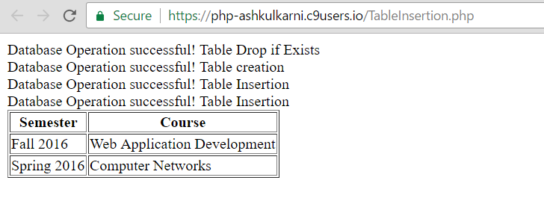

1. **PHP and MySQL.**

**Source Code Files: db_conn.php , hw8.php, REVIEW.sql, Show_Reviw.php, Confirmation.html**

