**read.table (for moderate data)**

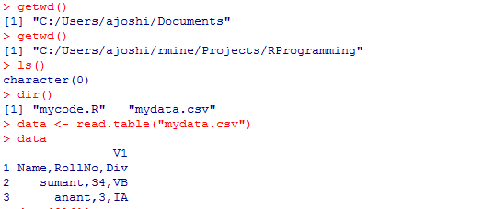

**read.table (for large data)**

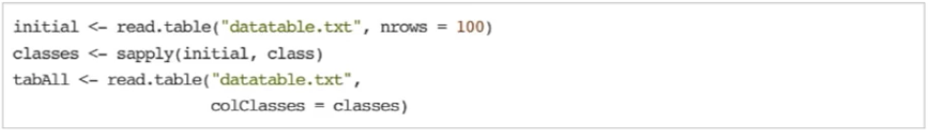

**Textual Data Formats [Single Obj] - dget and dput**

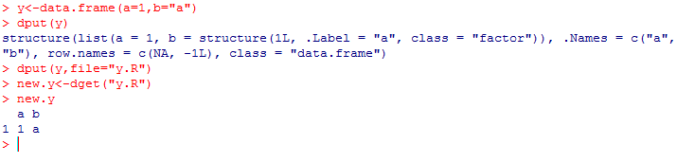

**Textual Data Formats [Multiple Obj] - dump and source**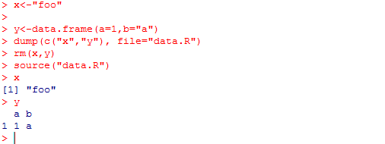



**This generates output like this**

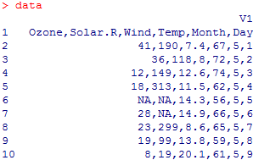

**Another way of reading table with header**

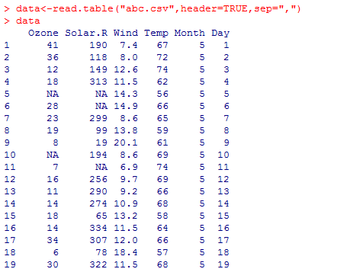

**To find data in Ozone column with Non NA, simply use**

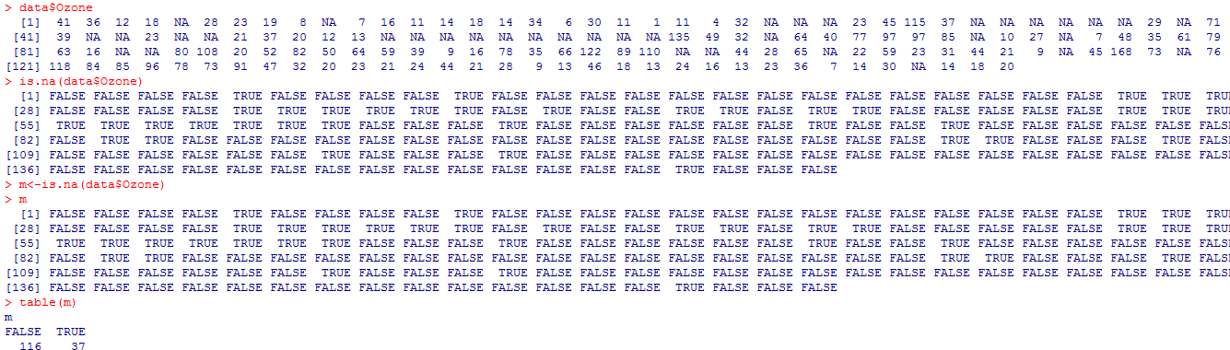

**Mean of Solar.r for temp>90 and Ozone above 31**

