Practical no 9 .Write down SQL using WHERE clause,GROUP BY,HAVING

NAME: saCHIN Rajendra Adhav BATCH:B1

ROLL NO:01 DIV= A

---------------------------------------------------------------------------------------------------

create database store;

use store

create table sales(

saleId int PRIMARY KEY,

ProductID INT,

Amount DECIMAL (10,2),

salesdate DATE

);

insert into sales(saleId,ProductID,Amount,salesdate)values(1,111,100.00,'2024-02-01');

insert into sales(saleId,ProductID,Amount,salesdate)values(2,222,150.00,'2024-02-02');

insert into sales(saleId,ProductID,Amount,salesdate)values(3,333,200.00,'2024-02-03');

insert into sales(saleId,ProductID,Amount,salesdate)values(4,444,120.00,'2024-02-04');

insert into sales(saleId,ProductID,Amount,salesdate)values(5,555,100.00,'2024-02-05');

select*from sales;

**WHERE CLAUSE:**

select*from sales

select saleId,ProductID,Amount,salesdate from sales where saleId=4

OUTPUT

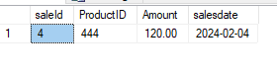

**GROUP BY CLAUSE:**

select*from sales

select saleId,ProductID,count(*)

from sales group by saleId,ProductID

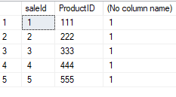

**HAVING CLAUSE:**

select saleId,ProductID,count(*)

from sales group by saleId,ProductID

having(ProductID)=444

**OUTPUT**

