**CHAPTER-1**

**INTRODUCTION**

Diabetes is a prevalent chronic metabolic disorder characterized by elevated blood sugar levels resulting from either insufficient insulin production or impaired insulin utilization by the body. With its incidence escalating globally, diabetes has emerged as a significant public health concern, imposing substantial burdens on healthcare systems and individuals alike. According to the World Health Organization (WHO), an estimated 422 million people worldwide were living with diabetes in 2014, with projections indicating a steady rise in prevalence.

The multifactorial nature of diabetes underscores the importance of early detection and intervention to mitigate its adverse health outcomes and complications. Timely diagnosis enables healthcare professionals to implement appropriate management strategies, including lifestyle modifications, pharmacotherapy, and regular monitoring, thereby improving patient outcomes and quality of life.

Machine learning, a subfield of artificial intelligence (AI) focused on developing algorithms capable of learning from data and making predictions or decisions, holds immense potential in revolutionizing healthcare delivery. In the context of diabetes, machine learning techniques offer a data-driven approach to predictive modeling, leveraging diverse patient characteristics and biomarkers to forecast disease risk or progression.

Attributes such as BMI, hobbies, lifestyles, and family history were not considered in the featured work. Incorporating these attributes into data collection can improve the accuracy of predictions and their applicability.

Top of Form

**1.1 SCOPE OF THE CAPSTONE PROJECT**

### 1.1.1 PROBLEM STATEMENT

### Diabetes is a chronic metabolic disorder characterized by high blood sugar levels over a prolonged period. It poses a significant global health burden, affecting millions of individuals worldwide. Early detection and management of diabetes are crucial in preventing its complications and improving patient outcomes.

### Machine learning (ML) techniques offer promising avenues for predicting diabetes risk based on various clinical and demographic features. However, developing accurate and reliable predictive models requires addressing several challenges and considerations.

### 1.1.2 EXISTING SYSTEM

* Researchers have explored data mining techniques like clustering and classification for diabetes detection in existing studies.

### Proposals have been made to leverage algorithms such as logistic regression for prediction, with comparisons conducted using a standard diabetic dataset.

### 1.1.3 PROPOSED SYSTEM

### This study proposes a binary classification system for diabetes detection using a local dataset.

### Machine learning algorithms, including Random Forest, Logistic Regression, and Support Vector Machines (SVM), will be employed for initial classification.

### The system aims to further enhance prediction accuracy through the integration of deep learning techniques.

### 1.1.4 OBJECTIVES

* To gather and preprocess diverse health data to establish a comprehensive foundation for model development.
* To develop the diabetes prediction model, rigorously validate its accuracy using various datasets, and refine it for optimal performance.
* To compare various machine learning models and analyze its results.

### 1.1.5 PURPOSE

* The project is to proactively identify individuals at risk of developing diabetes.
* This allows for early intervention and targeted preventive measures, leading to improved health outcomes, cost-effective resource allocation management.

**CHAPTER-2**

**PROJECT PLANNING**

This chapter describes the work breakdown structure, 2 Timeline Development Schedule, Cost Breakdown Structure, Cost Analysis, Risks Assessment.

**2.1 Top of Form**

**Work Breakdown Structure diagram**

Data Collection

Data pre-processing

Data Splitting

Data Analysis

Training Dataset

Testing Dataset

**Evaluation method**

1.Accuracy

2.Recall

3.Precession

**Training model**

1.Logistic Regression

2.Random Forest

3. Decission Tree

4.SVM

**Fig 2.1Work Breakdown Structure**

**2.2 Timeline Development – Schedule**

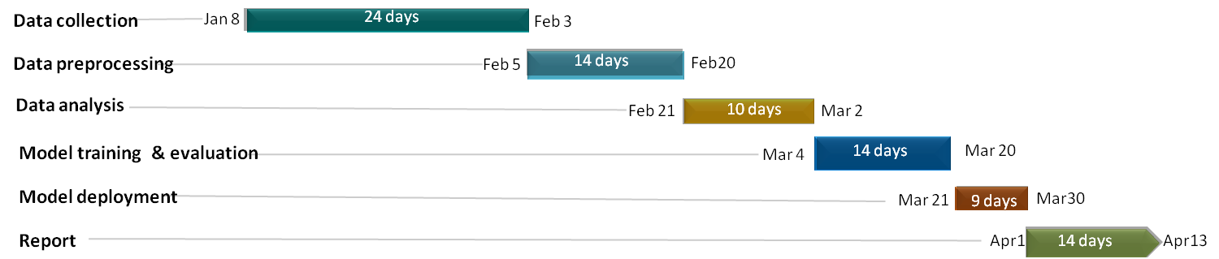

**Fig2.2 Timeline Development – Schedule**

|  |  |  |
| --- | --- | --- |
| **Data Collection Costs** | * Subscription fee for access to healthcare databases | ₹2000 |
| * Costs associated with obtaining additional medical records | ₹1000 |
| **Infrastructure Costs** | * Purchase of high-performance computing hardware | ₹50000 |
| **Personnel Costs** | * Faculty advisor (supervision and guidance), Student researchers | ₹0 |
| **Software Costs** | * purchase of necessary software licenses | ₹0 |
| **Training and Education Costs** | * Workshops or seminars on machine learning techniques | ₹2000 |
| * Machine learning training course for team members | ₹2000 |
| **Testing and Validation Costs** | * Printing costs for presentation materials | ₹1000 |
| * Cost for acquiring additional labeled datasets for validation | ₹2000 |
| **Deployment Costs** | * Website hosting for project documentation or presentation | ₹3000 |
| **Miscellaneous Costs** | * Travel expenses | ₹2000 |

**2.3 Cost Analysis**

**2.4 Risks Assessment**

### A project risk assessment is a process that aims to gain a deeper understanding of which project tasks, deliverables, or events could influence its success.

1. **Data Quality and Privacy**

|  |  |  |  |
| --- | --- | --- | --- |
| **Risk Description** | **Likelihood** | **Impact** | **Mitigation Strategy** |
| Incomplete or inaccurate data | High | High | Implement rigorous data cleaning and validation procedures. |
| Privacy concerns with health data | Medium | Medium | Anonymize and encrypt sensitive information, adhere to regulations. |

1. **Model Development and Validation**

|  |  |  |  |
| --- | --- | --- | --- |
| **Risk Description** | **Likelihood** | **Impact** | **Mitigation Strategy** |
| Model over fitting or under fitting | Medium | High | Regularize the model, use cross-validation, and monitor performance metrics. |
| Lack of interpretability of the model | High | Medium | Utilize interpretable models or provide model interpretation through explainability techniques |

1. **Ethical and Bias Considerations**

|  |  |  |  |
| --- | --- | --- | --- |
| **Risk Description** | **Likelihood** | **Impact** | **Mitigation Strategy** |
| Bias in the model predictions | Medium | High | Implement fairness-aware algorithms, conduct bias assessments regularly. |
| Lack of diversity in the training data | Low | Medium | Ensure diverse representation in the dataset and address data imbalance. |

1. **Model Deployment and Integration**

|  |  |  |  |
| --- | --- | --- | --- |
| **Risk Description** | **Likelihood** | **Impact** | **Mitigation Strategy** |
| Technical issues during model deployment | Medium |  | Conduct thorough testing in staging environments, and implement rollback plans. |
| Resistance or lack of user adoption | Low | Medium | Engage end-users early, provide training, and communicate the benefits clearly |

1. **Compliance and Regulatory**

|  |  |  |  |
| --- | --- | --- | --- |
| **Risk Description** | **Likelihood** | **Impact** | **Mitigation Strategy** |
| Failure to comply with healthcare regulations | Medium | High | Stay informed about regulations, involve legal experts, and adhere to standards. |

**2.5 Requirements Specification**

**2.5.1Functional Requirements**

Functional requirements in machine learning projects outline the specific functionalities, capabilities, and behaviors of the machine learning model and its associated components. These requirements focus on the tasks and processes related to data preparation, model training, evaluation, deployment, and maintenance. Here's a breakdown of functional requirements in machine learning.

1. **Input Interface**
   * The system should provide a user interface for users to input their age, gender, fasting plasma glucose (FPG), cholesterol levels (Chol), triglycerides (Tri), high-density lipoprotein (HDL) cholesterol, low-density lipoprotein (LDL) cholesterol, alanine aminotransferase (ALT) levels, and creatinine levels.
   * Gender should be represented as binary values (0 for female, 1 for male).
2. **Prediction Functionality**
   * The system should use machine learning algorithms to predict whether the user has diabetes or not based on the input features provided.
   * Predictions should be made in real-time and displayed to the user.
3. **Output Display**
   * The system should display the prediction result to the user, indicating whether they are likely to have diabetes or not.
   * Additionally, the system should provide some form of explanation or visualization to help users understand the prediction.
4. **Accuracy Evaluation**
   * The system should include functionality to evaluate the accuracy of the prediction model using appropriate metrics such as accuracy, precision, recall, and F1-score.
   * This evaluation should be accessible to administrators or developers for model refinement purposes.

**2.5.2 Non-Functional** **Requirements**

Non-functional requirements in machine learning projects encompass aspects of system behavior and performance, emphasizing qualities like reliability, scalability, performance, security, and usability. These requirements are crucial for ensuring that deployed models meet desired standards and effectively address user and stakeholder needs. They contribute to the overall quality and behavior of the system, ensuring robustness, trustworthiness, and sustainability. Here's a breakdown of non-functional requirements in machine learning.

1. **Performance**
   * The system should respond to user inputs and provide predictions within a reasonable time frame, ideally within a few seconds.
2. **Security**
   * User data, including sensitive health information, should be securely handled with data protection regulations.
3. **Scalability**
   * It should be able to scale horizontally by adding more server instances if needed.
4. **Reliability**
   * The system should be highly reliable, with minimal downtime or disruptions to service.
5. **Usability**
   * The user interface should be intuitive and easy to use.
6. **Compatibility**
   * The system should be compatible with web browsers to ensure accessibility for users.
7. **Maintainability**
   * The codebase should be well-organized, documented, and modular to facilitate ease of maintenance and future updates.
   * Version control should be utilized to track changes and collaborate on development efforts effectively

**2.5.3 User Input Requirements**

**Age**

* + Users should input their age in years.
  + Age should be a numeric value within a specified range (e.g., 18-100 years).

**Gender**

* + Users should specify their gender.
  + Gender should be represented as a binary value: 0 for female and 1 for male.

**Fasting Plasma Glucose (FPG)**

* + Users should input their FPG level in milligrams per deciliter (mg/dL).
  + FPG should be a numeric value within a specified range (e.g., 70-300 mg/dL).

**Cholesterol Levels (Chol)**

* + Users should input their total cholesterol level in milligrams per deciliter (mg/dL).
  + Cholesterol levels should be a numeric value within a specified range (e.g., 100-400 mg/dL).

**Triglycerides (Tri)**

* + Users should input their triglyceride level in milligrams per deciliter (mg/dL).
  + Triglyceride levels should be a numeric value within a specified range (e.g., 50-500 mg/dL).

**High-Density Lipoprotein (HDL) Cholesterol**

* + Users should input their HDL cholesterol level in milligrams per deciliter (mg/dL).
  + HDL cholesterol levels should be a numeric value within a specified range (e.g., 20-100 mg/dL).

**Low-Density Lipoprotein (LDL) Cholesterol**

* + Users should input their LDL cholesterol level in milligrams per deciliter (mg/dL).
  + LDL cholesterol levels should be a numeric value within a specified range (e.g., 50-200 mg/dL).

**Alanine Aminotransferase (ALT) Levels**

* + Users should input their ALT level in international units per liter (IU/L).
  + ALT levels should be a numeric value within a specified range (e.g., 5-100 IU/L).

**Creatinine Levels**

* + Users should input their creatinine level in milligrams per deciliter (mg/dL).
  + Creatinine levels should be a numeric value a specified range (e.g. 0.5-2.5 mg/dL).
    1. **Technical Constraints**

**Hardware Requirements**

Processor : Any Processor above 500 MHz

RAM : 4GB

Hard Disk : 500GB

Input device : Standard keyboard and mouse.

Output device monitor : VGA with High Resolution

**Software Requirements**

Operating System : Windows 10

Programming : Python 3.12 and related libraries

IDE : Jupyter Notebook

* 1. **Literature Survey**

|  |  |  |  |  |
| --- | --- | --- | --- | --- |
| **Title** | **Authors** | **Methods** | **Results** | **Dataset** |
| Diabetes prediction using machine learning and explainable AI techniques | Isfafuzzaman Tasin, Riasat Khan | XGBoost Classifier | Accuracy:- 88.5  Precision:- 0.81 | [Pima Indian dataset](https://www.bing.com/ck/a?!&&p=12a2c6f7738253e0JmltdHM9MTcwNjU3MjgwMCZpZ3VpZD0zNzAwODUwOS0zZWRmLTYwODgtMzE0YS05NzgyM2Y3MjYxZWUmaW5zaWQ9NTIxMA&ptn=3&ver=2&hsh=3&fclid=37008509-3edf-6088-314a-97823f7261ee&psq=pima+dataset+csv&u=a1aHR0cHM6Ly93d3cua2FnZ2xlLmNv) |
| Diabetes prediction using machine learning algorithms | M. Ramakrishna Murthy, M. Manoj Kumar, | Random Forest, Decision tree and Naïve Bayes, | **Random forest**  Accuracy:-84.4  Precision:- 50.8  **Decision tree**  Accuracy:-77.9  Precision:- 31.4  **Naïve Bayes**  Accuracy:-76.3  Precision:- 34.2 | [Diabetes Health Indicators Dataset](https://www.kaggle.com/datasets/alexteboul/diabetes-health-indicators-dataset?select=diabetes_012_health_indicators_BRFSS2015.csv) |
| Diabetes prediction using Machine Learning algorithms and  ontology | Hakim El Massari, Zineb Sabouri | SVM, Logistic Regression, Naive Bayes, Decision Tree, | |  |  |  | | --- | --- | --- | | **Model** | **ACC** | **PRE** | | **SVM** | 77 | 78 | | **LR** | 77 | 79 | | **NB** | 76 | 80 | | **DT** | 73 | 79 | | [Pima Indian dataset](https://www.bing.com/ck/a?!&&p=12a2c6f7738253e0JmltdHM9MTcwNjU3MjgwMCZpZ3VpZD0zNzAwODUwOS0zZWRmLTYwODgtMzE0YS05NzgyM2Y3MjYxZWUmaW5zaWQ9NTIxMA&ptn=3&ver=2&hsh=3&fclid=37008509-3edf-6088-314a-97823f7261ee&psq=pima+dataset+csv&u=a1aHR0cHM6Ly93d3cua2FnZ2xlLmNv) |
| Machine Learning based Diabetes Prediction and Development of Smart Web Application | Nazin Ahmeda , Rayhan Ahammeda | Random Forest (RF),Support Vector Machines (SVM),Logistic regression (LR), | |  |  |  | | --- | --- | --- | |  | **ACCURACY** | | | **Model** | **D1** | **D2** | | **RF** | 80.26 | 96.18 | | **SVM** | 80.26 | 91.49 | | **LR** | 77.63 | 84.04 | | [Pima Indian dataset](https://www.bing.com/ck/a?!&&p=12a2c6f7738253e0JmltdHM9MTcwNjU3MjgwMCZpZ3VpZD0zNzAwODUwOS0zZWRmLTYwODgtMzE0YS05NzgyM2Y3MjYxZWUmaW5zaWQ9NTIxMA&ptn=3&ver=2&hsh=3&fclid=37008509-3edf-6088-314a-97823f7261ee&psq=pima+dataset+csv&u=a1aHR0cHM6Ly93d3cua2FnZ2xlLmNv) |

**2.7 System Design**

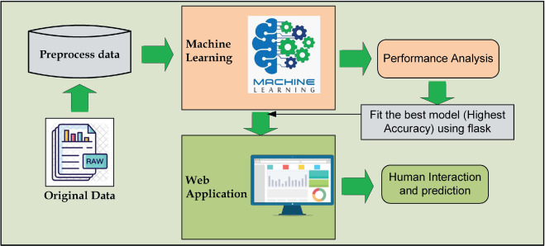

**Fig2.7 System Design**

### Data Acquisition and Preprocessing

### Data Source: Utilize a credible medical dataset on diabetes, such as Pima Indians Diabetes Dataset from UCI Machine Learning Repository.

### Data Preprocessing: Clean the data by handling missing values, outliers, and scaling numerical features for better model performance.

### Feature Engineering

### Analyze the data to identify potential relationships between existing features and diabetes.

### Consider creating new features based on domain knowledge, such as body mass index (BMI) from weight and height.

### Model Selection and Training

### Choose a machine learning algorithm suitable for binary classification, such as:

### Logistic Regression: Effective baseline model for classification problems.

### Random Forest: Handles mixed-type data and avoids overfitting.

### Support Vector Machines (SVM): Powerful for high-dimensional data and clear class separation.

### Train the model on a portion of the preprocessed data, optimizing hyper parameters for best performance.

### Model Evaluation

### Evaluate the trained model on a separate test set using metrics like accuracy, precision, recall, and F1 score.

### Consider using techniques like cross-validation to ensure generalizability of the model.

### Deployment and User Interface (Optional):

### Develop a user-friendly interface where users can input relevant data points like age, weight, blood sugar levels, etc.

### The model predicts the likelihood of diabetes based on the input data.

### Additional Considerations

### Explain ability: Explore Explainable AI (XAI) techniques to understand how the model arrives at its predictions, increasing user trust.

### Privacy: Ensure user data privacy by anonymizing sensitive information and following data security best practices.

**2.8 Implementation**

**Random Forest Algorithm**

Random Forest is a machine learning algorithm that belongs to the ensemble learning methods. It operates by constructing multiple decision trees during training and outputs the mode of the classes (classification) or the mean prediction (regression) of the individual trees. Each decision tree in the forest is built using a subset of the training data and a subset of the features.

Here's how the algorithm works:

1. **Random Sampling with Replacement (Bootstrap)**

* Random Forest samples the training data with replacement, a process known as bootstrapping.
* This means that for each tree constructed, a subset of the original dataset is randomly chosen, and some samples may appear multiple times, while others may not appear at all.

1. **Decision Tree Construction**

For each tree in the forest:

* Randomly select a subset of features from the total features available.
* Choose the best split among the selected features to partition the data.
* Split the data into child nodes based on the chosen split.
* Repeat the process recursively for each child node until a stopping criterion is met, such as reaching a maximum depth or minimum number of samples per leaf.

1. **Voting (Classification) or Averaging (Regression)**

After constructing multiple decision trees, when making predictions:

* For classification, each tree "votes" for the class label, and the mode of all votes is taken as the final prediction.
* For regression, each tree makes a prediction, and the average of all predictions is taken as the final prediction.

1. **Hyper parameters:**

* Random Forest has several hyperparameters that can be tuned for optimal performance, such as:
* **n_estimators**: The number of trees in the forest.
* **max_depth**: The maximum depth of each decision tree.
* **min_samples_split**: The minimum number of samples required to split an internal node.
* **max_features**: The number of features to consider when looking for the best split.

And many more, each affecting the behavior and performance of the model.

1. **Out-of-Bag (OOB) Score**

* Random Forest can optionally compute an out-of-bag score, which estimates the generalization performance of the model using the samples not included in the bootstrap sample used to train each tree.

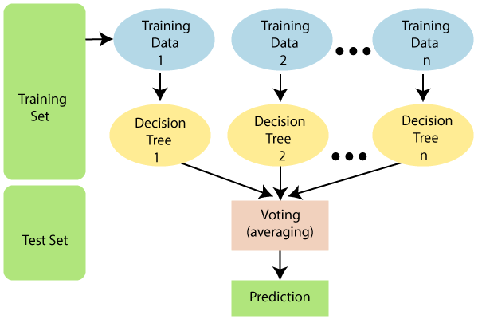

**Fig2.8.1 The working of the Random Forest Algorithm**

### CHAPTER- 3

### METHODOLOGIES

### Machine learning methodologies are different approaches to train algorithms to learn from data. In short, they're the tools and techniques used to build intelligent systems. These methodologies can be broadly categorized by how data is provided.

### Data Acquisition and Preprocessing

### Data Sources: Electronic health records, population-based surveys, and wearable device data can provide valuable information on demographics, medical history, lifestyle habits, and lab test results.

### Data Cleaning: Incomplete or inaccurate data can hinder model performance. Techniques like missing value imputation and outlier removal ensure data quality.

### Feature Selection and Engineering

### Feature Selection: Identifying the most relevant factors influencing diabetes onset is vital. Statistical methods or correlation analysis can help pinpoint these features.

### Feature Engineering: Deriving new features from existing data can improve model accuracy. For instance, calculating body mass index (BMI) from weight and height.

### Machine Learning Algorithms

### Logistic Regression: This linear model estimates the probability of an individual developing diabetes based on various factors. It's interpretable, making it easy to understand the impact of each feature.

### Support Vector Machines (SVM): SVMs create a hyper plane that best separates data points belonging to different classes (diabetic and non-diabetic). They can handle complex relationships between features.

### Decision Trees: These tree-like structures classify data points based on a series of sequential decisions. They offer clear decision-making logic but can be prone to overfitting.

### Random Forests: Ensembles of decision trees, where each tree votes on the classification. This reduces over fitting and improves modelgeneralizability.

### Artificial Neural Networks (ANNs): Inspired by the human brain, ANNs learn complex patterns from data through interconnected layers. They excel at handling non-linear relationships but can be computationally expensive to train.

### Model Evaluation and Refinement

### Metrics: Performance is assessed using metrics like accuracy, precision, recall, and F1-score. These metrics evaluate how well the model identifies individuals with and without diabetes.

### Cross-validation: The data is split into training and testing sets. The model is trained on the training data and evaluated on the unseen testing data to ensuregeneralizability.

### Hyper parameter Tuning: Adjusting the parameters of the chosen algorithm can significantly impact performance. Techniques like grid search or randomized search help optimize these parameters.

### Ethical Considerations in Diabetes Prediction with ML

### Bias: Datasets may harbor biases that can lead to discriminatory predictions. Mitigating bias through data selection and using fairness-aware algorithms is crucial.

### Interpretability: While some ML models are "black boxes," techniques like feature importance analysis can shed light on their decision-making process.

### Privacy: Protecting patient privacy is paramount. Secure data handling practices and anonymization techniques are essential.

### 3.1.1 Use cases

### Early Diagnosis and Prevention

### Machine learning models can analyze a patient's medical history, lifestyle factors, and genetic predispositions to identify individuals at high risk of developing diabetes. Early detection allows for timely interventions such as lifestyle modifications, diet changes, and medication to prevent or delay the onset of diabetes.

### Personalized Treatment Plans

### By analyzing patient data, including blood glucose levels, insulin sensitivity, and response to medication, machine learning models can assist healthcare providers in developing personalized treatment plans for diabetic patients. These plans can optimize medication dosage, timing, and types of treatment to better manage blood sugar levels and reduce the risk of complications.

### Remote Patient Monitoring

### Machine learning algorithms can be integrated into wearable devices or mobile applications to continuously monitor vital signs and glucose levels in diabetic patients. Real- time data analysis can alert patients and healthcare providers to potential fluctuations in blood sugar levels, allowing for timely interventions and adjustments to treatment plans.

### Clinical Decision Support Systems

### Machine learning models can aid healthcare providers in clinical decision-making by analyzing patient data and providing recommendations for diagnosis, treatment, and management of diabetes. These decision support systems can assist healthcare providers in interpreting complex patient data and identifying the most effective interventions for individual patients.

### Population Health Management

### Machine learning algorithms can analyze large-scale healthcare data, including electronic health records, insurance claims, and demographic information, to identify high-risk populations and geographic areas for targeted diabetes prevention and management programs. By identifying populations at increased risk of diabetes, healthcare organizations can allocate resources more effectively and implement preventive interventions to reduce the burden of diabetes on the healthcare system.

### Drug Discovery and Development

### Machine learning models can analyze biological data, including genetic, proteomic, and metabolic information, to identify novel drug targets and biomarkers for diabetes. By uncovering underlying molecular mechanisms of diabetes and related complications, machine learning can accelerate the discovery and development of new therapeutic interventions for the treatment and prevention of diabetes.

### Predictive Analytics for Complications

### Machine learning models can predict the likelihood of diabetic complications such as diabetic retinopathy, nephropathy, neuropathy, and cardiovascular disease based on patient data, including medical history, lab results, and imaging studies.

## CHAPTER- 4

## TESTING AND VALIDATION

**4.1Test plan**

### Objectives and Scope: Define clear objectives, such as accurately predicting diabetes, and specify the scope, including features, evaluation metrics, and constraints.

* **Data Preparation:** Describe the dataset, preprocessing steps (e.g., normalization, handling missing values), and ensure its representativeness.
* **Model Evaluation Metrics:** Define relevant metrics like accuracy, precision, recall, F1-score, and choose based on project requirements.
* **Test Cases:** Develop diverse test cases, including edge cases and challenges like imbalanced classes or noisy data.
* **Cross-Validation Strategy:** Determine cross-validation strategy (e.g., k-fold), considering dataset size and resources.
* **Model Training and Validation:** Describe model training, hyper parameter tuning, validation strategy, and techniques to prevent overfitting.
* **Test Set Evaluation:** Define how the final model will be evaluated using the test set, ensuring consistency with validation set results.
* **Deployment Considerations:** Discuss considerations for deploying the model in production, including scalability and ongoing monitoring.
* **Documentation and Reporting:** Thoroughly document the test plan and generate clear reports summarizing results and insights.
* **Review and Iteration:** Review the test plan with stakeholders, gather feedback, and iterate as necessary to ensure alignment with project goals.

**4.2 Test Case**

|  |  |  |  |  |  |  |
| --- | --- | --- | --- | --- | --- | --- |
| **S.no** | **Test Case** | **Description** | **Input** | **Expected Output** | **Actual Output** | **Result** |
| 01 | Valid Input | Test the application with valid input | Age=18, Gender=1, FPG=140, Cholesterol=150, Triglycerides=120, HDL= 40, LDL=100, ALT=100, CCR= 0.70 | Great! You DON’T have DIABETES | Great! You DON’T have diabetes | Pass |
| 02 | Valid Input | Test the application with valid input | Age=55, Gender=0, FPG=290, Cholesterol=190, Triglycerides=122, HDL= 47, LDL=120, ALT=105, CCR= 0.89 | Oops! You have DIABETES | Oops! You have DIABETES | Pass |
| 03 | Incomplete input | Test the application’s response with incomplete input | Age=60, Gender=0, FPG=290, Cholesterol=190, Triglycerides=122, HDL= 47, LDL=Empty, ALT=105, CCR= 0.89 | Invalid input. Please fill in the form with appropriate values | Invalid input. Please fill in the form with appropriate values | Pass |
| 04 | Invalid Input for gender | Test the application’s response with invalid input for gender | Gender =3 | Invalid input. Please fill in the form with appropriate values | Invalid input. Please fill in the form with appropriate values | Pass |

## CHAPTER- 5

## RESULTS AND OUTPUT

## 5.1 Trained Models and its Accuracy

|  |  |  |
| --- | --- | --- |
| **Sl No.** | **Model Name** | **Accuracy** |
| 1. | Random Forest Classifier/Gradient Boosting | 90.77% |
| 2. | Logistic Regression | 90.00% |
| 3. | Gaussian Process Classification (GPC) | 89.23% |
| 4. | Extra Trees | 87.69% |
| 5. | XGBoost | 87.69% |
| 6. | LightGBM | 87.69% |
| 7. | MLPClassifier | 86.92% |
| 8. | Support Vector Machine (SVM) | 86.92% |
| 9. | Decision Tree Classifier | 81.53% |

**Fig5.1 Accuracy Comparison of Different Models**

## 5.2 Random Forest Performance Analysis:-

## Classification Report Graph:

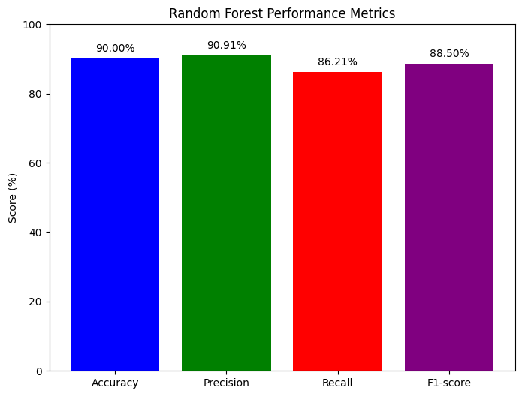

## Fig 5.2 Classification Report Graph

## 5.3 Confusion matrix:

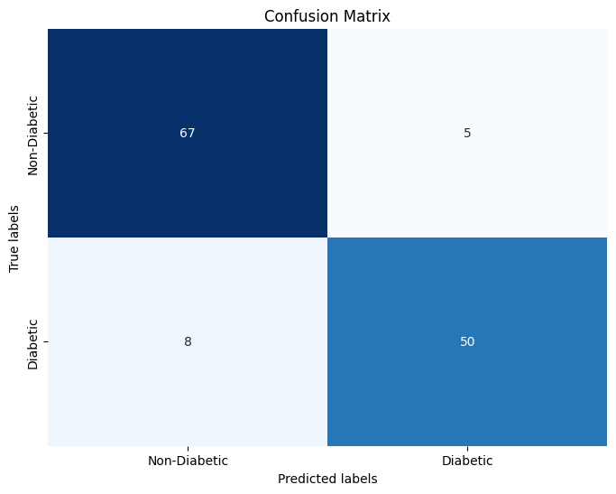

**Fig5.3 Confusion matrix**

## 5.4 Outputs

## 5.4.1 Home Page

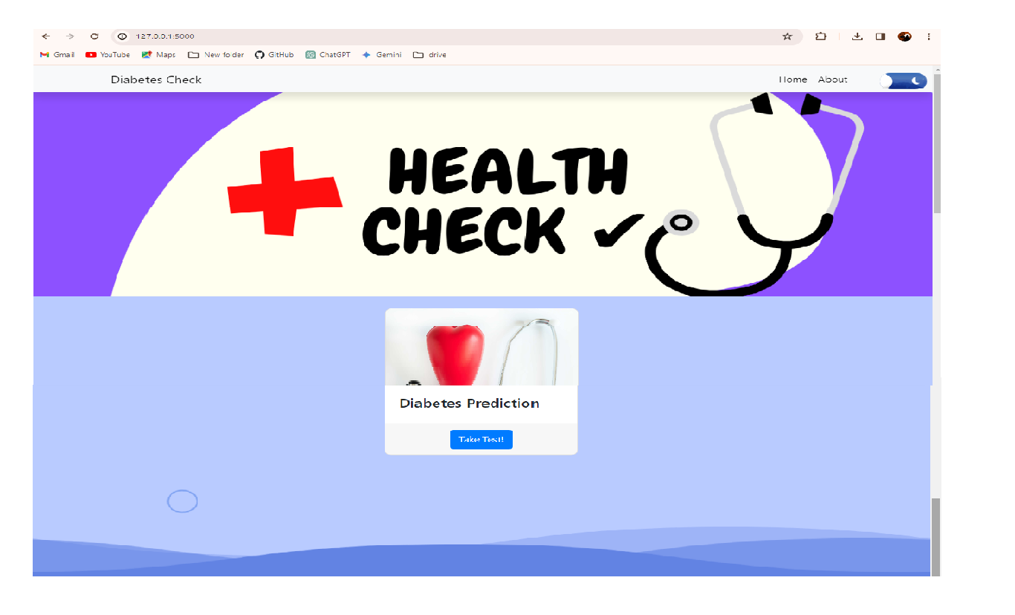

**Fig5.4.1 Home Page**

## 5.4.2 About Page

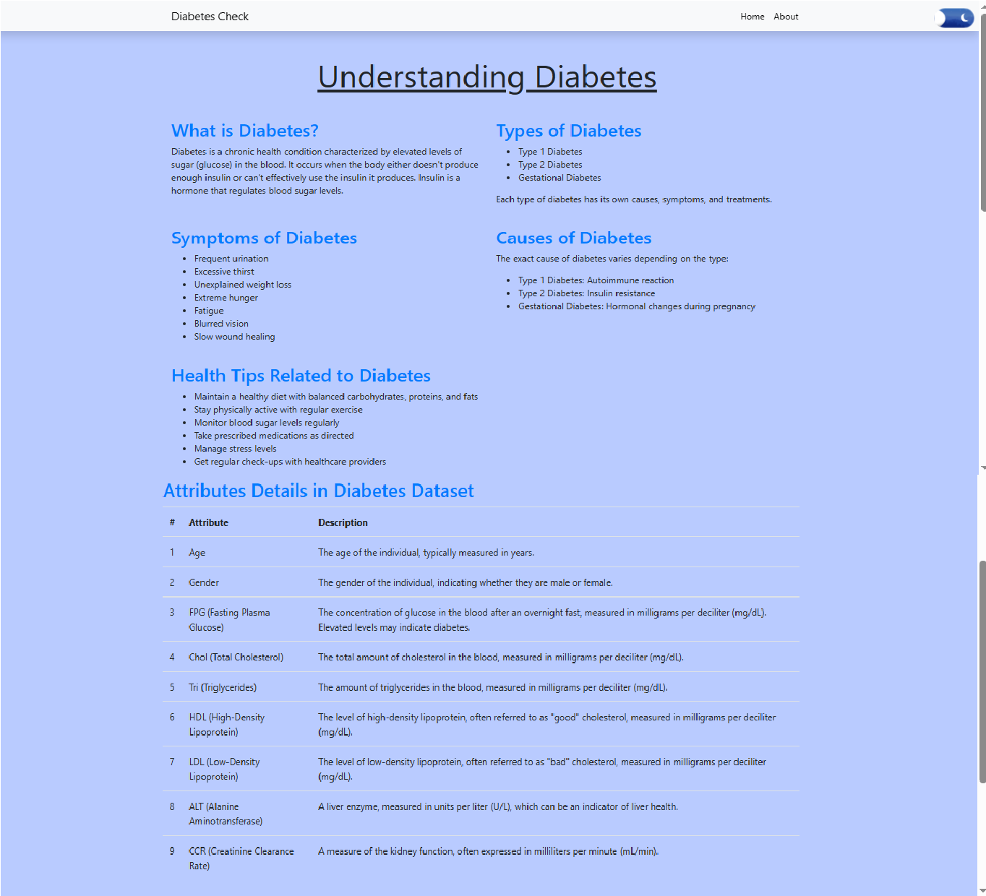

**Fig5.4.2 About Page**

**5.4.3 Input Page**

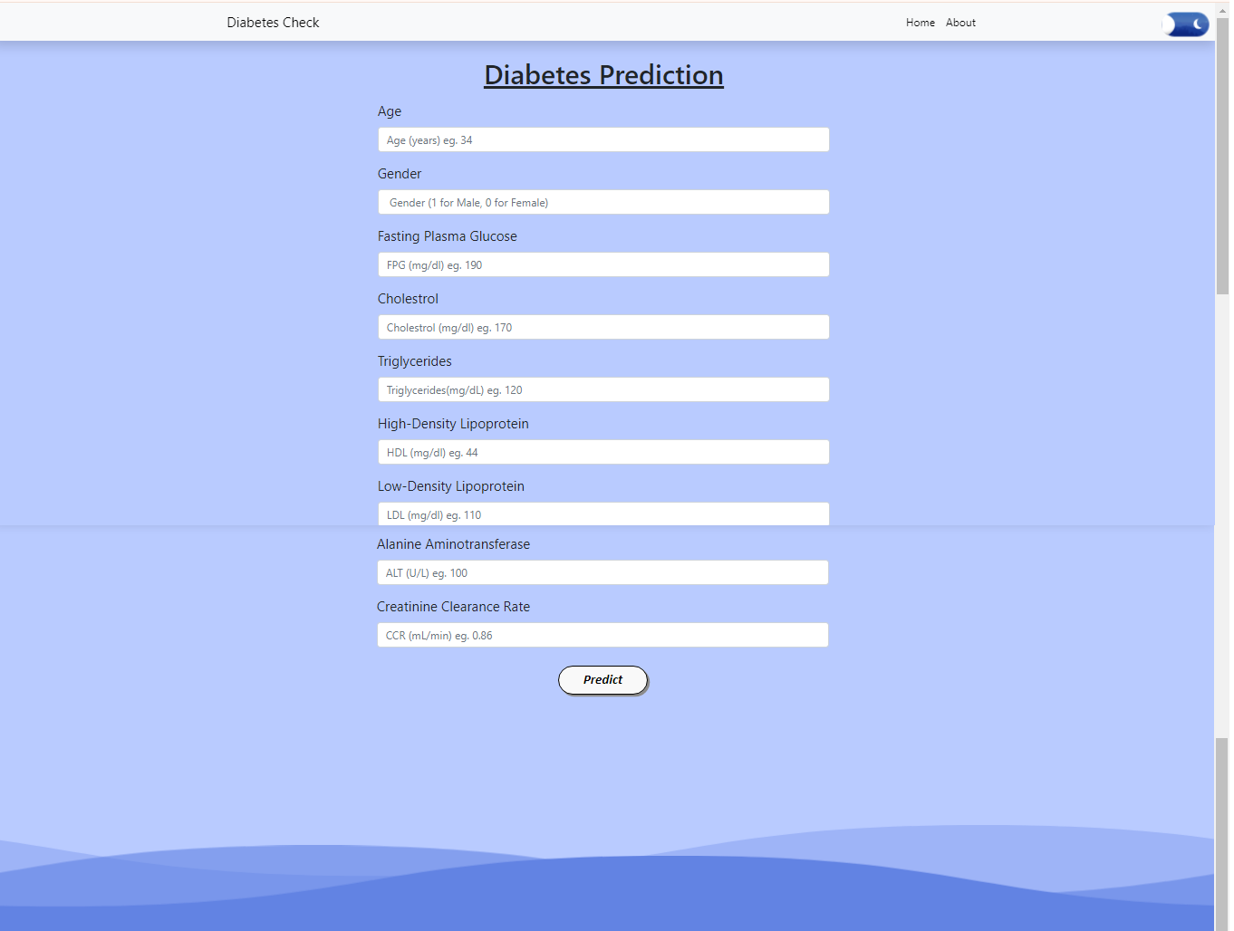

**Fig5.4.3 Input Page**

**5.4.4 Negative Output**

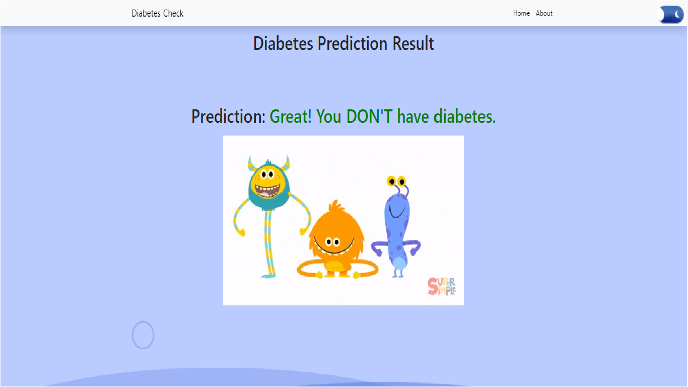

**Fig5.4.4 Negative Output**

**5.4.5 Positive Output**

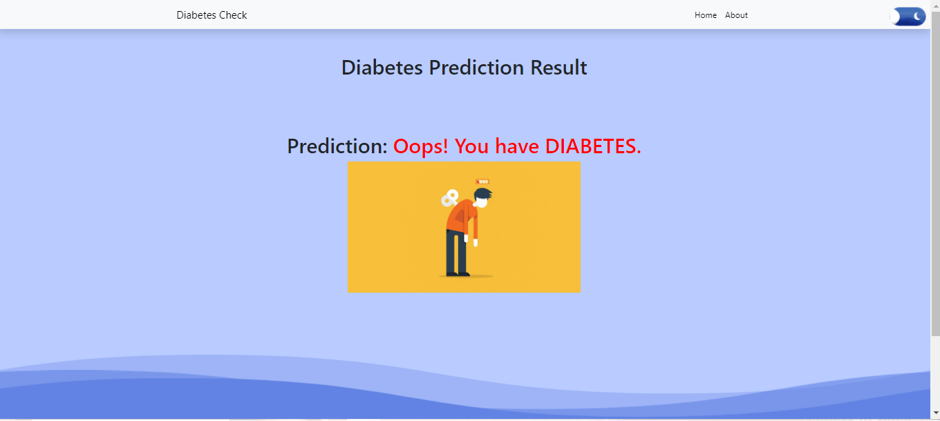

**Fig5.4.5 Positive Output**

**5.4.6 Invalid Input**

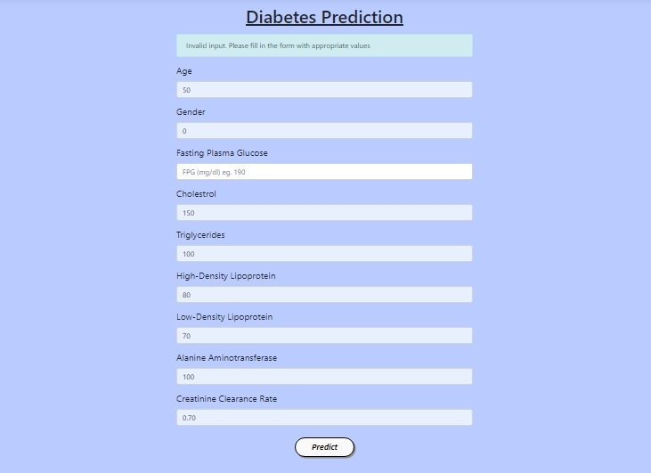

## CHAPTER- 6

**CONCLUSION & FUTURE WORK**

In essence, this project investigated the effectiveness of machine learning models in diabetes classification. By applying random forest algorithms and logistic regression to a pre-processed dataset, the project achieved impressive accuracy of around 90% for both. This achievement indicates the promise of developing efficient and non-invasive diagnostic tools for diabetes prediction using a limited set of readily available medical attributes. This underscores the significant contribution machine learning can make to preventative healthcare by enabling the early identification of individuals at risk.

**6.1 FUTURE WORK**

Future efforts could explore leveraging deep learning techniques to uncover even more intricate patterns within the data. Additionally, incorporating a wider range of patient data, such as lifestyle habits, body mass index, and family history, has the potential to further refine diagnostic accuracy and personalize risk assessments. An android application can be developed to improve the accessibility.

By pursuing these advancements, this project's findings lay the groundwork for the development of robust and informative clinical decision-making tools, empowering both patients and healthcare professionals in the fight against diabetes.

**REFERENCES**

* <https://www.google.com/>
* <https://chat.openai.com>
* <https://bard.google.com/chat>
* <https://www.kaggle.com>
* <https://www.w3schools.com/>
* <https://github.com/>
* <https://sci-hub.se/>
* <https://www.ncbi.nlm.nih.gov/pmc/articles/PMC10107388/>
* <https://www.ncbi.nlm.nih.gov/pmc/articles/PMC10107388/>
* <https://www.researchgate.net/publication/343536932_A_Review_of_Diabetic_Prediction_Using_Machine_Learning_Techniques>
* <https://sciencescholar.us/journal/index.php/ijhs/article/download/9617/6620>
* <https://www.amazon.in/Prediction-Diabetes-using-Vague-Theory/dp/3330074566>
* [https://www.analyticsvidhya.com/blog/2022/01/diabetes-prediction- using-machine-learning/](https://www.analyticsvidhya.com/blog/2022/01/diabetes-prediction-%20using-machine-learning/)