**Raita Mitra for Crop, Fertilizer and Plant Disease Detection**

Shivasharane Akkamahadevi Women’s

Polytechnic, Shiralakoppa

our guide Mr.Umesha D.K,

May 05, 2024

**Abstract**

This study presents a robust agricultural decision support system employing machine learning techniques for crop recommendation, fertilizer prescription, and disease anticipation, integrating essential agricultural indicators such as soil nutrient levels, pH, precipitation trends, and crop varieties. Through preprocessing and model training, the system utilizes Random Forest and Naive Bayes algorithms for crop and fertilizer prediction, achieving commendable accuracy rates of 99.09% and 99.2%, respectively, while disease prediction relies on the ResNet-9 model. By empowering farmers with well-informed choices regarding crop selection, optimal fertilization techniques, and disease control, the system enhances agricultural efficiency and sustainability. This research significantly contributes to precision agriculture, promoting sustainable methodologies and safeguarding food security through enhanced crop productivity and optimized resource allocation.

**Keywords**— Convolutional Neural Networks, Disease Detection Deep Learning, Agricultural Productivity. Crop Recommendation & Fertilizer Recommendation ,Machine Learning.

**I. INTRODUCTION**

This project harnesses machine learning to assist farmers in making informed decisions regarding crop selection, fertilizer application, and disease control. By analyzing factors like soil nutrients, rainfall patterns, crop types, and leaf images, it delivers personalized recommendations. Utilizing advanced algorithms such as Random Forest and Naive Bayes, the system aims for high prediction accuracy, ultimately optimizing agricultural practices for increased productivity and sustainability. Through the integration of diverse data sources, it addresses key challenges faced by farmers, aiming to enhance crop yield while minimizing resource wastage and environmental impact.

The developed system provides a user-friendly interface for easy access and interpretation of recommendations, empowering farmers with actionable insights and contributing to the advancement of precision agriculture. Combining cutting-edge technology with practical solutions to real-world agricultural problems, the project bridges the gap between traditional farming methods and modern data-driven approaches. Collaboration with agricultural experts ensures relevance and applicability to the farming community, with an emphasis on simplicity and usability to cater to the diverse needs of farmers worldwide. Driven by a commitment to improving food security and promoting sustainable farming practices, the project envisions a future where technology serves as a powerful tool for agricultural development, revolutionizing farming through data-driven decision-making and innovative solutions.

**II LITERATURE REVIEW**

SamyakShrimali et.al. achieved an accuracy of 95.7% and an F1 score of 96.1% in detecting crop diseases using the MobileNetV2 model architecture and image filters [1].Leninisha Shanmugam et.al. proposed a methodology for automatic detection of plant diseases using remote sensing images [2].The model described in the research papers makes use of the PlantVillage dataset, which contains a substantial number of images for training and testing. Specifically, the dataset used in the research includes 11993 images with 11 different classes of plant diseases [3].54,305 photos of 38 different plant disease classes [4], and a dataset providing good variations in color, orientation, and size of leaves for plant disease identification [5]. These diverse datasets enable the models to learn and generalize effectively, resulting in high accuracy rates ranging from 97.73% to 99.80% in disease classification and identification tasks. The utilization of such extensive datasets is crucial for training robust models capable of accurately identifying various plant diseases and pests in agricultural settings. The crop recommendation models discussed in the provided contexts utilize machine learning algorithms like Random Forest, KNN, Decision Tree, and others to suggest suitable crops based on factors such as soil nutrient values (N, P, K), rainfall, and pH levels. These models aim to enhance crop production by recommending the most appropriate crops for specific environmental conditions[6][7]. By analyzing various parameters like nitrogen, phosphorus, potassium, humidity, temperature, and other soil characteristics, these systems help in preventing soil degradation and maintaining crop health[8]. The Random Forest 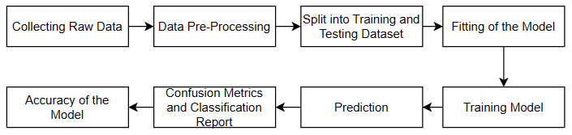algorithm, in particular, has shown promising results in accurately predicting the best crop choices for given land based on the input parameters, thus aiding farmers, researchers, and policymakers in making informed decisions regarding crop management and planning. The paper addresses the challenge of crop diseases in agriculture and proposes a deep-learning based framework for accurate disease prediction. The research discussed in the contexts utilizes deep learning methods and computer vision technology to train a deep convolutional neural network (DNN) on a dataset of plant leaf images to detect diseases. The study involved thousands of images of healthy and infected plant leaves for training the deep learning model, achieving high accuracy in disease classification [9]. Additionally, the research compared the performance of three deep learning models (CNN, VGG16, VGG19) on a dataset of 9,127 annotated plant images, with CNN demonstrating the highest accuracy of 0.97 and an F1 score of 0.95 [10]. The study also emphasized the importance of early disease diagnosis and precise categorization of plant leaf diseases, showcasing the potential of deep learning algorithms in this field [11].

**III METHODOLOGY**

**Figure 1: Steps involved in the Methodology**

The methodology for the Raita Mitra system project, encompassing crop recommendation, fertilizer recommendation, and plant disease classification using machine learning along side a Python Flask-based web application for the front-end, involves a systematic approach.

1. **Data Collection:**

We gather relevant data from various sources including historical crop yields, soil nutrient levels, weather conditions, and images of plant leaves with associated disease labels. We maintain our dataset on GitHub for easy access and collaboration. The dataset used in our project is an augmented version of the original Plant Village Dataset, created through offline augmentation techniques. The original dataset, containing approximately 87,000 RGB images of healthy and diseased crop leaves categorized into 38 different classes, can be found at the provided link. We have divided the total dataset into training 70295 images for training and validation 16705 sets and Number of plants 14 Number of diseases 26 following an 80/20 ratio while preserving the directory structure. Additionally, we have created a separate directory containing 33 test images for prediction purposes. Crop recommendation dataset for using 2201 and Fertilizer recommendation dataset for using 23 different type of crops.

1. 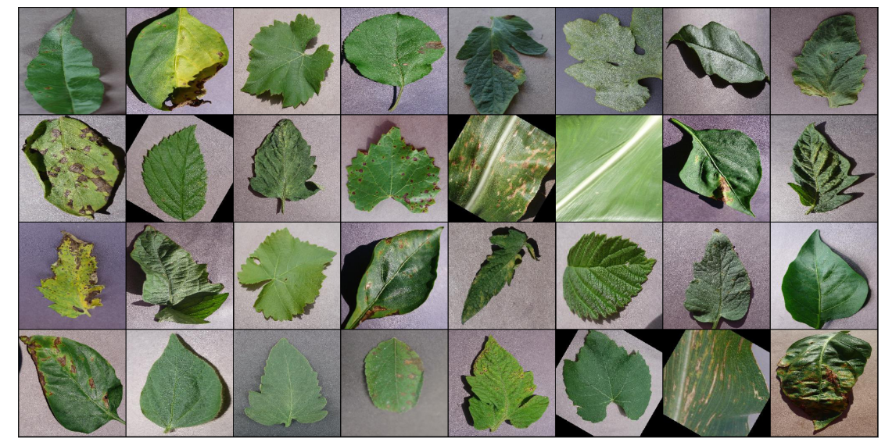**Data Preprocessing:**

Before training our models, we clean the data to remove any noise and inconsistencies. This ensures the quality and reliability of our predictions. The collected dataset of plant disease were separated into Healthy and Disease labels, Images in the dataset are 3 to 4 MB size ,which consumes lot of memory and time for processing ,Images were resized to shape We can see the shape (3, 256 ,256) of the image. 3 is the number of channels (RGB) and 256 x 256 is the width and height of the image.

Figure3.5 shows the some of the samples of labeled dataset used for proposed work.

**Figure 2: Examples of our labeled dataset**

**ResNet9**

In ResNets (Residual Networks), the architecture introduces residual blocks to tackle the limitations of traditional neural networks, particularly in training very deep networks. Unlike in conventional neural networks where each layer sequentially feeds into the next layer, in ResNets, residual blocks are employed. These blocks allow the flow of information not only to the subsequent layer but also directly to the layers that are 2-3 hops away.The primary purpose of using residual blocks is to mitigate overfitting, a scenario where the validation loss stops decreasing and starts increasing while the training loss continues to decrease. By enabling direct connections between layers across multiple hops, ResNets facilitate better gradient flow during training, thereby addressing the vanishing gradient problem commonly encountered in deep neural networks.

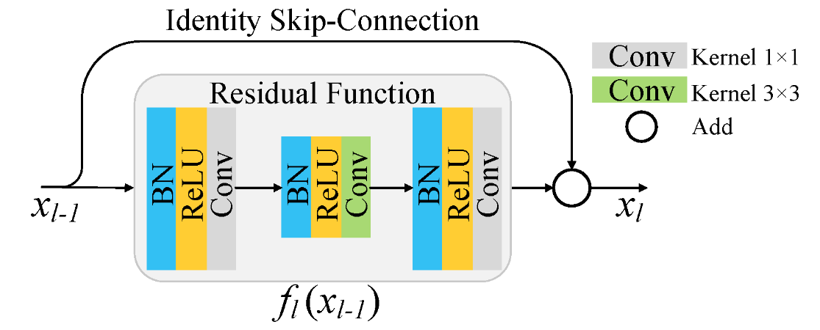

**Figure 3:Residual Function**

1. **Data Splitting:**

We split our dataset into training and testing sets using an 80:20 ratio. This allows us to evaluate the performance of our models effectively.

1. **Model Development:**

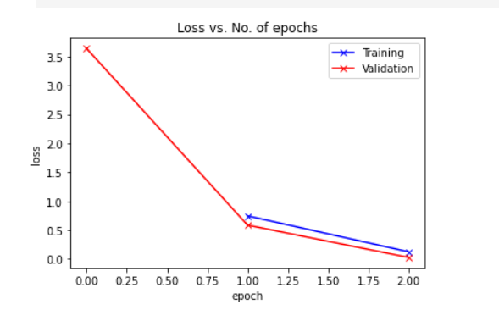We develop machine learning models using popular algorithms such as Random Forest and Naive Bayes. Random Forest is used for crop and fertilizer recommendation, while Naive Bayes is utilized for plant disease classification.

1. **Model Training:**

Our models are trained on the training data to learn patterns and relationships within the dataset. This step is crucial for accurate predictions.

1. **Model Testing:**

We evaluate the performance of our models using the testing data to ensure they generalize well to unseen data and provide reliable recommendations.The dataset used in our project is an augmented version of the original Plant Village Dataset, created through offline augmentation techniques. The original dataset, containing approximately 87,000 RGB images of healthy and diseased crop leaves categorized into 38 different classes, can be found at the provided link. We have divided the total dataset into training 70295 images for training and validation 16705 sets and Number of plants 14 Number of diseases 26 following an 80/20 ratio while preserving the directory structure. Additionally, we have created a separate directory containing 33 test images for prediction purposes.

**Figure: Training graphs for proposed Resnet model**

1. **Loss vs. No. of epochs**

**Figure: Training for proposed Resnet model**

**(b)Accuracy Vs Epoch graphs**

|  |  |
| --- | --- |
| **Algorithm** | **Result** |
| **Decision Tree** | **0.9%** |
| **Naïve Bayes** | **0.99%** |
| **SVM** | **0.97%** |
| **Logistic Regression** | **0.95%** |
| **Random Forest** | **0.99%** |
| **XGBoost** | **0.993%** |

Below, Figure 6.14 illustrates the accuracy of crop and fertilizer recommendation.

Crop & Fertilizer Accuracy Table

1. **Interpretation of Model Prediction**

Step 1: When Crop recommendation or Fertilizer recommendation Predict button is enabled the following “Result Page” will be opened.

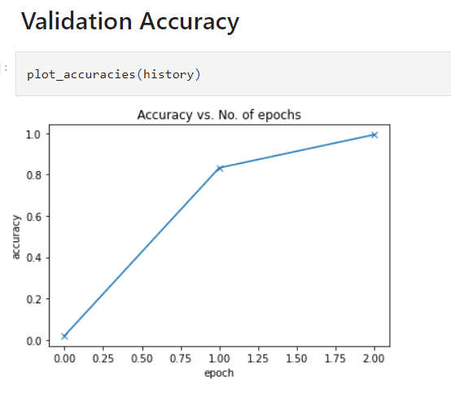

Crop Recommendation

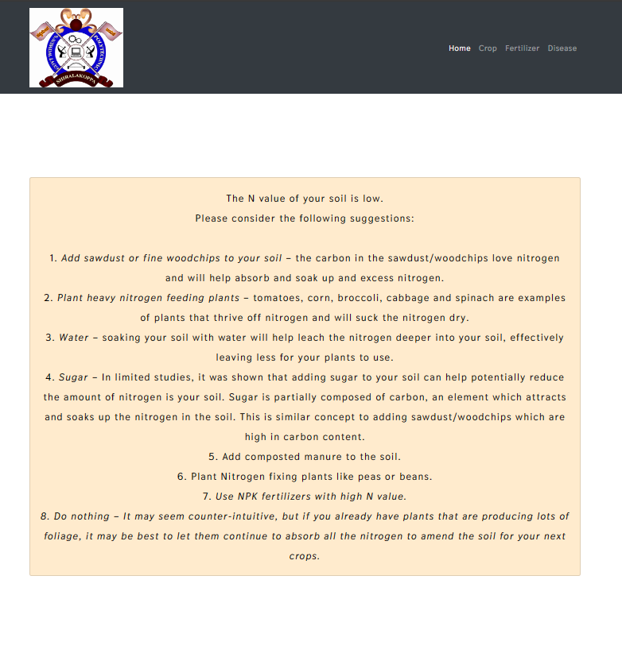

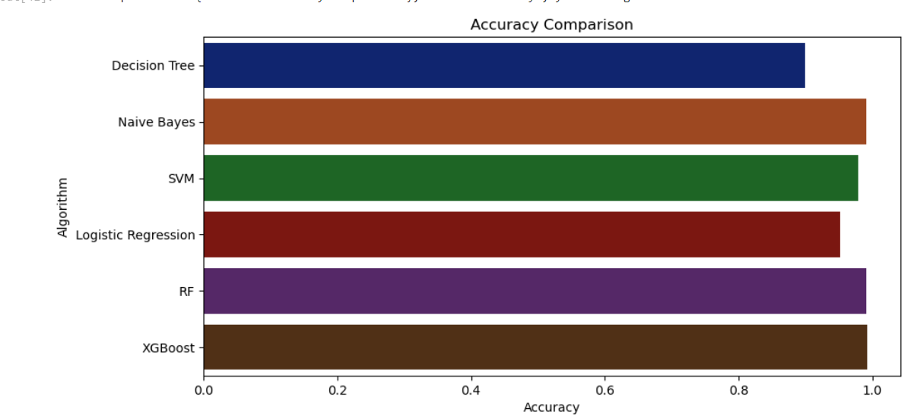

Fertilizer Recommendation

Step 2: When the “Classify Image is clicked both the original image and Predicted images will be classified proposed Res net model and its predicted class and suggestion will be displayed ”

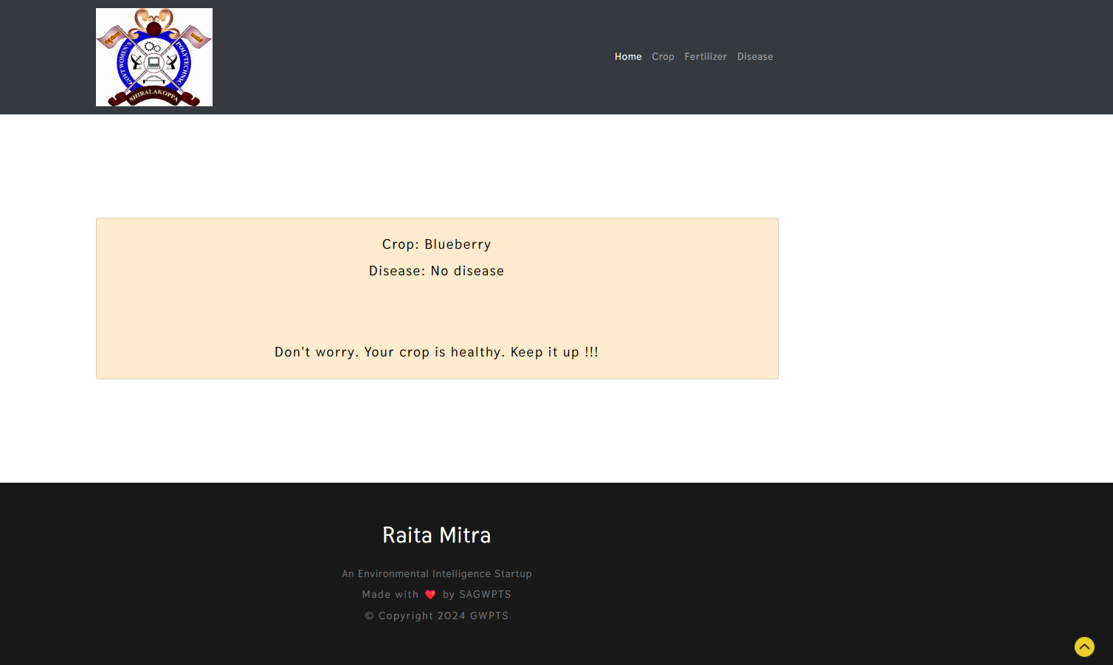

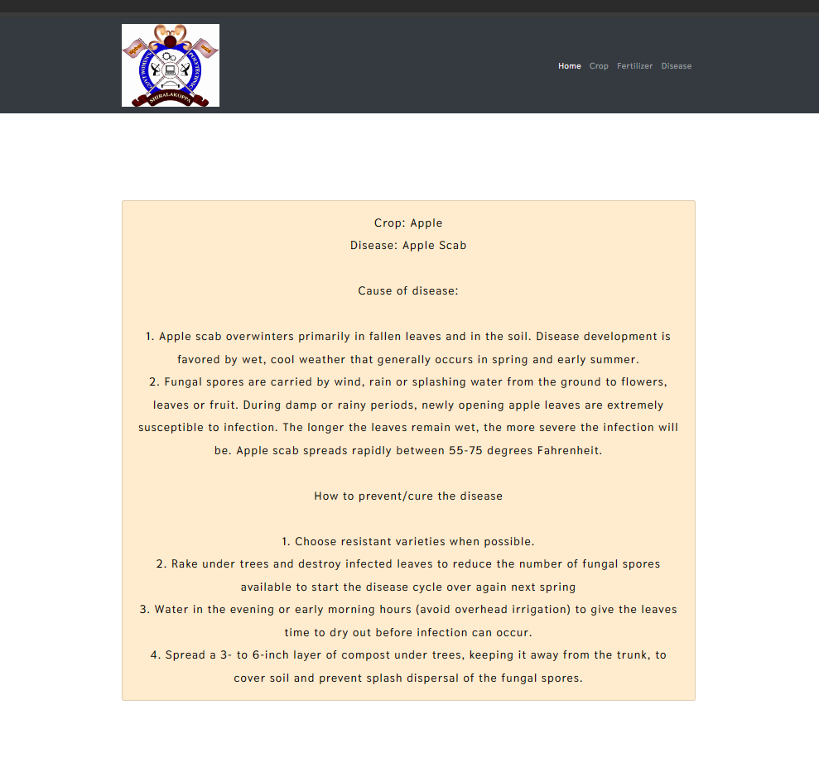

Plant Disease Detection

1. **Model Evaluation:**

Once our models are trained and evaluated, we integrate them into a unified system using Python Flask. This lightweight web application framework allows us to develop a user-friendly interface for farmers to input their data and receive recommendations.

H. Model Testing

**Step 1:** When the code for the GUI is run in Jupiter notebook the application will executed and the below shown screen will be opened .It contains the Homepage

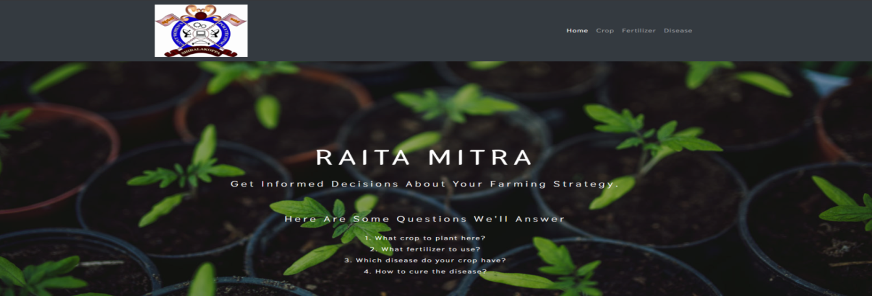

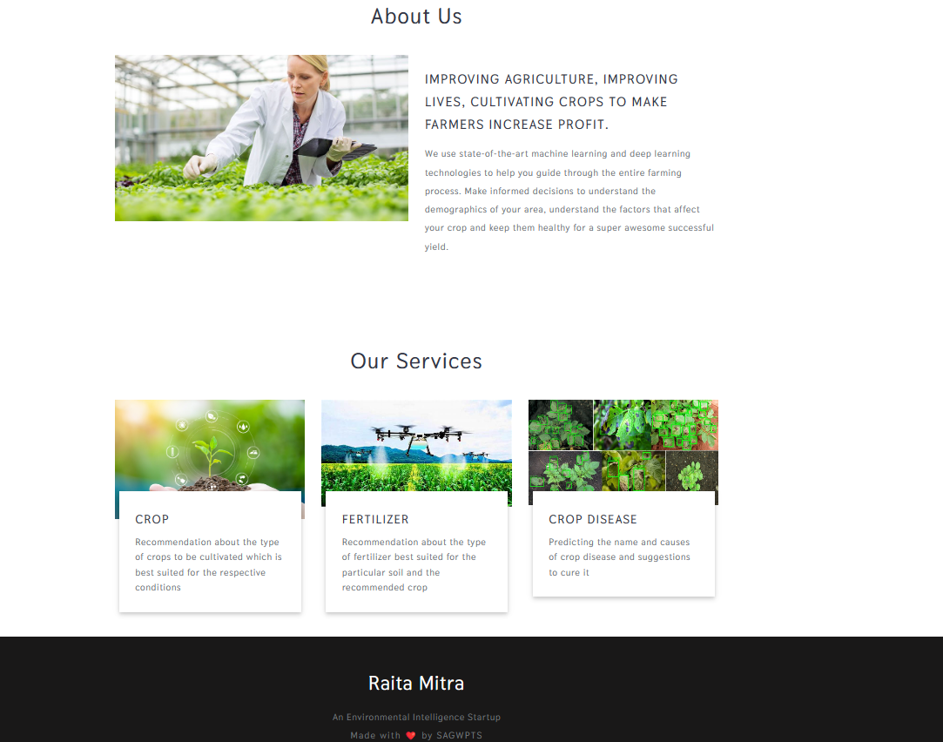

Home Page

**Step 2:** When the “Crop” or “Fertilizer” button is clicked, the following screen to crop recommendation interface will be opened. Input should be given in text form.

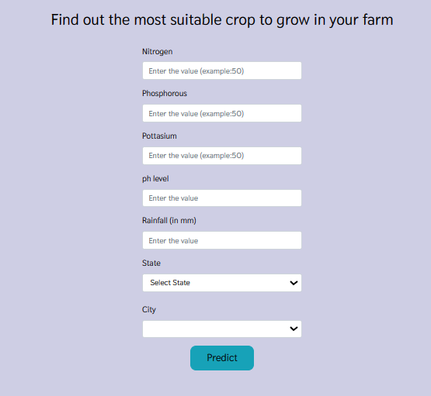

Crop Recommendation

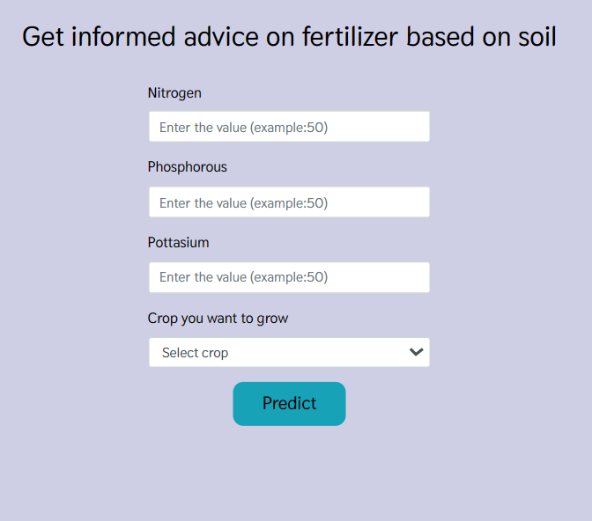

Fertilizer Recommendation

**Step 3:** The selected file will be uploaded and Predict button will be enabled on the screen. Click on Predict button to Predict the image.

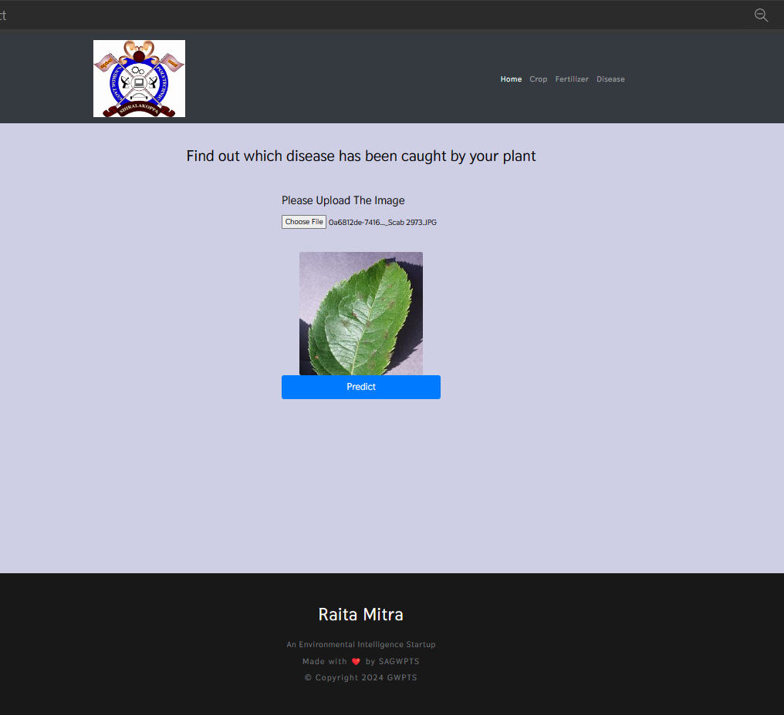

Plant Disease Detection

1. **System Maintenance:**

We continuously monitor the performance of our system and update our models with new data to improve accuracy. Additionally, we gather feedback from users to enhance the web application interface and add new features as needed. Flask's flexible architecture facilitates seamless updates and maintenance.By following these steps, we aim to provide farmers with accurate and timely recommendations for crop selection, fertilizer usage, and plant disease management, ultimately improving agricultural productivity and sustainability.

**IV. CONCLUSION**

The capstone project has reached a significant milestone with the successful integration of crop recommendation, fertilizer recommendation, and plant disease detection features into the Raita Mitra ML application. Leveraging ResNets for image classification, particularly in distinguishing between healthy and diseased plants, has yielded impressive results. By carefully tuning parameters and employing techniques such as learning rate scheduling, gradient clipping, and weight decay, the ResNet model has achieved impeccable accuracy, correctly predicting every image in the test set without errors. Additionally, incorporating ResNet-9 has further bolstered the application's capabilities, while the random forest algorithm has demonstrated exceptional accuracy, reaching 99%. These advancements hold promise for optimizing crop yield, resource management, and disease prevention for farmers. Looking ahead, there remain opportunities for further refinement and expansion of the application's functionality and usability.

**VI. FUTURE SCOPE**

* The future enhancement of the Raita Mitra project includes integrating AI for real-time disease detection, multi-lingual support , weather forecast integration, and mobile app development.
* More data can be collected manually via web scrapping to make the system more accurate
* Additional plant images can be collected to make the disease detection part more robust and generalized

**ACKNOWLEDGMENT**

We express deep gratitude to our guide, Mr. Umesha D K, and the Head of the Computer Science & Engineering department for their invaluable support. Special thanks to our Principal, Mr. D S Ravishankar, and all lecturers for their assistance. Additionally, we appreciate the unwavering encouragement from our parents, classmates, and supporters. Their contributions were essential to the successful completion of this project.

**REFERENCES**

1. [SamyakShrimali ,detecting crop diseases using the MobileNetV2 model architecture and imagefilters ,04 Jul 2023-Advances in technology innovation-Vol. 8, Iss: 3, pp 192-209](https://typeset.io/papers/an-improved-mobilenet-for-disease-detection-on-tomato-leaves-2dglo1eg)
2. [Leninisha Shanmugam, automatic detection of plant diseases using remote sensing images, 01 Aug 2023](https://typeset.io/papers/machine-learning-techniques-for-plant-disease-detection-an-1o2trsgw)
3. [Guangyuan Zhang, Kefeng Li, Peng Wang, Zhenfang Zhu,14 Jul 2023-Frontiers in Plant Science](https://typeset.io/papers/a-lightweight-model-for-efficient-identification-of-plant-1g8wo47q)
4. [Anita Shrotriya, Akhilesh Kumar Sharma, Nitesh Pradhan,09 Mar 2023-pp 191-196](https://typeset.io/papers/a-light-weight-deep-convolutional-neural-network-model-for-1o54w2t4)
5. [A light weight Deep Convolutional Neural network model for plant disease identification,09 Mar 2023](https://typeset.io/papers/a-light-weight-deep-convolutional-neural-network-model-for-817vii2b)
6. [Guangyang Deng, Chen Dong, Jiabo Chen, Jiaxing Gao , Crop planting recommendation algorithm based on ensemble learning,26 Jun 2023-Vol. 12721, pp 127211D-127211D](https://typeset.io/papers/crop-planting-recommendation-algorithm-based-on-ensemble-3dvz0m0n)
7. [P. Kumar, Kusum Lata, Sushant Jhingran, Crop recommendation using machine learning algorithms,11 May 2023-pp 100-103 , published in: International Conference on Database Theory](https://typeset.io/papers/crop-recommendation-using-machine-learning-algorithms-1avmdpms)
8. [Crop Recommendation System using Random Forest Algorithm in Machine , 04 May 2023](https://typeset.io/papers/crop-recommendation-system-using-random-forest-algorithm-in-3jjnncn9)
9. [Plant Disease Detection Using Image Processing and Deep Learning, D Bhaskar15 Jun 2023-Indian Scientific Journal Of Research In Engineering And Management-Vol. 07, Iss: 06](https://typeset.io/papers/plant-disease-detection-using-image-processing-and-deep-y1pwqhzr)
10. [Plant Leaf Disease Detection using Deep Learning, 31 May 2023-International Journal For Science Technology And Engineering (International Journal for Research in Applied Science and Engineering Technology)-Vol. 11, Iss: 5, pp 3458-3461](https://typeset.io/papers/plant-leaf-disease-detection-using-deep-learning-39hnff3n)
11. [Plant Leaf Disease Detection and Classification using Deep Learning Tech 30 May 2023-International Journal For Multidisciplinary Research (International Journal For Multidisciplinary Research)-Vol. 5, Iss: 3](https://typeset.io/papers/plant-leaf-disease-detection-and-classification-using-deep-27mj9kgr)