1. Below image shows the search result of branch type computer : Showing deleted record also. (always shows 1st deleted record with matching name)

Deleted branch can be retrieved back, once retrieved you have option to view /edit /delete.

On click of view - branch edit page is landed with blank values for name and code.

On click of edit and delete - nothing happens

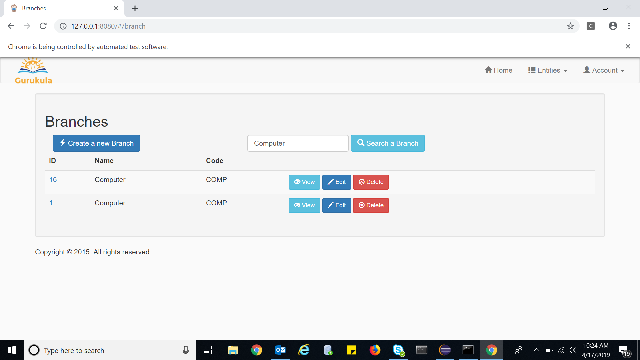

I feel deleted entries should not be displayed on search, if displayed also there should not be edit/view/delete options displayed

1. Registration functionality is not working.

After providing valid data, seeing the error message “**Registration failed!** Please try again later.”

There is no information given to the user which data he entered is wrong. Generalized message is shown in UI

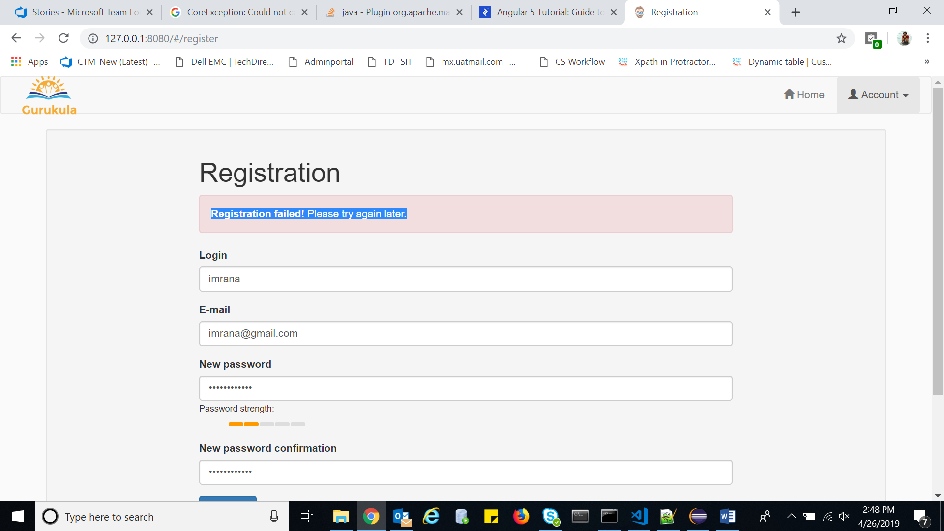

1. On searching a staff by passing value in staff searcher, Branch name is displayed as blank in listing.

Staff landing page displays the branch name correctly. This issue is seen only when a particular staff is searched using searcher

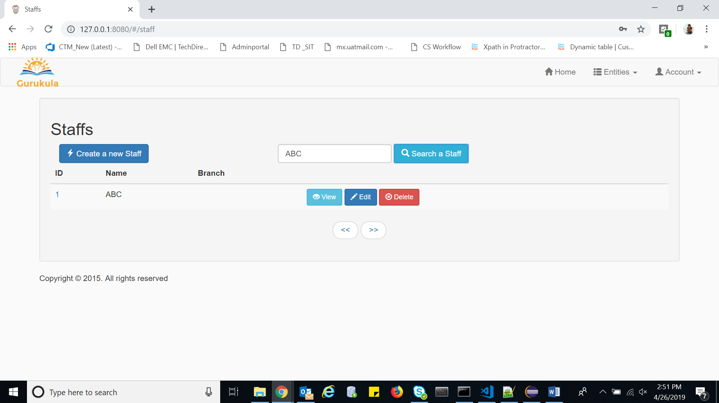

1. In staff landing page there is a button << which is not required when the records are less

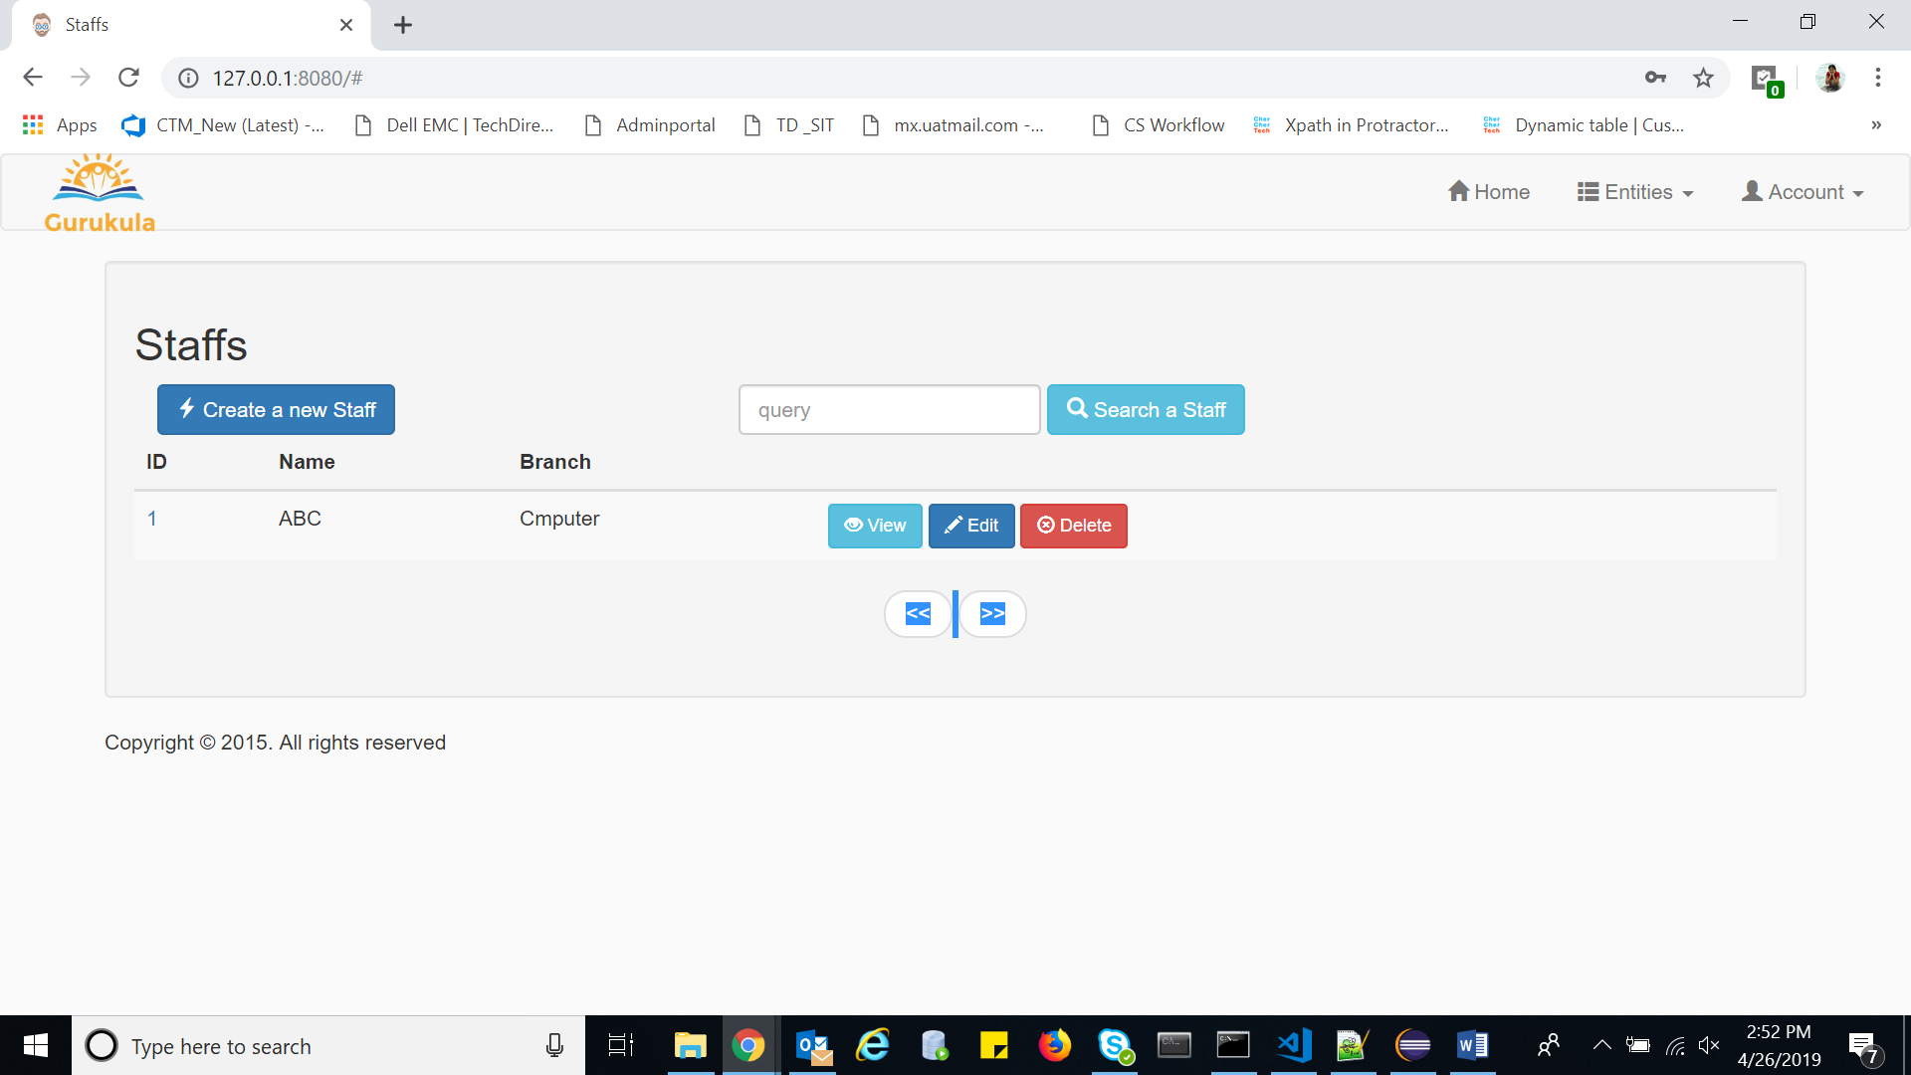

1. Delete button should be disabled when a Branch is being used for a staff. Currently delete button for that particular branch is active but on click of delete button in pop up there is no action

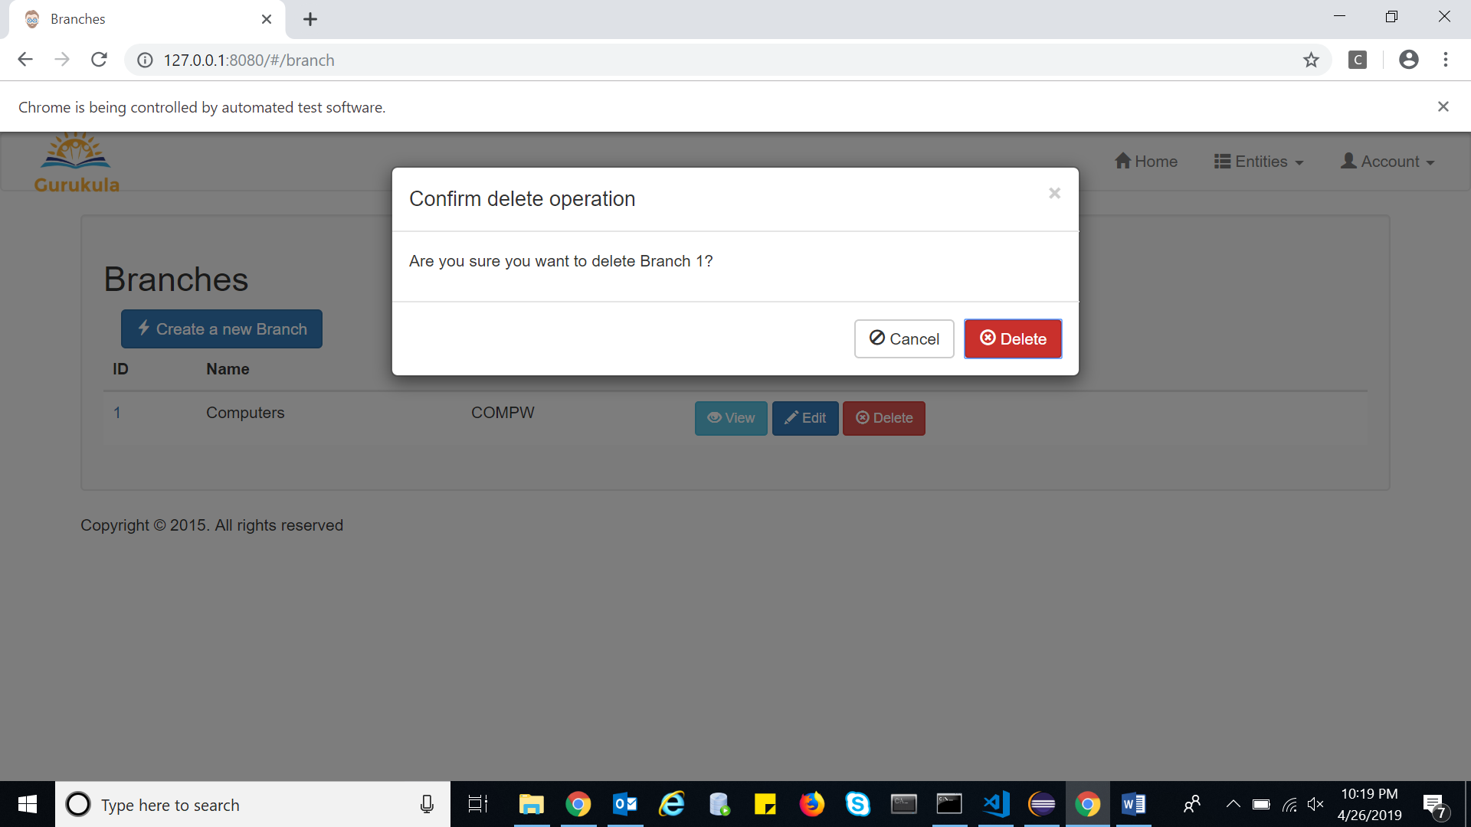

6 . **Automatic Login** checkbox functionality missing**.** Even if checked , next time login will again ask for credentials to login.

1. Password change and setting change save are not working.