Topics: Confidence Intervals

- For each of the following statements, indicate whether it is True/False. If false, explain why.

- The sample size of the survey should at least be a fixed percentage of the population size in order to produce representative results.
Ans:- false, sample size must be random.

II. The sampling frame is a list of every item that appears in a survey sample, including those that did not respond to questions.
Ans: false, because- The sampling frame refers to a list of an item which responds to the question and not the ones which do not respond to the questions

III. Larger surveys convey a more accurate impression of the population than smaller surveys.
Ans:- True.

- PC Magazine asked all of its readers to participate in a survey of their satisfaction with different brands of electronics. In the 2004 survey, which was included in an issue of the magazine that year, more than 9000 readers rated the products on a scale from 1 to 10. The magazine reported that the average rating assigned by 225 readers to a Kodak compact digital camera was 7.5. For this product, identify the following:

- The population
- The parameter of interest
- The sampling frame
- The sample size
- The sampling design
- Any potential sources of bias or other problems with the survey or sample
Ans:- A. 9000 readers out of total readers
B. Mean = 7.5
C. Total readers
D. 225
E. The sampling design- 7.5
F. Any potential sources of bias or other problems with the survey or sample- 7.5

- For each of the following statements, indicate whether it is True/False. If false, explain why.

- If the 95% confidence interval for the average purchase of customers at a department store is $50 to $110, then $100 is a plausible value for the population mean at this level of confidence.
Ans:- True

- If the 95% confidence interval for the number of moviegoers who purchase concessions is 30% to 45%, this means that fewer than half of all moviegoers purchase concessions.
Ans:- False If the 95% confidence interval for the number of moviegoers who purchase from the concession stand is 30% to 45%, then fewer than half of all moviegoers do

- The 95% Confidence-Interval for μ only applies if the sample data are nearly normally distributed.
Ans:- False with large enough sample, the central limit theorem implies a normal sampling distribution regardless of the distribution of data.

- What are the chances that ?

- ¼
- ½
- ¾
- 1
Ans :- 1/2 This is pure assumption. There is a 50% chance that the sample mean( X greater than the population mean(µ).

- In January 2005, a company that monitors Internet traffic (WebSideStory) reported that its sampling revealed that the Mozilla Firefox browser launched in 2004 had grabbed a 4.6% share of the market.

- If the sample were based on 2,000 users, could Microsoft conclude that Mozilla has a less than 5% share of the market?

- WebSideStory claims that its sample includes all the daily Internet users. If that’s the case, then can Microsoft conclude that Mozilla has a less than 5% share of the market?

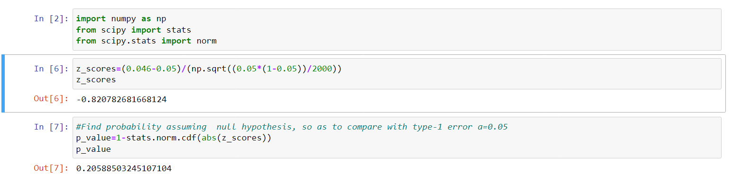

- A book publisher monitors the size of shipments of its textbooks to university bookstores. For a sample of texts used at various schools, the 95% confidence interval for the size of the shipment was 250 ± 45 books. Which, if any, of the following interpretations of this interval are correct?

- All shipments are between 205 and 295 books.
Ans:- INCORRECT because the given interval (205,295) is not for 100% is only for 95% C.I.

- 95% of shipments are between 205 and 295 books.
Ans:- INCORRECT because the interval doesn’t specify individuals.

- The procedure that produced this interval generates ranges that hold the population mean for 95% of samples.
Ans:- CORRECT because the 95% of interval contains the population mean.

- If we get another sample, then we can be 95% sure that the mean of this second sample is between 205 and 295.
Ans:- INCORRECT because the interval doesn’t describe the mean of another sample.

- We can be 95% confident that the range 160 to 340 holds the population mean.
Ans:- INCORRECT because the given interval doesn’t belongs to 95% C.I.

- Which is shorter: a 95% z-interval or a 95% t-interval for μ if we know that σ =s?

- The z-interval is shorter
- The t-interval is shorter
- Both are equal
- We cannot say

Ans : A. The z-interval is shorter.
Because it tell us difference between mean of distribution and data points in standard deviation .

Questions 8 and 9 are based on the following: To prepare a report on the economy, analysts need to estimate the percentage of businesses that plan to hire additional employees in the next 60 days.

- How many randomly selected employers (minimum number) must we contact in order to guarantee a margin of error of no more than 4% (at 95% confidence)?

- 600
- 400
- 550
- 1000
Ans : A. 600
margins of error estimate is 1/sqrt(n)
if 0.04=1/25 is margin of error
then n=25^2 or 625.
Choose 600.

- Suppose we want the above margin of error to be based on a 98% confidence level. What sample size (minimum) must we now use?

- 1000
- 757
- 848
- 543

Ans:- C.
Number of employee = n and assume that p = 0.0 & q = 0.5 margin of error = 0.04
Z score for 98% C.I. is 2.33

Margin of error = Z*√pq/n
0.04 = 2.33 √0.5*0.5/n
n = 2.33^2*0.5*0.5/0.04^2
= 1.357225/0.0016
n = 848.26

hence the option C is correct.

