How to break the template in Python lets do it

1. First of all create a folder inside the trial (your module/app) static / trial similarly templates/trial

Like this

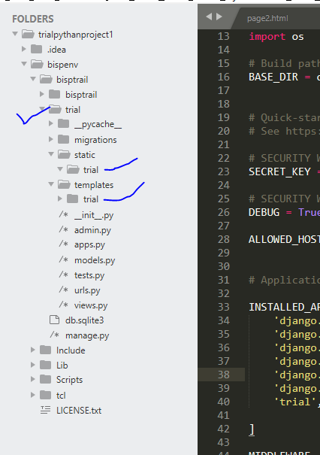

Now copy all the folders related to designing i.e. css , js, images folder in to the static / trial folder like this

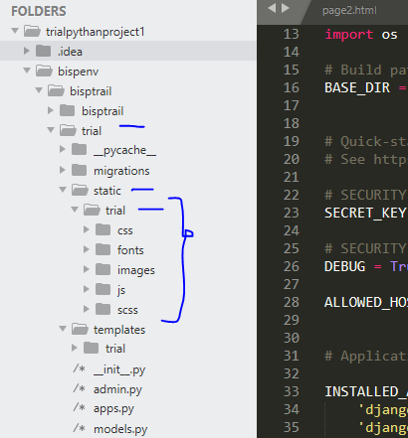

Now create a file base.html and save it inside the trial/templates/trial/base.html

This is the syntax of adding the css files in the head.html

{% load static %}

<link rel="stylesheet" href="{% static 'trial\\fonts\\icomoon\\style.css' %}">

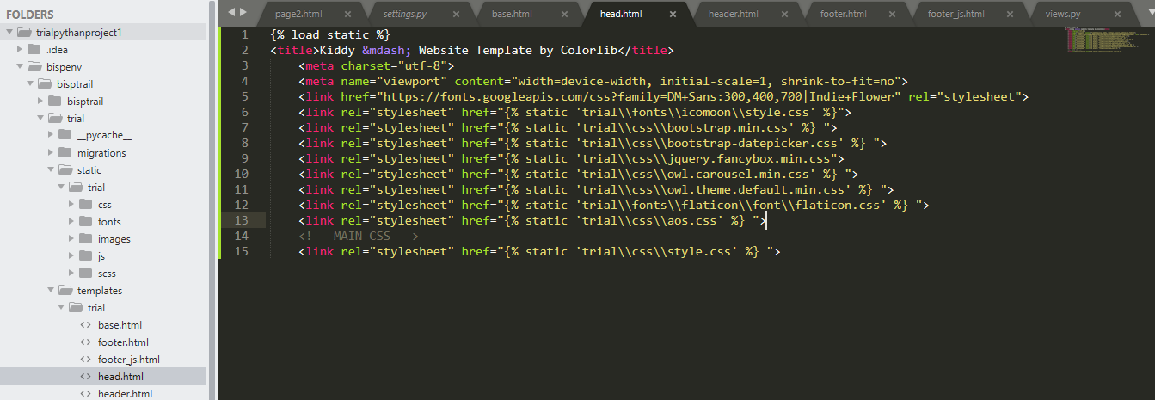

{% block content %}

{% endblock %}

This is equivalent to @yield(‘content’) in laravel

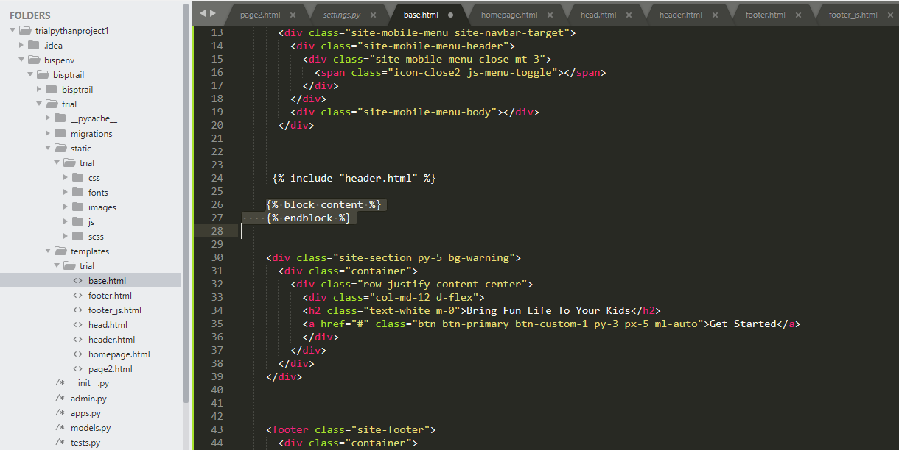

{% extends 'trial/base.html' %}

{% block content %}

{% endblock%}

This is equiivalent to

@section (‘content’)

@endsection ( in laravel)

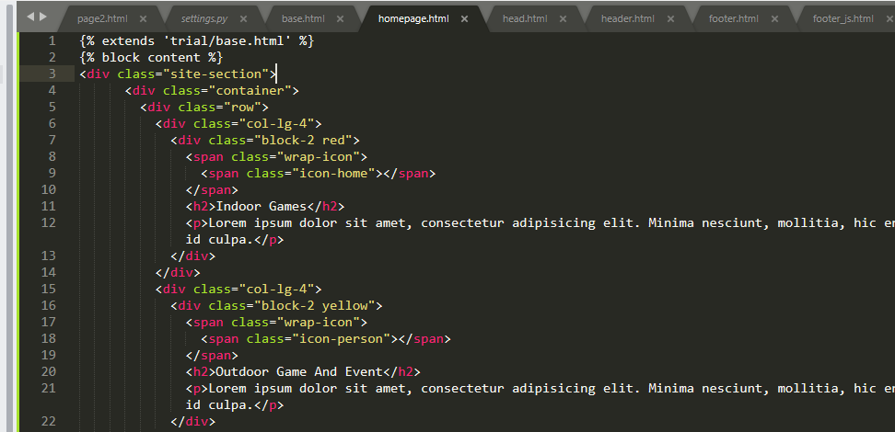

जहां manage.py file रखी है वहीं पर templates नाम का folder बनाना है and also you have to provide the location of that template folder in the settings.py like this

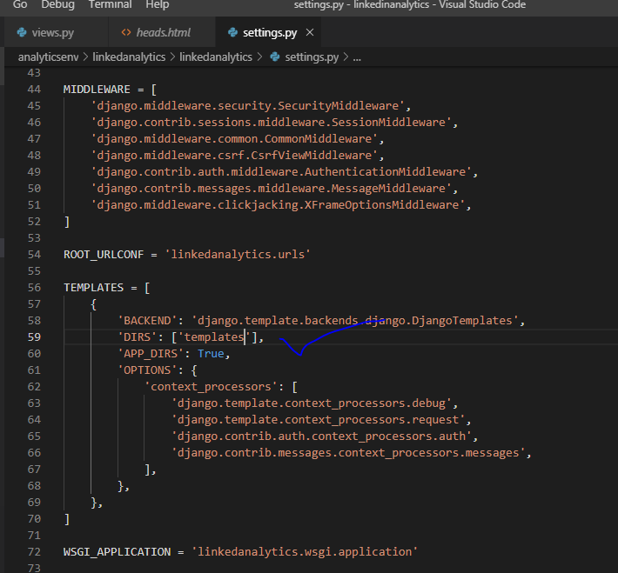

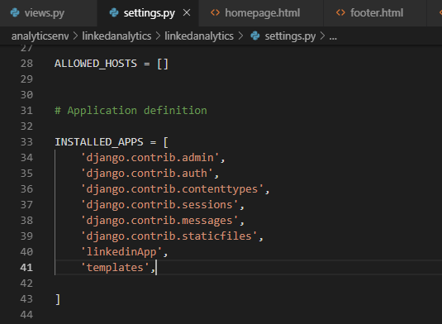

Templates adding in installed apps is also necessary

Each time you have to write {% load static %} in every file that is to be included

