EE 779 Assignment 4 (PCA)

Ashwin Kachhara, 10d070048

# Q3

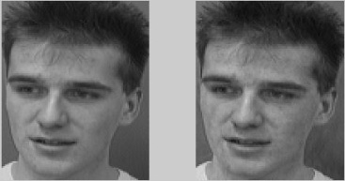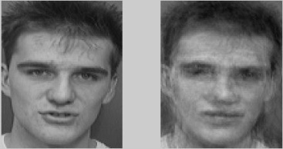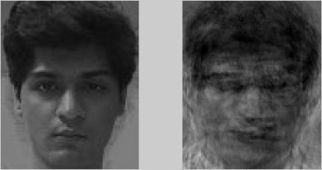

Above, are the original and reconstructed images (using 200 principal components) for one training set image, one test set image, and my own image.

The reconstructed training image is almost exactly the same as the original. The reconstructed test image is somewhat similar to the original test image (since this person was part of the training set and shot in same lighting conditions). myImg reconstructed is quite poor in quality.

The Mean Square Error for these cases is:

trainMSE = 13.31; testMSE = 178.39; myImgMSE = 244.60;

# Q4

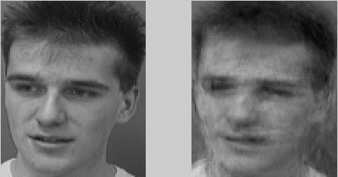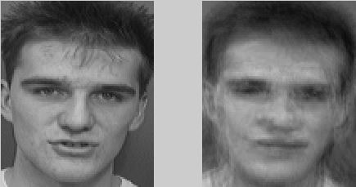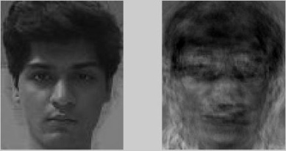

Above, are the original and reconstructed images (using 100 principal components) for one training set image, one test set image, and my own image.

In each case, the reconstructed images are worse than the previous set of reconstructed images. This is because, we are using fewer principal components to reconstruct the images.

The Error for these cases is:

trainMSE = 175.18; testMSE = 235.34; myImgMSE = 343.74;

# Q5

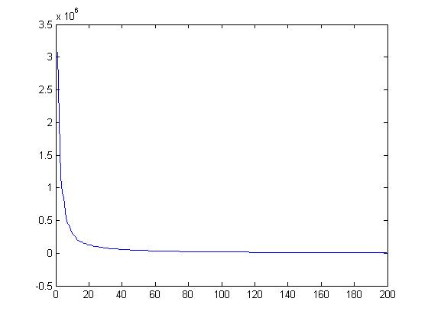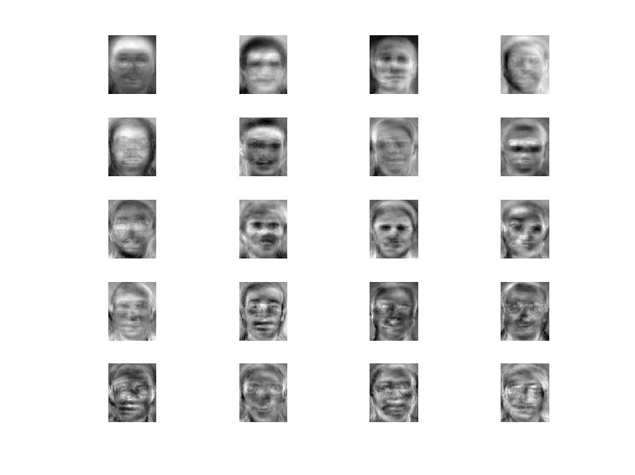

Graph on the left is the eigenvalues corresponding to the eigenvectors of the correlation matrix, arranged in decreasing order. At i=20, The eigenvalue is about 0.1, and since, larger eigenvalues contribute more to the reconstruction, we could use only about 20 eigenfaces for recognition. The corresponding 20 eigenfaces (ghosts) are in the image on the right.

# Q6

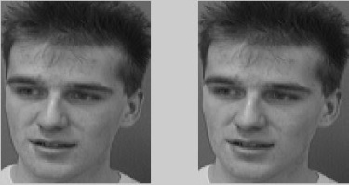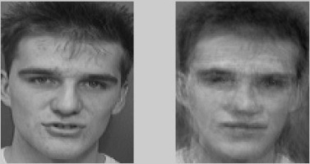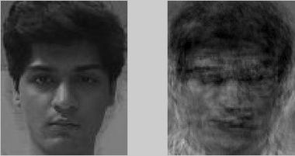

Above, are the original and reconstructed images (using 200 principal components) for one training set image, one test set image, and my own image.

Visually, the differences with Q3 are almost imperceptible, but the error values below show otherwise. They are much lower than Q3. This is because we used the best set of eigenvectors to reconstruct (pca_new.m). The Error for these cases is:

trainMSE = 1.1390e-25; testMSE = 160.94; myImgMSE = 241.56;

Without using the Turk-Pentland tricks, the computation time increased substantially i.e. **1093.70s** **in facerecog3 vs. 9.96s in facerecog1**! This is because, in standard PCA, we calculate the eigenvectors of the covariance matrix, C. Now, C in this case is a [10304 x 10304] matrix. Whereas, in Turk-Pentland method, we have to calculate the eigenvectors of a [200 x 200] matrix (or even smaller) followed by a vector-matrix product. Even these two operations combined are not very computationally intensive.