EE779 | Assignment 5

Ashwin Kachhara | 10D070048

# FastICA

It is an iterative algorithm for independent component analysis, based on maximizing the non-Gaussianity of the signals.

Steps:

1. Preprocessing: Centering (subtract the mean) and Whitening of the data.

Whitening is basically a linear transformation of the data to make it uncorrelated and variance 1. It is done by eigenvalue decomposition. If x = EDE’, then x_whitened = ED^(-0.5)E’x

1. The original signals can be considered a projection of the observed signals. The vector of this projection, w has to be found out, and we do that by solving an optimization problem to minimize the Gaussianity of the projection.
2. Initialize w. Use the above condition to update the value in each iteration till it converges.

# Scenario 1

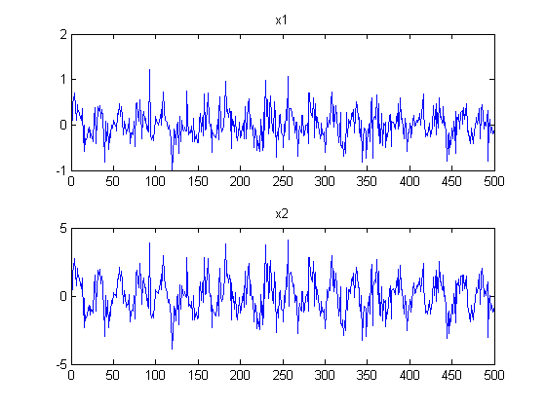

Above we plot the signals x1 and x2. We cannot really make out much meaningful information from these plots. It appears to be very noisy or corrupted by noise. Let’s take a look at some other interesting plots.

In the scatter plot of x1-x2, the plot clearly appears like a line with slope of about 45degrees. This indicates that the signals x1 and x2 are highly correlated, this may have been caused by the addition of the same noise function to both.

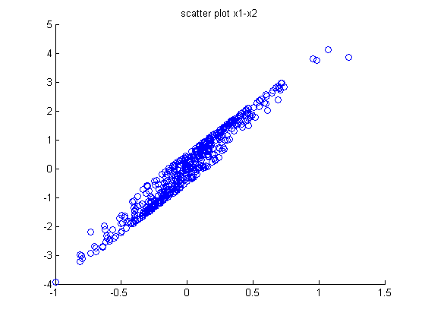

According to the histogram plots below, the signals appear to be slightly Gaussian, leading more credence to our hypothesis that the signals have been corrupted by Gaussian Noise.

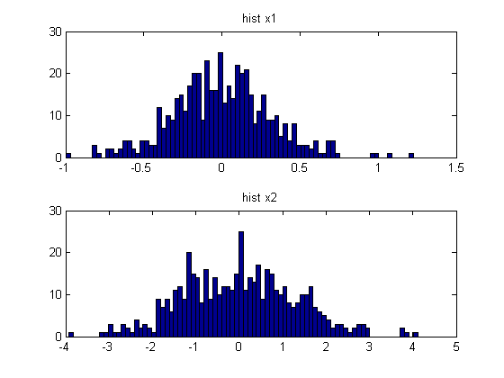

Now, we separate the signals using fastICA. Following are the plots corresponding to the separated set of signals

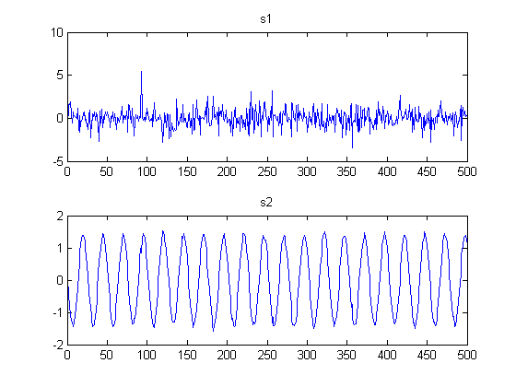

After separation, we can see that one signal was a pure sinusoid, and the other was a noise signal. The linear combination of these signals would be Gaussian noise-corrupted sinusoids. And the coefficient of the sinusoid would have to be quite low, since the original signals did not look remotely like sinusoids.

Scatter plot:

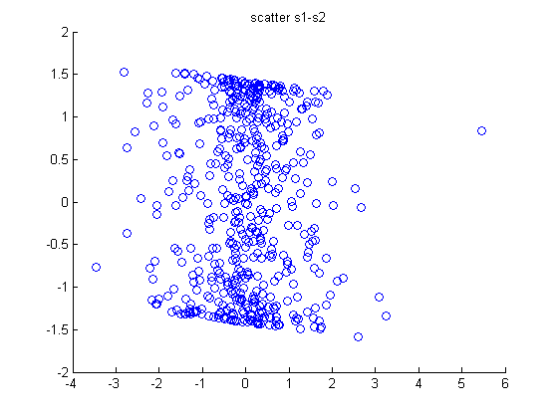

The signals are clearly uncorrelated now. S1, the noise signal seems to be concentrated around 0.

Histograms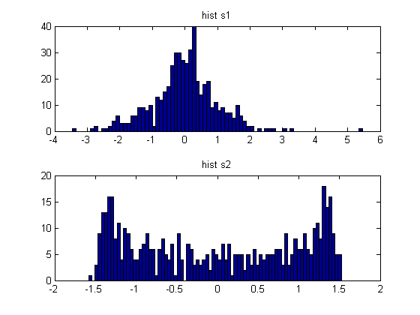

The sinusoidal signal, s2 seems to have an anti-gaussian histogram. The noise signal s1 seems to have a strongly Gaussian histogram. It was Gaussian noise.

The estimated mixing matrix:

A1 =

-0.1734 0.2624

-0.9448 0.9094

As we predicted above, the elements getting multiplied to s2 are much smaller in magnitude.

Below is a scatter plot of the only whitened signals. We see that whitening has removed the correlation between the signals. The scatter plot differs from that of s1,s2 in only the fact that this is a rotated version of that one.

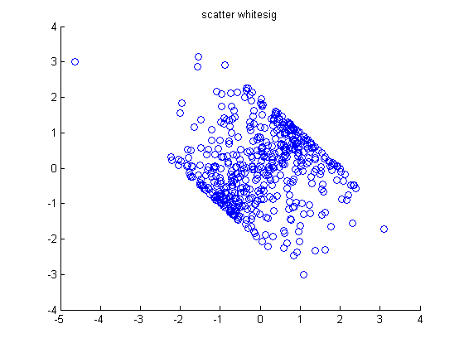

Below is the scatter plot of the signals projected onto the pca eigenvectors:

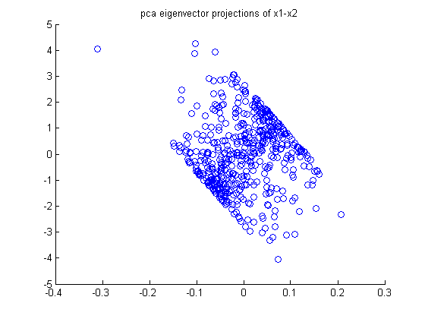

It is more squashed wrt one signal. But, the effect is the same, i.e. the data has been made uncorrelated.

# Scenario 2

The observed signals:

They both sound like two people speaking at once. One of the speakers is more prominent. It is hard to make out what they are saying except some words here and there.

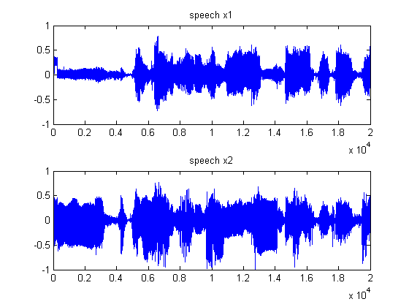

Scatter Plots:

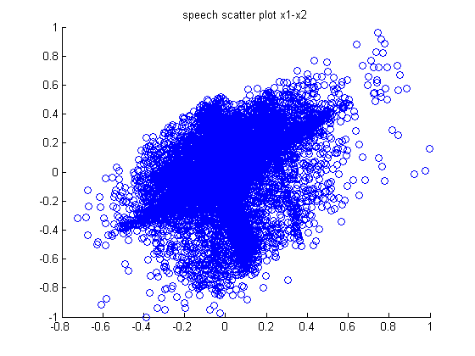

We see a distinct positive slope indicating that the samples are correlated. But the bulk of the observations seem to be almost circularly distributed.

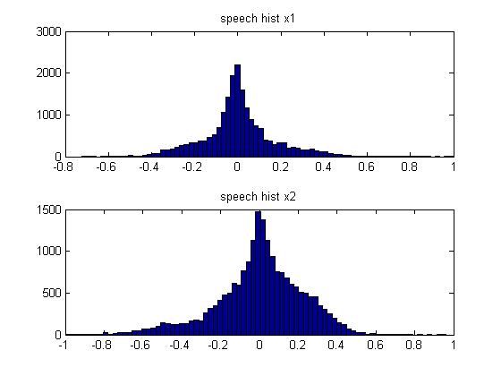

The histograms for the 2 speech observations appear to be some kind of super-gaussian distribution, judging by the slope of the histograms. This may be indicating that it would be convenient to separate using ICA.

The separated signals are as follows:

On playing the sounds, we clearly hear both the different speech segments as separated.

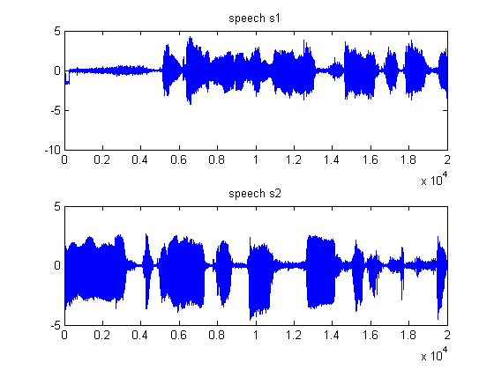

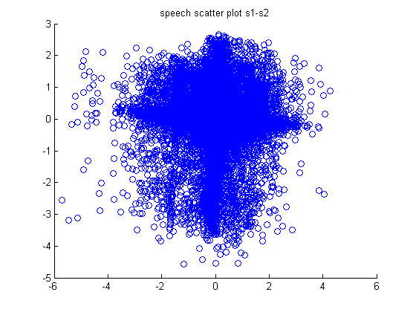

The speech scatter plot indicates that the resolved signals are uncorrelated.

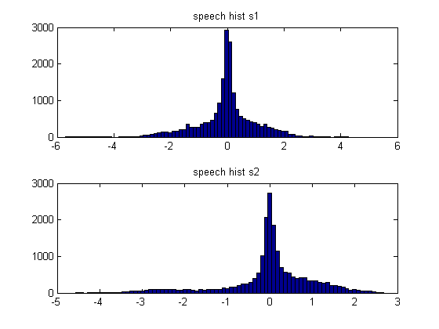

The histograms are clearly super-gaussian in nature. This justifies our use of ICA for signal separation.

The mixing matrix:

A2 =

-0.1647 -0.0242

-0.1141 0.1928

# Optional

### Can you relate A to the mixed data?

Yes, some qualitative relation is possible. For ex, in scenario 1, the observed signals are a lot like Gaussian noise. So, we infer that the mixture coefficients of this signal must be much higher than the other signal(sinusoid). And that is exactly what we observed after getting the matrix A

### What happens if the original signals are corrupted by Gaussian noise?

This will cause no problems. In scenario 1, we faced a similar situation. So, we just consider the noise to be another signal itself. Using ICA, we will be able to obtain the signals s1-sn and the noise signal. Hence, we will be able to get noise-free original signals

### What if the number of mixtures is less than the number of source signals?

In this case, the best result is not possible, because we have less number of mixtures. This situation is analogous to a linear system of n variables but with only m equations (m<n). At best, we can use PCA to reduce the dimensionality and hence we can compute an approximation to the required signals.