
MEDIGEEKS

Smart Phone Based Post Operative Rehabilation for Knee Surgery

Team Members details


Mentor





Dr. Ganesh K Associate professor

Ashwin Krishnan CK

Akshay N Dolainkar

Hansel Thomas D’Souza

Praveen Gudi
Problem provider Problem provider



Dr NAHAS Rahim Arthroplasty and arthroscopy

Dr Sharat Balemane Associate professor

Initial Problem statement

Individuals recuperating from knee replacement procedures or ligament repair often struggle to comply with established rehabilitation protocols. This noncompliance can result in prolonged recovery times, decreased mobility, heightened stiffness, and discomfort.
There is a necessity for a digital resource that informs, monitors, and encourages patients to adhere to recommended exercises and care practices, thereby promoting the best possible recovery results.

Refined problem statement

The problem (Unmet need)

- Not Personalized
Same exercises given to all patients, without adjusting to their age, surgery type, or
progress.
- No Tracking
Doctors and physiotherapists can’t see if the patient is doing exercises regularly or correctly.
- Difficult to Access
Going to clinics for physiotherapy is costly, time-consuming, and hard for elderly or rural
patients.
- No Real-Time Feedback
Patients don’t know if they are doing exercises correctly or if they should stop due to pain or
swelling.
- Unreliable Apps
Fitness apps are not made for surgery recovery, and videos don’t give medical advice or
track progress

Refined problem statement

The affected population (% or number)

- According to available data, the average global rate for knee replacement surgeries is around 175 procedures per 100,000 people
- Approximately 2.5 lakh people undergo knee replacement surgery in India every year
- Approximately 15-20% of people who undergo total knee replacement surgery may
experience dissatisfaction with the outcome.
- Major reason for this is inadequate post-operative care, including not following proper
physical therapy exercises and neglecting necessary rehabilitation protocols

Refined problem statement

The Anticipated benefit (Outcome) of the solution

- Virtual reality: Boosts mobility and cuts pain for 80% of rehab patients.
- Digital therapy: Doubles engagement, matches in-person results for pain, function, and mental
health.
- Remote monitoring: Shortens hospital stays and lowers readmissions with continuous care.
- Digital tools: Make rehab accessible anywhere, no travel needed.

What are the different approaches
discussed by the team?

Solution 1 :
Initially, we planned to track both the knee and hip movements for a more comprehensive movement assessment.

Solution 2 :
Later, we decided to focus only on knee tracking first, ensuring accuracy and efficiency before expanding to other joints.

Current Technologies
/ Predicate devices

- Gait Analysis Systems: Tracks knee movement using cameras & sensors.

(Source: Wikipedia - Gait Analysis)
- X-ray Motion Analysis: Real-time imaging for knee joint assessment.

(Source: Wikipedia - X-ray Motion Analysis)
- GALS Screen: Clinical method to detect locomotor abnormalities.

(Source: Wikipedia - GALS Screen)
- Smart Knee Implants: Sensor-based implants for post-surgery monitoring.
(Source: Financial Times - Smart Knee Implants)

Proposed Solution

What is the approach?
  - App and website for home use – Patients can access rehab plans anytime.
  - Seamless doctor-patient connection – Doctors can monitor progress remotely.
  - Easy data analysis for doctors – Doctors get clear data on patient recovery.
  - Graphical progress reports – Patients and doctors both see easy-to-read charts.
  - Simple and user-friendly design – Suitable for all age groups

Why this approach?
  - Patients find regular physiotherapy visits hard.
  - Tech like VR & remote rehab shows 80% better mobility.
  - Cheaper & more accessible than hospital visits.
  - Helps rural patients access care.
  - Combines expert advice with home convenience.

Proposed Solution

Unique feature in our idea:
Voice Cloning for Personalized Interaction: Doctors can pre-record instructions, allowing patients to
receive guidance in a familiar and comforting voice.

Mobile Accessibility: The app is fully mobile-based, making rehabilitation accessible anytime, anywhere without requiring additional equipment.

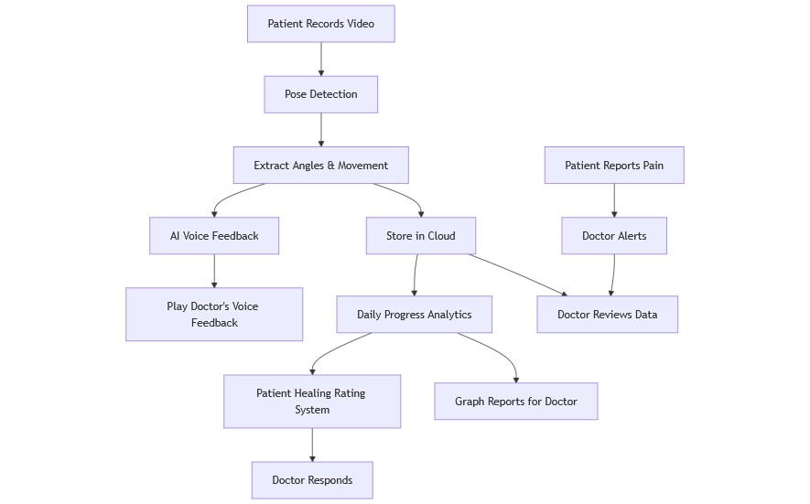
Prototype or Diagram of the proposed Device

Diagram of prototype CAD/CAM model

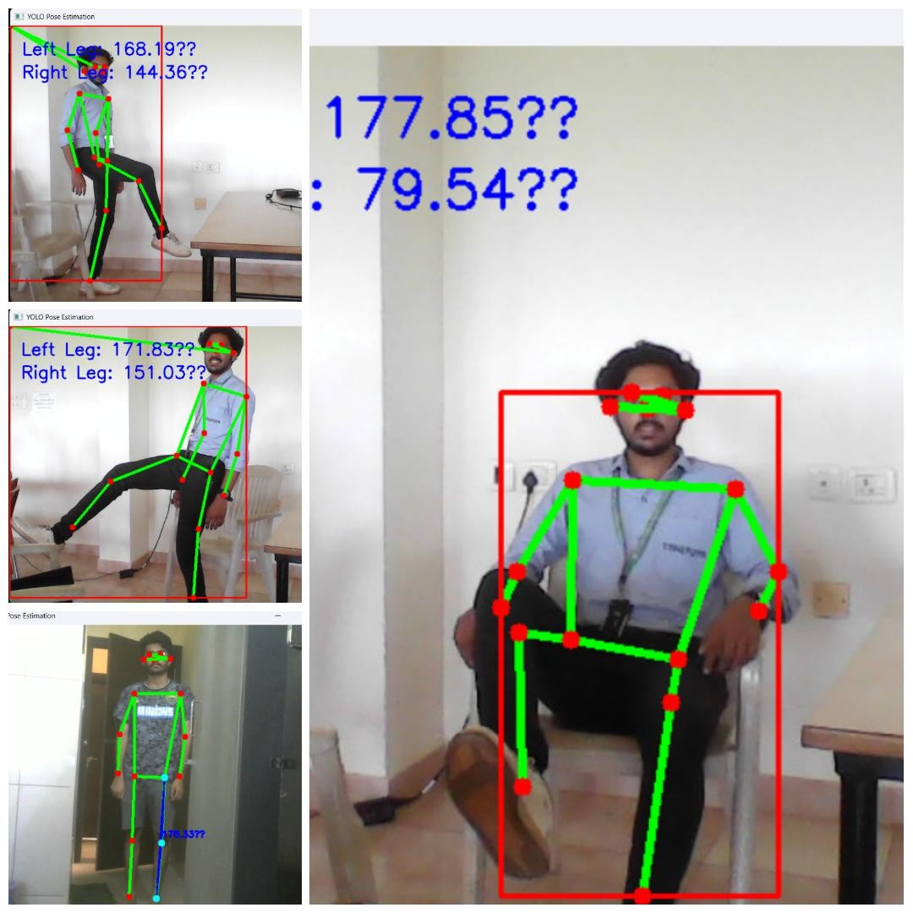
Prototype or Diagram of the proposed Device

Diagram of prototype CAD/CAM model

Prototype or Diagram of the proposed Device

Doctor Dashboard
Diagram of prototype
CAD/CAM model
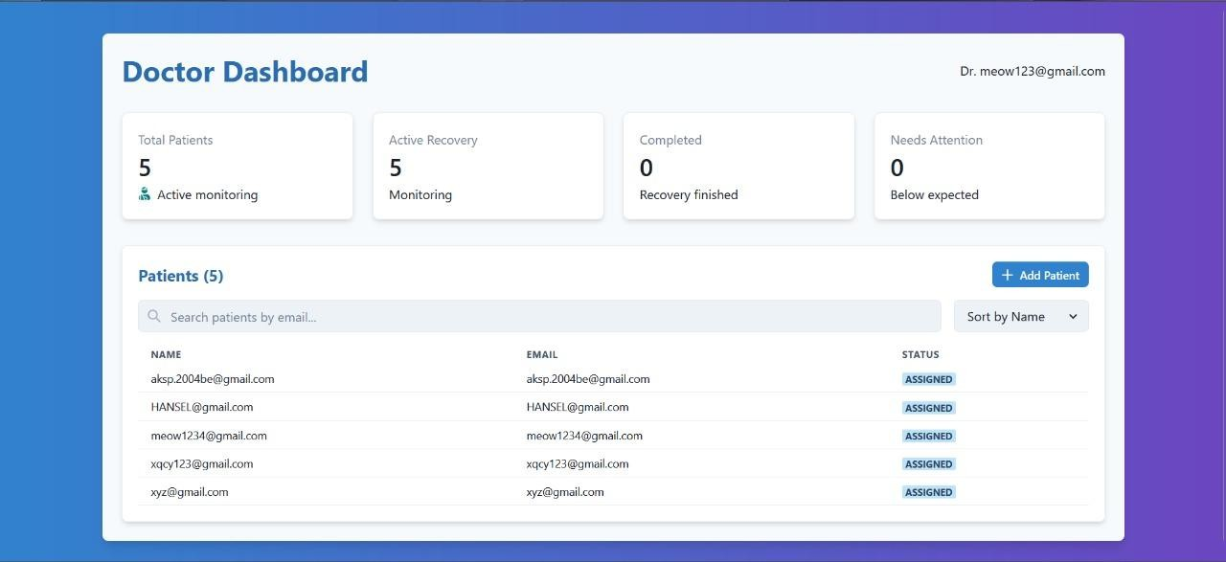

Prototype or Diagram of the proposed Device

Doctor Dashboard
Diagram of prototype
CAD/CAM model
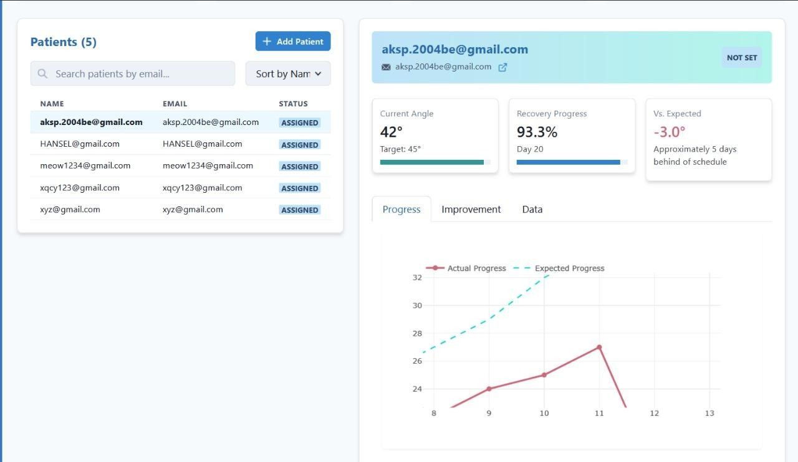

Prototype or Diagram of the proposed Device

Patient Dashboard
Diagram of prototype
CAD/CAM model
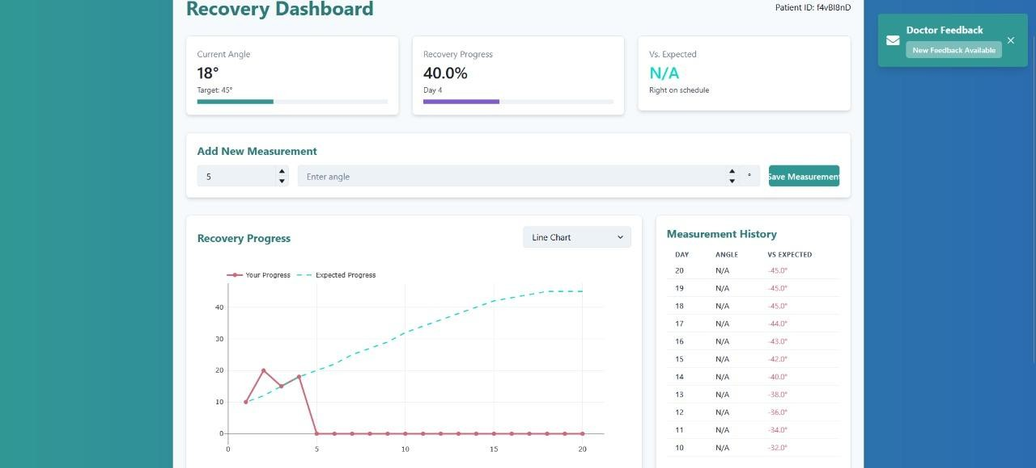

Prototype or Diagram of the proposed Device

Patient Dashboard (Voice feedback feature included – ©Dr Sharath )

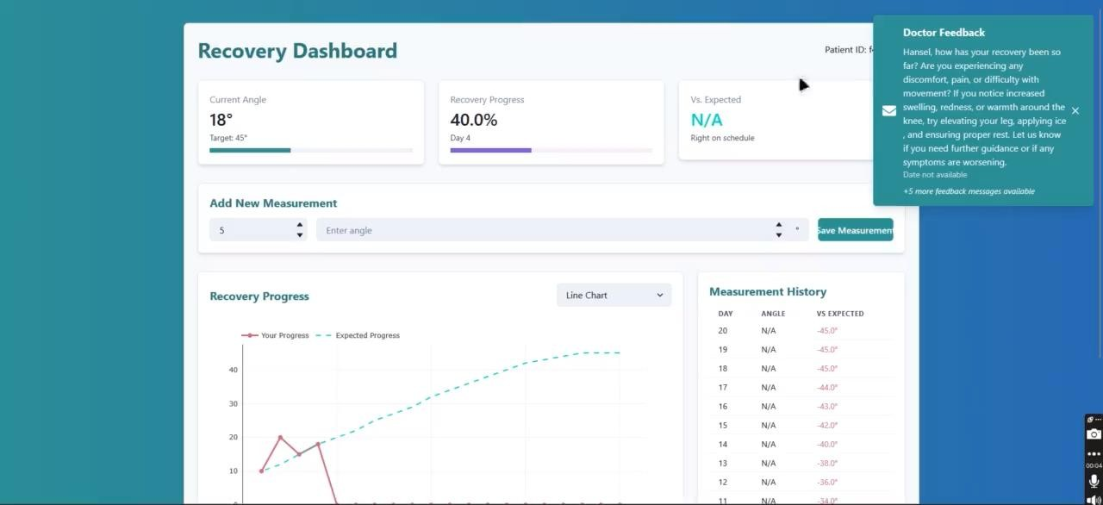
Diagram of prototype CAD/CAM model

Further stages planned

Enhance Existing Prototype
Improve the current prototype by adding more features and refining the user interface.

Develop Full Website and App
Build a fully functional website and mobile app to ensure patients can access rehabilitation programs from any device.

Add Native Language Support
Include regional language options to make the platform easy to use for patients from different backgrounds.

Integrate Guided Exercises
Add video-guided exercises with real-time feedback to improve patient compliance and recovery.

Expand to Other Joints
Once the knee rehabilitation system is complete, extend the solution to cover hip rehabilitation as well.

