COMPUTER NETWORKS
Demonstration of OSI and TCP/IP Models Using a Network Simulation Tool
Tool used: Cisco Packet Tracer (Simulation Mode)
1. Aim
To demonstrate how data moves through the layers of the OSI and TCP/IP models by building a small network in a simulation tool and observing the encapsulation of packets at each layer.
2. Theory: OSI and TCP/IP Models
The OSI model divides network communication into seven layers; the TCP/IP model, on which the Internet is built, groups the same functions into four. On the sender, each layer adds its own header (encapsulation); on the receiver the headers are removed in reverse order (decapsulation).
No. | OSI layer | TCP/IP layer | Data unit (PDU) | Example protocols | Example device
7 | Application | Application | Data | HTTP, DNS, FTP, SMTP | Web server
6 | Presentation | Application | Data | SSL/TLS, JPEG, ASCII | –
5 | Session | Application | Data | NetBIOS, RPC | –
4 | Transport | Transport | Segment | TCP, UDP | –
3 | Network | Internet | Packet | IP, ICMP, ARP* | Router
2 | Data Link | Network Access | Frame | Ethernet, MAC addressing | Switch
1 | Physical | Network Access | Bits | Cables, signals | Hub, cable, NIC
*ARP is commonly placed between layers 2 and 3.
3. Network Design
The topology has two LANs joined by a router. PC0 and PC1 sit on LAN 1 behind Switch0; PC2 and a web server sit on LAN 2 behind Switch1. Use PCs, 2960 switches, a 2911 (or 1941) router and a server from the Packet Tracer device list, connected with copper straight-through cables.
Device | Interface | IP address | Subnet mask | Default gateway
PC0 | FastEthernet0 | 192.168.1.10 | 255.255.255.0 | 192.168.1.1
PC1 | FastEthernet0 | 192.168.1.11 | 255.255.255.0 | 192.168.1.1
Router0 | Gig0/0 (to Switch0) | 192.168.1.1 | 255.255.255.0 | –
Router0 | Gig0/1 (to Switch1) | 192.168.2.1 | 255.255.255.0 | –
PC2 | FastEthernet0 | 192.168.2.10 | 255.255.255.0 | 192.168.2.1
Server0 | FastEthernet0 | 192.168.2.20 | 255.255.255.0 | 192.168.2.1

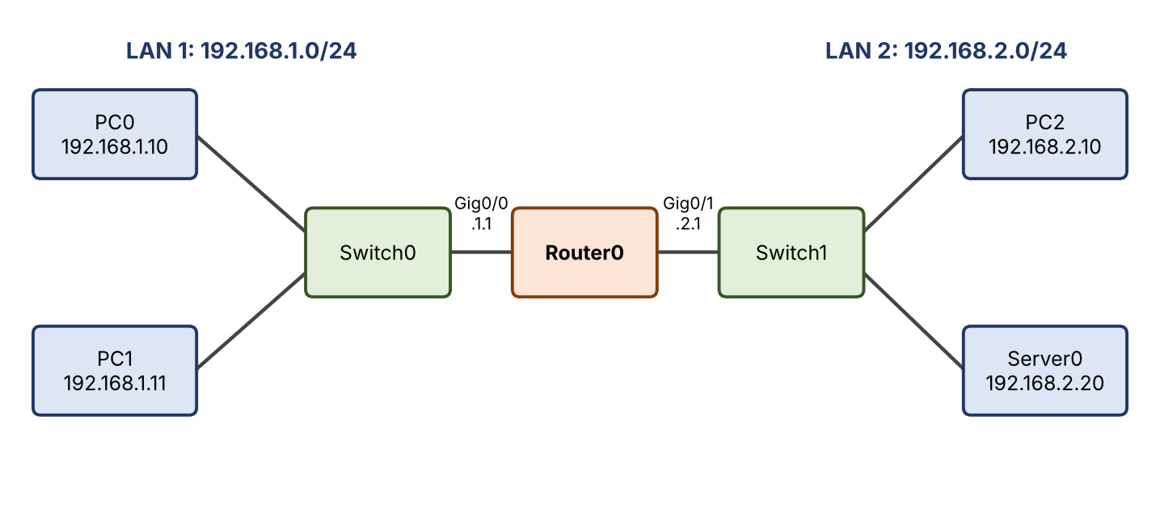
Figure 1: Network topology used for the simulation
4. Procedure
- Step 1 – Build: place the devices, connect them as in Section 3 and wait for all link lights to turn green.
- Step 2 – Configure hosts: on each PC and the server, open Desktop → IP Configuration and enter the address, mask and gateway from the table.
- Step 3 – Configure the router: open the router CLI and enter the commands below.
Router> enable
Router# configure terminal
Router(config)# interface gigabitEthernet 0/0
Router(config-if)# ip address 192.168.1.1 255.255.255.0
Router(config-if)# no shutdown
Router(config-if)# exit
Router(config)# interface gigabitEthernet 0/1
Router(config-if)# ip address 192.168.2.1 255.255.255.0
Router(config-if)# no shutdown
Router(config-if)# end
Router# show ip interface brief

- Step 4 – Test connectivity: from PC0 open the Command Prompt and run ping 192.168.2.10, then tracert 192.168.2.10.
- Step 5 – Observe the layers: switch to Simulation Mode, set the event-list filter to ICMP, ARP, TCP and HTTP, and send a ping from PC0 to PC2. Click Capture/Forward and open each packet’s PDU Information; the OSI Model tab shows the In Layers and Out Layers.
- Step 6 – Application-layer test: enable the HTTP service on Server0, open PC0’s Web Browser and visit http://192.168.2.20, again stepping through the packets in Simulation Mode.
5. Observations
The table lists what should be seen at each layer while a packet travels from PC0 to Server0. Compare it with your own simulation and note any differences.
Layer | Data unit | What to observe in the PDU details
Application (7–5) | Data | HTTP GET request generated by the browser on PC0 (a ping has no application data).
Transport (4) | Segment | TCP header with destination port 80 and a random source port; the three-way handshake (SYN, SYN-ACK, ACK) precedes the HTTP request. ICMP ping uses no transport layer.
Network / Internet (3) | Packet | Source IP 192.168.1.10 and destination IP 192.168.2.20. These addresses stay the same end to end; the TTL falls by 1 at the router.
Data Link (2) | Frame | Source and destination MAC addresses. PC0 first sends an ARP request to find the gateway’s MAC; the destination MAC is the router’s, and it changes again on LAN 2.
Physical (1) | Bits | The frame is converted to signals and sent on the cable; the switch forwards it using its MAC address table.

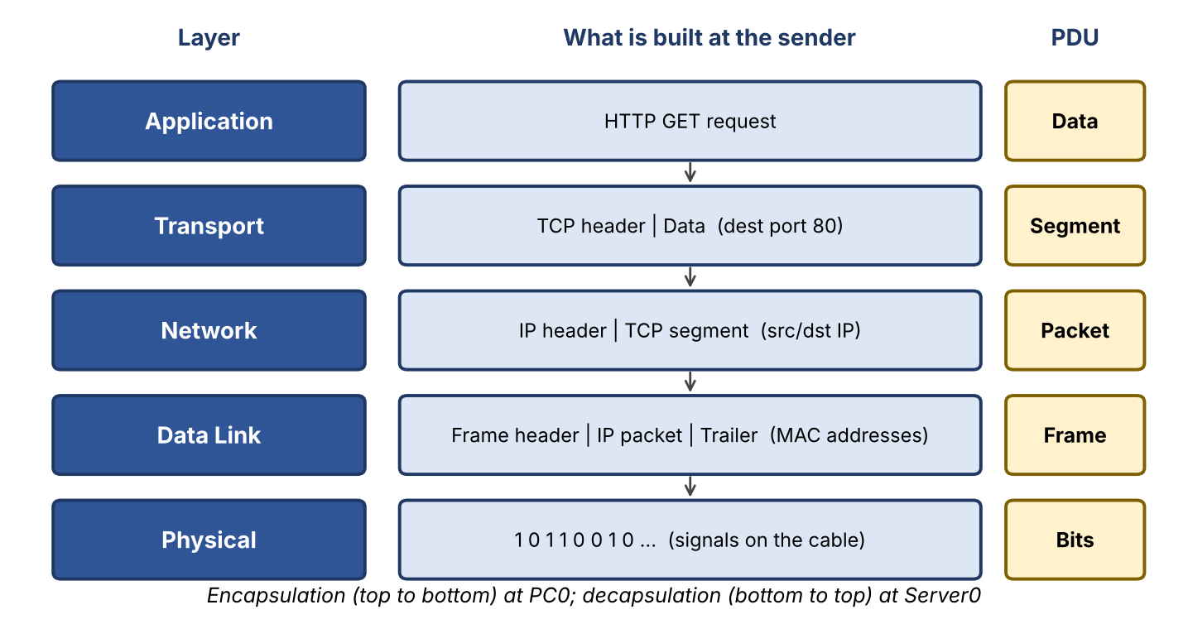
Figure 2: Encapsulation of an HTTP request from PC0 as it passes down the layers

Figure 3: Typical ping output (illustrative; your exact values may differ)
C:\> ping 192.168.2.10

Pinging 192.168.2.10 with 32 bytes of data:
Request timed out.
Reply from 192.168.2.10: bytes=32 time<1ms TTL=127
Reply from 192.168.2.10: bytes=32 time<1ms TTL=127
Reply from 192.168.2.10: bytes=32 time<1ms TTL=127

Ping statistics for 192.168.2.10:
Packets: Sent = 4, Received = 3, Lost = 1 (25% loss)
6. Results
- Connectivity: the first ping may show one lost reply because of ARP resolution; the remaining replies should succeed, and tracert should show 192.168.1.1 as the first hop.
- Encapsulation: at the sender the data is wrapped successively into a segment, a packet and a frame; at the receiver the headers are removed layer by layer.
- Device roles: the switch works at layer 2 (MAC addresses) and the router at layer 3 (IP addresses).
7. Conclusion
The simulation shows that every transfer passes through the same layered process. The OSI model gives a detailed seven-layer reference, while the TCP/IP model groups these into four practical layers; both explain how headers are added and removed so that data can cross different networks reliably.

